Yellowhead
Heritage Club
Sept., 2017
Hello and welcome to our newest members who have joined. I hope you have had a great summer. It has definitely been a busy one for me. I had the privilege of seeing my first total eclipse. My husband and I went to Wyoming to see it. It was incredible! That’s one more item off the bucket list for us. We survived doing a few kitchen renos, spent some time at the lake with family and friends. All and all it was a nice summer. There have been a few changes put in place. For those of you, who have Medoc travel insurance; please ensure that your membership fees are paid for 2017 so that you are covered. Also there will be a new online membership system for Good Life Fitness beginning Sept. 15, 2017. You will be able to go to a link and apply directly to Good Life Fitness for membership at a special reduced rate for Heritage members. Good Life will have a list of all paid Heritage members so again make sure your dues are paid. The new Good Life Fitness link is; https://corporate.goodlifefitness.com
United Way BBQ’s: We held BBQ’S and 50/50 draws at each of the depots. All proceeds will be going to United Way. The Heritage Club would like to thank all of the people who came out to volunteer for these events. A special thanks to Jack & Maxine Mcleod, Bob & Stella Lee, Shirley Stewart, Ross Spence, Marlene Paproski and Dakota Mcleod. Also thank you to Louise & Clayton Anderson for letting us use their vintage car grills and for delivering them to us each day. Together we raised $1017.30 for the United Way! Great job! Also thank you to everyone who came out and purchased a burger and drink to support this great cause.

Spider man came for a visit and a burger!
We had T-shirt give aways & 50/50 draws!

Stella drumming up business!

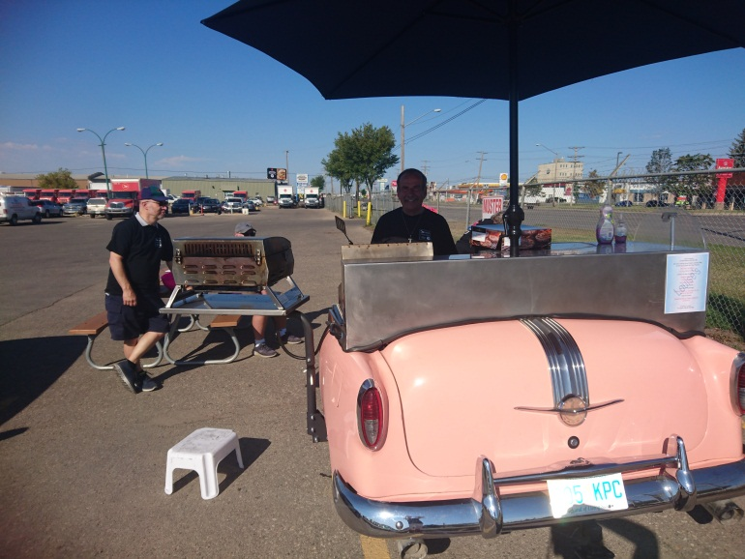
Louise & Claytons Classic Grill!

Saturday, October 21 at 7:15 pm. Escape City Adventure
248 3rd Avenue South, Saskatoon
Come on out and have some fun! Escape City puts you in the middle of a real life adventure that you’ll never forget. Work together with your team to find clues, solve puzzles and escape before your time is up. After an initial briefing covering the general rules, a friendly guide leads you and your team to the door of your escape room. Your group will enter and get acclimatized before the guide leaves you. Once the door closes, a video introduction will play, introducing the rooms theme and storyline. The video will give you instructions on how to get started. Then the group explores the room looking for clues and solving puzzles and challenges one by one as you work toward your escape.
Escape City makes you feel like you’re in the middle of the story. The rooms are designed in consultation with experts in the theatre and film industry to ensure that they transport you to another world! The rooms are designed to be challenging but if a puzzle is too difficult you can request a clue from the game master. Also you will be able to leave the room at any time if you need to get fresh air, take a break or go to the washroom but the clock keeps running. If you are interested in this event please contact Heather Spence at saskatooncpcheritageclub@gmail.com by or before Oct. 14th. We have three rooms booked so if you are late contacting us you may not get a spot. It should be a great time!

Partners For Life – Our Heritage Club is involved with the Canadian Blood Services Partners for Life Program. As a member of the Saskatchewan Partners for Life program our organization was one of 308 partners across the province. These 308 partners pledged 14,304 units and donated 14,764 units for an over-achievement of 103%! Saskatchewan partners brought in 824 new donors. Our Heritage Club has played an important part in ensuring that patients receive the blood and blood products they require for medical treatment. Congratulations to everyone involved. I encourage you to give blood at 1206 Emerson Ave. under the Yellowhead Heritage Club.
A challenge…let’s see if we can beat what we donated last year.

Heritage Web Page – Please do not forget to check out our national web site. Go to www.heritageclub.ca and click on find a chapter. When you click on Yellowhead our site will come up. Here you will be able to read the latest newsletter, learn about any new events coming up and also any monthly events that are happening. So if you lose your newsletter you can use this site so you don’t miss anything! Also please be patient with us as we are just learning to navigate this site as well.

Monthly Ladies Lunch – There has been another change with our ladies lunch. We will still be meeting on the first Tuesday of each month at 12:30. We will meet at Rock Creek Tap & Grill, 3020 Preston Ave. South in Stonebridge.

Weekly Breakfast
All are welcome to come and join us for our weekly breakfast. We meet every Tuesday morning at 8:30 am at the Smitty’s in Market Mall.

Card Club – We meet at 831 Delaronde Way at 1:00 pm. on the following dates:
Thursday, Sept. 7 & 21
Thursday, Oct. 5 & 19
Thursday, Nov. 2 & 16 & 30
Thursday, Dec. 7 & 14

If you have any special accomplishments to share in our newsletter give us a call or email. Also if you know of any of our members who are hospitalized or someone who has passed away please let us know. Thanks so much.
Spouses are also encouraged to join our club!
Membership Application for Heritage Club
If you know of any retired Posties who would be interested in joining please share this form with them. Thank you.
___________________________________
Heritage Club Registration
First Name: __________________
Last Name: ___________________
Gender: ___
Status (Active or Retired): ______
Home Address: ____________________________
____________________________________________________________________________________________________________________________________________
Telephone: __________________
E-Mail: ______________________
CPC Start Date: _______________
Total Years of Service: _________
Membership Fee is $10.00 for one year. Send to:
saskatooncpcheritageclub@gmail.com or mail to Heather Spence at 831 Delaronde Way
Saskatoon, Sk. S7J 3Y8.

Your Committee Members
President:
Heather Spence: 306-955-1408
Vice: Shirley Stewart
Sec. /Treasurer: Maxine McLeod
Members at Large: Robert Lee & Ross Spence
Sask. Crowns is asking for our support. They are a community based group who want Saskatchewan people to decide the fate of our crown corporations. They are gathering signatures on a petition. If they get the required number of signatures the government will be required to hold a province wide vote so as citizens we can decide whether or not to sell off or wind down our crowns like Sasktel, Sask Power, Sask Energy, SGI, STC, & Sask Water. Their website is: http://www..saskcrowns.ca. On the web site a petition can be downloaded, printed, filled with signatures and returned to them. They will also deliver or send you a petition if you wish to support this cause. If you would like to request a petition please call 306-384-2000. Sask. Crowns wishes to pass along thanks to you for any help you can give them to spread the word.
Interesting Facts:
*If you started with 1 cent and doubled your money every day, it would take 27 days to become a millionaire!
*The tongue of a blue whale weighs more than most elephants.
*A humming bird weighs less than a penny.
*10% of the world’s population is left handed.

