

Heartland Chapter – Heritage Club

Newsletter

Fall 2017

**President’s Message**

Well once again we are rapidly approaching a time of seasonal change. A time when we can enjoy the beauty of the ever changing colours of the leaves on the trees. The leaves which will soon fall to the ground in never ending piles. Then comes the raking the bagging and the dragging of ten ton bags to the curb. But all too soon we will have to turn to shoveling snow. How long is it before spring?

But then I also, am in the autumn of my years and each day good or bad is a good day to be enjoyed.

Speaking of good, we have some good news

Over the years our members have been asking about the possibility of family members joining the Heritage Club, so that they could take advantage of our many activities and benefits.

During our most recent National AGM, a number of changes were made to the National Constitution regarding eligibility for membership. Membership will now be accepted from your grown children, siblings and other relatives as long as they are related to a dues paying member, and become a dues paying associate member.

We will also accept membership from Canada Post Employees who have less than 20 years of service. On acceptance as a member and after payment of annual dues they will be considered an associate member until they reach the qualifying years of service at which time they will become a regular member.

*These new members will become eligible for all club benefits including Medoc insurance*

***Harold Onagi President***

Heartland Chapter – Heritage Club

1462 Church Ave.

Winnipeg, Mb R2X 1G4

(204) 987-5010

Email – heartlandchc@gmail.com

Office hours 9:00am to 12:00 noon

Monday and Thursday

Our answering Machine will take your

Message outside of these hours.

**Executive Phone numbers in the event that immediate contact must be made which cannot wait for office hours.**

Chapter Executive:

President - Harold Onagi 832-4398

1st Vice President Gord Arseny 668-6604

2nd Vice President Eileen Hay 222-5412

3rd Vice President Betty Johnstone 253-1325

Treasurer Paul Pelletier 237-3244

Secretary Darlene Fleming 415-7330

Adm. Officer Ed Paleshnuik 253-9464

Activity Councils

Wpg. & Area Buzz Lamond 452-7824

Brandon & Area Murray Sangster 728-7489

T. Bay Nth W. On Don Rosengren (807) 345-1624

Newsletter Editor 1st Vice President,

***Gord Arseny***

Dates to remember

Fun Golf Sept. 6, 2017

Annual Meeting Sept. 21, 2017

Holiday Party Casino trip Nov. 27-29, 2017

Christmas Dinner Dec. 6, 2017

**2018 Fiscal Year Heartland Chapter Annual Dues**

**2018 Fiscal Year (Jan. 1 to Dec.** **31, 2018) Heartland Chapter Annual Dues**

**Dues 2018 - $10.00 Dues 2019 - $10.00**

**Charity for 2018 - Charity for 2019 -**

**TOTAL CHEQUE: $ ________________**

**Name: _______________________**

**Address: ______________________________**

**City: _________________ Postal Code: ___________________________**

**………………………………………………………………………..cut……………………………………………………………………………………….**

**SANTA’S HELPERS NEEDED**

**The Christmas season is once again around the corner, and we are getting ready for all the mail that will soon arrive for Santa Claus. Each year children from around the world send their Christmas wishes to Santa. Over the years Canada Post employees, both current and retired, have been bringing joy and happiness to these children, by responding to their letters. We are looking for Heritage Club members who are willing to spend an hour or two replying to these letters either at home, or at Canada Post.**

**Each volunteer will receive a package containing suitable responses to choose from, which you can add as a postscript to the letters provided.**

**If you would like to help spread a little joy and happiness, please contact the Heritage Club at (204)987-5010, or by e-mail** [**heartlandcpc@shaw.ca**](mailto:heartlandcpc@shaw.ca)**, or complete the form below and return to us in the envelope provided.**

**Name: ………………………………………….**

**Address: ……………………………………………**

**Postal Code: ………………………………………………….. Phone: ……………………………………………**

**I can answer letters in: English: ………………… French: ……………………. Other: ………………….**

**I can answer letters at the Santa’s workshop: …………………………**

**ANNUAL DUES**

**Attention to all members: In order to be eligible for active member benefits you must be current with your yearly membership dues. That means the $10.00 for the current year must be received in our office and this year’s membership card issued.**

**A lot of members continue to take advantage of the superb medical travel plan, (Medoc Travel Insurance)**

**offered to members but DO NOT KEEP UP WITH THEIR**

**DUES !!!!**

**Remember …. $10.00 could save you thousands, or even more should you be unfortunate enough to become seriously ill while traveling.**

**Also remember the Provincial Medical you carry does not fully cover you when you travel outside of the Province.**

**To those who are paid up, thank you, and enjoy your worry free travels!**

**To those who are not, better get the cheque written!**

**BOWLING 2017/2018**

**Coronation Lanes 255 Tache, St. Boniface**

**The 2017/2018 Bowling Season will start on Thursday, Sept. 21, 2017 at 1:00 pm. We will be bowling every second Thursday until Dec. 7, 2017.**

**Bowling for 2018 will commence on Thursday Jan. 4 and continue every second Thursday until March 29, 2018.**

**This is strictly for fun – no fixed teams. Come and play when you can. Bring a friend or family member.**

**Rates for 3 games and shoe rental will be $7.00.**

**Hope to see you there!**

**Buzz Lamond**

**Activity Coordinator**

**2017 ANNUAL BANQUET**

**Our spring luncheon was a great success!**

**67 people attended, and were as usual, pleased with the food selection. Carole and Murray Sangster from our Brandon Chapter were in attendance, and we had five new retirees join us.**

**The 50/50 and watch draws made the winners happy, and we were able to donate over $250.00 worth of food to Agape Table.**

**Looking forward to seeing you all in the Fall!**

**Eileen and Betty**

**2017 ANNUAL MEETING**

**Your Executive has chosen to give all dues paying members a “thank you” for maintaining your membership and contributing to our club’s social and financial health.**

**Tickets for the Sept. Annual Meeting Luncheon at the Royal Fork will be $8.00 per person, and the Christmas Luncheon tickets will be $5.00 per person. This price includes spouses or significant others. If there is neither of these, please feel free to invite a guest at the reduced cost. However, extra tickets will be the usual price of $15.00 for September and $20.00 for Christmas.**

**Eileen and Betty**

**SOUTHWEST MB. ACTIVITY COUNCIL**

**At Southwest Activity Council in Brandon, we continued to meet at Huggy’s Restaurant the 2nd Tuesday of each month.**

**At our January 10th meeting we had a guest speaker, Carina, attend from Westman Women’s Shelter. She is the education councilor for the Y.W.C.A.**

**Carina gave us some very interesting and informative outline of what the Women’s Shelter’s purpose is, giving facts and figures such as how many women they provide with food, clothes, toiletries, baby needs etc. each month. She then presented us with 2 plaques. One was in appreciation for the large number of bags of toiletries we have been assembling and delivering to them for more than 10 years. The other was for the many and varied items of food, clothes, toys etc. our club has donated to the shelter over the past years.**

**As we have no place (office) to display them, Heartland Chapter Executive agreed to accept them and display them in the Regional Office in Winnipeg. Thank You to them for that.**

**On April 3rd, my wife and I attended a meeting at Seniors for Seniors regarding Medoc Health and Travel Insurance. It was put on by National Association of Federal Retirees (NAFR).**

**The guest speaker, from Johnson Insurance, spoke about the benefits of Medoc and gave some advice on procedures to follow if you should need to make a claim. At our April meeting, I gave a report on the information provided there.**

**Instead of a regular meeting in June, we decided to meet at Beef and Barrel Restaurant for lunch. This was attended by 18 people. After lunch, 7 of us went to Daly House Museum for a guided tour. Thank you to Betty Gillis for making the arrangements for both functions.**

**There will be no meetings in July or August. Arrangements have been made for us to hold our September Luncheon Meeting at Sandhills Casino on Tuesday September 5th, 2017 at 11 a.m.**

**Note: Change of date to the 1st. Tuesday of the month. Regular meeting dates resume on the 2nd. Tuesday of each month starting in October. Until we meet in September, Have a good summer!**

**Murray Sangster**

**Chair, Southwest Activity Council**

**13TH ANNUAL ED SEDLESKI MEMORIAL**

**GOLF TOURNAMENT**

**The Heritage Club (Heartland Chapter) hosted the Ed Sedleski Memorial Golf Tournament on June 14th at the Oakwood Golf Club. The event attracted 77 golfers for a wonderful day of golf and camaraderie.**

**The championship team this year, with a superb winning score of -12 was comprised of Les Daniels, Trevor Swampy, Lloyd Laroque, and Bruce Bruyere. The team was presented with a Sedleski Memorial trophy along with personal plaques and prizes.**

**All 77 golfers who participated went home with prizes and fond memories of a day well spent with friends and family.**

**A great meal was enjoyed by all who attended and the catering was first class as usual!**

**Next year our 14th Annual Tournament will be held at Oakwood on June 13th. Be sure to mark that date on your calendar and come and join us for a great day of golf, food and fun !**

**Buzz Lamond**

**Golf Chairman Wpg. & Area**

***2017 Team of Champion***

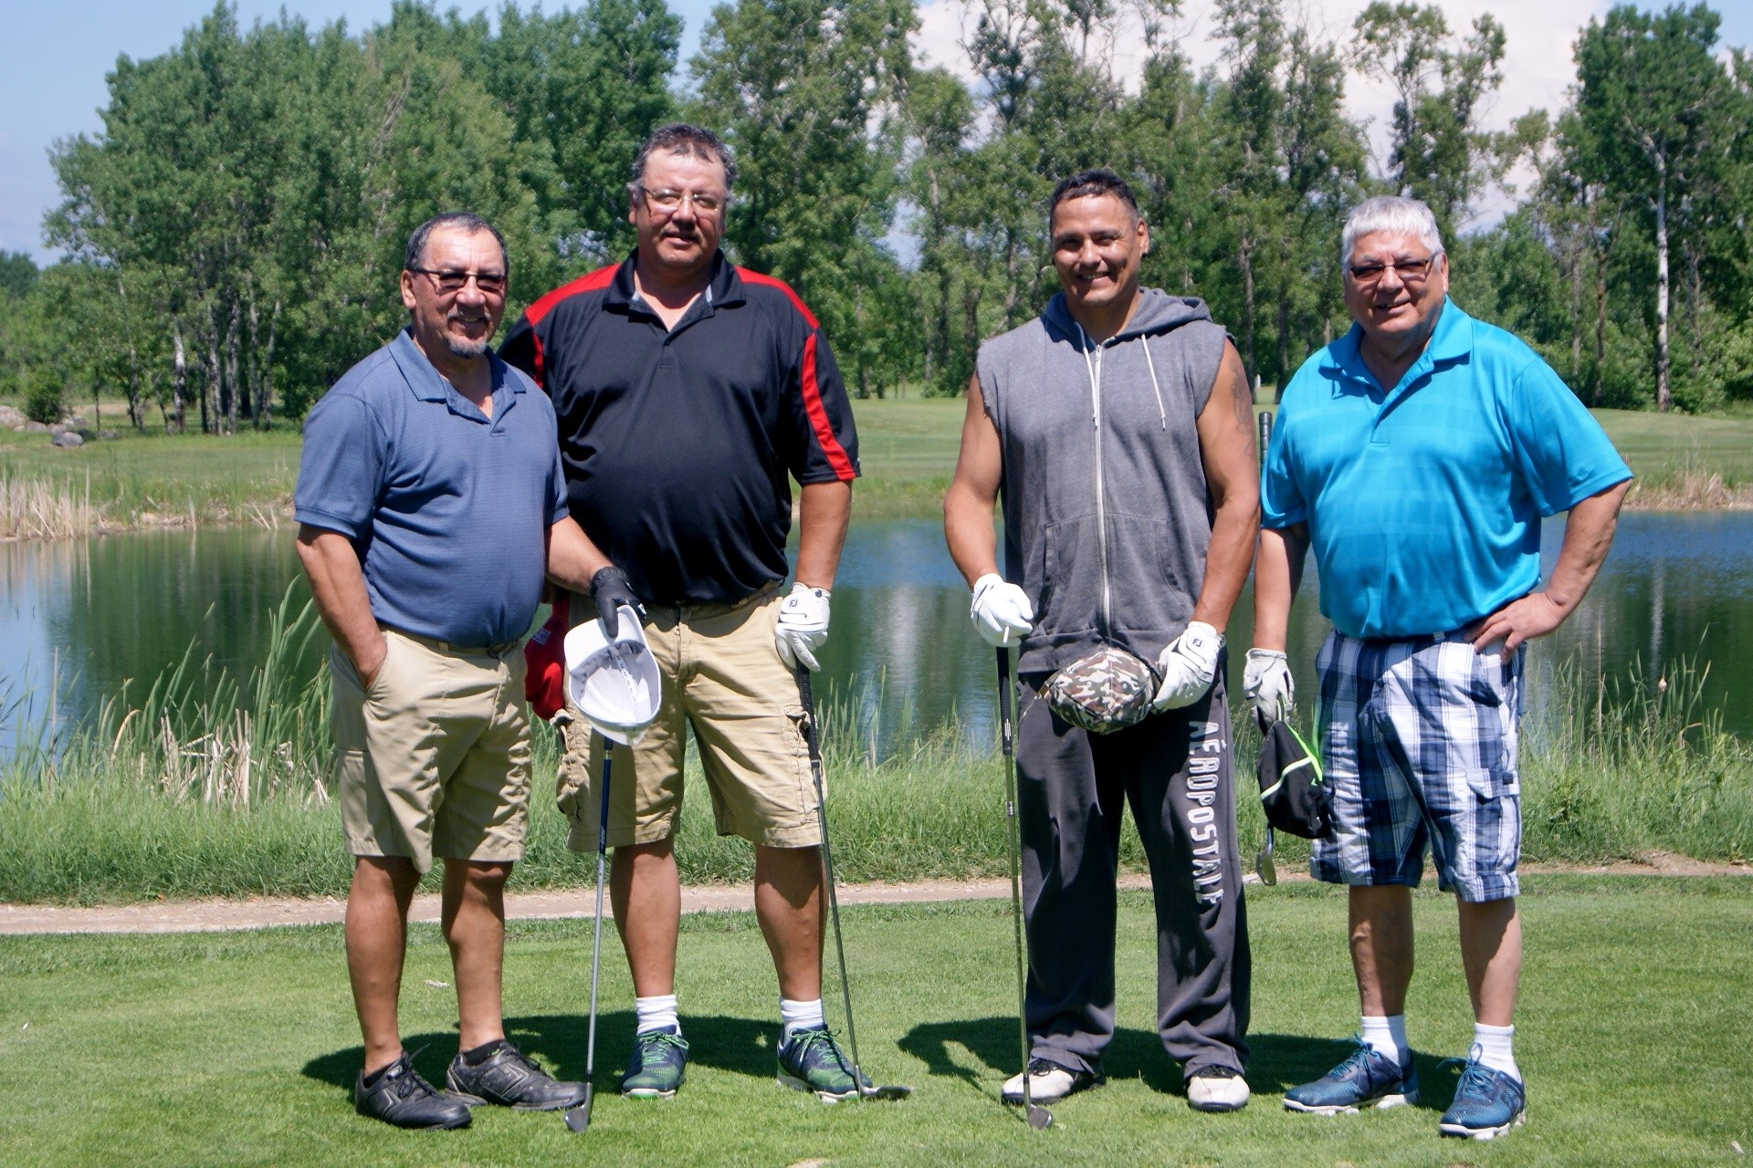

**arold,**

**Les Daniels – Trevor Swampy – Lloyd LaRoque**

**Bruce bruyere**

**MEMBERSHIP AND FINANCIAL**

**REPORT**

**2017 Paid Members: 2018 Pre-Paid dues:**

**Heartland Chapter 555 174**

**Associates 38 10**

**Cambrian 37 20**

**630 204**

**The 2018 cards will be sent out early in the New Year to those who have paid.**

**Treasurer Report to June 30, 2017:**

**Operating Acct. $14,447.72**

**Reserve Acct. $ 7,836.55**

**Premium Savings Acct. $ 5,577.76**

**$27,862.03**

**Paul Pelletier**

**Treasurer**

**If you recently moved, please provide us with the following information. Thank You !**

**(please print)**

**Name: ____________________________________________**

**Old Address: __________________________________________ ___________________________________________________________**

**Old Phone Number: ___________________________**

**New Address: _________________________________________**

**___________________________________________________________**

**New Phone Number: __________________________**

**Send to the Heritage Club Office at:**

**1462 Church Ave.**

**Winnipeg, Mb. R2X 1G4**

**SLEEPING GIANT ACTIVITY COUNCIL**

**Members and friends meet the last Friday of every month for lunch at the Port Arthur Curling Club, 214 Egan St., Thunder Bay.**

**For further information contact:**

**Don Rosengren**

**Chair, T. Bay Nth On (807)345-1624**

** KNITTING! KNITTING!**

**HELP! HELP! HELP!**

**Once again we are asking our members to help with our Christmas Program for needy children by knitting items such as scarves, gloves, mitts, toques, sweaters, etc. If you are willing to knit for this worthwhile project, please call the office and let us know your name, address and phone number.**

**If you require wool we ask you to purchase what you need and send your bill to the office. We will reimburse your costs.**

**All knitting should be dropped off at our office by November 16, 2017 to have them included in our Christmas Charity Programs. (if pickup is required, please call the office at (204)987-5010).**

**Ed Paleshnuik**

**Knitting Co-ordinator**

**TAKE A BREAK FROM YOUR DAILY**

**ROUTINE AND COME OUT TO SOME OR ALL OF YOUR CLUB ACTIVITIES**

**IN MEMORIAM**

**Lawrence Anderson**

**Edward Bishop**

**Gerald Dettman**

**Harry Moore**

**Roy Rozander**

**Ruth P. M. Wallman**

**Elsie McIntosh**

**Patrick R. Garrity**

**Jean (John) Lavoie**

**Boyd Hutchinson**

**This list of colleagues and friends who have passed**

**reflects those that we are aware of. We regret any**

**oversight to this list.**

**2017 Christmas Casino**

**Warroad November 27 – 29, 2017**

**Once again we will be joining with the Break-Away Holiday Casino trip to Warroad in November. The Holiday trip is one of the most popular trips of the year and a very large number of people book the for the following year on the way home from this trip, as a result the seats available are very limited.**

**The trip includes games, prizes and refreshments on the bus going down. Shopping at both the Canadian and American Duty Free Stores. A shopping trip to Thief River on the second day. A special group Christmas dinner. Lots and lots of Christmas gifts from Santa..**

**Casino promotion of slot play money and meal credits**

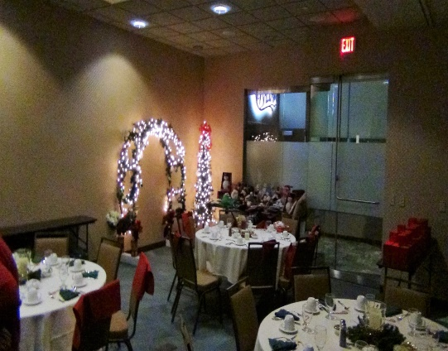

***Private Dinner party***

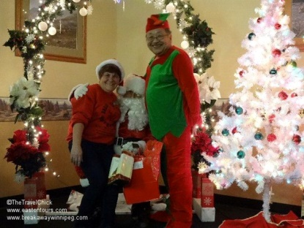

***Meet Santa and his helpers for Christmas Gifts***

**Pricing and trip details are not available at the time of printing, however as seats are going fast, should you be interested in going, please phone the office at (204) 987-5010 or send us a note and we will make every effort to reserve a seat**

**2017 MEMBERSHIP COMMUNITY VOLUNTEER SURVEY**

**Name: ….................................................................... Address: …………………………………………………………….**

**City: ………………………………………….. Prov.: …………………………… Postal Code: …………………………….**

**“People Helping People” is the motto of the Heritage Club. It’s that time of year again. We must start gathering information so that we can prepare our annual report of our activities for the national office. Please complete the attached volunteer hours form to enable us to complete the report. Remember, report all volunteer activities as a Heritage Club member. Every hour counts! Don’t forget your knitting hours and Christmas hours.**

**We must have your completed form in our office as soon as possible:**

|  |  |
| --- | --- |
| **ACTIVITY** | **ESTIMATED ANNUAL HOURS** |
| **Church** |  |
| **Community** |  |
| **Knitting** |  |
| **Literacy Program - School** |  |
| **Santa Program** |  |
| **Library/Museums** |  |
| **Hospital** |  |
| **Soup Kitchen/Food Bank/Meals on Wheels** |  |
| **Heritage Club** |  |
| **Seniors Homes/Shut In Programs** |  |
| **Income Tax Form Prep./Festivals** |  |
| **Fund Raising** |  |
| **United Way** |  |
| **Others -** |  |
| **Others -** |  |
| **Others -** |  |

**CHRISTMAS DINNER ARMY NAVY AIR FORCE VETS HALL**

**Empress North of Ellice Ave.**

**Wednesday, December 6, 2017. Doors open at 11:00 am Luncheon at Noon**

**HAM, MEATBALLS, PEROGIES AND ALL THE FIXINGS!!!**

**Name: …………………………………………… Active Mbr. Card No.: ………………………………….**

**Spouse/Partner: ………………………………………………………….**

**Active Mbr @ $5.00 ………….. Spouse/Partner @ $5.00 …………. Guest @ $20.00 ……………...**

**Sugar Free Dessert …………………..**

**The Heartland Chapter – Heritage Club, Its’ servants or agents, is not liable for any injury, loss or damage to**

**personal property arising from or in any way resulting from participation in these activities.**

**ANNUAL MEETING HEARTLAND CHAPTER**

**Thursday September 21, 2017**

**Royal Fork Buffet Restaurant – 1615 Regent West, Transcona**

**Doors Open 11:00 am Meeting 11:30 Lunch to follow**

**Complete and return for your annual meeting tickets**

**Please Note: Due to space limits only the first 80 pre-paid attendees will be accepted**

**Name: …………………………………………………… Active Mbr. Card no.: …………………………**

**Address: …………………………………… City: …………………… Code: ……………………………...**

**Spouse/Partner: ……………………………..**

**Guest: ………………………………………….**

**Active Member ………….@ $8.00 Spouse/First Guest ………….@ $8.00: $…………………….**

**Non-Active Member/Other Guests: …………….@ $15.00: $......................**

**Please quote your active member number to qualify for active member price. Completed order form and full payment must be returned to the Heritage Club, no later than September 8, 2017.**

**The Heartland Chapter – Heritage Club, its’ servants or agents, is not liable for any injury, loss or damage to personal property arising from or in any way resulting from participation in these activities.**

**FUN GOLF DAY TEAM SCRAMBLE**

**Southside Golf Course 2226 Southside Road**

**Wednesday, September 6, 2017**

**Modified Shotgun Start 12:00 Noon**

**Green fees for 18 holes will be $28.00 (taxes included) $1.00 green fee will go to charity.**

**18 hole green fee and shared power cart is $40.00 (taxes included) $1.00 green fee will go to charity.**

**To benefit the coordination of this event please! please! return your completed application form along with your**

**payment in full by August 23/ 2017.**

**Make cheques payable to The Heritage Club**

**and mail to:**

**The Golf Activity Coordinator**

**Canada Post (Heritage Club) 1462 Church Ave. Winnipeg, Mb. R2X 1G4**

**Name (Member): ……………………………… Phone: ………………………...**

**Name (Guest): …………………………………..**

**Green Fee @ $28.00 each: $ …………….. Green Fee & Shared Power Cart @ $40.00 …………….. Total: ………………..**

**The Heartland Chapter – Heritage Club, its’ servants or agents, is not liable for any injury, loss or damage to personal property arising from or in any way resulting from participation in these activities.**

**HERITAGE CLUB MEMBERSHIP**

**Membership consists of active and non-active members who take part in various activities throughout the year i.e. monthly luncheons, golf tournaments, club bowling, casino trips, annual banquet, annual meeting and Christmas banquet. Members are also actively involved in working in the community, as well as contributing food and money to charity. Members also knit hundreds and hundreds of items for adults and children in need of warm clothes.**

**Advantages of being an active member (paid up dues) include but are not limited to:**

**Activities that carry a cost per participant can be attended by active members at a reduced cost.**

**Receive discounts at hundreds of retail stores and services through access to Work Perks.**

**Receive access to Medoc (the best travel and cancellation insurance at a price other carriers cannot**

**match or beat).**

**Receive access to house and car insurance.**

**Receive access to Fitness Clubs**

**Receive access to the Heritage Club website.**

**CAMBRIAN CHAPTER**

**Your Chapter at present, does not have an active executive in place. Until a new executive from the area becomes available the Heartland Chapter will conduct business for the Cambrian Chapter.**

**Please send us news, topics of interest, changes of address, etc. and we will include these items in our newsletter. However, bear in mind that all printing and mailing costs are charged to the Chapter and therefore some newsletters are only sent out to Active Members. As you can see by the above noted information there is an advantage to being an active member (dues paying).**

**Just using the Travel and Cancellation Insurance, our members across the country save hundreds of dollars.**

**Should you or anyone you know be interested in an executive position with the Cambrian Chapter, the National Executive of the Heritage Club would be pleased to hear from you. The job is not very complicated or time consuming and there will be as much assistance as needed to help form a new executive. Please feel free to contact the undersigned at the address listed on the first page.**

**Harold Onagi**

**President**