THAMES HERITAGE CLUB NEWS
SPRING 2022

Hello,

Spring is coming as seen in the earlier sunrises. This new year will see a renewal of our area luncheons , annual golf tournament and potentially the Annual Reunion Banquet in the fall. I believe , with the falling infection rates and hospitalizations , light is on the horizon.

In this issue:

- Heritage President Communication
- call for membership renewal for 2022
- monthly draws .. 2022
- Santa’s Helper draws
- e-transfer service
- pension & benefit payment dates..2022
- Columbia Sportswear Employee Store
Invite
- GoodLife membership type summary

Your Benefits
Contact Numbers

C.P.C. Pension 1-877-480-9220
Superannuation 1-800-561-7930
C.P.P. / O.A.S. 1-800-277-9914
Canada Life 1-866-716-1313
Access H.R. 1-877-807-9090
Employment Ins 1-800-206-7218
Passport 1-800-567-6868
Can Rev Agency 1-800-959-8281

Your Benefits
Survivor procedures: To ensure the survivor of a retiree maintains pension , health and medical benefits , a number of contacts must be made after a retiree’s death.

Access H.R. (1-877-807-9090)
..retiree name
..employee I.D. number
..social insurance number
..copy of death certificate
C.P.C. Pension (1-877-480-9220)
..retiree name &employee I.D. number
..postal code
..month and date of birth
..copy of death certificate
..copy of retiree`s will
Canada Life (1-866-716-1313)
..retiree name
..employee number
..copy of death certificate
..plan numbers ..51057 & 51391
NOTE: Very important to notify Canada Life as soon as possible in order to set up a new automatic withdrawl in the survivor’s name in order to keep policy in force and maintain medical , dental and vision benefits.
C.P.P. / O.A.S. (1-800-277-9914)
..retiree name
..social insurance number
..copy of death certificate
NOTE: Besides the C.P.P. survivor
Pension , there is a Death
Benefit payable to the survivor
Superannuation (1-800-561-7930)
..retiree name
..social insurance number
..copy of death certificate
.. copy of marriage certificate
Note: Sun Life benefit premiums for Superannuation survivor will be educted directly from monthly survivor pension

Canada Rev Agency (1-800-959-8281)
C.R.A. is to be contacted when a member or spouse passes to prepare for T-1 and T-3 form completion.

Message From President

2022 has arrived on a positive note regarding Covid-19. We are hearing about decreasing numbers of infections and hospitalizations across the province. The sun is rising earlier each day signalling a weakening of winter’s dark presence. 2021 saw us swinging back and forth with news of the arrival of the Delta Variant and if that wasn’t discouraging enough , through the dust left by Delta came a new enemy named Omicron Variant. Despite these multiple attacks from the Covid family , we are here to talk about it.
We are presently seeing about 29.8% of the total membership with paid-up status regarding the 2022 membership dues. We ended last year (2021) with a 39.2% paid up status. Support from paid-up members keeps your Heritage Club functioning at a level that allows the multiple benefits that continue to be provided . One of the major initiatives we participate in each year is the “Letters-To-Santa” campaign. We started by participating in the London Santa Parade collecting letters to Santa from the public along the parade route. All the Santa’s Helpers answered a total of 10,826 letters-to-santa. We must not forget to recognize the many employees and retirees that volunteered. We had recognition draws of prizes for both the Operations helpers as well as Heritage Club helpers. Photos of the draws are included later on in this Newsletter.

********************************
Heritage Club Support To Members

Widows / Widowers

There were seven (7) consultations
held in 2021 with widows and widowers to assist them with survivor benefits , pension questions and contacts as well as completion of various documentation.

Pre-retirement Meetings

There were thirteen (13) meetings in 2021 and two (2) so for in 2022 with potential retirees covering what to expect in the way of documentation from Canada Post , the Pension Centre and Canada Life. Subsequent meetings have also been held with these retirees to assist them with the completion of these forms including witness signatures.

Operations Consultations / Meetings

Meetings have been held with the operations community regarding revisions to the amount of advance notice needed by potential retirees to notify the corporation of their intention to retire. Sufficient advance notice will prevent situations where retirees face the possibility of their retirement date arriving and all the necessary documentation has not yet been completed and submitted.

Volunteer Contributions

Members who are volunteering at any activity should be recognized for their participation. Let the Heritage Club know how much and how often .
Some examples are .....
.. seniors for seniors
.. tax assistance for seniors
.. volunteer lifeguard
.. recyclable material collection for a
cause
.. cancer clinic guide/assistant

C.P.C. Pension Payment Dates - 2022

January 31
February 28
March 31
April 29
May 31
June 30
July 29
August 31
September 30
October 31
November 30
December 30

Superannuation Payment Dates – 2022

January 27
February 24
March 29
April 27
May 27
June 28
July 27
August 29
September 28
October 27
November 28
December 28

C.P.P. / O.A.S. Payment Dates - 2022

January 27
February 24
March 29
April 27
May 27
June 28
July 27
August 29
September 27
October 27
November 28
December 21

G.S.T. / H.S.T. Credit Pymt Dates..2022

January 5
April 5
July 5
October 5

Canada Child Benefit Pymt Dates..2022

January 20
February 18
March 18
April 20
May 20
June 20
July 20
August 19
September 20
October 20
November 18
December 13

Canada Workers Benefit..Advance Pymt

January 5
April 5
July 5
October 5

Ontario Trillium Benefit (OTB)..2022

January 10
February 10
March 10
April 8
May 10
June 10
July 8
August 10
September 9
October 7
November 10
December 9

Veteran Disability Pension .. 2022

January 28
February 25
March 30
April 28
May 30
June 29
July 28
August 30
September 28
October 28
November 29
December 22

In Memorium - 2022

Denise Badgley
Bruce Greenaway
Dawn Lampman-St Denis
Mary Wise

New Members – 2022

Rebecca Giles
David Shrumm
Michelle White

*********************************

Pension Indexing - 2022

Canada Post Pension ......... 2.41%
C.P.P. / O.A.S. ................. 2.4 %
Superannuation ................. 2.4 %

********************************

Thames Heritage Club Executive

President: Henry Masek
519-204-8873
thamesheritageclub@gmail.com

1st Vice-President: Don Manns
519-451-4959
2nd Vice-President: Sherry Hexter
519-636-7411
Treasurer: Stew Metcalf
519-660-4193
Secretary: Dianna Snell
519-601-0085

Pre-Retirement Meetings

Future retirees may meet with the Heritage Club president to discuss what to expect in the way of documentation from both Canada Post H.R. and the Pension Centre along with assistance in completing the various forms

Contact Henry Masek @ 519-204-8873

Widow / Widower Consultation

There is a need for widows and widowers of former Canada Post employees to have support when facing the death of a spouse when it comes to pension , benefits and survivor documentation. This covers Superannuation , Canada Post Pension, Canada Pension Plan ,Old Age Pension , Canada Revenue Agency , Canada Life and Sun Life Benefits including (basic and over-65 life insurance policies) Your Heritage Club president will guide you through this complex area of concern.

Chuckle Corner

Spring Shopping Event

Your Heritage Club has arranged another Heritage Club Invitation for members to shop at the Columbia Sportswear Employee Store in London. Card carrying Thames Heritage Club Members for year 2022 can shop and enjoy a discount of between 40% - 50% off brands such as Columbia , Sorel , Mountain Hard Wear and Prana. This is an invitation-only event which occurs four times per year. Club members are to have their current club I.D., photo I.D. and the invitation and present it at the employee store from Mar 25 – Apr 17 , 2022 and shop.
Each member can bring along up to four (4) family and/or friends with them.
Full details on attached Columbia Invite.

Membership Benefits

Some of the membership benefits are ...

- discounted fees at GoodLife Fitness
- 40% - 50% discount at Columbia
Sportswear Employee Store Events
- very attractive travel insurance rates
With Medoc (Johnson Insurance)
- pre-retirement meetings to review
retiree documentation packages
- discount on cost of Annual Banquet
- 4 newsletters per year for paid-up
members (2 newsletters per year for
regular members)
- Widow / Widower consultation service
- discounted periodic luncheons at the
Mandarin Restaurant and other eating
establishments
- discount at Annual Golf Tournament
- discount of $100 to $500 per person on
Colette Tours
- discount of up to 20% at Choice ,
Comfort , Quality and Clarion hotels
- scholarships for university and college

*********************************

Newsletter E-Mail Option

You may receive your Newsletter via e-mail if you wish. Just notify your Heritage Club though e-mail at thamesheritageclub@gmail.com or by calling a member of the executive.

Death Of Member

In an effort to keep our information
up to date , we need to know when
any of our members is deceased.

Heritage Club members receive up to 50% off - online registration with a (paid-up) Thames Heritage Club membership. A detailed chart of all membership types is attached to this newsletter. For program details , options, pricing and geographic availability , please go to :
https://corporate.goodlifefitness.com
OR
Call Membership Experience Dep’t
1 – 800 – 387 – 2524

You will require your (paid-up) Thames Heritage Club number to access information regarding this offer.

REMINDER:

Any new GoodLife applications or renewals will be denied if current year membertship dues are not paid.

******************************

Address Change

To keep our mailing list current it
is necessary to have the latest proper
address of each member.

Send any address changes either
by mail to:

Thames Heritage Club
955 Highbury Ave
London , On N5Y 1A3
OR

by e-mail to:
thamesheritageclub@gmail.com

Monthly Draws

In order to recognize our members who actively supported our Heritage Club , despite most of the events having to be cancelled , we launched monthly draws of monetary prizes. All paid-up members are entered into each draw..

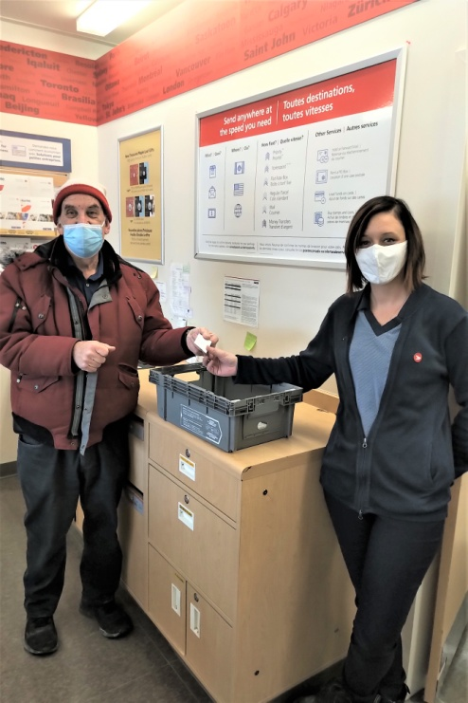
January 2022 Monthly Draw
Drawn by Jen McRobert
Asst – Lucan Post Office
... witnessed by Henry Masek

Winners:
-Joanne Teske
-Glen MacCuspey
-David Lusk

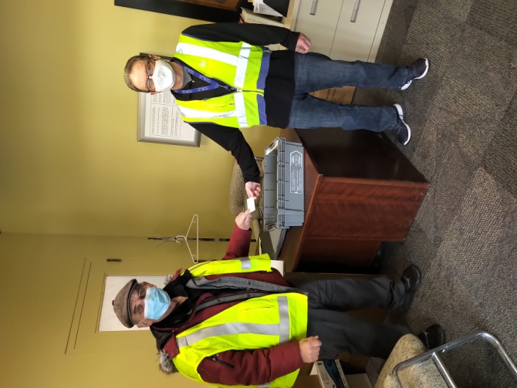
February 2022 Monthly Draw
Drawn by Rob Sutherland
Delivery Planning
.. witnessed by Henry Masek

Winners:
-Patrick O’Grady
-Janis Sloman
-Glen Deveaux

********************************
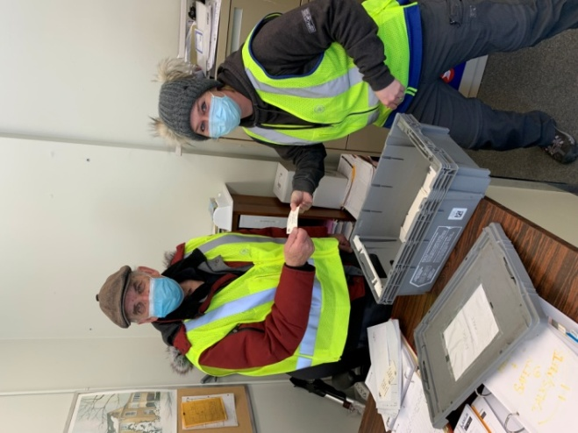
March 2022 Monthly Draw
Drawn by Tera Thompson
Ingersoll LCD witnessed by Henry Masek

Winners:
-Philip Mahas
-Dawna King
-Donald Miatello

London Santa Parade – 2021

In November 2021 the Heritage Club participated in the London Santa Parade.

Two members carried the Heritage Club Banner out front while other members collected Letters To Santa from the crowds along the route.

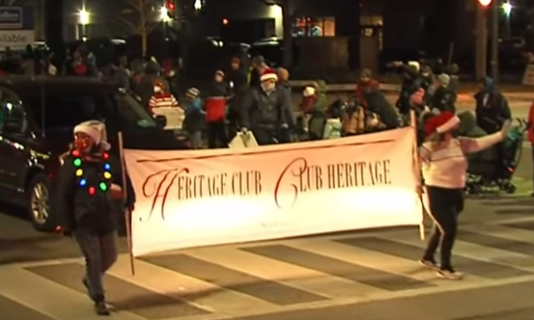

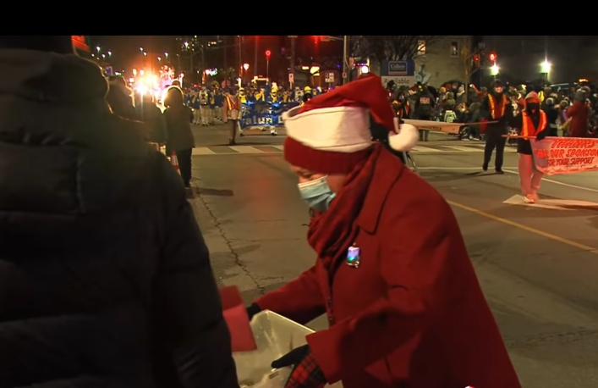

Santa’s Helpers Prize Draws - 2021

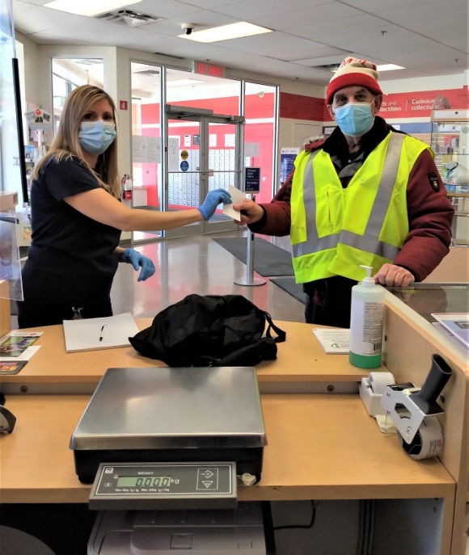
Operations Helpers

Drawn by Denise Duncan
London Business Centre Witnessed by Henry Masek

Winners – Leah Confurious Lon LCD-1
Olga Nethersole Lon LCD-5
Jason Leclaire Lon MPP

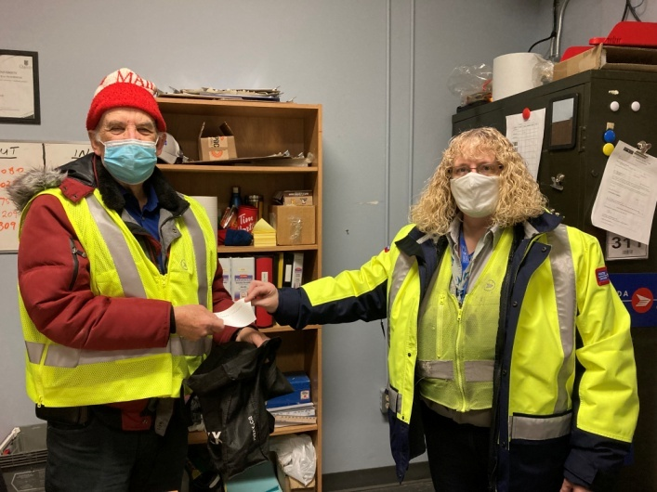
Heritage Club Helpers

Drawn by Lisa Phillips
London LCD – 3
Witnessed by Henry Masek

Winners – Cathy Metcalf
Marci Kosac
Sherry Henshaw
Membership Renewal Time

For those who have not already done so ,
and there a still some members out there , it is time to renew the Thames Heritage Club Membership dues for 2022 through
payment of the $12 yearly dues.
Your Heritage Club counts on your support to continue to offer membership benefits .

Send payment to:

Thames Heritage Club
955 Highbury Ave
London , On N5Y 1A3

(Note: Dues may be paid by e-transfer).
..send to: Henry Masek
hsmasek@hotmail.com

********************************
Salvation Army Christmas Kettle

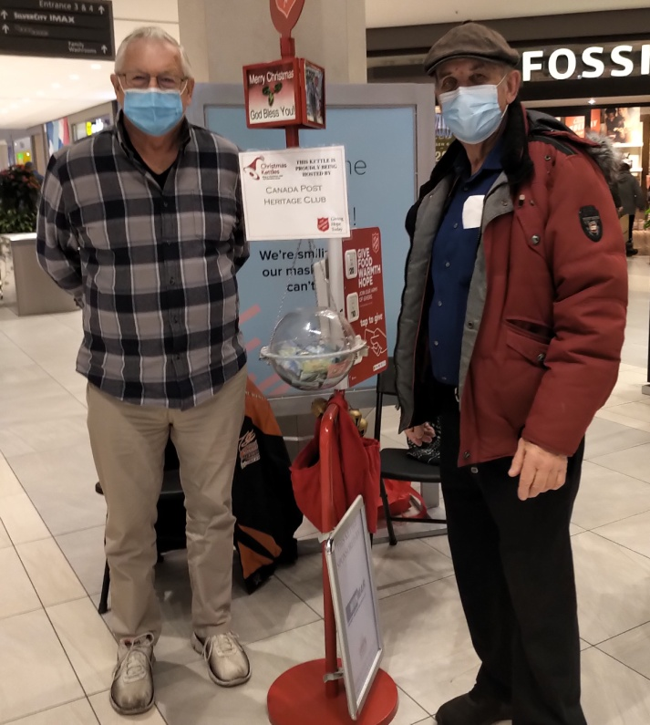

Each year Heritage Club members cover
the Salvation Army Kettle at Masonville
Mall for an entire day. In 2021 we
collected a total of $730.70 at our kettle.

2022 Scholarships Available

Heritage Club

3 Heritage Club scholarships of $2,000
available nationally. Open to dependent
children and grandchildren of all active
(dues paid for 2 years) members of any Heritage Club Chapter.
Application Deadline – June 30 , 2022

Contact holmese@ntl.rogers.com for details

Johnson Insurance

50 scholarships of $1,000 each available to dependents of a parent/guardian or grandparent who are ..
..Heritage Club Member
..completing high school in 2022 and
starting post secondary in the fall

Contact: Johnson.ca/scholarship
Deadline : August 2022

*********************************

GOODLIFE FITNESS
MEMBERSHIP TYPES
Performance | Ultimate | Premium | Essential Plus | Essential Zone A | Essential Zone B | Essential Zone C
All Clubs | All Clubs | All Clubs | One Club Access | One Club Access | One Club Access | One Club Access
Strength / Cardio | Strength / Cardio | Strength / Cardio | Strength / Cardio | Strength / Cardio | Strength / Cardio | Strength / Cardio
Pool | Pool | Pool | Pool | Pool | Pool | Pool
Full Digital Access | Full Digital Access | Lite Digital Access | Full Digital Access | Lite Digital Access | Lite Digital Access | Lite Digital Access
Group Fitness | Group Fitness |  | Group Fitness
Free Holds | Free Holds |  | Free Holds
Family Memb | Family Memb
Towels | Towels |  | Towels
Hydro Massage | Hydro Massage
Tanning | Tanning
Mindden | Mindenn
Recovery | Recovery
Squash | Squash
Empower | Empower
Empower HIIT
Hot Yoga
Performance Programs
Regymen
PEAK |  | The memberships noted above and the offerings are subject to change
FIELD

