THAMES HERITAGE CLUB NEWS
WINTER 2020/2021

Hello,

Winter has arrived. This year we continue to be stalked by a monster named COVID !! Almost every event planned for 2020 was cancelled in the name of isolation , social distancing and personal protection. With the majority of our membership being seniors , we have had to be extra careful. Your Heritage Club maintained our presence at numerous endeavours such as Santa Letter Campaign , Santa Claus Parade , Salvation Army Kettle , Christmas Hamper Campaign.

Your Benefits
Contact Numbers

C.P.C. Pension 1-877-480-9220
Superannuation 1-800-561-7930
C.P.P. / O.A.S. 1-800-277-9914
Canadat Life 1-866-249-5723
Access H.R. 1-877-807-9090
Employment Ins 1-800-206-7218
Passport 1-800-567-6868

Your Benefits
Survivor procedures: To ensure the survivor of a retiree maintains pension , health and medical benefits , a number of contacts must be made after the retiree’s death.

Access H.R. (1-877-807-9090)
..retiree name
..employee I.D. number
..social insurance number
..copy of death certificate
C.P.C. Pension (1-877-480-9220)
..retiree name
..employee I.D. number
..postal code
..month and date of birth
..copy of death certificate
..copy of retiree`s will
Canada Life (1-866-249-5723)
..retiree name
..employee number
..copy of death certificate
..plan numbers ..51057 & 51391
NOTE: Very important to notify Canada Life as soon as possible in order to set up a new automatic withdrawl in the survivor’s name in order to keep policy in force and maintain medical , dental and vision benefits.
C.P.P. / O.A.S. (1-800-277-9914)
..retiree name
..social insurance number
..copy of death certificate
NOTE: Besides the C.P.P. survivor
Pension , there is a Death
Benefit payable to the survivor
SUPERANNUATION (1-800-561-7930)
..retiree name
..social insurance number
..copy of death certificate
.. copy of marriage certificate
Note: Sun Life benefit premiums for survivor will be deducted directly from monthly survivor pension

Letters-To-Santa Campaign – 2020

This year your Heritage Club continued the expansion of the Santa Letter Program to cover local initiatives related to children. Letters-To-Santa stations were set up at the London Regional Children’s Museum , the Boys and Girls Club , Ronald McDonald House and the Children’s Hospital of Southern Ontario.

In total your Thames Heritage Club arranged replies to 5,910 Letters-To-Santa (5,847 English & 63 French). These letters originated as follows .....
.. mail stream .................. 5,761
.. Childrens Hospital ......... 24
.. Ronald McDonald House . 7
.. Boys & Girls Club ........... 4
.. Childrens Museum .......... 114

********************************

Salvation Army Kettle – Masonville Mall

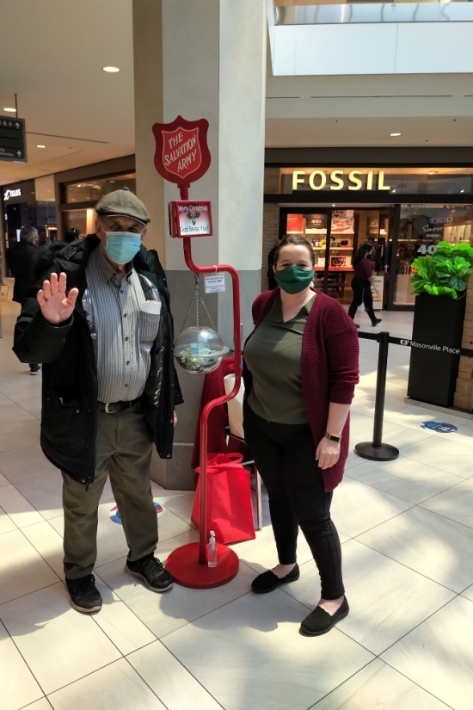
Henry Masek / Kelly Meaney

*******************************

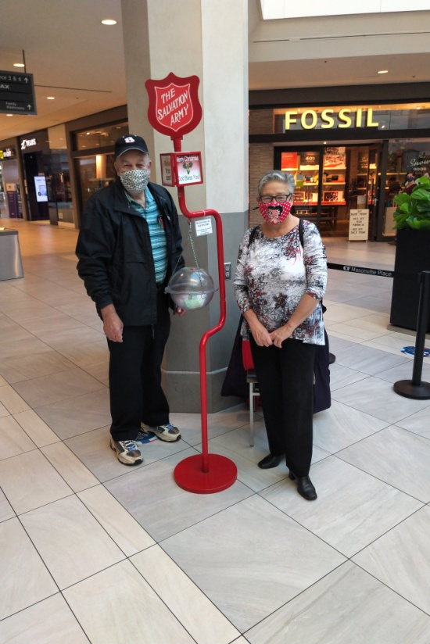
Stew Metcalf / Dianna Snell

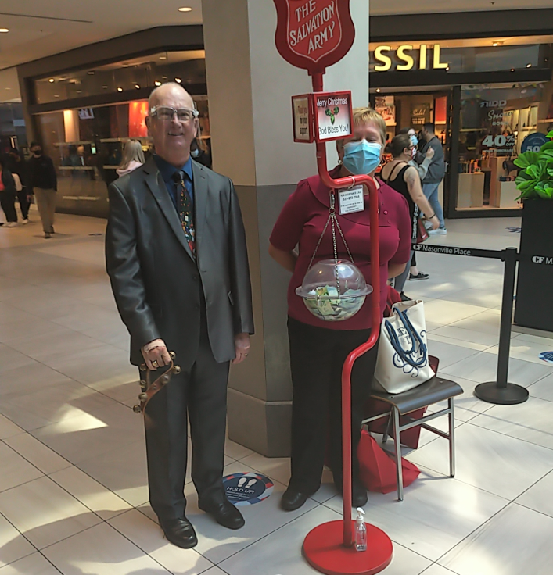
Don Manns / Doris Lodin

Santa Claus Parade – 2020 – London Airport

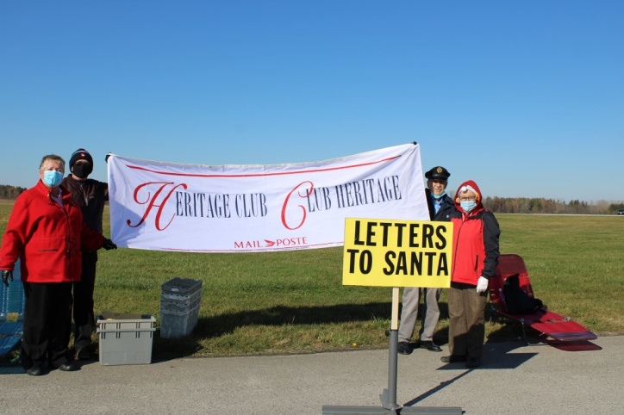

Santa Claus Parade Award

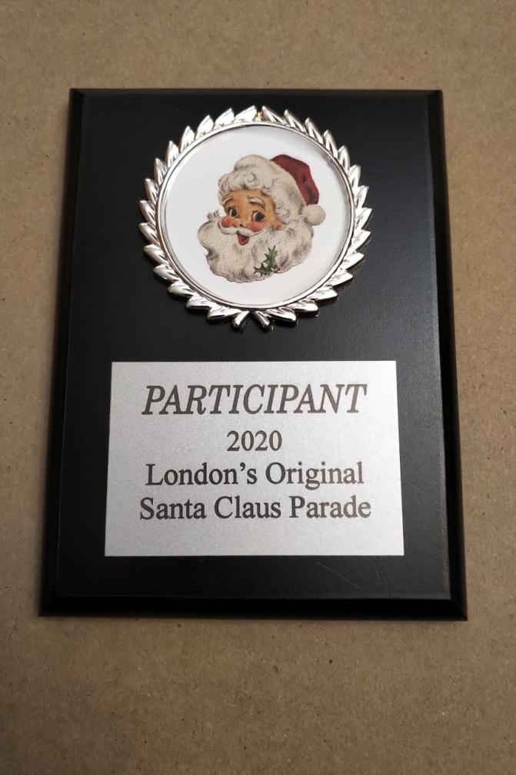

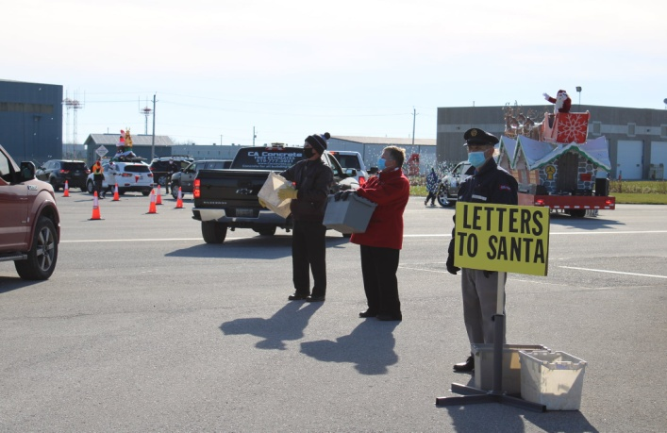

********************************

Salvation Army Christmas Hamper Donation

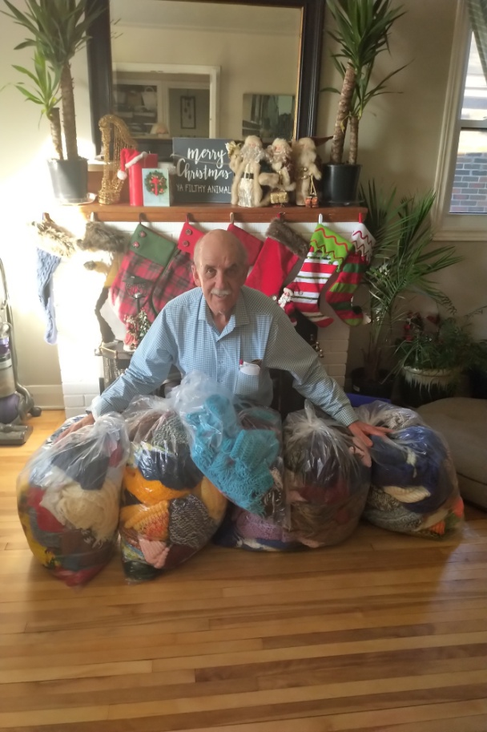

Hundreds of mitts , scarves and hats knitted by members

2021 Pension Indexing

Canada Post Pension............... 1.04 %
C.P.P. ................................... 1.00 %
Superannuation ..................... 1.00 %

Canada Post Pension Payment Dates
2021

January 29
February 26
March 31
April 30\
May 31
June 30
July 30
August 31
September 30
October 29
November 30
December 31

******************************

Pre-Retirement Meetings

Future retirees may meet with the Heritage Club president to discuss what to expect in the way of documentation from both Canada Post and the Pension Centre along with assistance in completing the various forms

Contact Henry Masek @ 519-204-8873

2020
In Memoriam - 2020

Anderson , Jacques
Babington , Wayne
Brooke , Ronald
Cotton , Allan
Dillon , Alice
Diniz , Joseph
Gratton , Ernest
Hazzard , Howard
McConville , Hugh
McIntosh , Ronald
McLellan , Merle
Richardson , Gordon
Trew , Donna
West , William
Williams , Sadie

New Members - 2020

Allingham , Greg
Butler , Candace
Cavanagh , Tracie
Couzens-Gray , Lisa
DaSilva , Tony
Eagleson , Martin
Eberhard , Susan
Fletcher , Michael
Green-Speirnan , Lorraine
Henshaw , Sherry
Iarusso , Emidio
Iarusso , Tony
Kelly , Lisa
McGrath , John
McGrath , Tracey
Orech , Rhema
Pasic , Janja
Pokropek , Marek
Rattazzi , Maria
Ritchie , Darrell
Roelofsen , Brenda
Wright , Kimberley
Zrini , Sue

Membership Renewal Time

For those who have not already done so ,
It is time to renew the Thames Heritage Club Membership dues for 2021 through
payment of the $12 yearly dues.

Send payment to:

Thames Heritage Club
955 Highbury Ave
London , On N5Y 1A3

(Note: Dues may be paid by e-transfer).
..send to: Henry Masek
hsmasek@hotmail.com

Some of the membership benefits are ...

- discounted fees at GoodLife Fitness
- 40% - 50% discount at Columbia
Sportswear Employee Store Events
- very attractive travel insurance rates
With Medoc (Johnson Insurance)
- pre-retirement meetings to review
retiree documentation
- discount on the cost of Annual Banquet
- 4 newsletters per year for paid-up
members (2 newsletters per year for
regular members)
- discounted periodic luncheons at the
Mandarin Restaurant and other eating
Establishments
- discount at Annual Golf Tournament
- discount of $100 to $500 per person on
Colette Tours
- discount of up to 20% at choice ,
Comfort , Quality and Clarion hotels
- Widow / Widower consultation service

NEW SERVICE

Widow / Widower Consultation

There is a need for widows and widowers of former Canada Post employees to have support when facing the death of a spouse when it comes to pension , benefits and survivor documentation. This covers Superannuation , Canada Post Pension, Canada Life and Sun Life Benefits. . Your Heritage Club president will guide you through this area of concern.

********************************
Newsletter E-Mail Option

You may receive your Newsletter via e-mail if you wish. Just notify your Heritage Club though e-mail at thamesheritageclub@gmail.com or by calling a member of the executive.

Thames Heritage Club Executive

President: Henry Masek
519-204-8873
thamesheritageclub@gmail.com

Vice-President: Don Manns
519-451-4959
Vice-President: Jane DèEarmo
519-452-7102
Treasurer: Stew Metcalf
519-660-4193
Secretary: Dianna Snell
519-601-0085

Monthly Draws

In order to recognize our members who actively supported our heritage Club , despite most of the events having to be cancelled , we launched monthly draws of a variety of monetary and merchandise prizes. All paid-up members are entered into each draw..

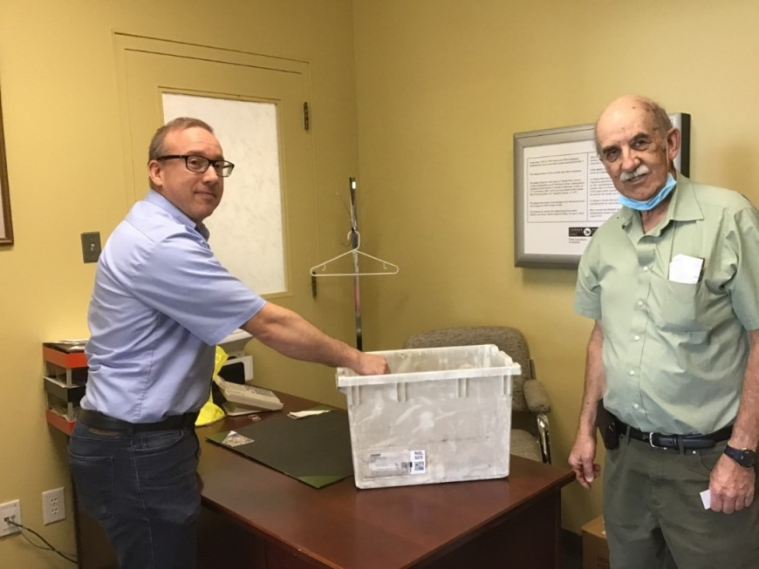
September Draw
Drawn by Jason Simon – Sup’t London LCD-1.......witness Henry Masek

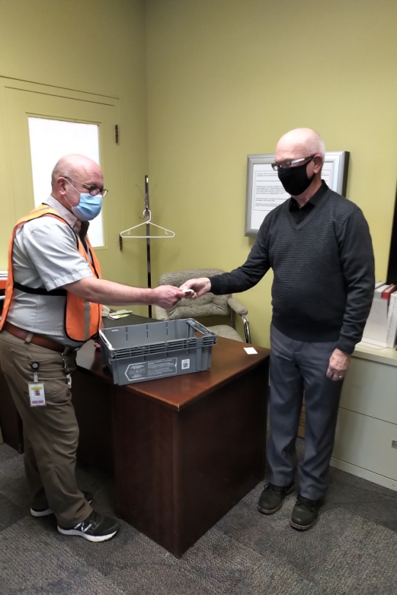
November Draw
Drawn by John Rolph – Cleaner
Witnessed by Don Manns (Vice Pres)

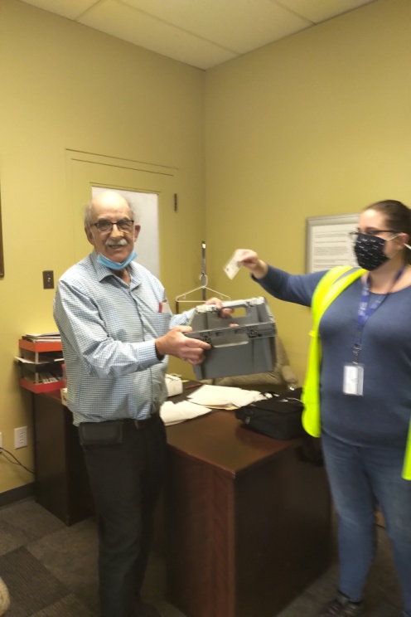
October Draw
Drawn by Lori White – Registration Clerk .........witness Henry Masek

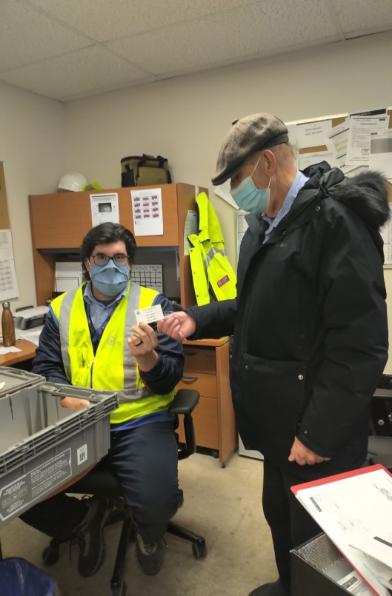
December Draw
Drawn by Adam Vermeersch
Supt London LCD-5
Witnessed by Henry Masek

Annual Election Of Club Executive

Due to the ongoing Covid-19 pandemic , the 2020 Annual General Meeting was cancelled.

Normally , at the Annual general Meeting , there is an election of officers to fill positions on the Club Executive. It may very well be another year of social distancing due to Covid-19.

We cannot allow the pandemic to postpone another election. To this end I am going to use the Newsletter to collect nominations for designated positions on the executive for 2021.

The Winter 2020/2021 Newsletter will contain a form with identified positions where members can nominate a member name for each position. The completed Nomination Form will be mailed in to the Heritage Club Office by February 8th , 2021.

The Nomination Form is attached to the Newsletter.

In the Spring Newsletter , an actual Election Form will be attached with all the nominated names shown for each available position.

Death Of Member

In an effort to keep our information
up to date , we need to know when
any of our members is deceased.

Heritage Club members receive up to 50% off - online registration with (paid-up) Thames Heritage membership

To learn more about this offer visit
https://corporate.goodlifefitness.com

You will require your (paid-up) Thames Heritage Club number to access information regarding this offer]

REMINDER:

Any GoodLife renewals will be denied if 2021 dues are not paid.

*********************************

Address Change

To keep our mailing list current it
is necessary to have the latest proper
address of each member.

Send any changes to the above either
by mail to:

Thames Heritage Club
955 Highbury Ave
London , On N5Y 1A3

OR

by e-mail to:

thamesheritageclub@gmail.com

THAMES HERITAGE CLUB

Call For Nominations – 2021

Position Term

2nd Vice President 2 Years

3rd Vice President 2 Years

Treasurer 2 Years

Return completed form to:

Thames Heritage Club
955 Highbury Ave
London , On N5Y 1A3

Deadline: February 8 , 2021

Name

-------------------------------------------

