SIMCOE CHAPTER– CANADA POST HERITAGE CLUB
72 Leuty Avenue Toronto ON M4E 2R4
Summer Newsletter - June 2021

President’s Message

Dear Members,

As the famous CUPW strike slogan goes: “ The Struggle Continues...” We made it through the tumultuous, unforeseeable difficulties of year 2020 and by now half of 2021. I hope you found inner strength and had support and help from your family and friends to make it through this difficult period. Please continue to stay positive, keeping yourself mentally and physically active and healthy. It is great to see in a short three months COVID19 vaccines have become available in Canada; more than half of us ( 21 Million) had our first shot by end of May 30, 2021 and close to. 5.2 %( 2 Million) of us had our second shot and we are seeing the light at end of the tunnel. It sure had been a strange year and a half, many of us have never experienced anything like it.

A staggering unfathomable 3.54 Million of people worldwide have died from the new COVID -19 virus which still threatens the survival of mankind. The past 17 months has left an indelible mark on each of our lives, affecting us in ways that we could not even think of. From destroying health and sanity to forcing us to adopt to ways and methods of life and work, these are not easy. We can only reflect on what 2020 taught us and up to now, cherish every moment in life, never take anything for granted, spend time with our loved ones, look for pleasure and appreciate small simple things, overcome and move on, despite the additional challenges. From 2021 on, It is very possible that we can all hope to become closer to our follow human beings in more ways and be more tolerant and understanding.

In our 32 years of existence, never has the Heritage Club been so idle. But all this is for the safety of our members and Canadian public COVID requires physical distancing and curtailed social activities to ensure safety above all else, and hopefully there will be a return to normalcy soon.

I want to thank everyone who renewed their club membership for this year through thick and thin. We are grateful for your continued support and loyalty. This ensures you continue to receive our newsletter four times a year, with access to news and great discounts we have negotiated for you as a paid member.

For those of you who have never joined as paid members, I hope you would consider joining. The membership fee is only $10 per year, it gives you great discounts at our luncheons, bus trips, hotels, fitness club, scholarship opportunities for your kids and grandkids, home, auto and travel insurance, etc.

Last year and most of this year have been an inactive year for us, but once things return to normal, and we can safely socialize in large group. We will be organizing social luncheons and activities and we will be following Government guidelines, so it is safe for our members. We hope you have safe, physically distanced interaction with close friends, family, and neighbours to ensure you do not feel isolated or lonely. Staying active mentally, socially in touch with other people is key to longevity and helps to fight off depression. Stay safe for now; we look forward to meeting you soon once again.

Anna Huang
President,Simcoe Chapter

NO UPCOMING EVENTS planned for 2021 at this time

Message from Time of Your Life Bus Tours:
We heard back from Time of Your Life Bus Tour in mid May . “As the vaccine roll-out continues and more people receive their shots, things will start to improve and there will be a return to more normal conditions. We are hopeful that, at that time, we will be able to offer you some tours, perhaps for Autumn and Christmas. It remains a "wait and see" situation. We will of course keep you updated on this.”

NEWS
National News
We have been contacted by Mr. Dave Penner, Director at Head Office, who is currently working on the new stamp launches for 2021. Due to Covid 19, the events this year will all be virtual. He would like to get as many of us as possible involved in stamp launches, and he would like to count on the Heritage Club to be involved. Please pay attention to our newsletters and go into the website below to follow up and support upcoming events to launch new stamps collections.
http://canadapost-postescanada.ca/shop/collectors/stamps-by-theme.jsf?execution=e1s1
Collectible stamps and coins | Personal | Canada Post

Life Events
Have you had any life events you would like the Heritage Club to announce?
Marriages, births, special anniversaries (i.e.50th wedding anniversary), special awards, deaths, hospitalizations, etc. Let us know so we can pay tribute.

Welcome to New Members/Retirees and/or 25-year service employees

Leslie Dampier, Roland Jong, Everton A Walker, Bonnie Downing, Alfonsa Scali &Theresa Moylan-Green

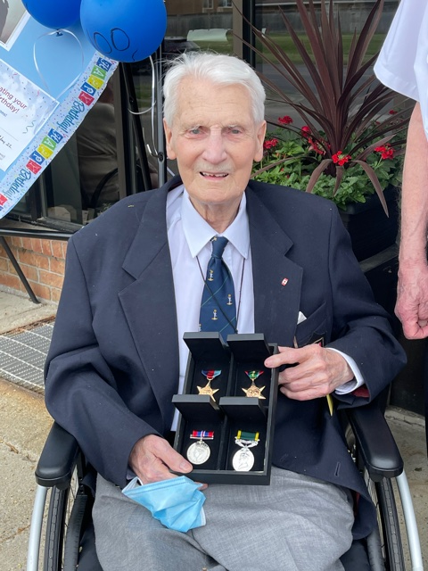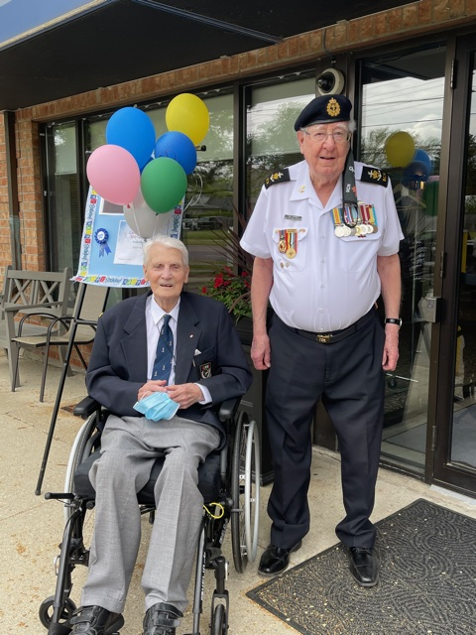
To help celebrate this happy and momentous occasion, Adam’s daughter, Marie Smith made arrangements to have friends and family drop by and pay respect out in front of Christopher Terrace retirement home in Burlington where Adam is staying.

There was a presentation of medals by the Chairman of Halton Naval Veterans, Mr. Andrew Barber, a Signalman in the Canadian Navy to Mr. Adam Houston as a Signalman of the British Army. Rev.Cannon Stuart Pike, a family friend and also a Legion Chaplain, gave prayers and blessings.

The legion will be doing something later once the COVID restrictions have been lifted.

Mr. Adam Houston, who is a World War Two veteran and a fellow retired CPC colleague, celebrated his100th birthday on May 22, 2021.

IN MEMORIUM (People we have sadly lost during the year)
Sadly, these members have passed away and some even a few years ago, but we only learned about them after our last edition of March 24, 2021.

Gloria Chang (April 2021), Andrew Cormack (Dec 2020) , William Daniels (Oct 2020), Brian Farrell (April 2020), Effie French (2 yrs ago), Anthony Gerada (7 yrs ago), Harold Harker (Dec 2020), Andrew Kukla (few years ago), Wah Chong Lee ( April 2020),. Our condolences to their family.
Mr. Andrew Cormack a member of Pineridge Chapter passed away on December 19,2020, He was the late husband of Mrs. Valda Cormack (member of Simcoe Chapter).Mr. Andrew Cormack started at the Bay Street Terminal in June 1966 and worked at Progress Plant, Milner Plant then lastly at South Central Plant. He retired in January 1996 due to health reasons.
Gloria Chang We regret to announce the passing of Gloria Po-Hing Chang on April 27, 2021, loving wife of Edward Chang. Gloria worked as a postal clerk at SCLPP. She is the loving mother of Lisa Chang, Stanley Chang, and Norman Chang. She was a fierce and loving mother who managed to raise 3 children as a single mother. She showed them love and strength. She was truly a super mom, very much loved and will be sorely missed by her family.

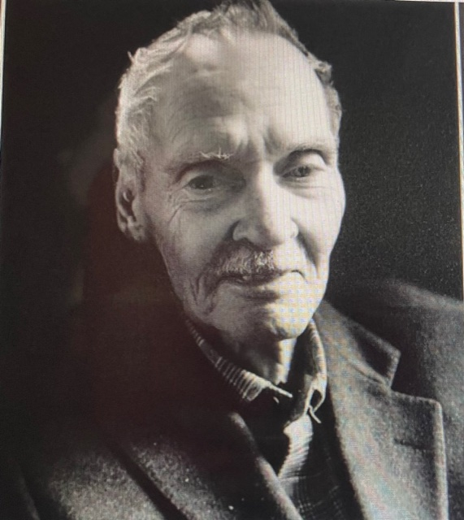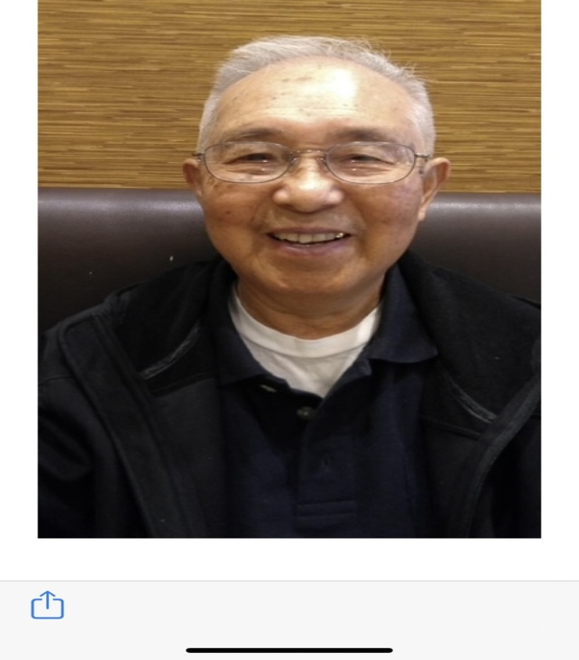
Mr. Harold Harker, a long time member of the Canada Post Heritage Club, passed away December 27, 2020 at the age of 88. He was survived by his wife, Debra, son Colin and his wife Tammy, daughter Colleen and her husband Tim, step-daughter Kimberly, step-son Steve and three grandchildren John, Olivia & Trent. He loved travelling, philately and numismatics. He will be forever missed and lives on in all our hearts.
Mr. Wah Chong Lee retired from Canada Post in 1996 after 20 years of dedicated service.
He passed away peacefully on April 13, 2020 from Covid in a Toronto long-term care home dedicating the remainder of his life to tend to his beloved wife, Bo Hang Lee, who also passed away peacefully on April 25, 2020 from Covid.

There is an interview coverage on Mr.& Mrs. Lee on YouTube: https://youtu.be/QNARmBKCTdg

It is with sadness that we announce the passing of Linda McPhail on May 18, 2021. Linda worked as a Benefits Analyst at SCLPP & Gateway and was very knowledgeablein all benefits available to employees. She was the “GO TO” person for any benefits query. Everyone had high praise and respect for her. She will be sadly missed.

GoodLife Fitness Discount
The GoodLife Fitness subscription year started in September 2020, through to2021. If you intend on applying under the Heritage Club discount, you must have paid your dues for 2021.

MEMBERSHIP FEES ARE DUE
It’s due in October every year and if you have not had the chance to send in your payment, please do so. Still only $10 per year for you and $10 for your spouse.

ATTENTION : Local Ads Small Business and Craft Merchants
“Tag Along Tags” Brand new and up-cycled gift tags with white quilt thread or matching colour yarn, card
stock quality 2 ¼ “X 1 ½ “oval size and 3’X2 “ rectangular size .Assorted mix of all occasion,artistic,scenic, geometric nature,animals,whimsical,stickers,stamps,multi-designs,plain white rectangular and oval tags and more. Great for gift bags, baskets, scrapbooks, price tags, mason jars, bottles, showers, labels, decorations,
gifts. Most back sides are white or one colour to match front scene, black back sides have white labels.
Package in clear plastic bags in packs of ten. 100 assortments of tags for $5.250 assortments of tags for $10.
500 assortments of tags for $15. To order please call Jessica Lui at 416-494-3749 or email jessielui@gmail.com

Heritage Club Scholarships
Heritage Club will be awarding three scholarships to students starting for the first time, their first year of full-time studies, provided it’s an accredited institution and the awards will be valued at $1,000 for university or college studies. To be eligible, students must be dependent children, including adopted children, stepchildren, grandchildren, and wards in legal guardianship of an active dues paying member of 2 years of a Heritage Club Chapter. All applications must be post-marked by June 30, 2021.

Santa Letter Program for 2020

The 2020 Santa Letter Writing Program elf draw winners had been announced and Congratulations to Blesilda Yap who had been drawn for $50.00 prize (only 10 winning tickets for all 24 chapters and we have won four years running). We want to thank all our 26 Simcoe Chapter volunteers, who despite the ongoing Pandemic were able to answer a total of 3,303 children’s letters. Great job!
Your executive team wants to acknowledge and thank our Santa coordinator Lea Maynard for all of her contribution to the Santa Letter Program. Mrs. Lea Maynard has expressed her wish to step down from heading the Santa coordinator’s position this year. We will miss her leadership, dedication, organization, passion and energy. I hope to count on continued support of our volunteers and hope to see even more volunteers lend their hands in this worthwhile wish and dream building mission. During this difficult time, the children all over the world who receive the Santa letter replies felt better about their lives and continue to believe in the magic of Santa Claus. The Santa Program has always been an important activity for Canada Post Corporation employees and Heritage Members.
Who we are?
Simcoe Chapter is one of 24 Chapters across the country; it covers an area of the Greater Toronto Area which is mainly east of Victoria Park Avenue (EasternYork County) encompassing Scarborough, and areas within historic Ontario, Durham and Northumberland Counties. Have you checked our national web site:heritageclub.ca Select Simcoe Chapter

What we do?
The Simcoe Chapter organizes subsidized luncheons, bus travel, annual banquet, and golf tournament with its partner Chapter for its’ members. Also, we collect and donate food for the food banks, as well as donations to various charities throughout the year. Many of our members generously donate their time to local charity organizations .In December of 2020; we donated $200 to Second Harvest, $200 to Salvation Army and $300 to Canadian Cancer Society as well as participation in the Santa Letter Writing Campaign.

Do you have any suggestions for trips or special events you would like to participate in? Please call President Anna Huang at (416)716-2898 or @ ahuang0513@gmail.com

Why Join? – The Membership Advantages
Johnson Home and Car Insurance: discounts of up to 35%
Discounts for you and who travels with you with MEDOC Travel Insurance

GoodLife Fitness: discounts up to 50% off the regular all club access rates.
Choice Hotels: discounts of up to 20% in Canada, and worldwide, which includes Comfort, Quality, and Rodeway Inns, Econolodge, etc.

Discounts to Simcoe Chapter events, luncheons, and bus trips.

Current employee discounts with Telus Mobility.

Special Scholarships for your kids and grandkids of $1,000 per school year.(Note: the member must
be a paid member for two consecutive years for their family member to qualify for consideration of application for scholarship award program.)
IMPORTANT: To benefit from these discounts, you must mention your Heritage Club membership number, and you must have paid your membership dues to the Simcoe Chapter for the current year, otherwise coverage could be denied or terminated.

Newsletter Distribution
This newsletter is produced quarterly and is distributed to every member and associate who has paid their annual dues to the Chapter. Also, a general distribution is made once a year to every person who have applied for general membership to the Heritage Club in our Chapter area. Articles of general interest for the newsletter are always welcome.
Volunteering
Do you do volunteer work: _____ Hours per month: _____
Name of Organization: _____________________________________________

The motto of the Heritage Club is “People helping People”; we would like to know of any activity you are currently participating in that benefits people and/or your community, such as fund raisers, work with health, religious or seniors ‘organizations, coaching children’s groups, etc., and the hours you spend at it per month. This is one of the criteria we are measured on by CPC, and it affects our yearly funding. You can report these hours on above form.

Our yearly funds from the National Executive is evaluated from the involvement of our members in Volunteer activities. I in turn, also do a year-end summary report of all the volunteer hours on behalf of Simcoe Chapter as recorded. I would ask that you keep a record of the hours that you spend this year doing volunteer work in your community and I thank you for helping me to collect your volunteer work hours. Please send this completed form / or information by December 15,2021 to Simcoe CPC Heritage
Club, 72 Leuty Avenue, Toronto, Ontario M4E 2R4. If you have any questions or concerns, please
contact Anna Huang at 416-716-2898 or Email: ahuang0513@gmail.com

2021 MEMBERSHIP COMMUNITY VOLUNTEER HOURS
Name: ……………………………………………………………………………………..

Address: ………………………………………………………………………………….

City: ……………………………Prov.: …………Postal Code: ………………………

Please use this form to track your volunteer hours for 2021. Do not forget your knitting hours and Christmas hours and all your volunteer activities as a Heritage Club member. Every hour counts!

ACTIVITY | ESTIMATED ANNUAL HOURS
Church
Community
Knitting
Literacy Program/School
Santa Program
Library/Museums
Hospital
Soup Kitchen/Food Bank/Meals on Wheels
National Postal Curling
Heritage Club
Seniors Homes/Shut In Program
Income Tax Form Prep./Festivals
Fund Raising
Christmas Hamper Program
United Way
Others -

MEMBERSHIP DUES RENEWAL SLIP

Name: ___________________________________________

Name of spouse (if applying as a couple): __________________________________________

Address: ___________________________________________________________________

Phone Number: _____________________ Email (optional):____________________________

Renewal for Self: ____ Couple: ____ Amount Enclosed: $_____
Is this a Renewal: _____ or a New Membership _____
** send Dues by cheque to Simcoe Heritage or through e-transfer toSimcoe.heritage2018@gmail.com
--------------------------------------------------------------------------------------------------------------------------------------------

Elections
The constitution of the Heritage Club, a volunteer organization, has a provision that the executive positions of a chapter are for a two-year term, after which they must be posted. Any current paid member of the Club, with over 25 years of service can submit their names for a position. In the beginning of 2020, Anna Huang took the position of President and Blesilda Yap as Treasurer. The position(s) are automatically renewed by the incumbent(s) if he/she is willing and if the position(s) are not contested. For any submissions, please inform anyone on the Executive, prior to end of November 2021. If the position is contested, we will hold an online election ballot for this year.

Your Benefit Contact Numbers:
Canada Post Pension Site: 1-877-480-9220
Access HR ( CPC Human Resources): 1-877-807-9090
Canada Life (Great West Life) Assurance: 1-866-716-1313
Canada Pension Plan/Old Age Security: 1-800-277-9914
Govt. of Canada Superannuation: 1-800-561-7930
Sun Life Insurance: 1-800-361-6212 CPC

Survivor Benefits.
As a Canada Post employee, many of your benefits will continue upon your death. To make certain the survivor of a retiree maintains the pension, health, and medical benefits several contacts must be made after the retiree’s death.

Access H.R. 1-877-807-9090 C.P.C. Pension – 1-877-480-9220
Retiree name Retiree name
Employee I.D. number Employee I.D. number
Social insurance number Postal Code
Copy of death certificate Month & date of birth
Copy of death Certificate

Superannuation 1-800-561-7930C.P.P. /O.A.S. – 1-800-277-9914
Retiree name Retiree Name
Social insurance number Social Insurance Number
Copy of death certificateCopy of death certificate
Note: Besides the survivor pension there is also a death benefit payable to the survivor.

Great West Life/ Canada Life 1-866-716-1313
Retiree name
Employee number
Copy of death certificate Plan number
Note: Very important to notify Great West as soon as possible to set up a new automatic withdrawal in the survivor’s name to keep the policy active and maintain medical, dental, and vision benefits.

Medical Insurance Premium and Expenses
⭕⭕️Attention all friends & colleagues from Canada Post ,
I found out after I retired for a few years that our extended health coverage we elected to get at retirement is tax deductible; you need to contact Canada Life and ask them to generate a premium receipt.
Call Canada Life. 1-866-716-1313 ( choose 1- English, 2- Retirees, 2 -Question on Premium )
request a premium receipt for tax purposes for current year and succeeding years.
Once you are registered ; they will automatically send it to you every year thereafter.
They will need your employee ID number, address, and email address.
⭕ reminder : For vision, drug , dental and other medical expenses the portion over and above your Insurance coverage ; submit expenses to Canada Revenue Agency.
⭕⭕️Johnson Travel Insurance via the Heritage club
Johnson Insurance will supply upon request a letter breaking down what you paid for travel insurance and medical insurance. The medical portion is tax deductible, if you travel out of the country for over 40 days and pay the additional medical, it is worth getting the letter.

YOUR EXECUTIVE COMMITTEE
Anna Huang, Chapter President, Newsletter Writer, Member's List, Recruitment
Email: ahuang0513@gmail.com Mobile 416-716-2898 Home 416-466-2595

Blesilda Yap, Treasurer / Secretary/ Editor
Email: babycua1@hotmail.com Mobile 416-723-1963
Email Transfers of payment of dues: simcoe.heritage2018@gmail.com

Ms. Ann Boles, Editor
Members at Large: Claire Andrews, Marcella Drover

Past President, Lea Maynard

