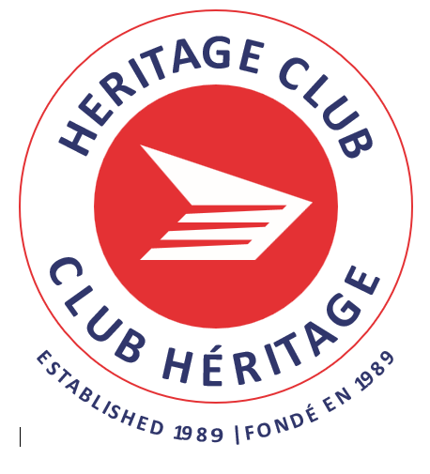
HERITAGE CLUB — HUMBER CHAPTER
FALL NEWSLETTER 2025



Your Humber Chapter Executive

Diane Biggs, President

Website: www.heritageclub.ca
On Facebook: Humber Chapter Heritage Club
Email: humberchapter2@hotmail.com

Debbie Neal, 1st Vice President

Sue Edelsward, Travel and Events

Barnie Joosten, Treasurer

Elsie Pettit, Executive at Large

Wayne Johnson, Executive at Large

President’s Message

TO ALL OF OUR MEMBERS,

Thank you to all our HUMBER HERITAGE CLUB members for your continued support.

In the last newsletter we updated you with regards to the changes throughout Canada Post and their involvement with several factors including the Heritage Club Chapters. Canada Post is still dealing with very severe changes to the industry. The existence of postal delivery is still very much up in the air.
For years, this was a public service to ensure our fellow members and people in general would be able to reasonably keep in touch with each other across our great country.
Many individuals rely on this service unfortunately; our club is affected as well.

In the past, Canada Post provided the Heritage Clubs free mailing service to send posters and newsletters to our 1100 members. Unfortunately, due to cost restraints we will no longer be able to send mail to these members. Most members will receive our info via email.

Therefore, we will only be sending posters or newsletters to paid-up members via email. Our National Heritage Club Executives are continuing their talks with Canada Post to reach an amicable resolution to our mailing process. We will keep you informed with updates.

Sincerely,
Diane Biggs

SANTA CLAUS LETTER WRITING PROGRAM

Another issue concerns the Santa Claus letter writing program, which has brought joy to children around the world. This past Christmas, we were told the program was on hold and the children’s letters they received were ultimately shredded. I am hoping that this year, the Grinch will see what a great goodwill program this is by Canada Post and continue to bring magic to children around the world everywhere.
Update: please contact our Santa helper for more information. Hopefully we will have more information to share with you in our next newsletter.

IMPORTANT INFORMATION FOR PENSIONERS:

Clarification of the 2024 Pension Benefit Statement

It states that a survivor will receive a lifetime survivor benefit plan from the plan, less applicable taxes. This estimate was calculated as of your commencement date. Our National President contacted Canada Post and received clarification from Julie Philippe, GM Total Compensation.
I would like to reiterate what the benefit plan has not been reduced. I can confirm that the wording on next year’s annual pension statement will be updated to indicate that the amount shown is before indexation. Moving forward, this amount will remain unchanged, as it’s based on the calculation performed at the members’ retirement date. It will only be recalculated – and indexation applied -if and when the survivor benefit becomes payable following the members death.

PAST EVENTS

Heritage Club kicked off an exciting and memorable start to the year of 2025, with our Valentine’s Day Celebration. The hope was so everyone felt thought of and loved.

What followed was our Spring and Easter luncheons at Mandarin.

All pictures posted under Gallery at https://heritageclub.ca/humber/

Cheese Tour Caravan June 5th

We stopped and shopped at eight various locations. The second last was a Dutch Bakery in Norwich featuring delectable pastries. Next, onto lunch at the Windmill Country Market, if you had room for any more food. Members and guests who attended expressed that this was one of the best functions of the year so far and will be looking forward to it for next year.

Comments: “What a great day and so much fun”.
“Great day, thank you and your team for organizing this event”.

BLUE JAYS June 21

What better way to show our support for our team but to attend a Blue Jays game at the Rogers Centre and cheer our heads off. This game didn’t disappoint, and we had 103 fans join us behind the outfield
on the third base side.

Celebrate Canada Day July 3rd, 2025

We were pleased to see so many of our members wearing red and white for this auspicious event. Canada Day known as Dominion Day, the National Day of Canada. It is the anniversary of the Canadian Confederation of July 01, 1867.
More than ever, it was the perfect opportunity to show the world that we are Canadians who are TRUE, NORTH, STRONG, & FREE.

Cruising Down The River – Friday, September 19, 2025

September 19, 2025, we took a three-hour relaxing cruise down the Grand River. It included a four-course gourmet lunch, tea, coffee, or soft drink, and dessert with complementary refreshments at the dockside café upon arrival.

RECONCILIATION DAY SEPT. 27 & 28

In honour of Orange Shirt Day and Canada’s National Day for Truth and Reconciliation, a small group of us met at the Small Arms Building where the Eagle Spirits of the Great Waters hosted their 5th annual Healing and Gathering Ceremony. There was food, a market and traditional dancing and more. We are proud of our member, Barry Gilbert, who is the leader and was essential on this beautiful day.

HALLOWEEN Oct. 30

Things got a little scary at Mandarin with all the ghouls, witches, clowns and elves and more. We came together and had fun. We even made a little boy’s day who received treats from a real-life witch!

OUR FUN ISN’T OVER YET! MEET US AT MANDARIN FOR OUR BIGGEST TURNOUT, THE CHRISTMAS PARTY. WHETHER YOU’RE NAUGHTY OR NICE, SANTA WILL BE THERE TO TAKE YOUR WISH LIST.
See the attached poster for more information.

belairdirect insurance, one of the top Insurance Companies, offers up to 35% discount for home and auto insurance.
Johnson/Medoc has been REBRANDED as belairdirect travel insurance, belairdirect offers up to a 35% discount for home and automobile insurance coverage.
For claim assistance call Global Excel Management at 1-800-790-3420 or 819-566-1002.

HEARING LIFE discounts up to 10% featuring price matching as well. As a Canada Post Heritage Club member call 1-877-735-1149 or visit HearingLifeAdvantage.ca to book your free appointment.
SPEC SAVERS, discounts on eyeglasses

Our Facebook Page
Join and follow us on Facebook where you can see pictures of past and upcoming events. Search for HUMBER CHAPTER HERITAGE CLUB, you’ll know you’re in the right place if you see Snoopy on the big red mailbox.

