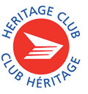
February – 2024
202 2022
2

Humber Heritage Club Executive:

Diane Biggs, President

Debbie Neal, 1st Vice President

Elsie Pettit, 3rd Vice President

Barnie Joosten, Treasurer

Linda Young, Secretary

Wayne Johnson, Executive at Large
Heritage Club Website www.heritageclub.ca

PRESIDENTS MESSAGE TO ALL OF OUR MEMBERS ”HAPPY NEW YEAR, 2024”

First of all, I wish to send a thank you to all our members who continue to support the
Humber Heritage Club. Thank you for paying your dues, the tireless volunteer work throughout the year and for making the Humber Chapter a welcoming place to attend.

The Executive, as well as myself, would like to acknowledge and send a very special thank you to the members who show up early to our functions to lend a hand. We couldn’t do it without you. Also, a warm welcome to all our new members who joined in 2023.

I also wish to acknowledge and thank our executive team members for their continual work in our organization and participation in support of the Humber Heritage Club.
If you are interested in joining the executive team, please call me at 905-487-4311 to learn about more open positions.

A special thank you to Jayne Clayton for her fourteen years of service as our secretary, photographer, minute taker and many more functions too numerous to mention with Humber Heritage Club. Jayne is just stepping down and will still be attending our events.
Linda Young has offered to fill this position with our executive team. We welcome Linda and are looking forward to working with her.

Diane Biggs and your Executive Team

Chapter Membership Dues

GOOD NEWS! NO DUES INCREASE!

FYI - Four newsletters in 2024 will only be sent out to members who have paid their yearly dues. These will be via e-mail. If you don’t have an email, a letter will be mailed

Members in the Know

BARRY GILBERT is the President of The Eagle Spirits of the Great Water on the treaty lands and territory of the Mississauga of the Credit. In particular, the territory of the Amshinabek, Huron-Wendat, Haudenonsatines, Ojibway and Chippewa people. If you would like more information, please contact him at
tekawitha371@gmail.com

ARNO ILIC is the Author of two fascinating books – “The World According to A I (it’s not what you think) “and “Letters in the Lunchbag”. If you would like to speak to Arno or are interested in purchasing one of his books, please contact him at
www.ilicmanagement.org

DOUGLAS REID makes and creates a wonderful assortment of hand-crafted BIRD HOUSES. He is also a geometric accomplished painter as well. He can be reached at reidwhelan@sympatico.ca

LINDA YOUNG started her business BAKED TO EAT during the pandemic to pay for her three year old grandson’s hearing aid. She makes a great variety of delicious homemade cookies and cupcakes. If you would like to place an order for her Baked To Eat treats, she can be reached at
lindayoung@hotmail.com.

If you have an interest that you would like to share with our members, please contact us at humberchapter2@hotmail.com

A skeleton walks into a bar and says
“Hey bartender, I’ll have a beer and a mop”

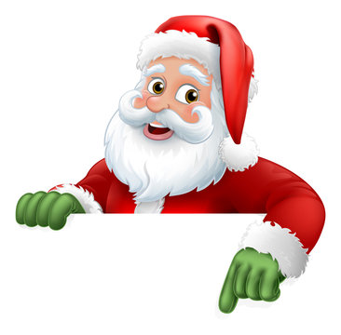
Santa Elves HO-HO-HO Letter Writing Program

What an incredible year! Humber Chapter volunteers really stepped up as usual! Our Chapter helped Santa in answering 7,050 letters to children and 362 schools!
Every elf worked tirelessly to ensure all of the children received a reply from Santa Claus.
Thank you to all our volunteers and for keeping the magic of Christmas alive.
Also, a special letter of thank you will be posted soon. Watch for it in the mail.

If you are interested in participating next year or would like more information about it, please reach out to our Santa Coordinator Debbie Neal at 647-215-1515. It is a worthwhile program and just what you need to get into the Christmas spirit!

NEW FACEBOOK PAGE

Join and follow us on Facebook page to see pictures of past and upcoming events. Post your pictures there to share with our members! Search for HUMBER CHAPTER HERITAGE CLUB. You know you’re in the right place if you see Snoopy on top of the big red mailbox.

Humber Chapter Heritage Club

https://www.facebook.com/groups/860687395308937

Canada Post Employees & Retirees Group (2300 members)

https://www.facebook.com/groups/312323678873408

Canada Post Scholarship Program 2024

The Heritage Scholarship Program is open to all dependent children and grandchildren of dues (paid for present and last year) members of the Heritage Club. There are three (3) scholarships of two thousand dollars each ($2000.00). The full application for this scholarship is available on the Canada Post Website. The closing date is June 2024. For more information, please contact our National Program Coordinator, Eldred Holmes at

holmese@nl.rogers.com.

Johnson Scholarship Program 2024

Johnson Insurance also has a scholarship program available for our paid up members. Information regarding the Johnson scholarship will be in our next newsletter.

https://www.johnson.ca/scholarship

Paid Membership Features some of the following:

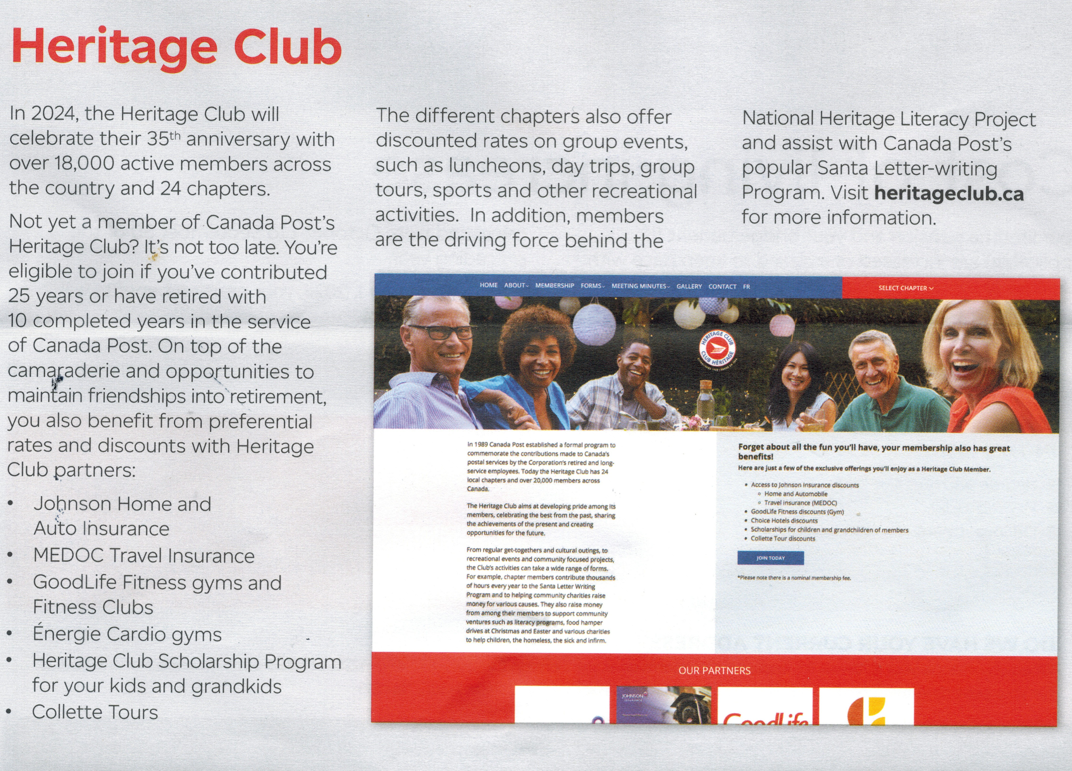

2023 EVENTS

February 11 Valentines Day

We celebrated this special day with our members at the Mandarin restaurant with Hearts and Chocolates.

Breakfast Meetings, Peters – March & July

Our breakfast get-together at Peter’s Restaurant on Eglinton was very successful. It was so successful that we held it twice. Peters are known for their six-inch corned beef sandwich so a lot of our members took home take-out containers. It was a great opportunity to catch up with friends and enjoy everyone’s company. We are looking at various restaurants that feature a breakfast menu. Stay tuned for future dates and places.

Spring Mandarin April

St. Patrick’s Day was celebrated by our members, especially those wearing green.
Birthday Luncheon, August

We celebrated our members’ birthdays at the Mandarin restaurant with many prizes. Also, members who attended had the option of receiving a future Birthday card recognizing their special day.

Mino Bimaadiziwin Sept. 30

Our member, Barry Gilbert, who is the President of the Eagle Spirits of the Great Waters, celebrated his third gathering and healing ceremony. Our members were invited to attend and found it to be very informative for all who attended. We learned a great deal about the past life of indigenous people.

October 01- Mandarin Seniors Day

What a gathering at the Mandarin. We featured a half price Seniors Day. Members paid $10 and $15 for guests.

Niagara Falls Casino Trip, October

We travelled by bus to Niagara Falls for a day of gambling. Hopefully we will go again in the summer.

Halloween Luncheon, October

Costumes and masks were optional. Our members received a special treat from our ghostly vampire. We all had a spooky fun time. This event is never too old to celebrate. Boo!

Christmas December 04

A very merry celebration took place at the Mandarin restaurant. We brought a good volume of prizes and received good feedback from our 81 members.

NEWSWORTHY 2024 FUTURE EVENTS

I’m excited to see the many events that 2024 has in store for us and look forward to seeing you at one of our many functions. We’ll be kicking this year off at the Open Cork Restaurant (Feb. 08) during the week of Valentine’s Day. If you miss it, pop on our Facebook page to see photos of your friends enjoying an afternoon out.

We will be travelling to a casino by bus in 2024!
Celebrating Valentine’s Day and Easter.
The Butterfly Conservatory in Niagara Falls or Cambridge.
Some of our top restaurants in Toronto will be one of our top features in 2024.
Stay tuned for more events and details in our upcoming 2024 newsletters.
If you have a favorite outing or restaurant that you feel our members would appreciate, please feel free to send us the information.

Charities Supported in 2023

In 2023 the Humber Chapter donated $2125.00 to the following Charities.

Canadian Red Cross
Kid’s Sport, Surrey B.C.
Mississauga Food Bank
Lions Foundation of Guard Dogs
Sick Kids Hospital
Royal Canadian Legion, Poppy division
Ontario Shore Mental Health
Covenant House
Salvation Army
Scott Mission
Fred Victor Society
Alzheimer Society
The Leukemia & Lymphoma Society
Canadian Red Cross (Ukraine)
Heart & Stroke
Caledonia Food Bank-The Exchange
Eagle Spirits of the Great Waters

Change of Address

Name
Old Address
New Address
City
Postal Code
Phone Number
Email

Your Benefits Survivor procedures:

To ensure the survivor of a retiree maintains pension, health and medical benefits, a number of contacts must be made after a retiree’s death.

Access H.R. (1-877-807-9090) Retiree name, Employee I.D. number, Social Insurance Number, Copy of death certificate

C.P.C. Pension (1-877-480-9220) Retiree name & Employee I.D. Number, Address, Postal Code, Month and date of birth, Copy of death certificate, Copy of retiree`s will.

Canada Life (1-866-716-1313) Retiree name, Employee number, copy of death certificate, Plan numbers - 51057 & 51391 NOTE: Very important to notify Canada Life as soon as possible in order to set up a new automatic withdrawal in the survivor’s name in order to keep policy in force and maintain medical, dental and vision benefits.

C.P.P. / O.A.S. (1-800-277-9914) Retiree name, Social Insurance Number, copy of death certificate
NOTE: Besides the C.P.P. survivor pension, there is a Death Benefit payable to the survivor.

Superannuation (1-800-561-7930) Retiree name, Social Insurance Number, copy of death certificate, copy of marriage certificate Note: Sun Life benefit premiums for Superannuation survivor will be deducted directly from monthly survivor pension.

Canada Revenue Agency (1-800-959-8281) C.R.A. is to be contacted when a member or spouse passes to prepare for T-1 and T-3 form completion.

In Memoriam

It is with great sadness to share with you the list of Humber Heritage Club members who have passed away in 2023 or earlier.

Teasdale | Kenneth | Miller Lake
Curkan | Gary | Mississauga
Turner | Lloyd | Walkerton
Morin | George Philip | Mississauga
Neto | Carlos Sousa | Mississauga
Jones | Cecilia | Mississauga
South | W. Doug | Bramalea
Deleniana | Vergilio | Mississauga
Ready | Robert | Mississauga
O’Reilly | Mary Teresa | Mississauga
Oreto | Vincent | Oakville
Hollick | John | Mississauga
Megahey | John Gerald | Mississauga
Prajza | John | Toronto
Aiken | Bob | Hamilton
Chin | Florence | Mississauga
Foreman | Peter Herbert | Mississauga
Baxter | Joe | Wasaga Beach
Taylor | Brian | Etobicoke

If you are aware of any of our members who have passed away, please notify us. Humber Heritage Club will send a donation to the charity of choice of any one of our paid members.

