People helping people

Heartland Chapter of Heritage Club going strong
By: Simon Fuller
Posted: 11/12/2019 2:21 PM | 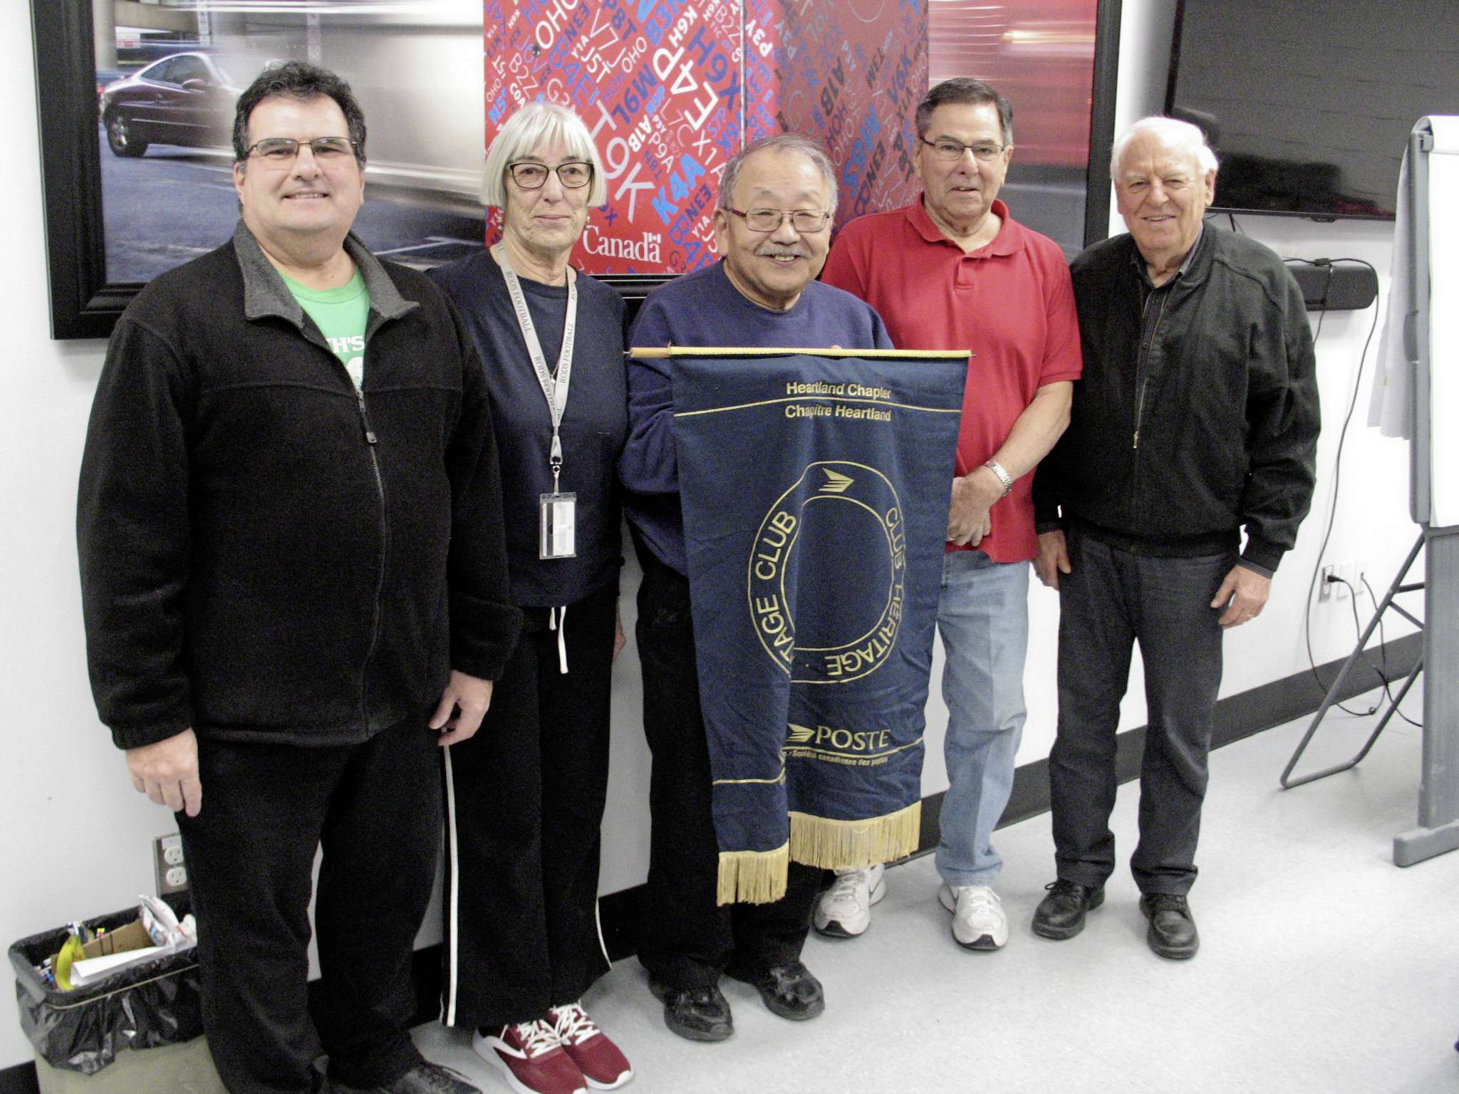
Members of the Heartland Chapter of the Heritage Club of Canada's chapter executive are pictured recently. From left to right: Paul Pelletier, treasurer; Eileen Hay, second vice-president; Harold Onagi, president; Gord Arseny, first vice-president; and Ed Paleshnuik, administrative officer. (PHOTO BY SIMON FULLER/CANSTAR NEWS/THE LANCE)
They used to deliver mail to Manitobans — and now they deliver any number of items to individuals and organizations in need.

The Heartland Chapter of the Heritage Club of Canada, which was established in 1989, is one of a number of chapters across the nation. Membership in each chapter is open to working or retired Canada Post employees that fall under a certain criteria.
Among other things, chapter members dedicate their time and effort to numerous charitable events, activities, and causes. The local chapter is based at the Canada Post office depot at 1462 Church Ave., and office hours are Monday and Thursday mornings. Several members of the chapter’s executive live in southeast Winnipeg.
"Our chapter is for long-serving and retired Canada Post employees," administration officer Ed Paleshnuik, who lives in Southdale, said.
The chapter’s motto is a simple one — "people helping people." And based on the list of charitable pursuits the members have on the go, it certainly lives up to its name.
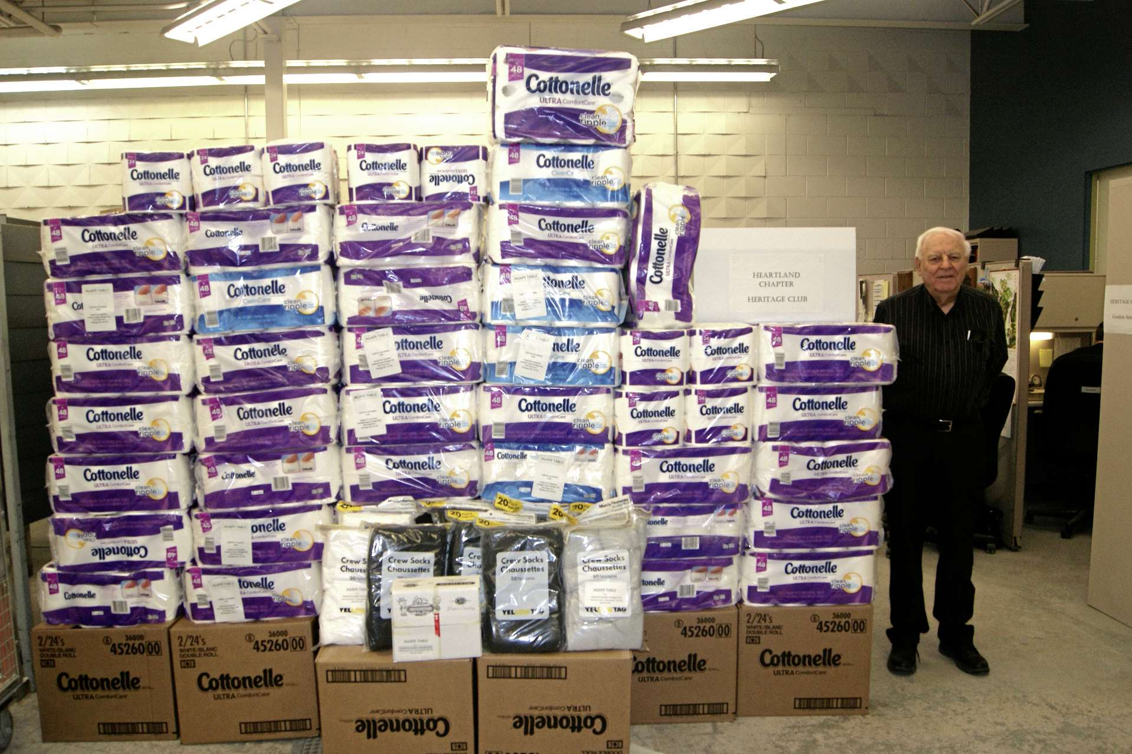
SUPPLIED PHOTO
Heartland Chapter of the Heritage Club of Canada member Ed Paleshnuik is pictured in this file photo with some of the toilet paper rolls the group purchased for charitable causes.
This year alone, for example, the group has donated more than 7,500 diapers, over 2,500 pairs of socks, and feminine hygiene products to Agape Table. And in light of the changing of the seasons, members are once again busy knitting items such as toques, scarves, sweaters, gloves, and mitts for local children in need.
Chapter president Harold Onagi said the group has previously supported other non-profit organizations such as Siloam Mission and Rossbrook House, and felt there was a need this year to lend some helping hands to Agape’s cause.
"We’ve learned to concentrate our efforts," said Onagi, who lives in St. James, noting the chapter has also collected a massive number of rolls of toilet paper to donate this year. "When certain stores put toilet paper on sale, we’re there."
"We also have a dedicated group of around 15 to 20 knitters, and last year the group produced more than 1,000 knitted items. The majority of the knitted items go to kids."
Paleshnuik said community members are also welcome to drop off knitted items or any wool donations.
"We’ll happily make space, and pass on the wool to the people who are knitting," he said, adding individuals are welcome to drop off donations at the front desk at 1462 Church Ave., or if the donation is large enough, organizers can arrange a pick up.
The chapter has also been active supporters of other local causes in recent years, including Misericordia Hospital, United Way’s Koats for Kids, and the West Central Women’s Resource Centre.
For more information, email heartlandchc@gmail.com or call 204-987-5010.
Simon Fuller
Community journalist — The Lance
Simon Fuller is the community journalist for The Lance. Email him at simon.fuller@canstarnews.com Call him at 204-697-7111

