2nd Vice President-Gil Summerell
3rd Vice President-Mike Bonnie
Secretary-Wanda Fisher
Treasurer-Ed Ewanchuk

President: Gary Fisher
101-3606 25th Ave
Vernon, B.C. V1T 1P3
cpheritageclub29@sha w.ca
New email address
250-545-6375

PRESIDENT’S MESSAGE

I hope you are having a good summer. Our summer began with the Presidents’ meetings in Regina. I would like to thank Conway Crozier-Smith and his team from the Golden Sheaf Chapter for putting on an excellent conference.
On behalf of the Central Yukootok Chapter, I was very proud to accept the Community Service Award at the annual banquet. Many thanks to our members for their many volunteer hours and for their contributions by way of in-house draws etc. which helped us to make the important donations to various hospitals and service clubs. These efforts are what enabled us to achieve this award.
Along with a group of golfers and others, I was pleased to acknowledge Bill Blair at our recent Bill Blair Memorial Golf Tournament. The whole event went well and the participants thoroughly enjoyed themselves.
I look forward to seeing you at our 30th Anniversary Party next month.
Regards,
Gary Fisher

CENTRAL YUKOOTOK HERITAGE CLUB

Newsletter #41, August 2019

Heritage Club web site: heritageclub.ca/people helping people
Kelowna- Fred Jarvis 250-878-5522
South Okanagan: Mike Bonnie 236-422-1061
Prince George-Corinne Printz 250-964-7479
Vernon-Fred Stoll
250-545-4273
Newsletter Editor
Pamela Dyrda
250-308-2665 new
pubbajean@gmail.com

Pg 2
COUNCIL NEWS:

PRINCE GEORGE:
Our spring meeting was a little later than usual. (Who knew retirement would be so busy!) We met for lunch at White Spot with 18 attending. Several photo albums were on display with photos from waaay back. “OMG, did you see your old photo from 1970!” One album was full of newspaper clippings as well: a real documentation of the time. Items discussed included the last page of the April newsletter and other sources of info for “that time” in the future. We encouraged those who were not members yet to join officially. We discussed the importance of recording the volunteer hours anywhere in the community. And we visited!!
Obituary note William Greenley passed away on May12th, 2019. He had 26 years with Canada Post. Pat Rogers has joined us in Prince George. Welcome, Pat. Submitted by Corrine Printz
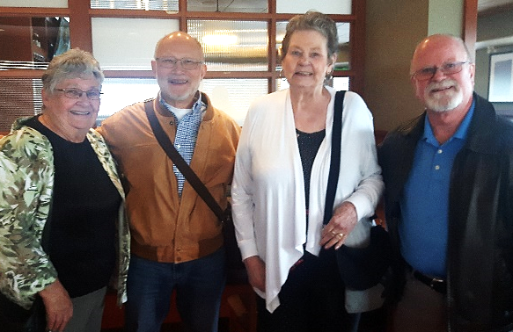
1. Pat Rogers, Ray Nagai, Jeanelle Desgagne, Les Redding.
2 Ray Nagai, Pat Kinsley, Pat Rogers
3.Sheryl Hannam Norma Raycraft, Corrine Printz

VERNON:
A luncheon meeting was held on May 30 at Apple Lane Restaurant with thirteen members attending. Merv Mathers brought along some beautiful hand-made clocks which he personally crafted from an old post office sorting table. These will be presented as prizes at the Bill Blair Memorial Golf Tournament.
Merv Mather was the winner of the in-house draw.

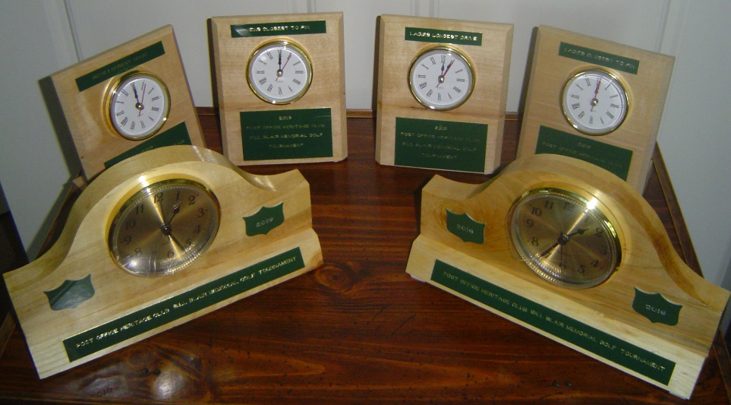

Our annual BBQ was held on June 26 at the Schubert Center with twenty-eight members and one guest attending. It was a lovely evening and Fred Stoll, Reg Shumay and Fred Jarvis all did an excellent job cooking the steaks.

Pg 3
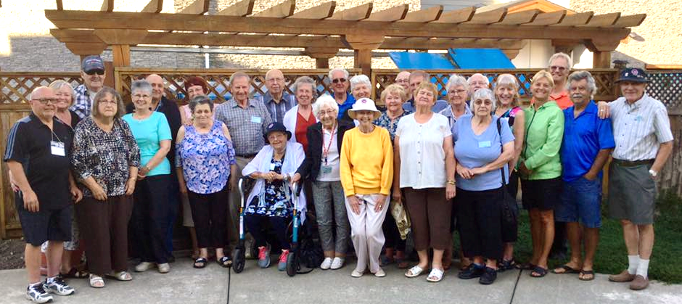
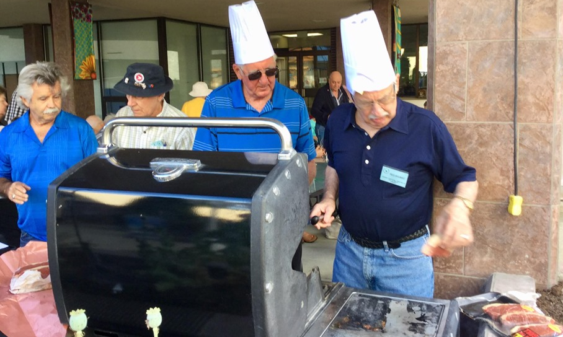
BBQ turnout and the cooks
Our Council donated $300 to the Okanagan Regional Library in Vernon to sponsor three of their events during their Summer Reading Club Program. Stephanie Thoreson accepting the cheque from Gary Fisher--
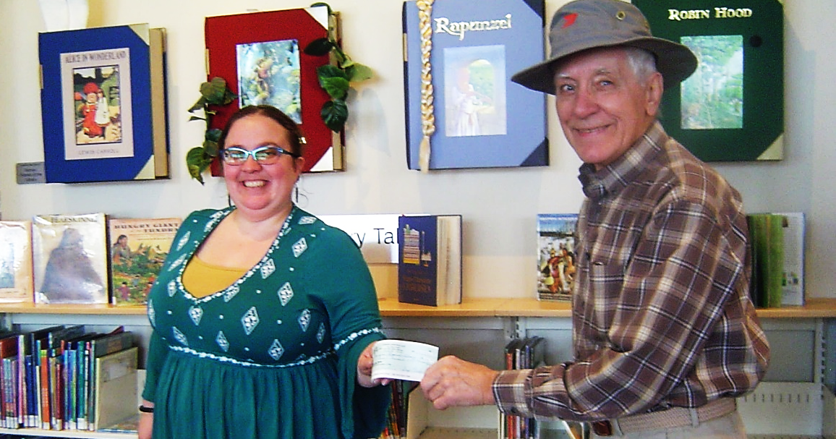
Submitted by Wanda Fisher

Pg 4
SOUTH OKANAGAN:

Our latest luncheon took place June 17 2019 at Zia's restaurant in Summerland, with 15 attendees including Ch 29 President and Secretary Gary and Wanda Fisher. As usual we had a 50/50 draw with two winners sharing on half of money raised.
We here in Penticton are looking forward to the 30th Anniversary of the Heritage Club being celebrated in Penticton on Monday and Tuesday September 16 and 17 at the Days Inn, 152 Riverside Drive Penticton. If you are interested but have not yet sent in your application, THERE IS STILL TIME! Send you application and cheque for the Luncheon Buffet, $20 for paid members and $35 for un-paid members or guests to Gary Fisher,101-3606 25th Ave. Vernon BC V1T 1P3

The last luncheon for 2019 in South Okanagan will take place on TUESDAY, OCTOBER 22 2019 AT NOON. THERE HAS BEEN A CHANGE OF TIME AND THE VENUE! The luncheon will be held at THE BARKNG PARROT, located in
the Pentcton Lakeside Resort 21 West Lakeshore Drive, Penticton. Hope to see you there! Submitted by Mike Bonnie Goldeyefan@gmail.com

CHAPTER NEWS:
The President’s Meetings that were held in Regina this year were successful and we would like to thank Conway Crozier-Smith from the Golden Sheaf Chapter and his team for putting on a super conference. Central Yukootok Chapter received $1,244 from the Heritage Club. This amount represents our seed money which is based on $3.00 per paid member and $1.00 per non-paid member. We also received $500 from Canada Post for our achievements on our Annual Report. Central Yukootok was also the recipient of the Community Service Award for our volunteer work and the many donations we made in 2018. You can read the complete minutes from the meetings on the web site heritageclub.ca/people helping people At the top of the page you will see the header for Minutes of Meetings. Go to AGMs and then to AGM Regina 2019.
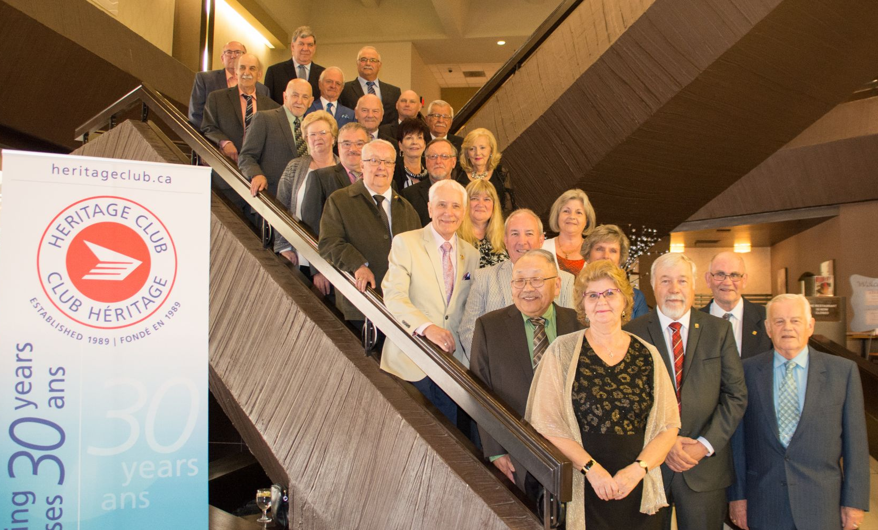
All the Chapter Presidents.

Pg 5
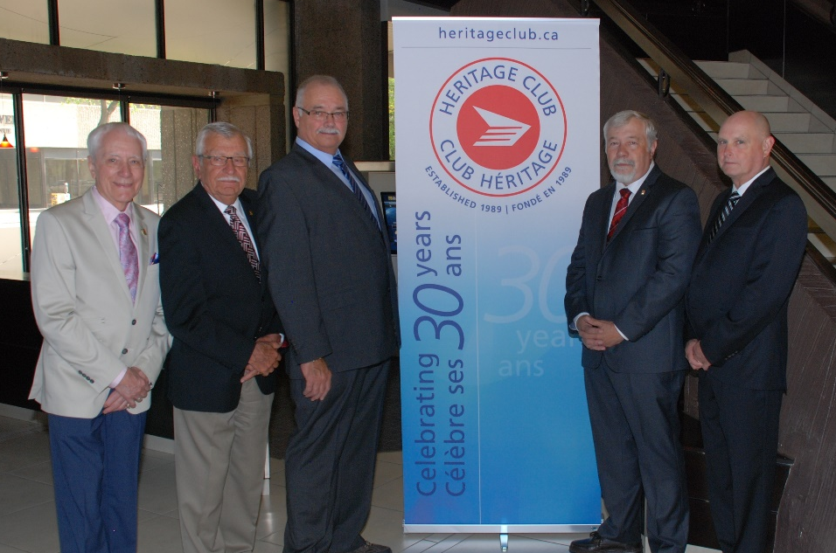
National Executive. Left to right is Gary Fisher, 3rd Vice President;
Gary receiving the cheque presented by Christine Blain from Canada Post
Nick Ronsky, Treasurer; Eldred Holmes, 1st Vice President;
J.P. Leguerrier, National President; Claude Bruneau, 2nd
Vice President.
Gary receiving the Community Service Award from J.P.
Leguerrier National President
Our annual Camp Out will be held starting Wednesday September 4 at Skimikin Lake Forestry Site. Willard and Diane Turner will lead the group with fun games, fireside chats, fishing, hiking and a general good time. Skimikin Lake is located off Trans Canada Hwy. west of Salmon Arm. For complete information contact Willard Turner at tassie1978@icloud.com or 250-766-5494.

Pg 6
We held the Bill Blair Memorial Golf Tournament on Sunday August 11 at Spallumcheen Golf Course. It was a great success. The winning team for the trophy was made up by James Best, Carlayne Baxter, John Barrowclough and Gary Fisher. The winners of Merv Mathers’ lovely clocks were as follows:
Ladies longest drive: Bunny Stoik; Men’s longest drive: Steve Blackstock; ladies closest to the pin: Carlayne Baxter; men’s closest to the pin: Joe Derochier. Everyone enjoyed an awesome soup and sandwich buffet and were joined by several non-golfers who came for the lunch only. A toast was made in honour of Bill Blair. A nice array of prizes was handed out to the golfers. We would like to thank Johnson Ins., Vantage One Credit Union, James Best and Merv Mathers for their contributions.

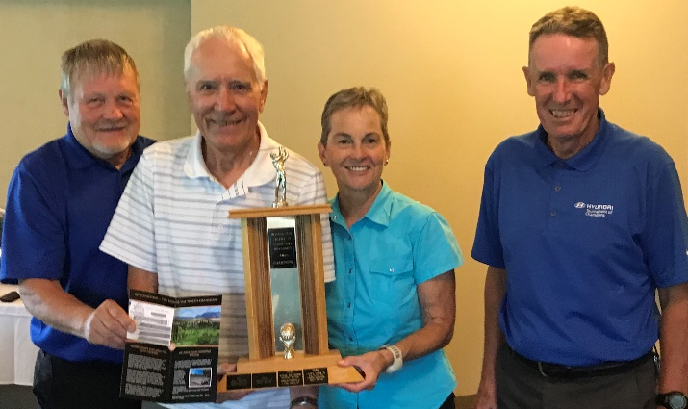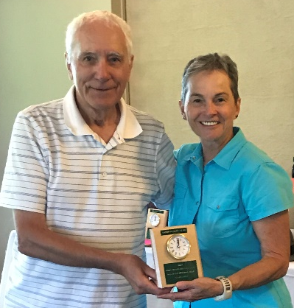
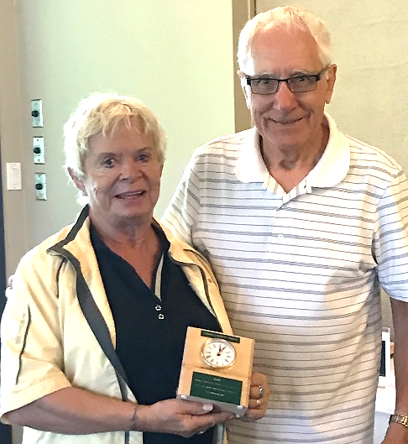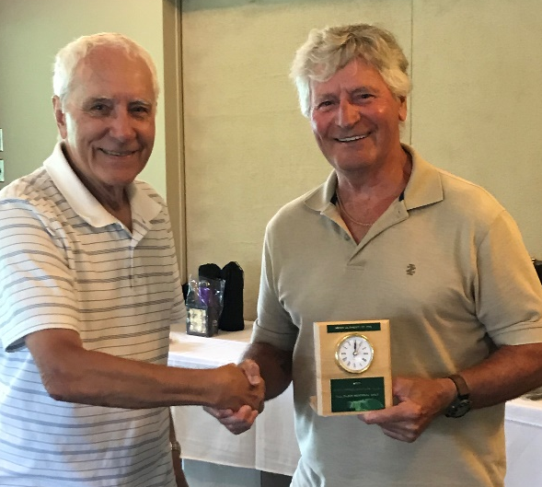
Top L-R - Best Team--John Barrowclough, Gary Fisher, Carlayne Baxter & James Best
Middle-Ladies closest to the pin Carlayne Baxter & Gary
Far right-Men’s longest drive-Mike Blackstock and Gary
Lower L-R-Ladies closest to the pin-Bunny Stoik and Gary
middle-Men’s closest to the pin-Joe Derochier and Gary

We would like to thank our Vernon Council member Merv Mathers for the beautiful clocks that he personally crafted from an old post office sorting table and that were handed out as prizes.

A reminder about our 30th Anniversary Party which will take place on Monday September 16 and Tuesday September 17. There will be a desert and coffee Meet & Greet on Monday night at 7:00 p.m.

On Tuesday morning we will hold a short General Meeting at 9:00. Following that, there will be a full hot and cold luncheon buffet at 12:30. We will have a special cake and door prizes. For complete information and registration forms contact Gary Fisher (contact information on the front page of this newsletter).

Pg 7
We recently received some wonderful postal artifacts which were donated by Cal Hornby from Penticton and Roberta Campbell which belonged to her late husband Colin. These items were then donated to the Armstrong Post Office and are now on display there. If you are passing through Armstrong, drop in and take a look at them.
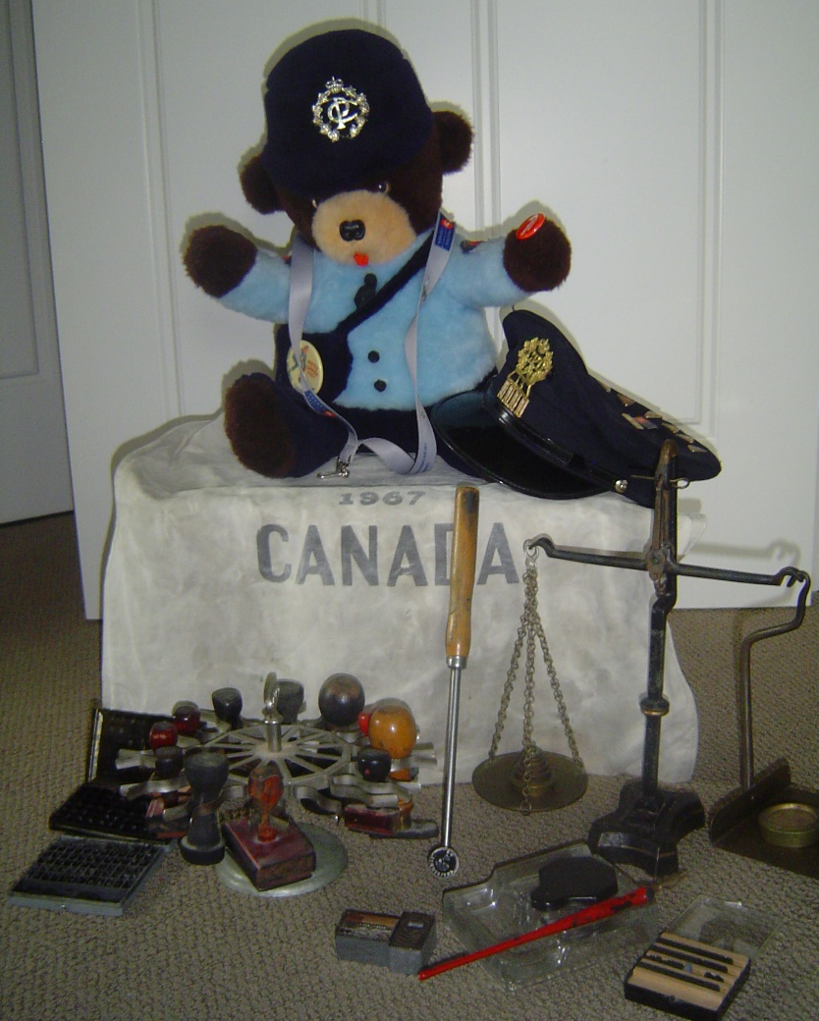
CONGRATULATIONS! to Del Fulgham of Vernon for reaching 100 years of age on July 20. Only .02 per cent of Canadians live to be 100, making Del one of roughly 8,000 centenarians living in Canada today.

We donated 9 pounds of pull tabs and aluminum to Judy Keckalo of the Royal Purple which that organization uses to support their charity.
There is a star in our midst! One of our members, Don Defty of Kelowna has been involved in some film work since his retirement and was recently in a movie. Here is his story:
> From Postal Worker To "Movie Star".
>
> My name is Don Defty and I was asked to write something about my recent movie role as part of a series of articles, that we could include, in our newsletter, about life, travels, interests, hobbies, etc of our members, in their retired life.
> I retired in 2012, after 34 years, as a clerk and dispatcher, having worked in Kelowna, Whitehorse, and Moncton.
> I had always had an interest in working in the film industry, and have done behind the camera work, production assistant, etc, on my holidays.

Pg 8
> After retirement, there was a casting call, for a film, here in Kelowna, and I thought, why not become a paid extra. This lead to being represented by one of the top talent agencies in Vancouver and an agent. I have done 6 movies, 2 commercials and a TV pilot, so far.
> Just over a year ago, I got "THE" call, specifically requesting me for a role as a stand in and body double for the venerable Richard Dreyfuss. He is famous for roles in American Graffiti, Jaws, Close Encounters of the Third Kind,etc, for those that don't know who he is. Not only did I get to work along side of this Oscar winner, but also included, Gina Carrano ( Deadpool, Fast and Furious 6 ), Sydelle Noel (Black Panther), and Brendon Fehr ( Roswell, C.S.I. Miami ). The other stars of the movie are the real wolves that we had, on set.
> I make my on screen, acting debut, in this action, thriller, called Daughter of the Wolf. One day was set aside to film, me ,in full hair and make up. (see photos ).
> I couldn't believe all these production people and camera people were there, just to film me, in a fight scene, where my character get killed by a pack of wolves This is where I felt like a real movie star and not just a background extra.
> The movie is scheduled to be released, to limited Worldwide markets, on May 10th, of this year.
The movie was released on August 6 on video-on-demand and through iTunes and Apple TV.

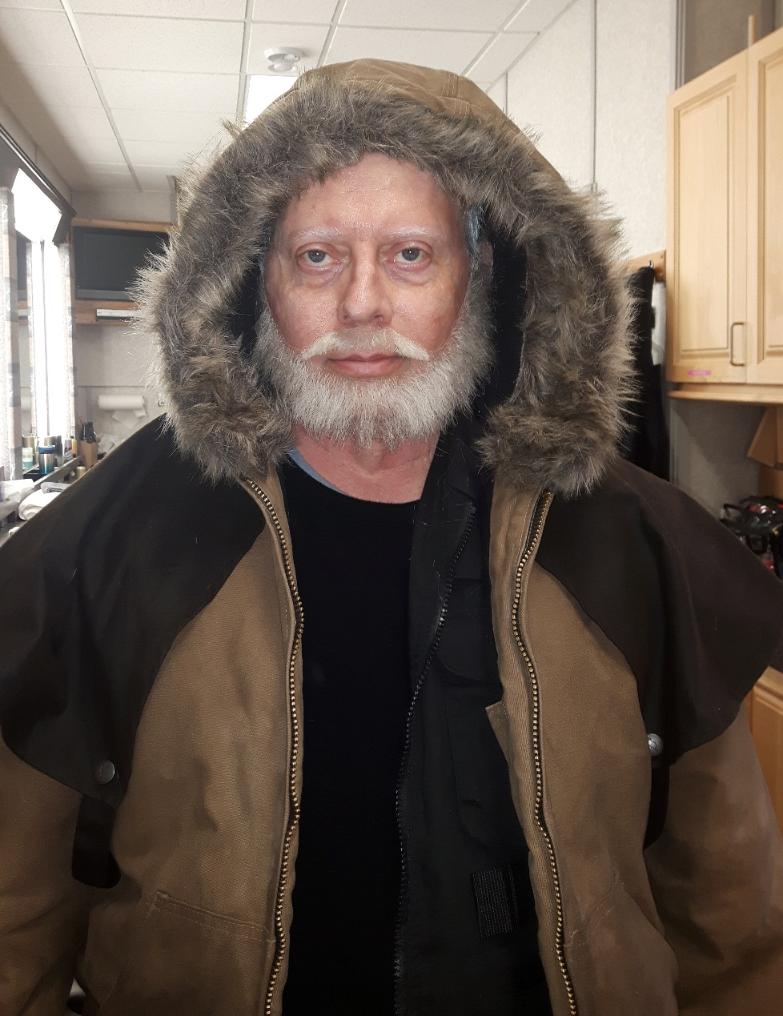
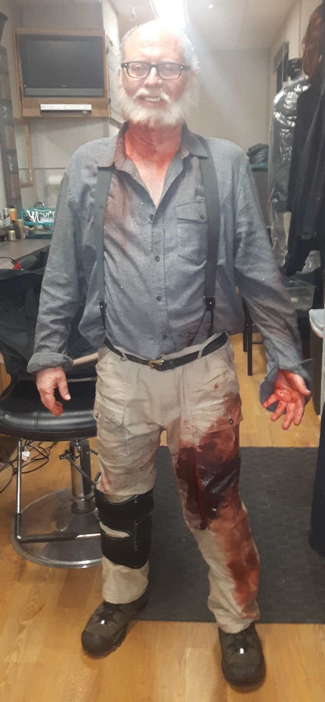

Pg 9

BLAST FROM THE PAST – Those were the days

The following are a few memorable items on mail transportation in the Cranbrook area in the early years. They are excerpts from The Cranbrook & District Key City Chronicles published in 2002. The book was a project of the Cranbrook & District Key City Chronicles Society 1898. The Chairman was our member Marvin ‘Skip’ Fennessy of Cranbrook. Skip worked as a postal clerk for 36 years under several Cranbrook Postmasters.
The first mail in the late 1800’s left Cranbrook by way of Fort Steele and Golden from Mr. Beattie’s Post Office. R.E. Beattie was the first Postmaster.
In 1931 protests filed with the postal department from various parts of the East Kootenay district resulted in a bus line being inaugurated between Cranbrook and Athalmer. Postmaster Harris advised the public that beginning Saturday, October 3rd and every Saturday until further notice by the department, a regular stage-mail service will be inaugurated with delivery to post offices between Athalmer and Cranbrook on the south trip and return mail from Cranbrook on the north trip.
Cranbrook Courier - January 4, 1940: The valley mail delivery service has changed hands. Mr. R.S. Bavin retired at the close of 1939. January 1st saw the shiny new mail truck driven by Mr. Jack Shibley of Invermere make its initial trip from Cranbrook to Golden.
Postmaster William Harris received word that commencing December 15, 1947 airmail service to the southern interior would commence via Canadian Pacific Airlines. On December 29, 1947 airmail service began with the first bags of mail from Cranbrook and Kimberley post offices being hauled to the airport by Cranbrook Taxi Service.
Cranbrook News - July 5, 1951: Alf Kershaw has operated a public stage between Fort Steele and Cranbrook for the past 26 years, carrying passengers and mail between the two points. The line was discontinued at the end of June, after over a quarter century of operation.
Cranbrook Courier – September 26, 1957: Dench Canada Ltd. have been awarded the contract for carrying surface mail through this area between Medicine Hat and Nelson. Jack Shibley will continue his present mail contract between Cranbrook and Golden serving the Columbia Valley on the existing thrice weekly service. Don Revie will also continue his mail contract between Cranbrook and Kimberley as at present, with three round trips daily.
Cranbrook Courier – June 27, 1957: An announcement has been made that effective on October 1, 1957 the transportation of surface mail between Medicine Hat and Vancouver will be handled by trucks instead of railway as at present. The change is made necessary due to the fact that next fall Canadian Pacific Railway will replace present equipment on Trains 67 and 68 with rail diesel equipment, with no provision for the conveyance of mail. Under the new system two 35-foot semi trailers…….. will operate seven days a week between Medicine Hat and Nelson. These will make mail delivery stops at Lethbridge, Cranbrook and points west of the city. They will also make connections with U.S. mail trucks at Kingsgate………. In addition to the foregoing, “through” service of smaller trucks will provide a “local” service between Medicine Hat and Lethbridge, also between Cranbrook and Lethbridge………….

