# 

CENTRAL YUKOOTOK HERITAGE CLUB

Newsletter #36, January, 2018

Chapter 29 Executive

Council Presidents

Kelowna- Irene Hawrysh 250-762-8525

Penticton-Gil Summerell 250-495-3350

Prince George-Corinne Printz 250-964-7479

Vernon- Bill Blair 250-545-7075

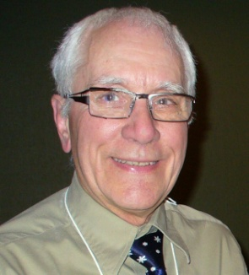

President: Gary Fisher

101-3606 25th Ave

Vernon, B.C. V1T 1P3

[gwfish@shaw.ca](mailto:gwfish@shaw.ca)

250-545-6375

Heritage Club web site: heritageclub.ca/people helping people

President’s Message:

Well, a new year begins, and I hope 2018 brings good things to everyone.

Again this year, I will be representing our Chapter at the annual Presidents’ Meetings which will take place in Toronto from May 28-31. If you have any concerns please let me know and I can express them at that time.

The other event that I will be looking forward to is our bi-annual banquet. This year it will take place in Vernon at the Prestige Inn from September 10-12. This year we have chosen weekdays so that it will not conflict with weddings or reunions etc. We are planning what we hope will be a good time for everyone and I hope that we can attract a good crowd. Watch for your Banquet Package in our April newsletter. I would like to urge you to encourage your fellow members to come out for some great fellowship. Why not get together with others and make up a group to travel with.

In the meantime, I am looking forward to getting together with you at our various luncheons and functions.

Regards,

***Gary Fisher***

Gary Fisher

1st Vice President- Bill Blair

2nd Vice President-Gil Summerell

Secretary-Wanda Fisher

Treasurer-Ed Ewanchuk

Newsletter-

Pamela Pfannmueller

pubbajean@gmail.com 250-446-2331

President’s Message:

Happy New Year. We welcome in 2013 with this, our 16th newsletter. I hope your year has begun with a smooth start.

This newsletter also introduces a new editor. Pat Rogers has stepped down as editor for a well deserved rest. Thank you Pat, we cannot thank you enough for the donation of your valuable time and effort. We welcome Pam Pfannmueller and gratefully accept her offer to be our new editor.

Personally, I am looking forward to another year of leading our chapter to fulfill our obligations to community causes, social activities and increased membership. Over the last couple of years, I have noticed an increase in enthusiasm for our chapter. We continue to have new long service employees and retirees register with National Office to become members of the Heritage Club. I am encouraged when I learn of members who continue to get together on their own, maintaining lasting friendships.

As always, I encourage all registered members to become active, paid members and reap the benefits of membership, which include discounts on home and travel insuran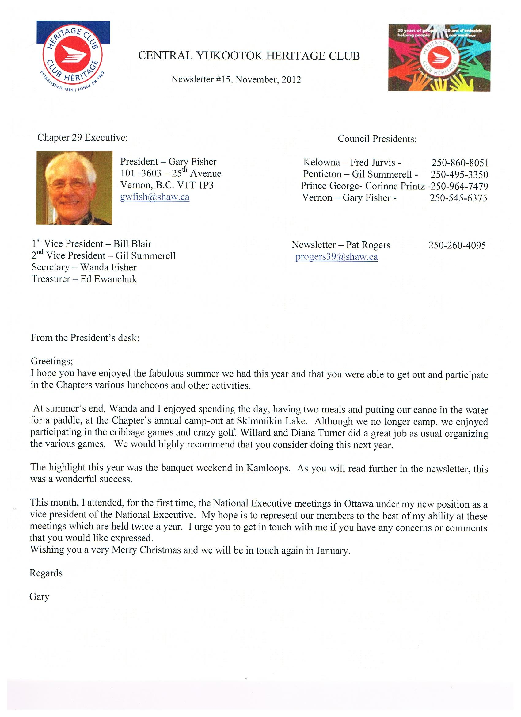ce through Johnson Insurance, the many discounts available through Work Perks, and discounted rates at Good Life Fitness. As well, your membership fee ( a mere $10 per member, $5 for spouse) entitles you to receive our quarterly newsletters which keep you up to date with what is happening in the chapter so that you can join in some wonderful social and worthwhile activities in your area. I always feel sad when I hear someone say that they wished they had known about a get together, but missed it because they did not receive a newsletter.

So Sign up! and Join In! and don’t miss out. I look forward to hearing from you.

Regards,

Gary Fisher

**COUNCIL NEWS**

**KELOWNA**

Congratulations to Anne Millsap of Kelowna on her retirement. Anne is currently enjoying a well-deserved vacation down south and we will look forward to seeing her at one of our functions in the new year.

The Kelowna CPC Heritage Club held a few luncheons over the past year of 2017. We also had a Bowling afternoon and supper at Freddies Brew Pub which 16 people enjoyed some 10 pin bowling and a great supper. Our year wound up with a Christmas Banquet held at The Legion with 30 members present. A fun evening and Money raising event whereby we raised $253 along with additional funds we were able to donate $300 to The Foundry in Kelowna towards Youth Mental Health.

Upcoming events for Kelowna for the coming year in 2018 are as follows:

**JANUARY 31, 2018 @ 3:00 PM**

5 PIN BOWLING AT FREDDIE'S BREW PUB 948 McCURDY RD.

THOSE WHO WANT TO STAY FOR A BREW AND SUPPER AFTERWARDS ABOUT 5:00 PM CAN DO SO. IF YOU DON'T WANT TO BOWL, YOU CAN COME OUT AND CHEER US ON OR JUST JOIN US FOR SUPPER.

**FEBRUARY 21, 2018 @ 1:00 PM**

CABIN FEVER LUNCHEON

LUNCHEON AT THE ASIAN PEAR ON 2050 HARVEY AVE IN KELOWNA.

JOIN US FOR GOOD FOOD AND FELLOWSHIP FOR A COUPLE OF HOURS.



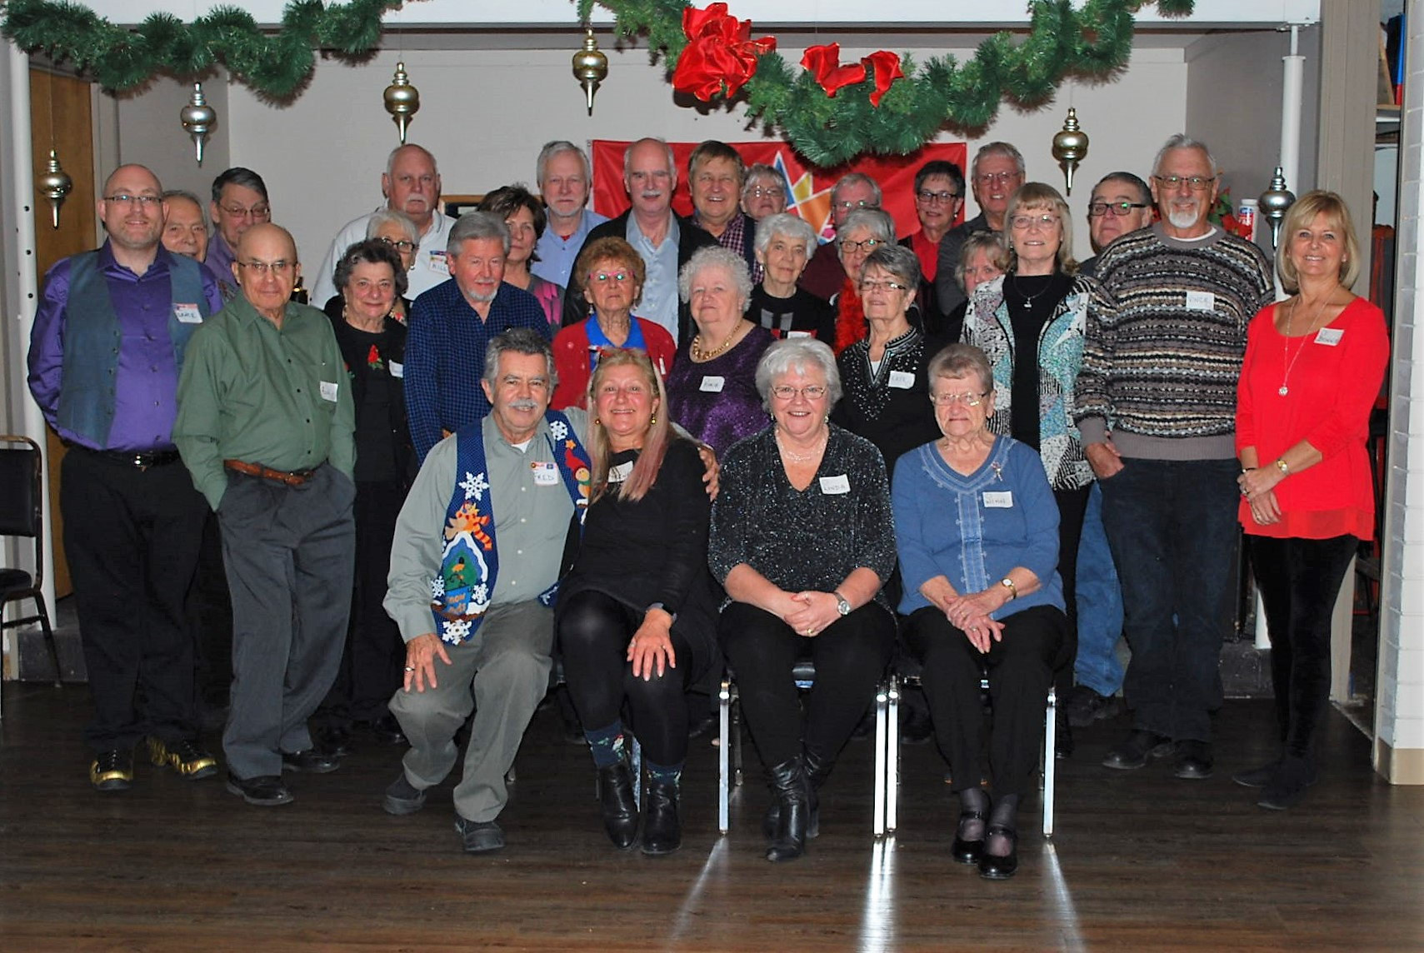

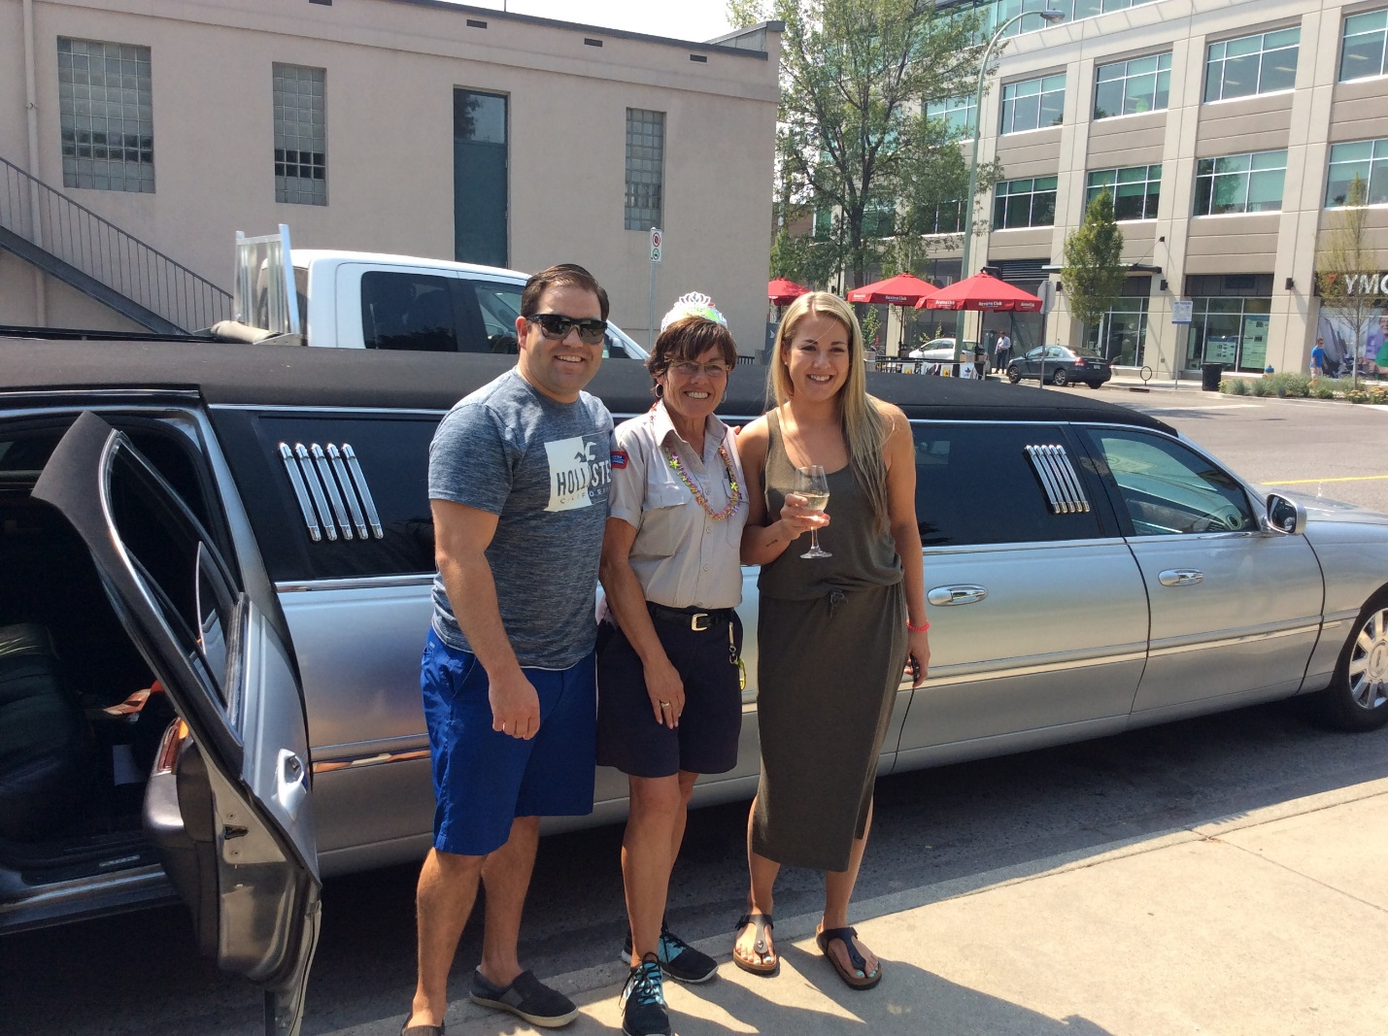

**MARCH 20, 2018 - TUESDAY 12:30**

LUNCHEON AT THE ROYAL CANADIAN LEGION, 1380 BERTRAM ST, KELOWNA.

GOOD LUNCH AT 12:30 AND THEN STAY AND PLAY SOME CARD GAMES AND/OR BOARD GAMES IN THE MAIN ROOM OF THE LEGION. ENJOY A BREW AND GREAT FELLOWSHIP.

**APRIL 18, 2018 - WEDNESDAY 1:00 PM**

SPRING LUNCHEON

OLD SPAGETTI FACTORY 1755 CAPRI ST, KELOWNA.

JOIN US FOR LUNCH AND WELCOME BACK OUR WINTER TRAVELLERS WHO HAVE RETURNED HOME FROM WARMER CLIMES.

**VERNON**

We held a very intimate Christmas dinner with 16 members at the Schubert Center. The winner of the wine raffle was Doreen Johnston. Our Christmas charity was Santa’s Anonymous and we collected a number of new unwrapped toys as well as $85 cash which was presented to them by Gary Fisher. Through a personal donation, we were able to donate $200 to Teen Junction to enable them to take 20 youth to a cultural performance sometime in the new year.

**SOUTH OKANAGAN**

“Welcome to Heather Hutton on her retirement to Princeton.

We held our winter meeting on December 5th at the Cascades Casino in Penticton. We had 16 in attendance at “the Room”. Due to the absence of our Treasurer the Finance report was not available and Mr. Otway forgot to bring the minutes of the last meeting. I passed around the Van Fraser Newsletter to let our members see the trips the have planned for 2018 and if they were interested in any of them let me know and I will follow-up with Fred Dannels Bob Otway and I gave an overview of the changes to the Santa Letter programme and how it will affect Santa’s Helpers. It was going to be a very brief meeting so I asked each of the members to give a brief resume of their time with Canada Post. Some very interesting careers. Lunch was held in “Matches” restaurant. The food was very good as was the service. We had two 50/50 draws of $10.00 each and they were won by Sam/Shirley Grunert and Judy Otway. we put $22.00 into out bank account. Our next meeting will be held on March 20th at Zia’s in Summerland. “

Gil Summerell President South Okanagan Chapter

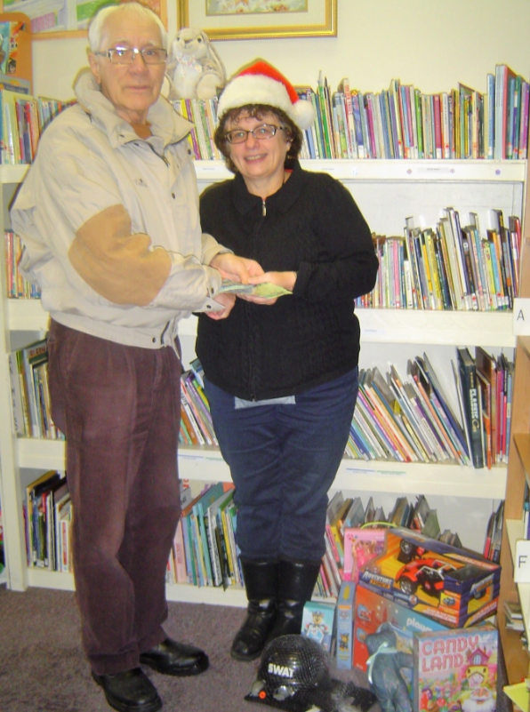

**KOOTENAY COUNCIL**

We were sorry to hear the news that R.J. Warren had suffered a major stroke on October 31. He was sent to Kelowna for rehab and he returned to Nelson just before Christmas, where he will continue his recovery. R.J. has been an active volunteer as President of the Nelson Mixed Slow Pitch and is Chief of Referees for the Nelson Minor Hockey Association. Anyone who knows R.J. knows that he has a great disposition and we are positive that with his outlook, he will make steady progress to recovery. We wish him all the best in 2018.

**MEMBERSHIP DUES**

It is now time to renew your membership with the Heritage Club for 2018. A membership dues form is included in this newsletter. Please make your cheque payable to the Heritage Club and return both to Gary Fisher at the address on Page 1 of this newsletter.

**SANTA LETTERS**

We want to know if you wrote Santa Letters in 2017. We know there are many of you out there and we are anxious to hear from. Thus far we have heard from 3 elves in Kitimat who wrote 120 letters; 4 elves in Prince George who wrote 1400 personal letters and 23 school letters; 1 elf in Quesnel who wrote 421 letters; 3 elves in the Penticton are who wrote 1080 personal letters and 20 school letters and 1 elf from the South Okanagan who wrote 183 letters. Thank you to all our elves for this wonderful gift of letter writing.Please e-mail your information to Gary Fisher at [gwfish@shaw.ca](mailto:gwfish@shaw.ca)

**VOLUNTEER SHEETS**

We will be finalizing our 2017 reports this month, therefore we would like to have your volunteer sheets returned ASAP. This information is passed on to Canada Post and it is very important to them to be aware of the valuable services provided by our Heritage Club members. Please note that this is not a contest or a judgment of you as a member. No names are forwarded to Canada Post, only accumulated hours are passed on.

**DONATIONS**

As the new year begins and with it the start of our Council luncheons and other activities, please remember to bring aluminum foil, pull tabs, stamps on paper and used eye glasses with you to any functions. These are collected and go to various groups. Note: We are NOT saving Campbell Soup Labels and this time.

As well you can help to contribute to the Canada Post Community Foundation by purchasing the Canada Post Community Foundations stamps. The extra $1 paid for a booklet of these stamps goes directly to the Foundation. The Canada Post Foundation for Children makes a real difference in the lives of children and youth in communities across Canada by helping local organizations, charities and schools. The Foundation has provided millions of dollars to build libraries, create sports and breakfast programs, and ensure access to crisis lines, anti-bullying and mental health initiatives, special needs clinics and life-skills training. The money has helped promote physical activity and play for children of all abilities and helped at-risk youth. Canada Post employees do their part by holding fundraisers and making donations through the Dime a Day payroll deduction program. The rest comes from customer donations and sales of the fundraising stamps.

**BANQUET**

MARK YOUR CALENDARS! 2018 is our Banquet Year! The event this year will take place in Vernon at the Prestige Hotel on September 10, 11 and 12. Please note that we have changed from a weekend to mid-week, to avoid conflicts with weddings, graduations etc. There will be a Meet and Greet on Monday September 10, Golf Tournament and other activities and our Banquet Dinner on Saturday September 11 and the bi-annual general meeting on Sunday September 12. Our April newsletter will include your Banquet Package with forms and complete information on all the activities. Please note that you will only receive the April newsletter if and when we receive your membership dues. Your dues entitle you to receive the three newsletters besides our annual January newsletter.

**WEBSITE & NEWSLETTER**

Don’t forget to check out our web site at heritageclub.ca people helping people Here you will find our newsletters as well as a list of upcoming events. As well, you can visit the pages of the other Heritage Club Chapters across Canada. You may have friends and past employees who belong to a Chapter in an area that you previously worked, and you can see what they are doing.

You will notice a slightly different format in this newsletter.  This is due to the absence of our editor Pam Pfannmueller who, as you can see from the photo, is enjoying a fun, warm winter in Los Aroyos Verdes, Bucerias, Mexico. We would like to thank Pat Rogers of Vernon, who graciously volunteered to help put together this newsletter in Pam’s absence. Vivian Davis will be travelling down to visit Pam and bring her back to us in the spring. We miss you Pam. Take care and have a wonderful winter.

**BEREAVEMENTS**

Our belated condolences go out to the families of the following, who passed away in 2017: **Lloyd Claffey’s wife Edna** from Vernon; **Sonja Lemay’s brother Rob** from Salmon Arm; **Victor Kazimer’s brother Andy** from Vernon and **Joyce Kennedy’s husband Bill** from Terrace.

We are very sorry to announce the passing of one of our Founding Members, **Robert ‘Pat’ Fennessy** on Christmas morning. Bob’s postal career grew along with the growth of Cranbrook in the sixties and seventies. He began there in 1948 at the age of 20 and by the time he was 28, he was appointed the youngest Staff Postmaster in western Canada. Major work accomplishments included converting Cranbrook to terminal office when mail transportation went from train to truck in 1957, and the inauguration of letter carrier delivery in 1966. Bob retired in 1985 as area postmaster and the end of 37 years of varied and dedicated service to the postal system. An active member of the Cranbrook community, Bob was president of the Rod and Gun Club, coached minor hockey for several years in mid career, and was involved in the Lions Club for many years. He helped organize the Heritage Club and was the first president of the Yukootok Chapter.

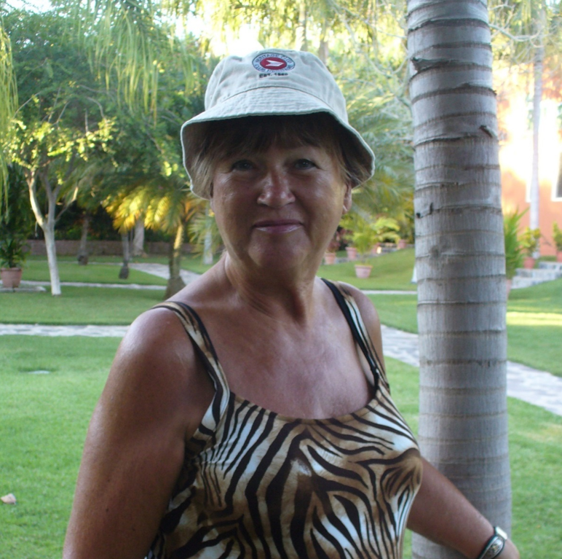

Pam Pfannmueller in Mexico