Chapter 29 Executive

CENTRAL YUKOOTOK HERITAGE CLUB

Newsletter #28 January, 2016

Council Presidents

President: Gary Fisher
101-3606 25th Ave
Kelowna- Angelee Skywork 250-868-2656
Penticton-Gil Summerell 250-495-3350
Vernon, B.C. V1T 1P3 | Prince George-Corinne Printz | 250-964-7479
gwfish@shaw.ca  250-545-6375 | Vernon- Bill Blair | 250-545-7075

Heritage Club web site: heritageclub.ca/people helping people

1st Vice President- Bill Blair
2nd Vice President-Gil Summerell
Secretary-Wanda Fisher
Treasurer-Ed Ewanchuk
Newsletter-Please note new phone number Pamela Pfannmueller * 250-446-2331 pubbajean@gmail.com

President’s Message:

Happy New Year. I hope you had a good Christmas with family and friends and are welcoming in the NewYear in good health.

If you have not gone south this winter, these cold months are a time to find comfort at home, with books, movies and games. And of course, there is no better time to sit down and fill out your 2016 Membership Dues form! This will ensure that you receive the other three annual newsletters which will keep you abreast of all the happenings within the Heritage Club.

Personally, I am looking forward to seeing you at our various functions this year. These especially, include our planned visit to Whitehorse and Dawson City in July, and our bi annual Banquet weekend in Penticton September 16th – 18th.

Once we have soldiered through the cold months, the spring and summer months will bring sunshine and you will need to protect your head and ears with one of our exclusive Heritage Club hats. Some of us with thinning crowns will certainly be in need of this! Therefore, be sure to get your order to us in plenty of time so that you can be sporting one of these useful dome covers for your walking, gardening, golfing, fishing or just sitting in your favourite lawn chair!

Take care and I will be in touch again in April. Regards,
Gary Fisher

Pg 2

COUNCIL NEWS:

Vernon Council:
Our Christmas dinner was held on December 15 with 21 members enjoying a three course turkey dinner. There was a silly Christmas trivia quiz and following dinner Kathy and John Froese lead everyone in some Christmas carols. A wine raffle was won by Sophie Kniaz. The raffle netted $55.00. Door prize winners were Jean Haug, Nancy and Patrick Wilson, Ron Rogers and Vivian Davis. Everyone contributed to our Santa’s Anonymous charity by donating a trunk load of new toys and knitted items as well as $90.00 in cash. These were presented to Santa’s Anonymous by Council President Bill Blair.
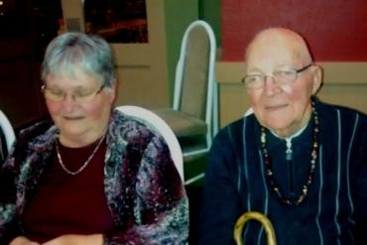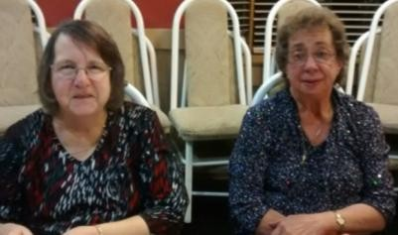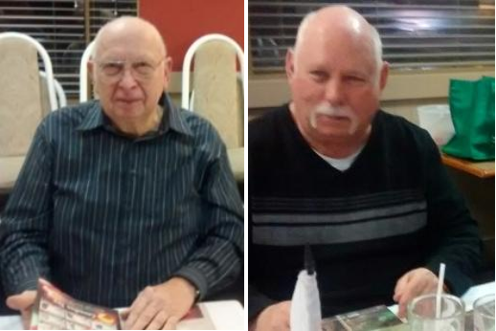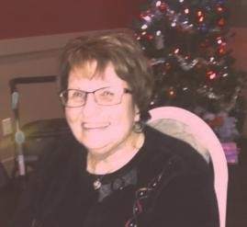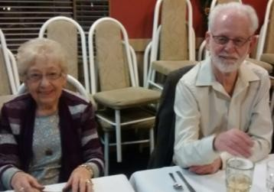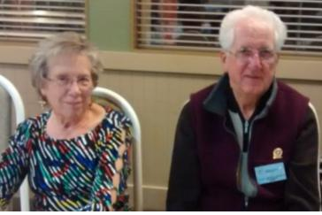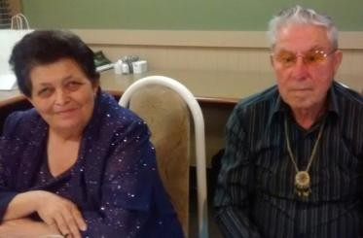Our next lunch will be on Thursday February 18 at Asian Avenue at 12:00 noon. The cost is $16.00 per person, all inclusive, not including tea and coffee.
Submitted by Wanda Fisher

South Okanagan Council:

Fifteen members attended our Christmas get together at Troy’s Grill in Osoyoos. We had a discussion about insurance issues regarding cancellation on 41st day of coverage due to ‘prior condition’. We welcomed Pam Pfannmuelller to her first meeting since her move. Pam has offered to hold a barbeque at her home in Rock Creek this coming summer, an idea that met with positive comments. Our next luncheon meeting will take place in Penticton on March 8 at the Bear’s Den. Submitted by Gil Summerell

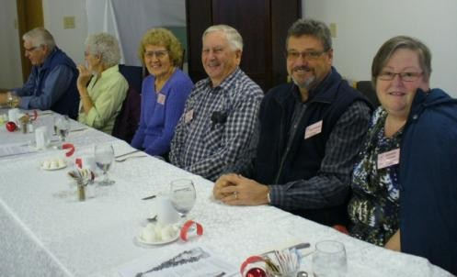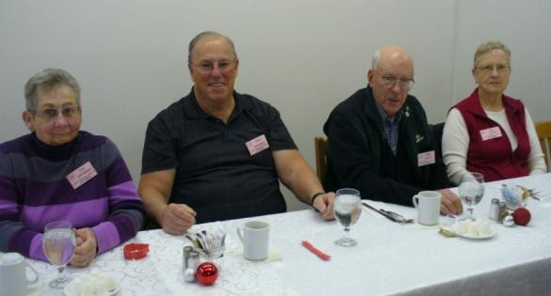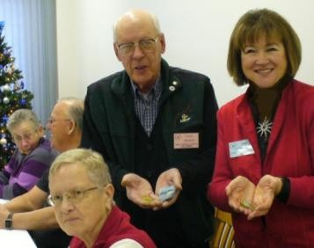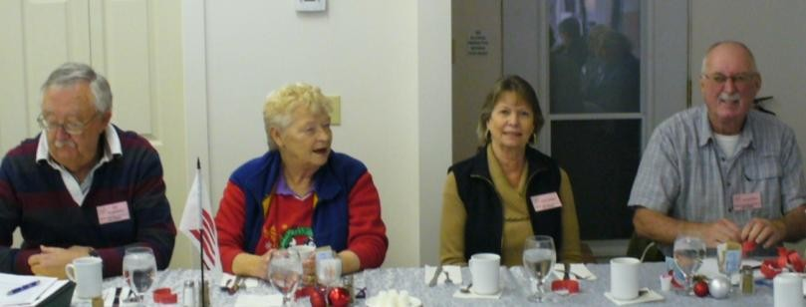Lucky 50/50 winners Frank Wernick and Pamela Pfannmueller

Pg 3

Kelowna Council:

We tried a number of different things last year, as follows:
Luncheon in February, Golf and supper afterwards at Aspen Grove in Lake Country; Lawn Bowling in June; Picnic in July and then an organizing luncheon October and a great Christmas Banquet in December where we had 31 members in attendance.
It is with great sadness that we just learned of the passing of one of our members, Dorothy Dymtruk on December 30,
2015. She had a great time at our Annual Christmas Banquet and often attended our luncheons as well. Thank you to all members who support our events. Look forward to another great year coming up.
Fred Jarvis Heritage Co-ordinator.

Prince George Chapter

We couldn’t catch up to our president to plan a fall get- together, but eventually, the ‘lost was found’, in her “other mission”. Corrine and husband Dale are very busy during November / December with various events to star in. Pat Kinsley spear-headed a get together with a number of retirees, some Heritage members, some not, and answered an estimated 1500-1800 Santa letters. A few of us got together at Tim’s a couple of times, some gathered at a home, more done individually. Much appreciated by management, who cooperated and helped magnificently!

Blast from the Past:

Picture courtesy of The Prince George Citizen. Submitted by Lyn Murphy
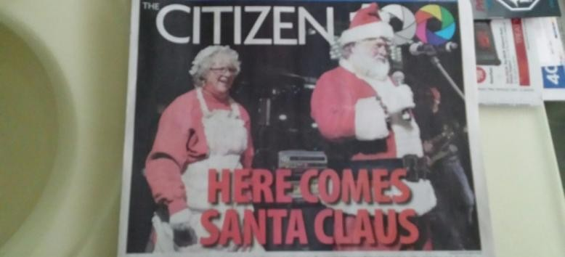
Postal Inspectors: trench coats and wide brimmed fedoras, back alley chases, late night fog shrouded stake outs? Perhaps in a Sam Spade novel, but not in real life. “Postal inspectors are a breed apart and yet working stiffs just like any body else”, said Henry Bloom, of chief investigation headquarters, back in 1979, when he retired.

Henry joined the post office in 1940. He applied for the job of Postal Inspector because he did not want to be desk- bound. “I talked to the people who worked in the department’s inspection service, and liked what I heard. I was fortunate enough to be taken on and I never left”, he said. He learned everything about his job by being paired with different inspectors. During his field operation days, he travelled from coast to coast and to the United States.

Henry dispelled romantic notions about the work. “It was a job”, he said. “We were never out to ‘get’ anybody. “It was just a lot of hard work getting facts that would stand up in court.” In the last century, postal inspectors were responsible for the observance of postal law and regulations, the establishment of new offices and routes, financial audits, the investigation of robberies and abstractions, inquiries into complaints of misconduct, making regular visits to each post office and generally overseeing the performance of postal service. Over the years, powers and duties have evolved and, in some instances, tasks have been transferred to other functions. In general, the duties of today’s Postal Inspectors are to promote and maintain effective preventive security measures and programs for the protection of employees, the mail, corporate assets and values, and the management of information at postal facilities.

On of the department’s finest achievements, Henry believed, was getting postal administrations around the world to work together to control terrorism through the mail. “Postal Inspectors are as old as the postal service in Canada”, he said. “There was, and is a need for people with good judgment and discretion”, he explained, “because the handling of mail holds a certain fascination for people with a bent for larceny. Somebody has to protect the mail and the Post Office’s business from those who would tamper with it”
By Maurice Lablanc, 1994

Pg 4

Today: Canada Post has a team of Postal Inspectors—the first investigative body established in Canada in 1772. The team helps protect the mail by advising on security requirements, investigating reported incidents of mail theft, damage to Canada Post property, fraud, threats to employees, corporate policy violations and mail-related criminal offences, including those which are tied to Identity Theft/Fraud. You can visit the Postal Security Center for more information at: www.canadapost.ca/cpo/mc/aboutus/corporate/security/default.jsf

CHAPTER NEWS:
If you have not done so, please send your volunteer sheets to Gary Fisher by mail or e-mail ASAP. We cannot stress the importance of these sheets enough. The information obtained from the sheets is relayed to Canada Post Corporation and indicates to them, the valuable role that retired and long service employees of Canada Post play in keeping our communities alive.
2016 Membership Dues forms are included in this newsletter. Your Membership dues assist us in operating the Chapter, such as putting out the newsletters, subsidizing our banquets and making those all -important donations. Membership entitles you to discount rates with Johnson Insurance and Good Life Fitness. As well, you will receive three more newsletters in April, August and November. You will definitely want to receive the April newsletter particularly, as this is a Banquet year and the Banquet package will be included in this issue. The package will include forms and complete information regarding the event which will take place September 16 – 18 in Penticton, at the Days Inn & Conference Centre. Bob Otway and Gil Summerell are heading up the committee. Bob is urging everyone to book their hotel rooms as soon as possible at 1-250-493-6616. When you call for your reservation ask for the Heritage Club block. The weekend will include a free Meet & Greet on Friday 16th. On Saturday the 17th, our Annual Chapter Golf Tournament will be held, as well as other activities for non golfers. The evening of the 16th will be the Banquet dinner. On Sunday the 18th, we will hold our bi annual general meeting.
Gary Fisher informs us that he has in his possession, quite a few membership cards waiting for registered members to receive once they have paid their dues and become an active member. So don’t let these cards continue to take up space in the filing cabinet, submit your dues and become an active member! So get your memberships working for you for your travel, house insurance and fitness needs!

SANTA LETTERS:
This year we did 1553 Santa Letters for the South Okanagan . This includes letters from Princeton which we have done for the last 10 years or more.
Of these, 149 were French. I want to thank the two students from the French immersion class at the Penticton Senior Secondary school for their assistance with the French letters. The volunteer time they put in gives them credits for a trip to Africa that is being sponsored by big business. They were supervised by myself and one of the mothers during the volunteer time.
I also want to thank Cal and Wilma Hornby, Judy Otway, Marilyn from the Main Post Office and Brian and Lorraine
Budzinski who did Summerland, all for their excellent work.
The schools were awesome, having all the classes ready with printed class names. I picked up all the schools and delivered them all back.
One teacher sent a letter to Santa saying that he did not want a Porsche, but would just like to borrow one for a day to race up and down Naramata Road. Santa replied that the Porsche was his favourite car, but his sleigh was a hell of a lot faster. Submitted by Bob Otway
Overall for the Chapter area, of the people who have reported from Kitimat, Prince George, and Quesnel, we answered
5005 letters, with 21 people participating at a total of approximately 400 hours. Bereavements:
We would like to extend our sincere condolences to the family of Karla Howard of 100 Mile House, Williams Lake and
most recently, Kamloops and to the family of Hazel Docksteader of Vernon.
We are also very sad to hear of the passing of Dorothy Dmytruk on December 30, 2015. Dorothy enjoyed the Kelowna Christmas Party on December 10 and her death comes as a shock to us all. Dorothy has been a long time member of the Heritage Club since its beginning in 1989. Her husband, Norm, was a much loved and respected President of the Heritage Club from 1994 – 1996.

Pg 5

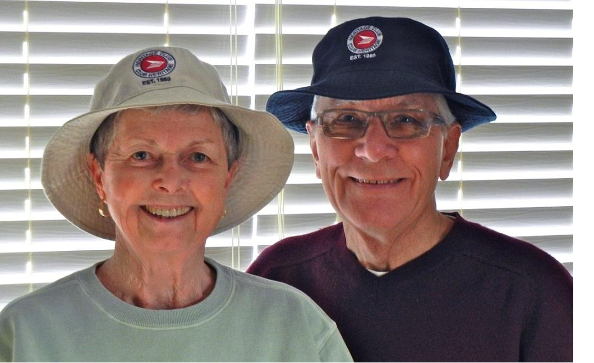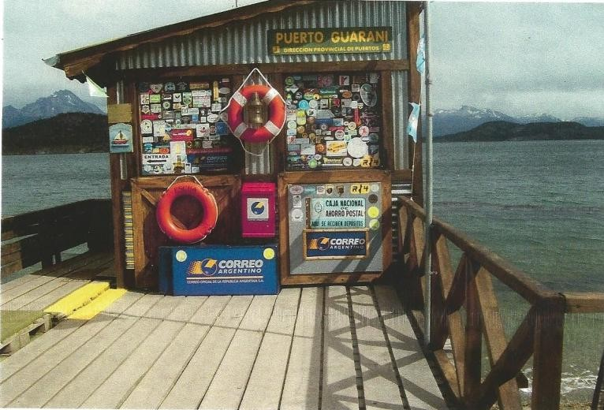

Gary and Wanda Fisher are shown sporting the new Heritage
Club 'Fundraiser' Hats.

Grandpa’s Post Office
By Elinor Florence

Here is a fun little photo which is the Southernmost post office in Ushuaia, Argentina. Submitted by Wanda

When I was growing up, the post office was more than a place where we got our mail -- it was almost a second home.

I grew up on a farm near Battleford, Saskatchewan where my mother’s father Charles Light served as postmaster. Every time we went into town, we would visit “Grandpa’s Post Office” where we were allowed to come behind the counter, play with the stamp hammer, and inhale the wonderful smells of paper and ink.

If we heard someone come into the lobby and unlock their mailbox, we would (if Grandpa’s back was turned) make faces at them through the open back of the mailbox and scare them!The post office was actually Great-Grandpa’s Post Office first, although he died when I was still quite small. My great-grandfather Frederick Light was the postmaster until my grandfather came home from the trenches of France in 1919.

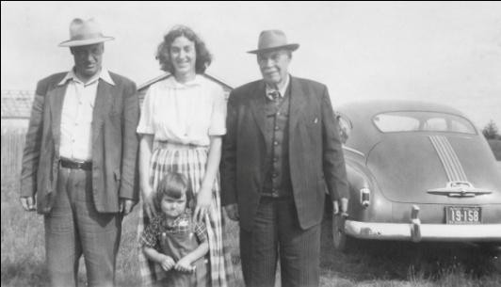Before the war, Charles had worked for his father in the post office and found it utterly boring. He could hardly wait to join up. But after five long years serving with Lord Strathcona’s Horse, and having been wounded twice, he was very happy to settle into a regular job!And after Charles married and had a family, his wife Vera and all five children, including my mother June, worked in the post office, sorting mail – the third generation of Lights to work in the post office.

Here’s a photo of three generations standing: Charles, June, and Frederick. I’m
the little girl, and I see by the licence plate on the Pontiac that this was taken in 1954.

Battleford is a small town, although it enjoys the distinction of being the former capital of the Northwest Territories, which at the time included all of Saskatchewan and Alberta. During its heyday, before the railway was installed
on the other side of the Saskatchewan River and North Battleford sprang up, some beautiful public buildings were constructed, including the red brick post office built in 1911.
During the 1920s and 1930s, my grandfather wasn’t rich, but he had a steady government income which saw his family
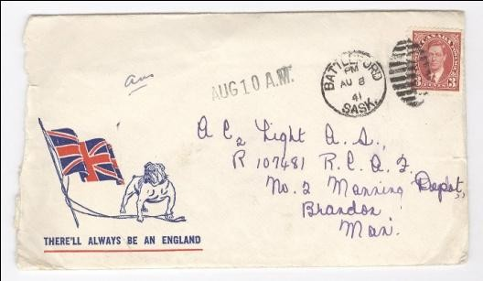through the Depression.When war broke out, suddenly the volume of mail increased exponentially as the boys left for their training in other parts of Canada, and then for overseas.

Mail was a lifeline to the home front. My mother June recalls writing letters until her hand cramped, some of them to boys she scarcely knew. Here’s a letter she wrote to her brother Alan Light, training with the Royal Canadian Air Force in Brandon, Manitoba. You can see he wrote “ans” on the top left corner to remind himself that he had answered.

Pg 6

And people sent hundreds of parcels overseas, containing newspapers, hand-knitted socks and scarves, soap, dried fruit and candy. They were wrapped in heavy cotton fabric and sewed shut with needle and thread. The addresses were inked on the surface of the cloth with a fountain pen.

My grandfather’s income rose during the war, because he received a commission on stamps. He also paid his assistant’s wages out of his own salary, so it was to the benefit of the whole family when the children were old enough to become unpaid helpers.

My mother June Light, who is 91 years old and lives near me in Invermere, B.C., recalls: “Dad’s brother, my uncle Fred Light, owned the Lighthouse Service Station in Battleford across the street from the post office. He had the contract to pick up the mail bags from the train station in North Battleford, across the river, every evening at 8:50 p.m.

“Dad would wait until the mail arrived and have it all stamped and sorted before he went home at night, so people would have it first thing in the morning. He didn’t get home until about 10 and then he was back in the post office the next morning at 7, ready to open the doors to the public at 8 a.m. It was a long day, but he always took a two-hour lunch break and had a nap.”

The importance of mail wasn’t lost on the First War veteran. He knew all the families in town who had boys overseas. If
he saw that one of them had sent a letter, he would deliver it himself on his way home from work.

Letters were stamped with the time and date using a steel hammer. According to my mother: “My Dad could stamp letters faster than anyone. We were always trying to keep up with him, and once in a while we would stamp our thumbs. I even lost a thumbnail once!”

One of the benefits of being the postmaster is that you were the first person to receive your own mail. Once my grandfather’s friend wrote him a letter that had nothing on the envelope but a drawing of a light bulb instead of his name, Mr. Light.

Another benefit for the local postmaster was having first choice of mailboxes. For decades, the Light family mailbox was Number One. And after my grandfather died, the mailbox was inherited by my mother’s eldest sister Peggy. My Aunt Peggy’s address was Number One, Battleford, Saskatchewan until the day she died in 2001.

In 1987 Canada Post commemorated the post office with its own stamp. Today the future of the post office is in question, as Canada Post struggles with declining revenue.

Obviously I’m hoping there won’t be any reason to demolish this handsome brick building, which to me will always be
“Grandpa’s Post Office.”

Elinor’s wartime novel Bird’s Eye View. This book is especially
appealing to postal
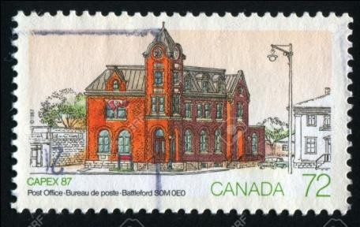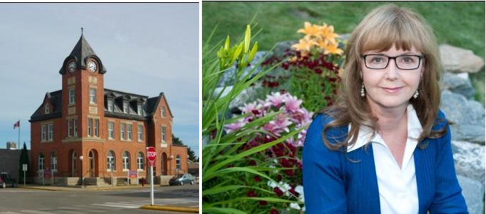history buffs!

Career journalist Elinor Florence grew up on a farm in Saskatchewan, a former World War Two training airfield. She worked for newspapers and magazines including Reader’s Digest before turning to fiction. Married with three grown daughters, Elinor lives in Invermere, B.C. Read more about Elinor, and visit her blog called Wartime Wednesdays, at
www.elinorflorence.com or email her at elinor1@telus.net.

Moving: Please, please let us know when you move! There are many extra costs incurred when mail is returned, when we have to locate the individual and resend the mail.

