**Bluewater Chapter**

**NEW YEAR EDITION**

# HERITAGE CLUB

**est. 1989   |   People helping people**



# President’s Message

Happy New Year from our family to yours!

Bluewater Chapter had a fantastic 2019! This is because of YOUR involvement. We have new members, we have been able to donate to several worthy causes, had social gatherings such as luncheons and our golf outings, we made the local paper and most recently a group of us participated in the Santa Letter Writing Program. We have lots more in store for the NEW YEAR ahead and we are hoping that YOU WILL JOIN US.

We wish you the very best this coming year and look forward to seeing you.

Bob Emmons,

Bluewater Chapter President

# Santa Claus, Mrs. Claus and his Bluewater Elves

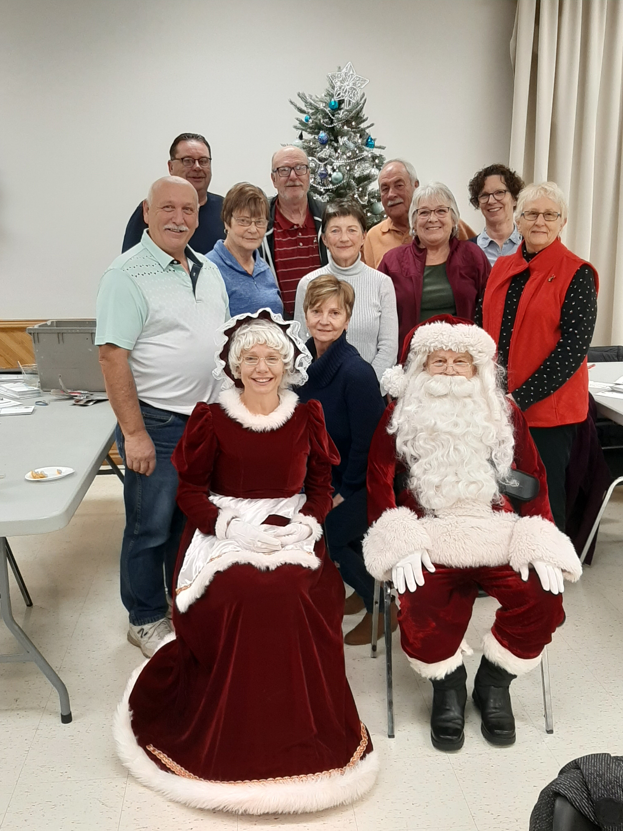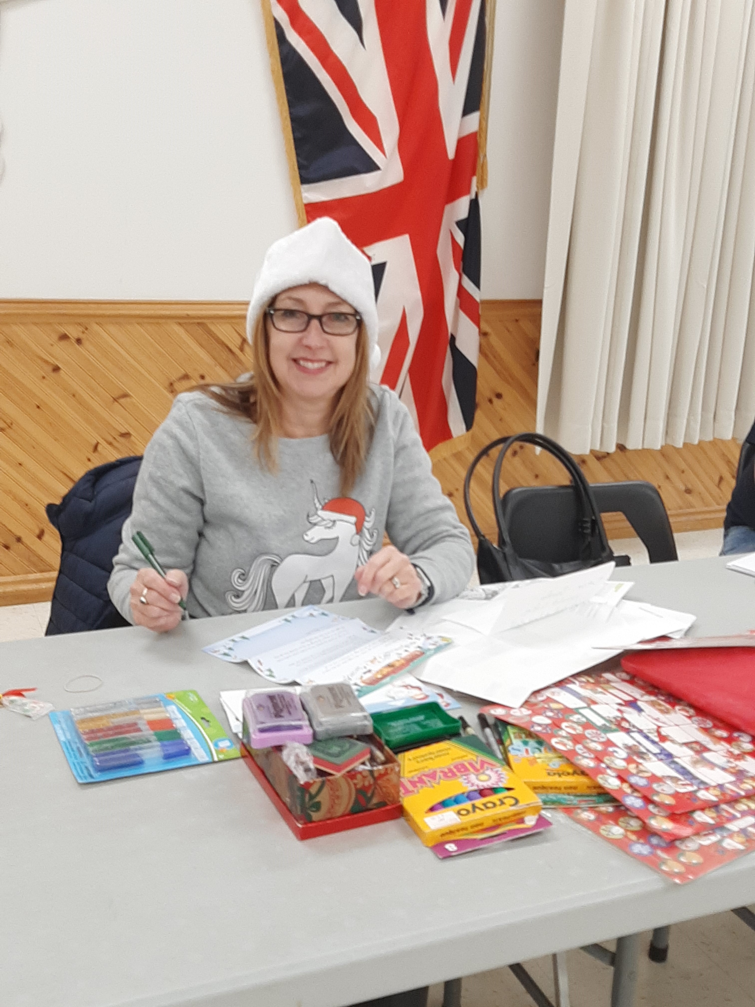

Special thank you to Santa’s helpers this year:

Mike and Linda Belchuk, Connie and Bill Lamb, Andrea and Bruce Krale, Lyle Drouillard, Carmel Lebert, Mary Ellen Bryden, Marge McDonald, Jo Anne Garon, Carmen Starnichuk and Mr and Mrs. Claus

# RING IN THE NEW YEAR

# Membership Luncheon

Please join us at

CASCADES CHATHAM CASINO

**615 Richmond St, Chatham, ON N7M 1R2**

**ON January 17, 2020**

**AT 12 noon in front of The Buffet**

This invitation includes your spouse or significant other. We need to make reservations ASAP. Please let us know that you will attend no later than January 13, 2020. To RSVP please email Holly Perreault at [heritageclubmembership@gmail.com](mailto:heritageclubmembership@gmail.com)

**If there is enough chapter interest, we would like to book a bus trip to the Huron County Playhouse.**

**Email Holly Perreault if you are interested and we will make this happen.**

**February Coffee Social**

**Please join us at**

**Tim Hortons on Manning Road and EC Row**

**At 10:30am on**

**February 21, 2020**

**Obituaries**

**It is with heavy hearts that we announce the passing Barbara Mitchell**

**We send our sympathies and condolences to her family and loved ones.**

**Your Benefit Contact Numbers**

**Canada Post Pension Site: 1-877-480-9220**

**Govt. of Canada Superannuation: 1-800-561-7930**

**Canada Pension Plan/Old Age Security: 1-800-277-9914**

**Great West Life Assurance: 1-866-249-5723**

**Sun Life Insurance: 1-800-361-6212 CPC**

**Human Resources: 1-877-9090**

# Heritage Club Scholarship Program

# Congratulations to the 2019 winners of the Heritage Club Scholarship Program. The winners were from the Pineridge, Van Isle and Heartland Chapters being recipients of $1,000 each. Deadline for the coming year’s applicants is June 30, 2020. In order to be eligible, students must be dependent children, including adoptive children, stepchildren, grandchildren and wards in legal guardianship of an active member (dues paying member of 2 years) of a Heritage Club Chapter. Details are on Heritage Club Website under “ links” or contact [holmese@ntl.rogers.com](mailto:holmese@ntl.rogers.com)

# Yearly Dues Benefits

1. As a paid member of the Bluewater Chapter, you and your spouse/partner will be entitled to purchase a membership to Good Life Fitness at approximately 50% reduction in cost.

2. Special rates for Johnson's Medoc Travel Insurance are available for Bluenose Chapter members in good standing. (Dues paid for the current year)

3. National Heritage Club Scholarship Program. Three scholarships will be available to the children and grandchildren all dues paying members ( two years)

4. Preferential quotes for home and auto insurance from Johnson Insurance

5. Special rates with Choice Hotels

6. Travel discounts with Collette Tours

7. Cell Phone deals with Telus More information on all of these benefits can be obtained on our website,

[www.heritageclub.ca](http://www.heritageclub.ca)

# Membership Renewal REMINDER

If you have not already renewed your Bluewater membership, you may do so by sending your Annual $10 dues to for 2020:

Mike Belchuk, Vice President

143 Brien Ave East

Essex, Ontario

N8M 2P2

This membership due entitles you to our various discounts. If you are not sure if you have paid your 2019 dues, you can again, contact Holly Perreault.



If you have recently moved or are planning a move, please let us know, so that we can keep our information up to date.