Yellowhead Heritage Club November 2016
Our Heritage Travel Companions
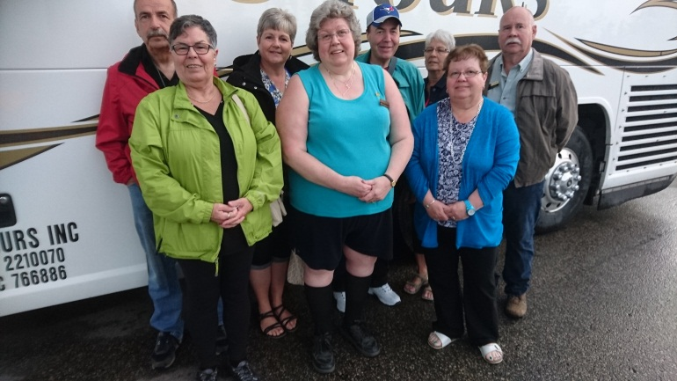
Hello everyone. Our Maritime adventures were amazing! I hope some of you were able to follow along on Face Book. We were very happy with RYJO Tours. They put together a great tour and we saw so much! The hotels were top notch and the food was fabulous including a 60 foot buffet overlooking Niagara Falls! I can’t think of a single negative thing to say about RYJO. It is our plan to travel with them again in the future.
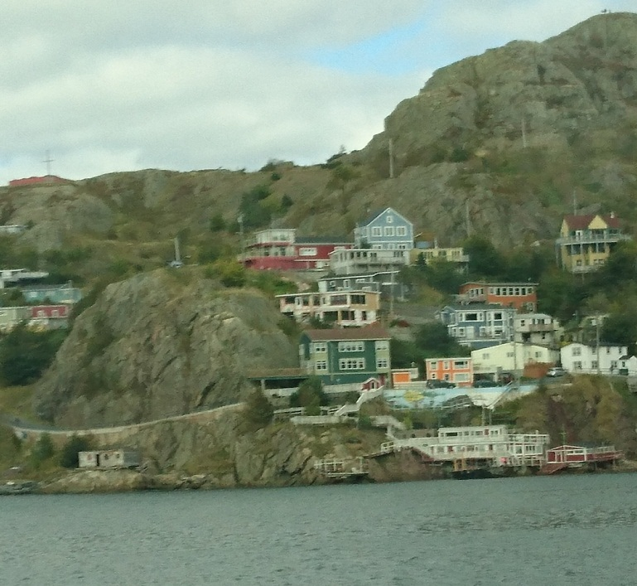
St. Johns, Nfld.

Christmas Party: Saturday, December 3rd, 2016:
Please come and join us for a catered turkey dinner and all the trimmings. This event will be held at 831 Delaronde Way. Please bring a $10.00 gift for our gift exchange and mark it male or female. Wine and beer will be provided. The cost of this event is $17.00 for paid members and $20.00 for non- paid members. Please RSVP by November 28th to Heather Spence (306-955-1408). Cocktail hour will begin at 5:30 pm; dinner will be served at 6:00 pm. See you there!
Legion Steak Dinner; Friday, Nov. 25th, 2016
Place: The Legion on Arlington Ave.

Dinner Menu:
Strip loin Steak
Baked Potato
Garlic Toast
Caesar Salad

Dinner: 6:30
$20.00 per person
Please RSVP to Heather Spence by no later than Nov. 19th, 2016. Seating is limited.

Santa Letters
Once again the Christmas season is approaching and we are looking for retirees who are willing to answer Santa letters once again. Your specially crafted replies bring such joy and delight to every child’s heart when they receive that letter in the mail addressed directly to them from Santa himself. We continually hear stories about how the children treasure these letters and take pride in sharing them with their families. You, the Heritage Club elves are not only valuable but your kindness is priceless. Santa letters start arriving in late November and pick up from there. We need you to make this happen. Please fill out the form below and reply to:
Santa’s Workshop
817 51st. St. E.
Saskatoon, Sk. S7K 0G9
Or reply to saskatooncpcheritageclub@gmail.com
Santa Letter Volunteer
Name: ________________________________________
Address: _____________________________________
Phone #: _____________________________________
Email: ________________________________________

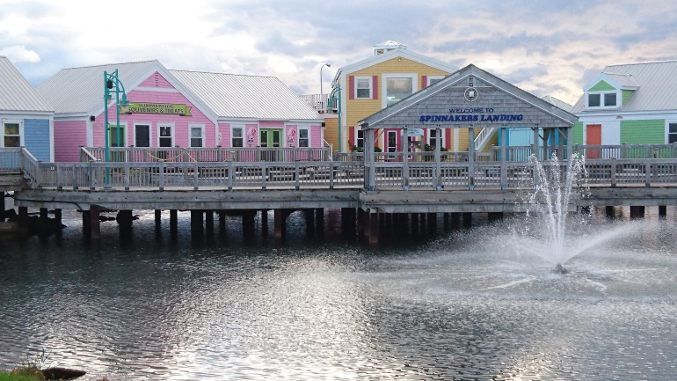
P.E.I.

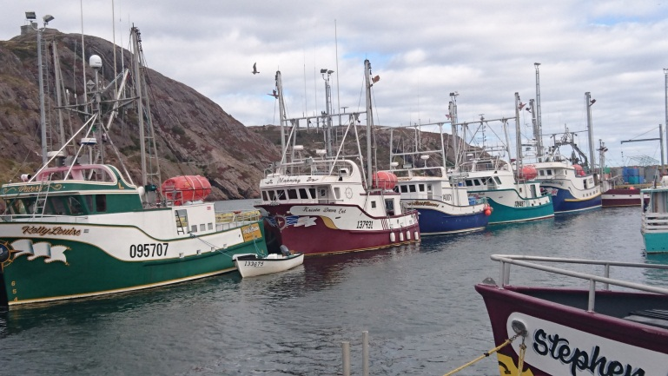
St. John’s Nfld.

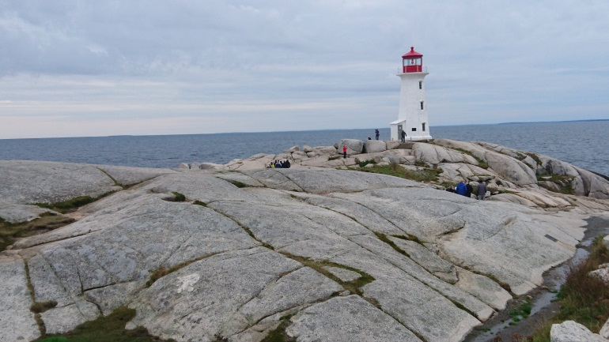
Peggy’s Cove
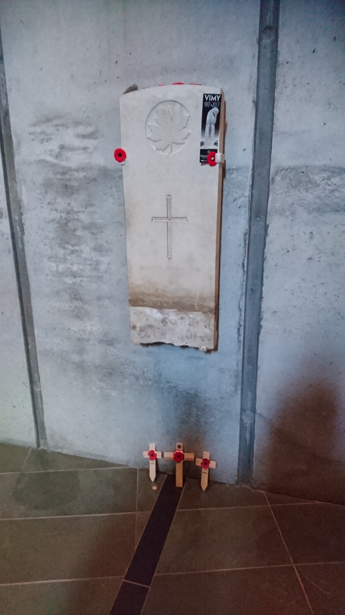
Memorial Hall; Pause & reflect here upon the service & the sacrifice of thousands of Canadians in war & peace. This headstone is from the First World War grave of Canada’s Unknown Soldier and is a tangible reminder of the human cost of war.
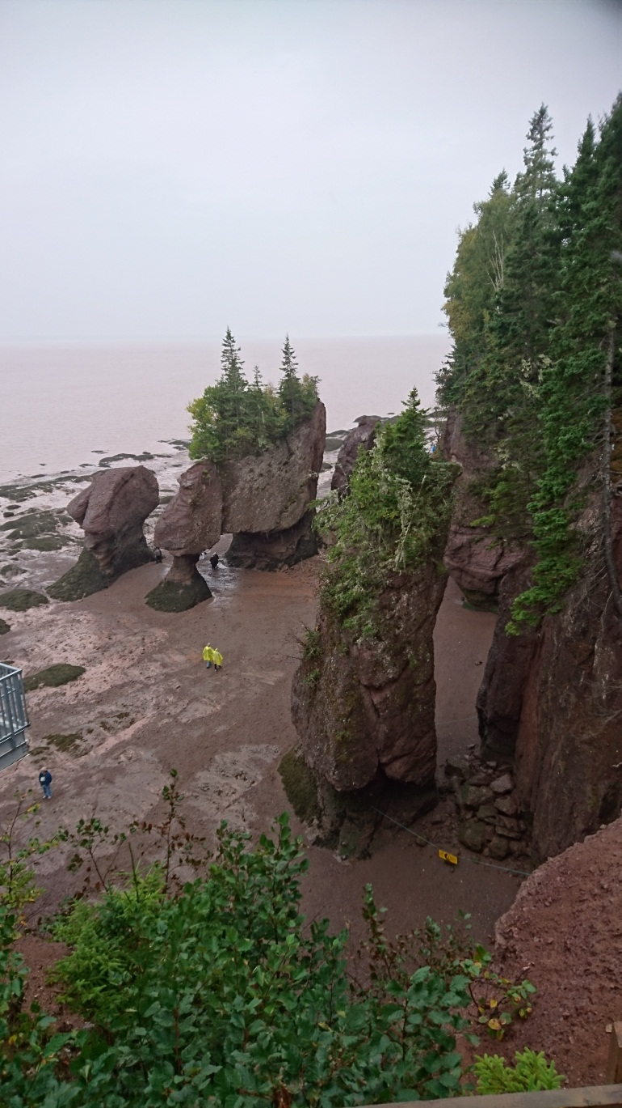
The Bay Of Fundy & The Flower Pot Rocks

Partners For Life – Our Heritage Club is involved with the Canadian Blood Services Partners for Life Program. We have received a certificate recognizing our organizations contributions for 2015! As a member of the Saskatchewan Partners for Life program our organizations was one of 308 partners across the province. These 308 partners pledged 14,304 units and donated 14,764 units for an over-achievement of 103%! Saskatchewan partners brought in 824 new donors. Our Heritage Club has played an important part in ensuring that patients receive the blood and blood products they require for medical treatment. Congratulations to everyone involved. I encourage you to give blood at 1206 Emerson Ave. under the Yellowhead Heritage Club.
A challenge…let’s see if we can beat what we donated last year.

Heritage Web Page – Please do not forget to check out our national web site. Go to www.heritageclub.ca and click on find a chapter. When you click on Yellowhead our site will come up. Here you will be able to read the latest newsletter, learn about any new events coming up and also any monthly events that are happening. So if you lose your newsletter you can use this site so you don’t miss anything! Also please be patient with us as we are just learning to navigate this site as well.

Monthly Ladies Lunch – There has been a slight change with our ladies lunch. We will still be meeting on the first Tuesday of each month. It has been decided that we will meet at different locations. If you are interested in attending please contact Heather Spence a day or so before for the location of the lunch for that month at 306-955-1408
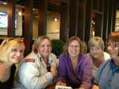 Just a few of our lunch ladies!

Weekly Breakfast (CHANGING DAYS) Our monthly breakfast has now become a weekly breakfast. We will meet every Tuesday morning at 8:30 am at the Smitty’s in Market Mall. We would love to have you drop in and join us!
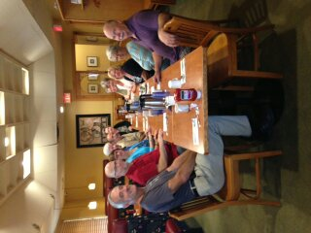
Breakfast Club

Card Club – We meet at 831 Delaronde Way at 1:00 pm. on the following dates:
Thursday, Dec. 8
Thursday, Jan. 12 & 26
Thursday, Feb. 9 & 23
Thursday, Mar. 9 & 23
Thursday, Apr. 6 & 20

If you have any special accomplishments to share in the newsletter give us a call or email. Also if you know of any of our members who are hospitalized or someone who has passed away please let us know. Thanks so much.

Spouses are also encouraged to join.

2017 Membership Fees Due Jan. 1

Membership Application for Heritage Club

First Name: __________________
Last Name:___________________
Gender: ___
Status (Active or Retired): ______
Home Address: ____________________________
____________________________________________________________________________________________________________________________________________
Telephone: __________________
E-Mail: ______________________
CPC Start Date: _______________
Total Years of Service: _________
Membership Fee is $10.00 for one year. Send to:
saskatooncpcheritageclub@gmail.com or mail to Heather Spence at
831 Delaronde Way
Saskatoon, Sk. S7J 3Y8.

Your Committee Members

President:
Heather Spence: 306-955-1408
Vice: Shirley Stewart
Sec. /Treasurer: Maxine McLeod
Members at Large: Robert Lee & Ross Spence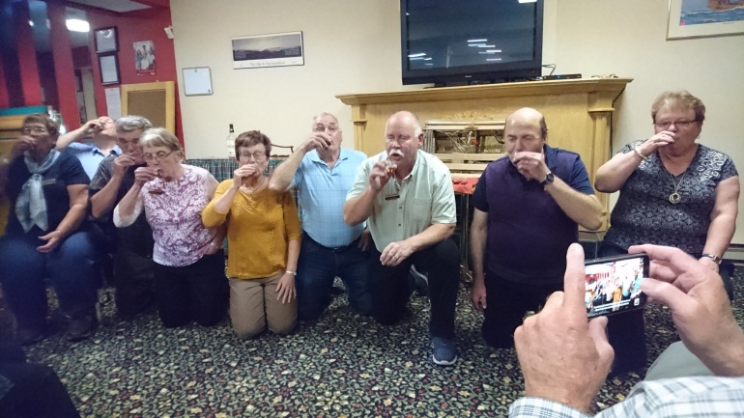
Screeching Ceremony-becoming honorary Newfoundlanders!

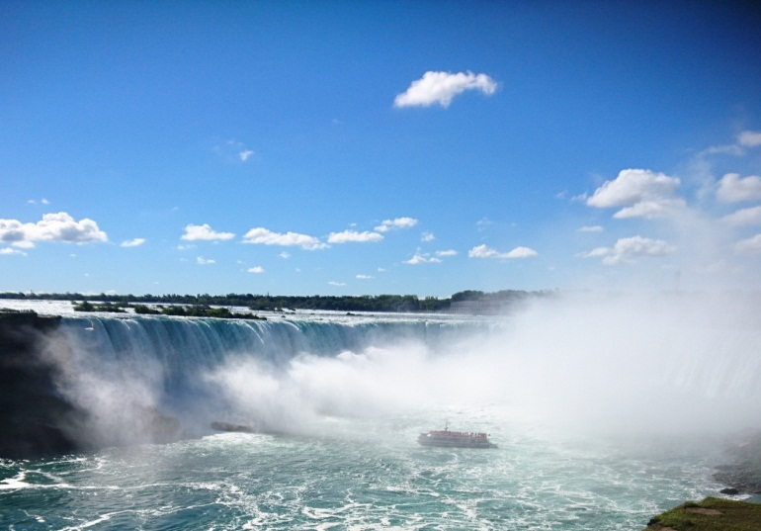
Niagara Falls, Ont.
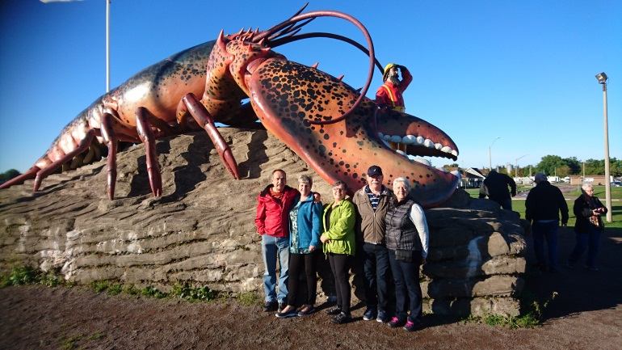
Shediac Lobster, N.B.
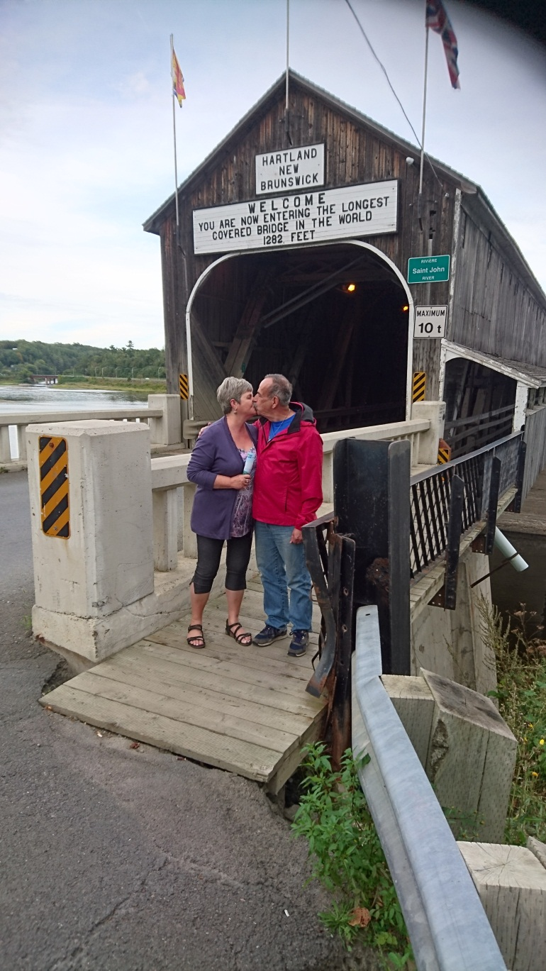
The World’s Longest Covered Bridge also called the Kissing Bridge!

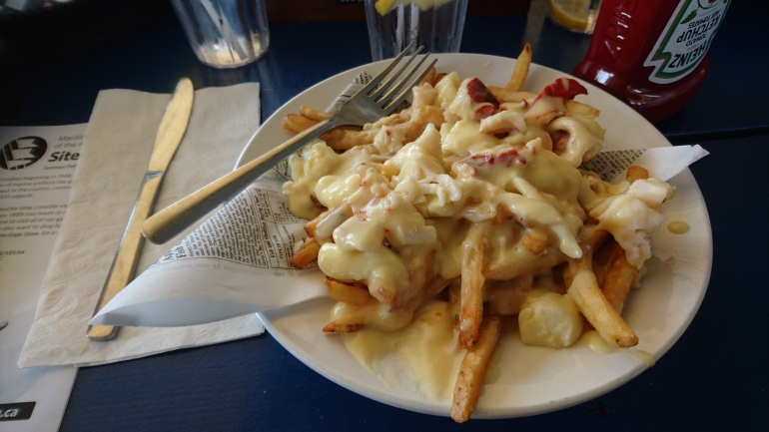
Lobster Poutine in Halifax!

