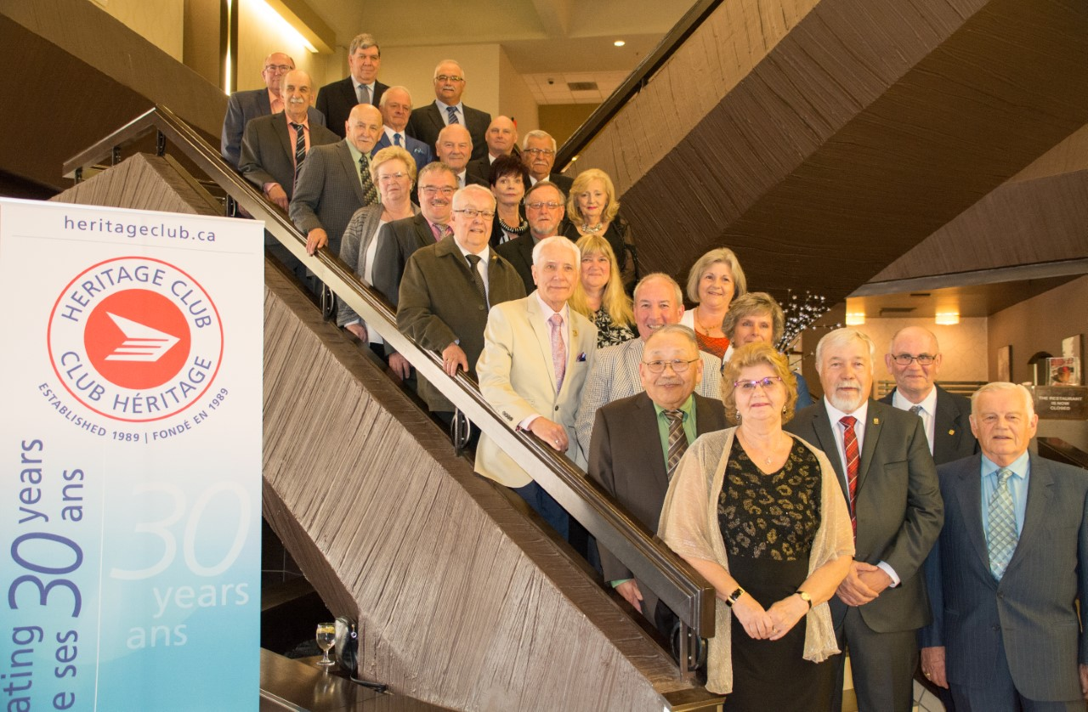
AGA REGINA – 1-4 juin, 2019

(see next page)

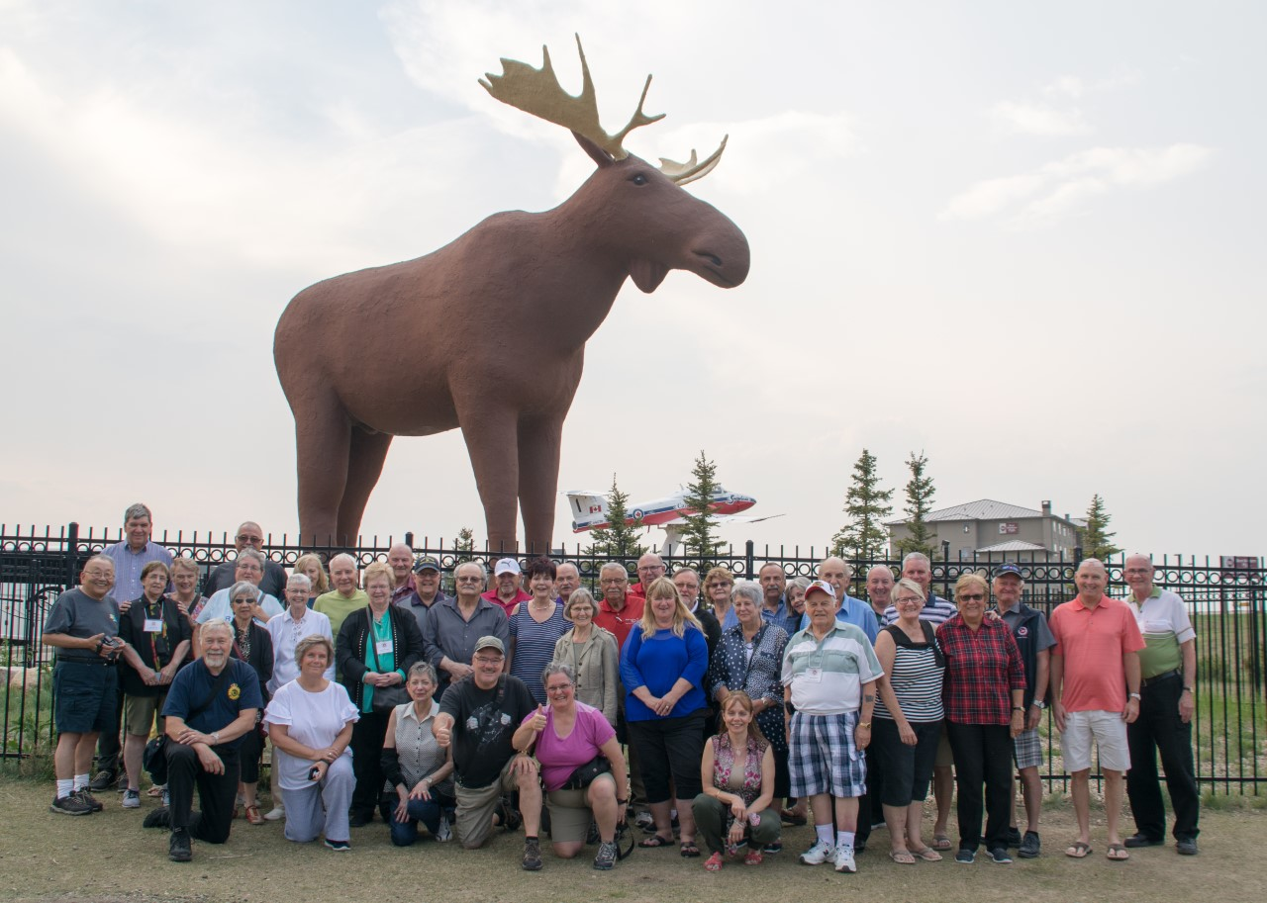
MAC THE MOOSE

