Heartland /Cambrian Chapter Heritage Club
Fall Edition 2018
President’s Message

Where does the time go. There was a time when we seemed to wait for ever for Christmas time or a special birthday. A day seemed like a week and a week like a month. I can remember a time when I thought that once I retired I would have lots of time to do things I had put off doing. Now a week seems like just a day has passed, time seems to speed up as we grow older.

So once again we are writing up our fall edition. But enjoy the fall because soon we will have to turn to shoveling snow.

This past year has been a good one for our club.
Thanks to our members generosity, fund raising efforts, volunteer work in our community. Our Chapter has once again been recognized by the National Executive at our Annual National Meeting. Our Chapter and it’s hard working members have been awarded the Community Service Award for Chapters with over 500 members. A big Thank You to all our active members and friends who continue to support us in our goal “People Helping People.

For example during the period starting late 2013 to 2017, our knitting members and friends sent us, 73 quilts and afghans, 1,027 touques, 848 scarves, 1,491 pairs of mitts, and 309 other knitted items. That’s a lot of knitting, person hours, a lot of wool, but more importantly a lot of people who were warm and cozy during our cold winter days.

A big Thank you keep up the great work
The needy in our community, have you as a guardian angel keeping them warm.

.
Harold Onagi President

Heartland Chapter – Heritage Club
1462 Church Ave.
Winnipeg, Mb. R2X 1G4
(204)987-5010
Email – heartlandchc@gmail.com

Office hours 9:00am to 12:00 noon
Monday and Thursday
Our answering machine will take your message outside of these hours.
………………………………………………………………………..

Executive phone numbers in the event that
immediate contact must be made which cannot wait
for office hours.

………………………………………………………………………………….

Chapter Executive:
President Harold Onagi 832-4398
1st Vice President Gord Arseny 668-6604
2nd Vice President Eileen Hay 222-5412
3rd Vice President Betty Johnstone 253-1325
Treasurer Paul Pelletier 987-5010
Secretary Darlene Fleming 987-5010
Adm. Officer Ed Paleshnuik 253-9464

Activity Councils
Wpg. & Area Buzz Lamond 452-7824
Brandon & Area Murray Sangster 728-7489
T.Bay Nth. W. On. Don Rosengren (807) 345-1624

Newsletter Editor 1st Vice-President
Gord Arseny

Dates to Remember
Fun Golf Sept. 5, 2018
Annual Meeting Sept. 20, 2018
Holiday Party Casino Trip Nov. 27 – 29, 2018
Christmas Dinner Dec. 6, 2018

ANNUAL DUES

Attention to all members: In order to be eligible for active member benefits you must be current with your yearly membership dues. That means $10.00 for the current year must be received in our office and this year’s membership card issued.
A lot of members continue to take advantage of the superb medical travel plan, (Medoc Travel Insurance) offered to members but DO NOT KEEP UP WITH THEIR DUES!!!!
Remember ….. $10.00 could save you thousands, or even more, should you be unfortunate enough to become seriously ill while traveling. Also remember the Provincial Medical you carry does not fully cover you when you travel outside of the province.
To those who are paid up, thank you, and enjoy your worry free travels! To those who are not, better get the cheque written!

2019 FISCAL YEAR HEARTLAND CHAPTER ANNUAL DUES

2019 Fiscal Year (Jan. 1 to Dec. 31, 2019) Heartland Chapter Annual Dues

Dues 2019 - $10.00 Dues 2020 - $10.00

Charity for 2019 - Charity for 2020 -

TOTAL CHEQUE: $ _____________________

Name: _______________________
Address: _________________________
City: ___________________________ Postal Code: ________________________

SANTA’S HELPERS NEEDED

The Christmas season is once again around the corner, and we are getting ready for all the mail that will soon arrive for Santa Claus. Each year children from around the world send their Christmas wishes to Santa. Over the years Canada Post employees, both current and retired, have been bringing joy and happiness to these children, by responding to their letters. We are looking for Heritage Club Members who are willing to spend an hour or two replying to these letters either at home, or at Canada Post.
Each volunteer will receive a package containing suitable responses to choose from, which you can add as a postscript to the letters provided.
If you would like to help spread a little joy and happiness, please contact the Heritage Club at (204)987-5010, or by e-mail at heartlandcpc@shaw.ca, or complete the form below and return to us in the envelope provided.

Name: …………………………………
Address: …………………………………………
Postal Code: …………………………………………. Phone: ………………………………………..

I can answer letters in: English: …………………… French: …………………….. Other: ………………………….
I can answer letters at the Santa’s workshop: ………………………………….
BOWLING 2018/2019
Coronation Lanes 255 Tache, St. Boniface

The 2018/2019 bowling season will start on Thursday, Sept. 6th, 2018 at 1:00 pm. We will be bowling every second Thursday until Dec. 13th, 2018.
Bowling for 2019 will commence on Thursday Jan. 3rd and continue every second Thursday until March 28th, 2019.
This is strictly for fun – no fixed teams. Come and play when you can. Bring a friend or family member. Rates for 3 games and shoe rental will be $7.00.
Hope to see you there!

Buzz Lamond
Activity Coordinator

2018 ANNUAL BANQUET

Hello all! Hoping your summer is a good one!
A good time was had by all at our Spring Annual Banquet. 76 people attended. There were 3 new attendees and 1 guest. As usual the food was great! The 50/50 draw was won by Betty Johnstone, Barb Zayac and John Gifford. Ray Hince won the coin. The Tin for the Bin donations went to Agape, and as usual you were very generous with food items. The applications for the Annual Meeting, Christmas Luncheon and Southside Golf Tournament are in this issue, please make a note of the dates. Hoping to see you at one or more of these occasions.

Eileen & Betty

2018 ANNUAL MEETING

Tickets for the September Annual Meeting Luncheon at the Royal Fork will be $10.00 per person, and the Christmas Luncheon tickets will also be $10.00 per person. This price includes spouses or significant others. If there is neither of these, please feel free to invite a guest at the same reduced cost. However extra tickets will be the usual price of $15.00 for September and $20.00 for Christmas.

Eileen & Betty

SOUTHWEST MB. ACTIVITY COUNCIL

In the first six months of 2018, we have held a luncheon meeting on the first Tuesday of the month. For June, we went to Lee’s Chinese Restaurant where we enjoyed a buffet lunch.
We don’t hold meetings in July or August. Tuesday, Sept. 11th is scheduled to be our start up
meeting for the next season. This meeting will be held at the Sandhills Casino, hopefully with the participation of our Heartland Executive of Winnipeg.
Our paid membership stands at 37 as of our last meeting.
Hoping the summer is going well for everyone! Until next time!

Murray Sangster
Chair, Southwest Activity Council

MEMBERSHIP AND FINANCIAL
REPORT TO JUNE 30th. 2018

2018 Paid Members: 2019 Pre-Paid Dues:
637 239

Charitable donations to date - $1564.00

Revenue to date - $1731.00 (over budget and expenses are on track to budget with the exception of computer expenses, which is presently $460.05 under budget).

We will be using the over budget amount to subsidize the cost of the Christmas Luncheon in December.

Paul Pelletier
Treasurer
14TH ANNUAL ED SEDLESKI MEMORIAL
GOLF TOURNAMENT

The Heritage Club (Heartland Chapter) hosted the 14th Annual Ed Sedleski Golf Tournament at the Oakwood Golf Club. The event was held on Wed., June 13th and attracted 75 golfers for a great day of golf and comradeship. According to the participants they enjoyed themselves immensely.
The golf course, the weather, and the delicious meal contributed to a great event.
The champions this year with a score of -10 was comprised of Vic Hart, Chris Hart, Dan Sylvester and John McPike. The team was presented with the Ed Sedleski Memorial trophy, along with personal plaques and prizes for their victory.
The ladies closest to the pin prize of $50.00 was won by Kathy Evinger at a distance of 9 ‘6”. The men’s closest to the pin prize was won by Dale Dixon at a distance of 21”.
The putting contest and the prize of an Oakwood gift certificate was won by Brad Collins.
All of the 75 golfers who participated went home with prizes and fond memories of a day well spent with friends and family.
Special thanks to our volunteers Gord Arseny, Eileen Hay, Harry Onagi and Elvera & Larry Born.
Their assistance was invaluable.
We will be continuing with our 15th Annual Tournament next year at Oakwood on June 12th, 2019. We are anticipating that it will be bigger and better than ever!

Buzz Lamond
Golf Chairman Wpg. & Area

2018 Champion Team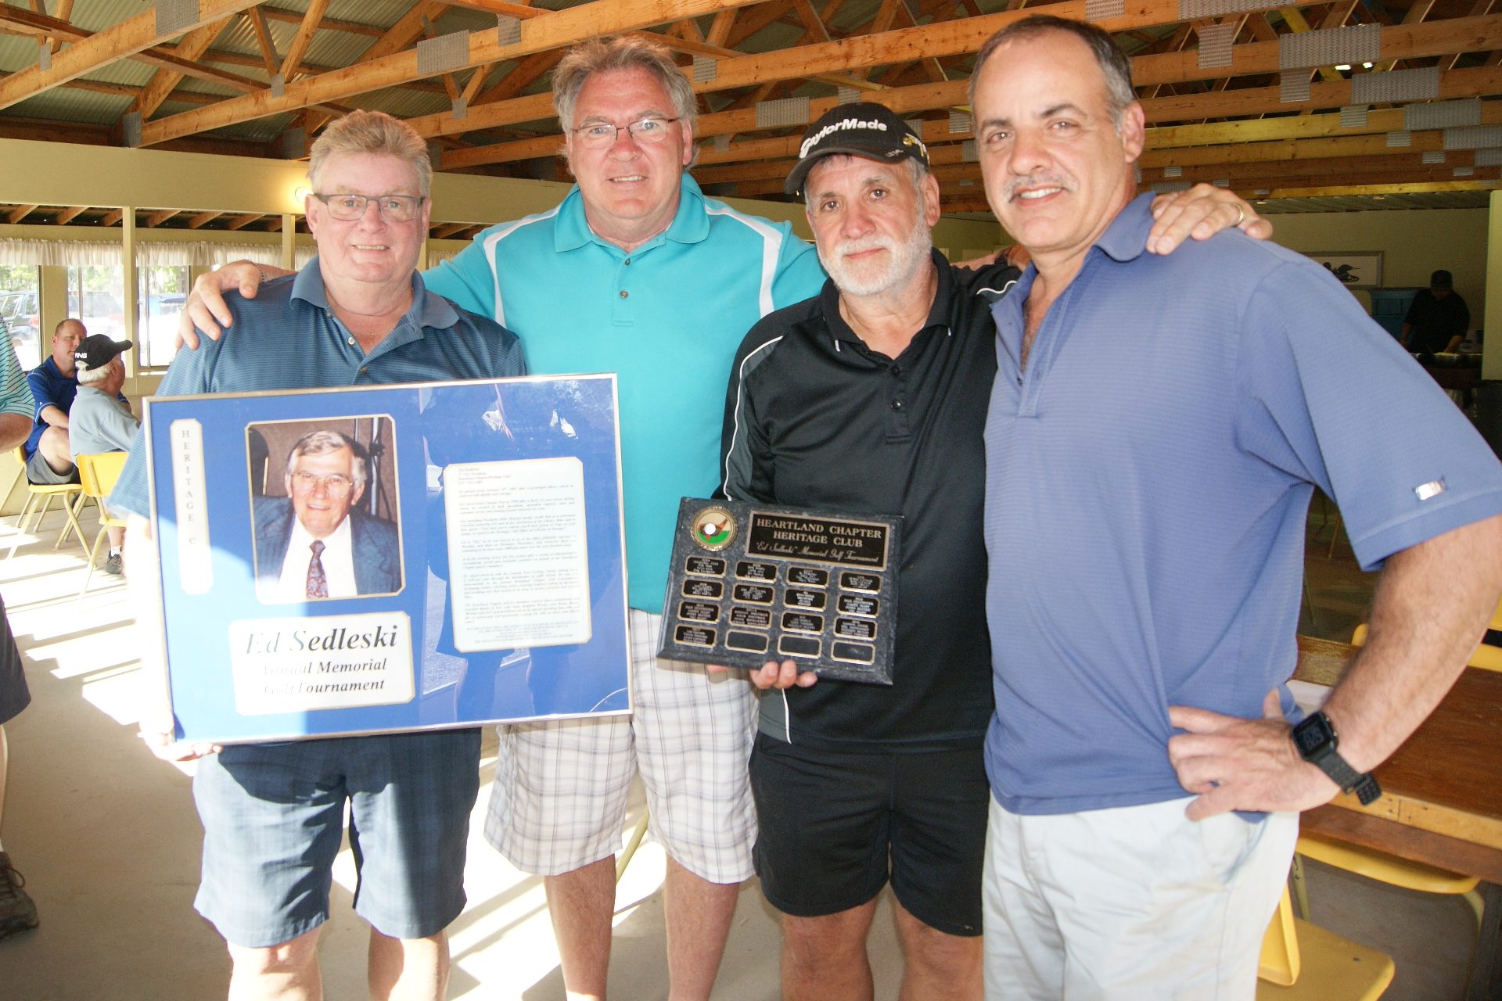

NEWLY CONTRIBUTING MEMBERS

George Chin
Elizabeth Martin
Shirley Ogden
Claire Nadeau
Keneth Perchaluk
Sharon Jefkins

IN MEMORIAM

Metro Hrabarchuk
Donald Mathias
Grace Tucker
Edna Mattes
Patrick Ryan
Jack Watson

SLEEPING GIANT ACTIVITY COUNCIL

Members and friends meet the last Friday of every month for lunch at the Port Arthur Curling Club, 214 Egan St., Thunder Bay.
For further information contact:

Don Rosengren
Chair, T. Bay Nth On. (807)345-1624

If you recently moved, please provide us with the following information. Thank You!
(please print)

Name: _____________________

Old Address: _______________________________
Old Phone Number: _____________________

New Address: _________________________________
New Phone Number: _____________________

Send to the Heritage Club Office at:
1462 Church Ave.
Winnipeg, Mb. R2X 1G4

KNITTING! KNITTING!
HELP! HELP! HELP!
Once again we are asking our members to help with our Christmas Program for needy children by knitting items such as scarves, gloves, mitts, toques, sweaters, etc. If you are willing to knit for this worthwhile project, please call the office and let us know your name, address and phone number.
Thanks to several donations, our office has a good and varied supply of wool on hand.
If you require wool you now have three options:
#1 – Drop in to the office on Mon. or Thurs. morning and pick out the wool you need.
#2 – Call the office and let us know what type of wool you require and the amount. We will send it out to you.
#3 – If option 1 or 2 is not suitable, we ask you to purchase what you need and send your bill to the office. We will reimburse your costs.
All knitting should be dropped off at our office by Nov. 15th, 2018 to have them included in our Christmas charity programs. (If pickup is required, please call the office at (204)987-5010).

Ed Paleshnuik
Knitting Co-ordinator

TAKE A BREAK FROM YOUR DAILY
ROUTINE AND COME OUT TO SOME OR
Donation to Agape Table August 2018, this trip 4,032rolls of toilet paper, 2,070 diapers of various sizes, 680 pairs of socks as well as $1,000.00 worth of Feminine Hygene Products. Just under $3,000.00 in total. Thanks to the generocity of members supporting our fund raising efforts
ALL OF YOUR CLUB ACTIVITIES

In the opposite column you will find a picture of toilet tissue, socks, diapers and feminine hygiene products, which we have purchased on your behalf and will be donated to Agape Table.

CASINO TRIPS
Our next Casino Trip will once again be to the Shooting Star Casino in Monhomin Mn. on Tues. Oct 16 to Thurs. Oct 18, 2018. The cost for this trip is $139.00 per person Double occupancy, ($189.00 single) Tour package includes $110.00 slot play, 2 X $5.00 meal Coupon, 2 coupons to exchange $150.00 at US bank rate plus 5% plus $10.00 Be back coupon.

2018 Holiday Tour, Shooting Star Nov 27-29,
$199.00 per Person double occupancy. Party on the bus, Christmas party at the Casino, special prizes and gifts for everyone, special games and more. Plus receive the Tour package……This trip is already filling fast and usually fills up long before trip date. If interested please contact the office and put your name on our list.

2018 MEMBERSHIP COMMUNITY VOLUNTEER SURVEY

Name: ……………………………………………… Address: ……………………………………………………………………
City: …………………………………….. Prov.: ………………………………… Postal Code: …………………………….

“People Helping People” is the motto of the Heritage Club. It’s that time of year again. We must start gathering information
so that we can prepare our annual report of our activities for the national office. Please complete the attached volunteer hours form to enable us to complete the report. Remember, report all volunteer activities as a Heritage Club member. Every hour counts! Don’t forget your knitting hours and Christmas hours.

We must have your completed form in our office prior to Dec. 31, 2018.

ACTIVITY | ESTIMATED ANNUAL HOURS
Church
Community
Knitting
Literacy Program - School
Santa Program
Library/Museums
Hospital
Soup Kitchen/Food Bank/Meals on Wheels
Heritage Club
Seniors Homes/Shut In Programs
Income Tax Form Prep./ Festivals
Fund Raising
United Way
Others
Others
Others

CHRISTMAS DINNER ARMY NAVY AIR FORCE VETS HALL
Empress North of Ellice Ave.
Thursday, December 6, 2018 Doors open at 11:00 am Luncheon at Noon

HAM, MEATBALLS, PEROGIES AND ALL THE FIXINGS!!

Name: ………………………………………. Active Member Card No.: ……………………………………………..
Spouse/Partner: ………………………………………………………….
Active Mbr. @ $10.00 …………….. Spouse/Partner @ $10.00 ………………. Guest @ $20.00 ……………….
Sugar Free Dessert …………………………………..

The Heartland Chapter – Heritage Club, its’ servants or agents, is not liable for any injury, loss or damage to
personal property arising from or in any way resulting from participation in these activities.

ANNUAL MEETING HEARTLAND CHAPTER
Thursday, September 20, 2018
Royal Fork Buffet Restaurant – 1615 Regent West, Transcona
Doors Open at 11:00 am Meeting at 11:30 Lunch to Follow

Complete and return for your Annual Meeting tickets.
Please Note: Due to space limits only the first 80 pre-paid attendees will be accepted
DO NOT FORGET A TIN FOR THE BIN

Name: ……………………………………………………. Active Member Card No.: ……………………………………..
Address: …………………………………………. City: ………………………………. Postal Code: ………………………………..

Spouse/Partner: …………………………………….
Guest: ………………………………………………

Active Member ………………..@ $10.00 Spouse/First Guest ………………………@ $10.00: $ ………………………….
Non-Active Member/Other Guests: …………………@ $15.00: $ …………………………

Please quote your active member number to qualify for active member price. Completed order form and full payment must be returned to the Heritage Club, no later than September 14, 2018.

The Heartland Chapter – Heritage Club, its’ servants or agents, is not liable for any injury, loss or damage to personal property
arising from or in any way resulting from participation in these activities.

FUN GOLF DAY TEAM SCRAMBLE
Southside Golf Course 2226 Southside Road
Wednesday, September 5, 2018
Modified Shotgun Start 12:00 Noon

Green fees for 18 holes will be $28.00 (taxes included) $1.00 of the green fee will go to charity.
18 hole green fee and shared power cart is $40.00 (taxes included) $1.00 green fee will go to charity.
To benefit the co-ordination of this event, please! please! return your completed application form along with your payment
In full by August 23/ 2018.

Make cheques payable to The Heritage Club
and mail to:
The Golf Activity Coordinator
Canada Post (Heritage Club) 1462 Church Ave. Winnipeg, Mb. R2X 1G4

Name (Member): ……………………………………. Phone: ……………………………………
Name (Guest): …………………………………………
Green Fee @ $28.00 each: $ ………………………. Green Fee & Shared Power Cart @ $40.00 ……………………. Total: ………………………..

The Heartland Chapter – Heritage Club, its’ servants or agents, is not liable for any injury, loss or damage to personal property
arising from or in any way resulting from participation in these activities.

HERITAGE CLUB MEMBERSHIP

Membership consists of active and non-active members who take part in various activities throughout the year i.e. monthly luncheons, golf tournaments, club bowling, casino trips, annual banquet, annual meeting and Christmas banquet. Members are also actively involved in working in the community, as well as contributing food and money to charity. Members also knit hundreds and hundreds of items for adults and children in need of warm clothes.

Advantages of being an active member (paid up dues) include and are not limited to:

Activities that carry a cost per participant can be attended by active members at a reduced cost.
Receive access to Medoc (the best travel and cancellation insurance at a price other carriers cannot
match or beat).
Receive access to house and car insurance.
Receive access to fitness clubs.
Receive discounts at select Hotels
Receive access to the Heritage Club website.

CAMBRIAN CHAPTER

Your Chapter at present does not have an active executive in place. Until a new executive from the area becomes available the Heartland Chapter will conduct business for the Cambrian Chapter.

Please send us news, topics of interest, changes of address, etc. and we will include these items in our newsletter. However, bear in mind that all printing and mailing costs are charged to the Chapter and therefore some newsletters are only sent out to active members. As you can see by the above noted information there is an advantage to being an active member (dues paying). Just using the Travel and Cancellation Insurance, our members across the country save hundreds of dollars.

Should you or anyone be interested in an executive position with the Cambrian Chapter, the National Executive of the Heritage Club would be pleased to hear from you. The job is not very complicated or time consuming and there will be as much assistance as needed to help form a new executive. Please feel free to contact the undersigned at the address listed on the first page.

Harold Onagi
President

