Heartland/Cambrian Newsletter
February 2019

President’s Message
Your executive and I, hope that 2019, well be a year filled with much Health, Happiness and Prosperity for all our members and their loved ones.
The year certainly started off with record breaking cold and a promise of lots of snow to come. But being retired means you can stay home and not go out into the cold and snow. And that’s something all our working members can look forward to in the years to come.
The past year, we saw many new active members joining our ranks, as well as some old members becoming active by paying annual dues, but we also saw a number of old collegues answering the march of time, leaving us with memories gathered over time.
The past year has also been a successful one, with all our activities held, with so many of our members taking part. We also had much success in our fund raising efforts, donations from members and friends, as well as our knitting program. Thanks to all their work and effort we delivered a room full of Toilet paper, diapers, socks and feminine hygiene products to Agape Table. Products that are not normally donated to them nor products they cannot buy because of rules. Just think what your life would be like without these basic necessities of life. The knitting we received this year once again saved so many people from the cold and fear of frost bite
A BIG THANK YOU, to all our contributors.
We look forward to your continuing support of People Helping People and at all our functions some of which are listed in our newsletter .
President,
Harold Onagi

Heartland Chapter – Heritage Club
1462 Church Ave.
Winnipeg, Mb. R2X 1G4
(204)987-5010
e-mail – heartlandchc@gmail.com

Office hours 9:00 am to 12:00 noon
Monday and Thursday
Our answering machine will take your
message outside of these hours.

Executive phone numbers in the event that immediate contact must be made which cannot wait for office hours.

Chapter Executive

President Harold Onagi 832-4398
1st Vice President Gord Arseny 668-6604
2nd Vice President Eileen Hay 222-5412
3rd Vice President Betty Johnstone 253-1325
Treasurer Paul Pelletier 987-5010
Secretary Darlene Fleming 987-5010
Adm. Officer Ed Paleshnuik 253-9464

Activity Councils

Wpg. & Area Buzz Lamond 452-7824
Brandon & Area Murray Sangster 728-7489
T.Bay Nth. W. On. Don Rosengren (807)345-1624

Newsletter Editor 1st Vice President
Gord Arseny

ANNUAL DUES

Annual Membership Dues are still only $10.00. Annual dues cover the year starting January 1st to the end of December each year. When you pay your dues you will receive an active member card with the coverage year in large print. The card will bear your active member number on the lower right hand side. The number will start with the year you are paying for, i.e. 191234. When you’re asked for this number (event applications etc.), please quote the full number starting with 19----. All active members will be kept up to date on all information and activities within the Heartland Chapter.
Please remember we will only print our labels for people who have paid. So if you have not submitted your dues by June 30 of the current year you will not get any further local mailings.
Non-active members will continue to receive information being mailed by the National Office of the Heritage Club as well as an annual newsletter from the Heartland Chapter related to the chapter’s annual meeting.
A reminder of annual dues will be printed in all issues of the newsletter, so please keep your card handy to check if it is current. In the past a few people have sent in annual dues each time they see the below submission form.

Remember you must be a dues paying member to qualify for continued Medoc coverage.

Please use a cheque payable to: Heartland Chapter

---------------------------------------------------------cut-----------------------------------------------------------

2019 FISCAL YEAR HEARTLAND CHAPTER ANNUAL DUES

2019 Fiscal Year (Jan. 1 to Dec. 31, 2019) Heartland Chapter Annual Dues

Dues 2019 - $10.00 Dues 2020 - $10.00

Charity for 2019 - Charity for 2020 -

TOTAL CHEQUE: $ ________

Name: __________________________

Address: _____________________________

City: ______________________ Postal Code: ____________________

2019 ANNUAL MEMBERSHIP

Thank you to the 362 members who have paid their 2019 annual dues already!
Remember that members who pay their annual dues by June 30 of each year will receive all chapter newsletters issued throughout that year.
HEARTLAND CHAPTER – HERITAGE CLUB
ELECTION OF OFFICERS
According to the will of the membership, election of members to the Executive will be conducted by mail-in ballots. Members of the Executive are elected for two – year terms. Half of the Executive Members are
elected on alternating years in order to allow continuity of transition.
Please ensure that the person you nominate is fully aware of your nomination and has given his/her consent to stand for election.

OPEN FOR NOMINATION

POSITION | NOMINEE | NOMINATOR
1ST Vice President
3rd Vice President
Treasurer

Send completed form to: Heartland Chapter – Heritage Club
Canada Post Corporation
1462 Church Ave.
Winnipeg, Mb. R2X 1G4

Nominations must be received no later than Thursday, March 21, 2019

HERITAGE CLUB – MEMBERSHIP BENEFITS

Membership consists of active and non-active members who take part in various activities throughout the year.
Advantages of being an active member (paid up dues) include but are not limited to:

- Activities that carry a cost per participant can be attended by active members at a reduced cost.
- Access to Medoc (the best travel and cancellation insurance at a price other carriers cannot match or beat).
- Access to house and car insurance.
- Access to reduced membership fees at Goodlife Fitness. Members of the Heritage Club get a 50% discount off regular prices. To learn more about this offer, go to our website.
- Access to a great corporate rate at all Choice hotel properties worldwide. Includes; Comfort Inns, Quality Inns, Econolodge and Rodeway Inns.
- Telus Mobility – Heritage Club/Canada Post Purchase Plan. Discounts on cellular phones and cellular phone services. Available from an Ontario dealer, but they ship for free.
- Heritage Club Scholarship Program – 2019
The Heritage Club awards three (3) scholarships to children or grand-children of all dues paying members of the Heritage Club. The Scholarships are valued at $1000 for university and $500 for college studies. The scholarships will be awarded to students starting, for the first time, their first year of full-time studies. Submissions must be postmarked on or June 28, 2019.
ATTENTION RETIRED KNITTERS
GOOD NEWS!
If you are no longer knitting and have wool cluttering up your living space, I have good news for you!
Consider donating the wool to our (Knitting for Charity) program. Firstly you will regain some space and reduce your clutter. Secondly you will feel good knowing that our knitters will turn your unwanted wool into mitts, toques, scarves etc. for the less fortunate in our community.
Option 1 – Drop it off at our office or at any of our events.
Option 2 – Call the office and we will make arrangements to have your wool picked up.
How’s that for Good News!!

KNITTING, KNITTING, KNITTING !!
The 2018 knitting program in Winnipeg was a success!
Winnipeg received knitted items from Sheila Llewellyn, Margit Walker, Ruth Jarmoc, Ruth Blackadar, Savellia Love, Ted Marcinkowsky’s friend Larry Pelzer, Joan Schroeder, Darlene Heron, Mona Anderson, Nicola Cairns, Lori Lucier, Barb Custance, Dorothy Aime, and Anne Faseruk, all from Winnipeg, Margaret Leary from Miniota, Gwen Battaglia from Sanford, Pauline Novak from Kenora, Lynda Zolondek from Letellier, Lillian Dodd from Gunton and Patricia Brown from Upsala, On.
This year a total of 1027 items were donated with an approximate value of $13,221.
These items were delivered to Wolseley Family Place, Koats for Kids and Agape Table. Both the Winnipeg group and the Brandon group could sure use some help. Is there anyone out there who would be willing to join these groups? You will find it very rewarding and will help make our communities a better place to live.

Thanks for your continued support for this program and your many hours of work. Thanks to all our present knitters, and any knitters who helped with this program in the past. The less fortunate in our communities will be a little warmer this cold winter thanks to your efforts.
As coordinator of the “knitting for charity” program, I would like to personally acknowledge and thank those who helped, Elvira and Larry Born, Nancy and Harry Onagi, Gail and Buzz Lamond, Betty and Marion. Special thanks to Gord and Georgette Arseny who prepare the signs, take the pictures, set up the display at the luncheon and ensure the thank you letters are prepared.
This program would not succeed without the knitters and all my helpers.
Thanks Again!

Ed Paleshnuik
Knitting Coordinator

MEDOC TRAVEL INSURANCE
Attention to all members; in order to be eligible for Medoc Travel Insurance you must be current with your yearly membership dues. That means the $10.00 for 2019 must be received in our office and this year’s membership card issued.
Remember …… $10.00 can save you thousands, or even more should you be unfortunate enough to become seriously ill while traveling.
To those who are paid up, thank you, and enjoy your worry free travels.
To those who are not paid up well, better get that cheque written!!
Our address is: 1462 Church Ave.
Winnipeg, Mb. R2X 1G4

Please note A list of all members who have paid dues is sent in at the end of
each month and is checked to verify qualification for our Club benefits.
SOUTH WEST ACTIVITY COUNCIL
2018 Year End Report

We had another good year at South West Activity Council of Manitoba in 2018 with a paid up membership of 40. We held 10 monthly luncheon meetings with an average attendance of 15.
Our regular luncheon meetings resumed on Tuesday, Sept. 11th at Sand Hills Casino, south of Carberry. We had 23 attend including 5 people from the Executive of the Heartland Chapter in Winnipeg. Following a short meeting, including reports and messages from Heartland, we enjoyed lunch. Plans are to hold the Sept. meeting there again in 2019. My wife, Carole and I attended the annual meeting of the Heartland Chapter of the Heritage Club in Winnipeg on September 20th.
A meeting to assemble our annual donation of bags of toiletries for the Women’s Shelter was held at the home of Carole Sangster. Thank you to all the members who came to help make up 85 bags. Also, thank you to Carol Shelvey for making the bags.
Thank you to our knitters, Florence Brown, Elsie Czerkawski, Sandra Barrett and Carole Sangster for their efforts. Another thank you goes out to Len Wenger for purchasing and delivering vegetables to Helping Hands Soup Kitchen. Also, thank you to Millie Wenger for her many hours of baking various items for Helping Hands.
On a sad note, we received word that Rodger Walters passed away on January 7th. He was a very regular attendee of our meetings as well as other functions such as golf. He often had a good joke to tell us.
Members of our club have made donations of time and money to charities such as:

Samaritan House $ 146.47
Women’s Shelter $1105.00
(85 bags of toiletries)
Helping Hands $ 500.26
Crisis Pregnancy Centre $ 100.00
Christmas Cheer $ 100.00
Funds for Furry Friends $ 100.00
Individual Donations $2444.47

Total $4496.20

Also our members have reported a total of 2096 hours of volunteer time.
“Best Wishes” to all for a great 2019!!

Murray Sangster,
President, Southwest Activity Council

CHRISTMAS LUNCHEON 2018

The attendance this year was very good! We had 136 paid and 10 who did not attend. Some were due to illness, others for unknown reasons. There were quite a few who paid their dues at the door, which helps Paul. Of those attending, 8 were first time attendees.
The 50/50 and silent auction did very well, but the best seller was the coins. Kudos to Larry, he sold tickets worth $200.00. The Tin for the Bin donations were very good. Agape came and picked up the donations and full slab of cake that was left over. Thanks to Buzz for arranging this to happen.
The knitting display was awesome! As usual our knitting friends did a great job of providing good quality items for donation to those in need. A thousand thanks to the “girls and boys” who set the display up. Gord took pictures this year and Harry took the pics of the auction winners. Thanks also to Nancy, Georgette, Paul, Rick, Betty and Annette for helping at the front with ticket sales and name tags.
Now to the not so good part …. The food was somewhat lacking this year. Small portions, some cold potatoes, coleslaw that was off somewhere yoohoo and the fact that we had to ask for sour cream, and plates and forks for the cake. I have spoken to Irene (caterer) and let her know that in future we would appreciate her keeping a better eye on the food table. There was a ton of food not served, and although we know there will always be leftovers, this year it was considerable.
I also explained that next year will be our 30th anniversary luncheon, and we cannot have a repeat of this year (very nicely though). In fairness the cost was $20.00 a plate, which is less than our usual cost per person.
We collected $360.00 for the 50/50 draw ($180.00 was given out). Winners were Buzz Lamond - $95, Nancy Onagi - $50. and Linda Melanson - $35. The Tin for the Bin valuation of food and cash donation was $692.00.

Eileen Hay
2nd Vice President
BANQUET LUNCHEON 2018

The turnout was great! We had 76 people in attendance at the Royal Fork Buffet on Lagimodiere. The food got lots of kudos, especially the sushi bar and the chicken. We had some new members attend, some who brought either other family or friends. One gentleman, Mark Dziobas’ dad said to look for him again in September! Karen Duncan gave a bag of wool and Stan Knight brought a box of individual shampoos etc. for donation. Jerry Margits and Stan Knight of Gull Lake, Sask. were new attendees.
The winner of the $20.00 superman coin was Ray Hince.
The winners of the 50/50 draw were Betty Johnstone, Barb Zayac and John Gifford.
There was $31.00 cash in the Tin for the Bin and the amount of food goods donated was great! Thanks to Larry Born for delivering these donations to Agape Table!
Harry’s new sound system worked well. Everyone enjoyed Betty’s jokes and Horace Ducharme’s contribution.
A number of people approached me to say they did not realize the value of our knitting and were amazed that our chapter had been requested to make a presentation at National with regards to the success of this part of our club’s activities.
Thanks to Rick Hay and Paul for manning the ticket table. They did a fabulous job!

Eileen Hay
2nd Vice President

SLEEPING GIANT ACTIVITY COUNCIL

Members and friends meet the last Friday of every month for lunch at the Port Arthur Curling Club, 214 Egan St., Thunder Bay.
For further information contact:

Don Rosengren
Chair, T. Bay Nth W. On. (807)345-1624

CHAPTER HIGHLIGHTS 2018

Hello . . . Hoping you all managed to survive the winter in good health. Thanks to all the members who attended the luncheons and Christmas dinner last year. And not to forget the golf tournaments that Buzz organized. We have had fabulous turnouts! This is our 30th year of operation, so if you are able, please join us to help celebrate. It is always nice to be able to catch up. We have had quite a few new members join us for these events, so welcome if you are one of them. To all members, your generosity in supporting our club and the associated charitable organizations is much appreciated.
Agape Table in particular has expressed their gratitude for our donations. We also support Koats for Kids and the Wolseley Women’s Centre with our fabulous knitters work. The volunteer sheet many of you filled out is just one of the many things that go into our report to National, so please continue to send them c/o Betty at the office.
In closing PLEASE take note of both dues and event applications in this newsletter. Mark your calendars and, as we expect the best turn out ever, make sure your forms for our luncheons are in early (as there is limited space).
HAPPY 30TH ANNIVERSARY TO US ALL!!

Eileen and Betty

If you recently moved, please provide us with the following information.
Thank You!
Name: _____________________________
Old Address: ____________________________
Old Phone Number: _________________
New Address: ____________________________
New Phone Number: ________________
Send to the Heritage Club Office at:
1462 Church Ave.
Winnipeg, Mb. R2X 1G4

BOWLING 2019
Coronation Lanes, 255 Tache, St. Boniface

We are in full swing regarding our bi-weekly bowling. We usually have 10 to 12 bowlers participating every second Thursday at 1:00pm. We will continue our season until the end of April. If you are interested in joining us, please call Buzz Lamond at 452-7824 if you have any questions.

2019 GOLF NEWS AND ACTIVITIES
WINNIPEG & AREA

Once again as in the past years your golf committee has scheduled three golf tournaments for the 2019 season.
Our Spring Tournament will be held on Wed.
May 8th, 2019 at Southside Golf Course – 18 hole Texas Scramble – tee time 12 noon, modified shotgun start.
Our 15th Annual Ed Sedleski Golf Tournament is scheduled for Wed. June 12th, 2019 at Oakwood Golf Course – 18 hole Texas Scramble – tee time 12 noon, shotgun start. Dinner served at approximately 5:30pm. Every golfer will receive a prize.
Our Fall Tournament will conclude the 2019 season. It will be held again at Southside Golf Club on Wed. September 4th, 2019 – 18 hole Texas Scramble. Tee time will be 12noon – modified shotgun start.
We have included an application form in this newsletter for the Spring Tournament on May 8th at Southside.
Please complete the enclosed form and return it to the address indicated on the form no later than April 26th, in care of Buzz Lamond. Make cheques payable to Heritage Club (golf tournament).

Buzz Lamond
Golf Chairman

CAMBRIAN CHAPTER

We are still in need of help in the far reaching area of the Heartland Cambrian Chapter. We need some members in the area to help us conduct business for the Cambrian Chapter. If you can help, please contact us. But in the meantime, please send us any news, topics of interest, change of address etc. and we will include these items in our newsletter. However bear in mind that all printing and mailing costs are charged to the chapter and therefore some newsletters are only sent out to active members. As you can see by the above noted information there is an advantage to being an active (dues paying).
Just using the travel and cancellation insurance, our members across the country save hundreds of dollars. Dues paying members in Ontario can also take advantage of automobile insurance from Johnson as well as home insurance.
Should you or anyone you know be interested in an executive position with the Cambrian Chapter, the National Executive of the Heritage Club would be pleased to hear from you. The job is not very complicated or time consuming. There will be as much assistance as needed to help form a new executive. Please feel free to contact the undersigned at the address listed on the first page.

Harold Onagi
President
Heartland Cambrian Chapter

TAKE A BREAK FROM YOUR DAILY ROUTINE AND COME OUT TO SOME OR ALL OF YOUR
CLUB ACTIVITIES

ANNUAL BANQUET THURSDAY, MAY 16, 2019
ROYAL FORK BUFFET RESTAURANT – 1615 REGENT AVE. WEST
Meeting at 11:30 – Lunch at 12:00 noon
(We are allowed 2 hours for this gathering)

Join us for a delicious meal from a large selection of food. Get a group together of former co-workers to join you for a meal and reminisce about your years of work and play, or come out and make new friends. Cost per person includes beverages, taxes and a dollar towards our charity fund.
$10.00 active member, $10.00 active member’s spouse or friend, $15.00 for guest(s)
PLEASE BRING A NON PERISHABLE FOOD ITEM FOR THE LESS FORTUNATE IN OUR COMMUNITY
Please complete and return for your Annual Banquet tickets:

NAME:____________________________ Active Card No: __________________________________________
ADDRESS: ______________________ CITY: __________________ CODE: _____________________________
Number of Tickets: ________ @ $10.00 Active Member _______ @ $10.00 spouse or one guest: $ _________
Number of Tickets: ________ @ $15.00 each for non-active member, spouse or quest: $ _________________

Please quote your active member number to qualify for active member price. Completed order form and full payment must be returned to the Heritage Club, no later than May 3rd, 2019.

The Heartland Chapter – Heritage Club, it’s servants or agents, is not liable for any injury, loss or damage to personal property arising from or in any way resulting from participation in these activities.

FUN GOLF DAY TEAM SCRAMBLE
Southside Golf Course 2226 Southside Road
Wednesday, May 8, 2019
Modified Shotgun Start 12:00 Noon

Green fees for 18 holes will be $30.00 (taxes included) $1.00 green fee will go to charity.
18 hole green fee and shared power cart is $42.00 (taxes included) $1.00 green fee will go to charity.
To benefit the coordination of this event please! please! return your completed application form along with your option of (green fee only) (green fee plus half cart) payment in full by April 26, 2019 to:
Heritage Club – Heartand Chapter
1462 Church Ave.
Winnipeg, Mb. R2X 1G4
Name (Member): _________________ Phone: ___________________________
Name (Guest): ___________________
Green Fee @30.00 each: $ _________ Green Fee & Shared Power Cart @ $42.00 Total: ________________

The Heartland Chapter – Heritage Club, its’ servants or agents, is not liable for any injury, loss or damage to personal property arising from or in any way resulting from participation in these activities.

IN MEMORIAM

William Romaniuk
Jean Motkaluk
Real P. Sabourin
Peter John Kuryk
Daniel Krywy
Walter Drewniak
Rose Mykytyn
Kenneth L. Lemke
Joseph Moski
Olga Hrehorak
Arnold Eyford

This list of colleagues and friends who have past reflects those that we are aware of.
We regret any oversight to this list.

NEWLY CONTRIBUTING MEMBERS

Doris Cook
Darrin P. J. Kohut
Donald Bertrand
Fawcett Garrioch
Brent Burling
Donald Pilling
Lisa Pilling
Iris Melnyk
Kevin Denby
Dale Elmore
Brian Repski
Robert Sylvester
Lisa Sprung
Barbara Burke
Eleanor Kipe
Lionel Head
Lori Lucier

Welcome to all new members!

TREASURER’S 2019 REPORT

INCOME
Dues - $7000.
Canada Post Achievement - $ 500.
National Office - $2800.
Total - $10,300.

EXPENSES
Council Meeting - $4000.
Office - $ 700.
Printing - $1000.
Computer - $ 600.
Other - $ 100.
Banking - $ 100.
Luncheons - $3800.
Total - $10,300.

Paul Pelletier
Treasurer

CHANGES TO YOUR MARITAL STATUS
AFTER RETIREMENT

If you enter into a spousal or common-law relationship after retirement, your new spouse or common-law partner will not automatically be eligible for survivor benefits from the plan.
You can reduce your pension to provide survivor benefits to your spouse or common-law partner acquired after retirement. You have one year to do so from the later of:
The day on which the other person becomes your spouse or common-law partner.
The day on which your pension benefit becomes payable.
If your spousal or common-law relationship ends, you may have to share some or all of the pension you have accrued during your spousal relationship, subject to applicable provincial property law. The pension benefit can be split according to a court order, a separation agreement or a written agreement between the spouses.
IMPORTANT DOCUMENTS: In the event of separation, annulment or divorce (past or present) you should inform the pension centre and send the following:
A written request to divide the pension, submitted by you, your current/former spouse or common-law partner, or lawyer.
Certified copies of any legal documents - We require the full court order or written agreement requiring division of pension at source. Most commonly a separation agreement, or any written agreement between you and your spouse or common-law partner assigning a share of the pension.
If there are no legal documents that deal with the division of family property, we will accept a sworn affidavit, witnessed by a notary, confirming there is no requirement to divide your pension at source due to the end of your spousal or common-law relationship and there is no change to your full entitlement to your pension benefit.

IMPORTANT INFORMATION YOU MAY
WANT TO FILE

TIME MARCHES ON: As each year passes the inevitable march of time claims our members. As we travel this road of life, we give thought to our loved ones and be prepared for the end of our journey. Some of the things we can do to make the end easier for those we leave behind are:
- Complete a current will and testament.
- Designate a Executor(s).
- Record financial information, (income, savings accounts, safety deposit boxes, investments, debts, location of important documents, etc.).
- Prepare a list containing your last wishes i.e. type of service, final arrangements etc. This document will help survivors who make expensive emotional decisions rather than decisions more in line with how you want things done. Some people even prepare a statement for the service, name speakers at the service, special people to recognize.

- Some people also make pre-arrangements, i.e. pay in advance for all arrangements.
- A useful booklet is available at all funeral homes which contains more important information.

WHO TO CONTACT FOR INFORMATION IF YOU ARE THE SURVIVING SPOUSE
OF A RETIRED EMPLOYEE

Canada Post Human Resources: (204)987-5000
Ext. 75279

Canada Post Pension Service: 1(800)480-9220
Mon. to Fri. 8am to 4pm eastern time

Superannuation: 1(800)561-7930
Mon. to Fri. 8am to 4pm local time

Old Age Pension: 1(800)277-9914

Canada Pension Plan: 1(800)277-9914

Canada Post Extended Health Plan: (Administered by Great West Life) 1(866)249-5723

Prescription Drug Plan: 1(866)716-1313

Public Service Health Care: (Administered by Sun Life) 1(888)757-7427

Pensioners Dental Plan: (Administered by Sun Life) 1(888)757-7427

Medoc: 1(866)606-3362

Casino Outing

Shooting Star – Feb 18-20
Spirit Lake – March 18-20

Phone the Heritage Club Office for Details
204 987-5010
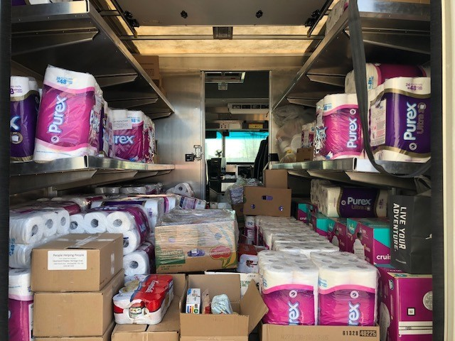
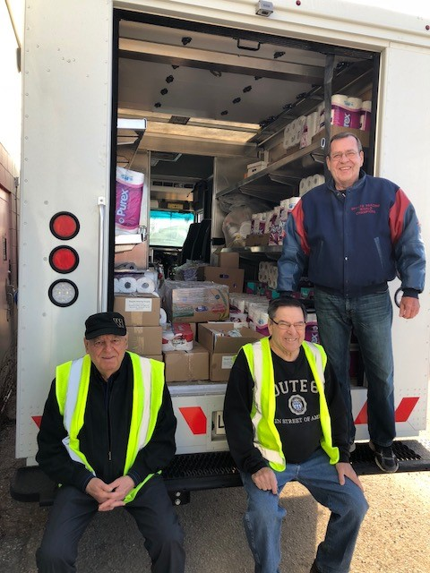
Wolseley Family Place has a broad range of services and programs that address the needs of children and their families in the community. These services fall into three broad areas:
- Education
- Support
- Community Links
To provide families with opportunities to reach their fullest potential. To reduce the risk of child abuse and neglect. To develop programs that improve the health of families and their children.
Wolseley Family Place is a voluntary drop-in program which relies on the participants for direction and guidance. The Centre is community-based within the active area of West Broadway, and has many partnerships within and outside of this community.
The program and service initiatives of Wolseley Family Place are facilitated and implemented to the needs of the families and children.

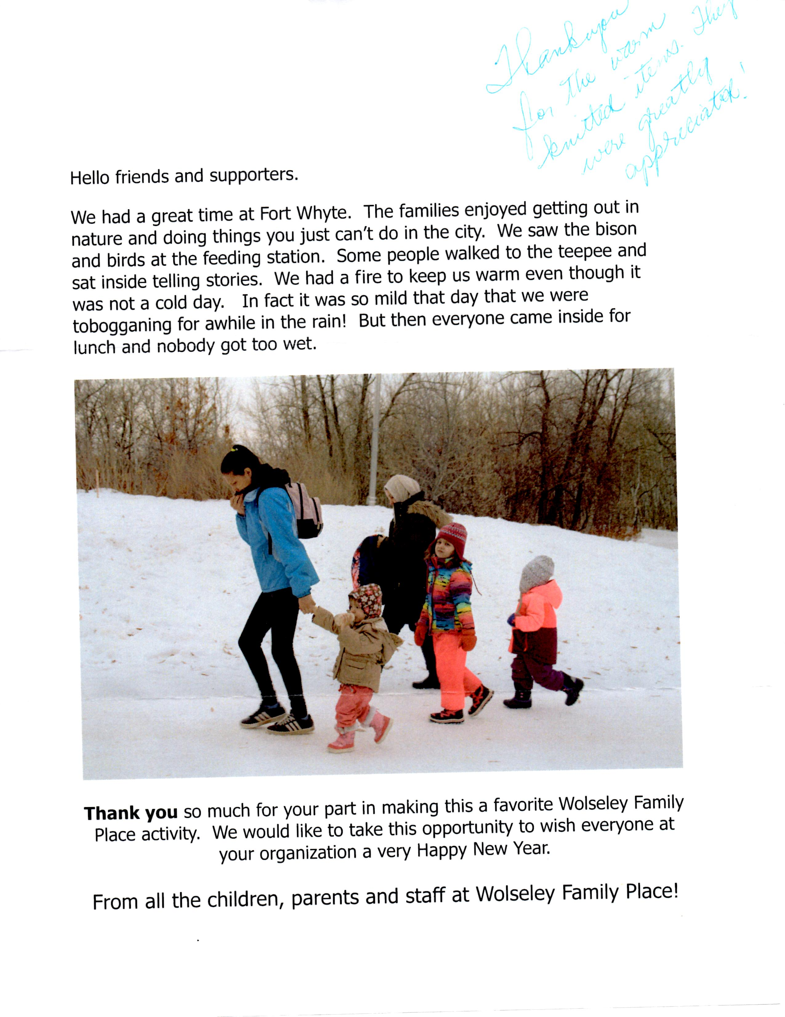
Canada Post Truck full of Toilet paper, Diapers, Feminine Products and Warm Socks being delivered to Agape Table

Agape Table
We provide Emergency food services for breakfast, soup, coffee, tea and juice. We provide a safe, community environment for people to go. Did you know we served over 130,000 bowls of soup last
Men, Women, Children, housed at risk, homeless, working, low income seniors, single parents, persons with disabilities, new comers and many more.
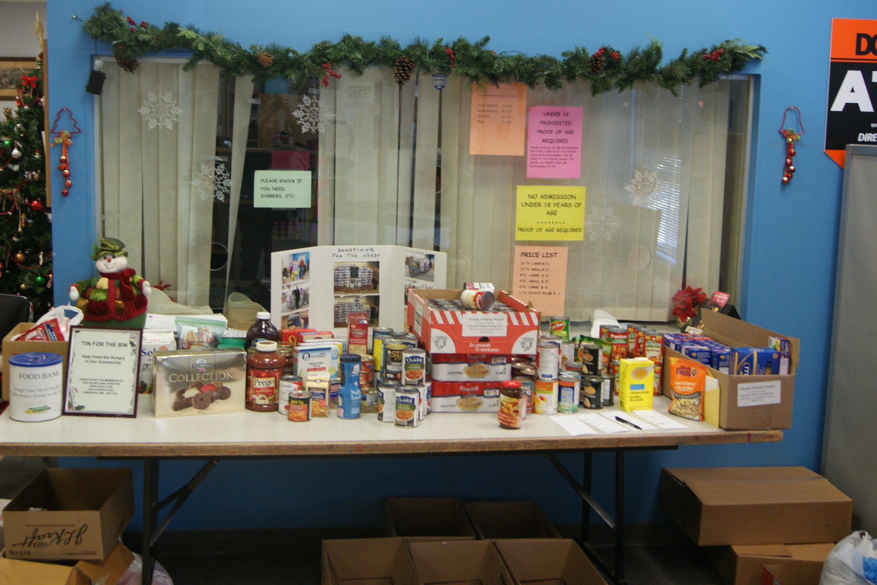

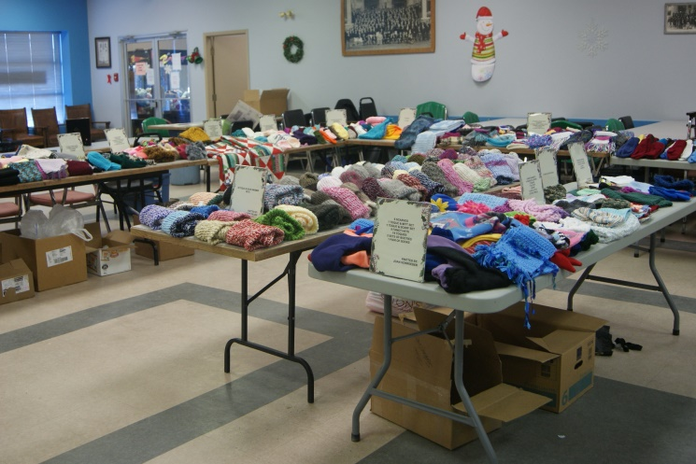
A big thank You to those that volunteered for our Santa Letter Program, But we sure can use a lot more people. PLEASE PLEASE consider volunteering for 2019, we sure can use you!
On behalf of the less fortunate in our community , the cold and hungry, the homeless And the poor, The Executive of your Club , Thank You for your hard work and Generocity.

Each and every Volunteer Knitter is recognized at our Christmas luncheon with a display of their handiwork along with a poster listing items knitted
Each year we have been able to give a little more to our charities and we have started for 2019

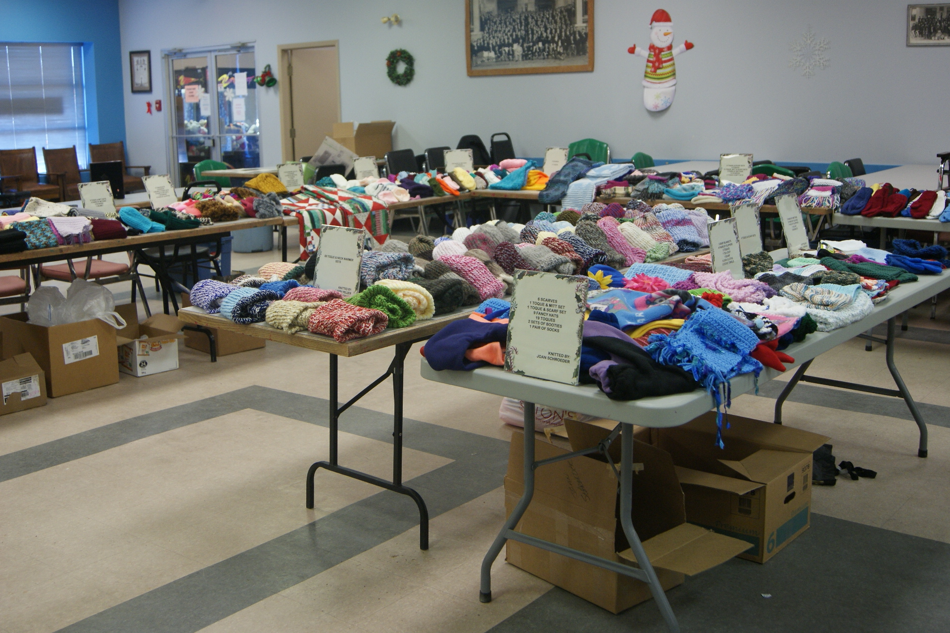
More Donated Knitting for 2018
Donated Knitting for 2018

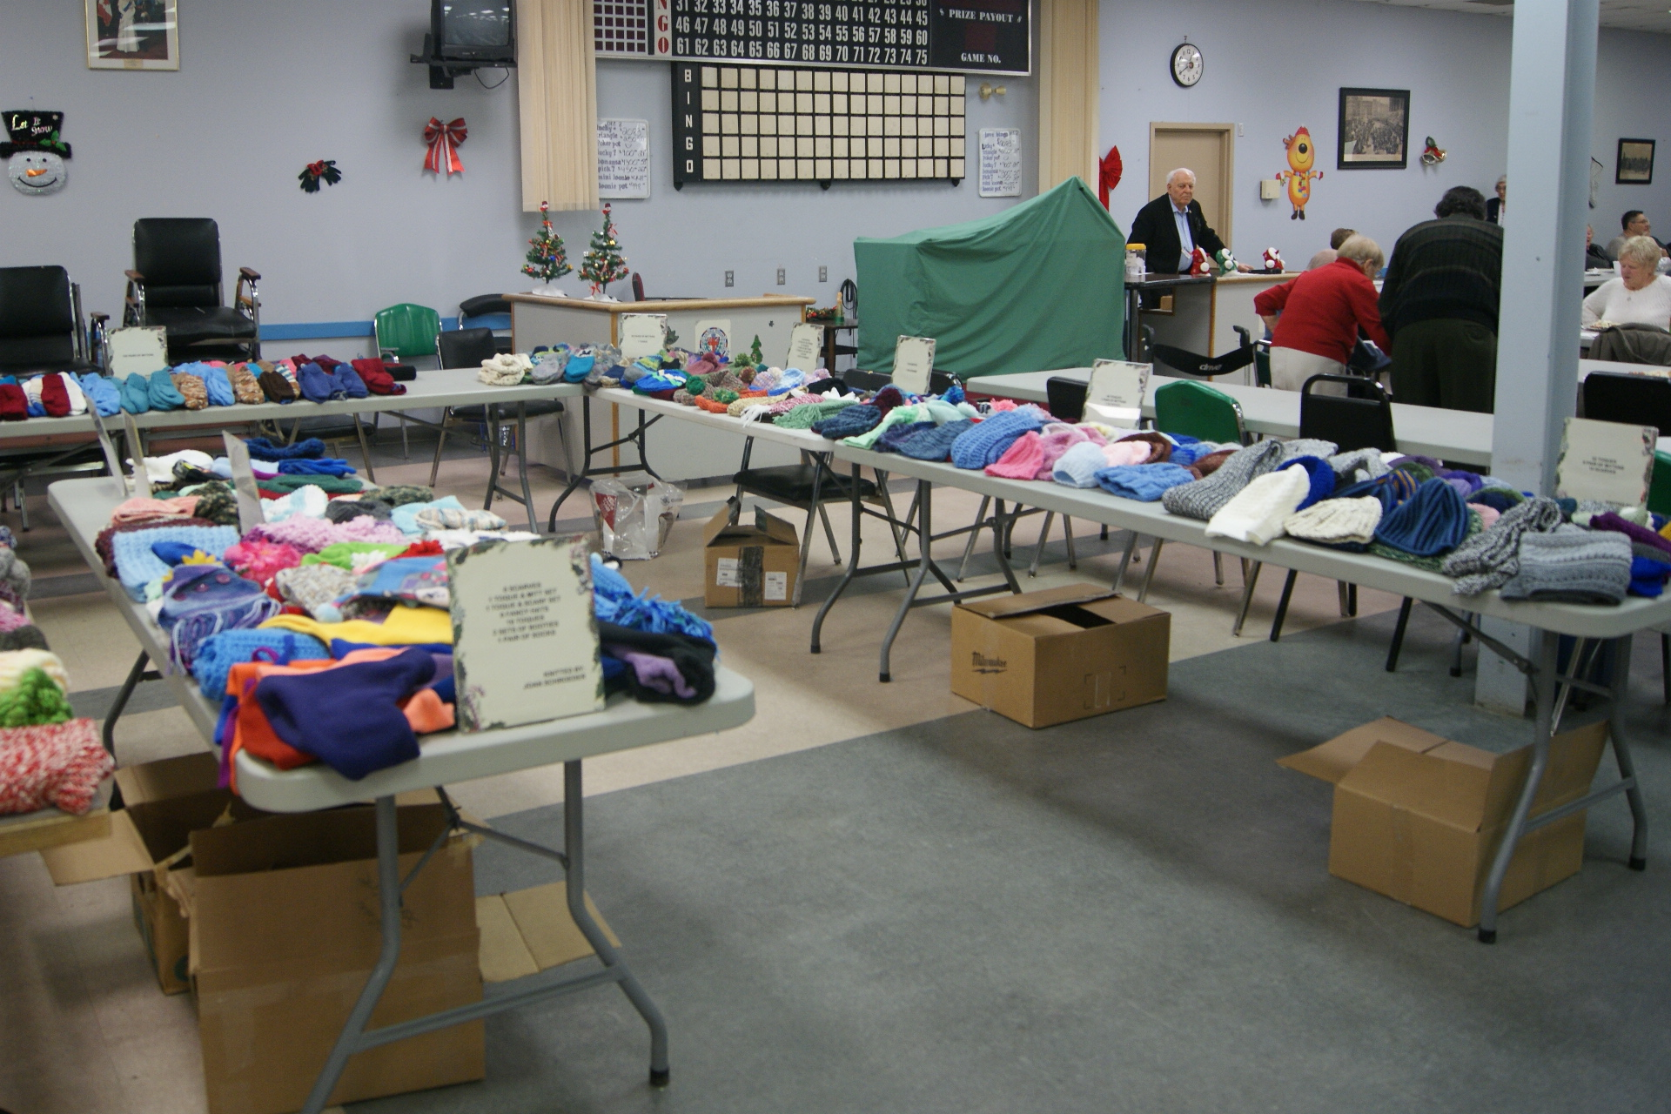
Christmas Tin For The Bin Table

