HERITAGE CLUB HISTORY – HOW IT CAME TO BE
as recalled by Daniel Mulvihill
The Heritage club began with a conversation I had with Bill Kennedy, the VP Personnel, after I had made a point in a meeting about being able to recruit a number of retired field managers to explain the workings of Canada Post to the public. Bill asked to see me in his office the following morning and I originally thought I had made a mistake referring to retired Canada Post people to help the new Corporation.
When I met Bill the next morning, he asked me what Canada Post did for employees on their retirement. I explained to him that really there was no set procedure or program to honor retirees. If a request was made, they could be presented with a long service medal (probably worth about 50 cents) and maybe some buddies might take them out for a beer. This was the usual process for entrant class employees and lower level supervisors and managers. Senior people in the organization such as District Directors, senior Postmasters and HQ senior people usually were given a send off by their peers.
When I was the Director of personnel in two different regions over 10+ years (Atlantic and Ontario), I must admit that I was not really aware of what was available for long service and retiring employees. I don't think I was alone as I don't recall the subject ever being mentioned in any of our monthly personnel council meetings with HQ people. There was obviously little attention paid to the subject and I don't think the field Directors were even aware of where the responsibility fell at the HQ level.
Bill was rather shocked that such was the case in an organization the size of Canada Post. Bill came from Bell Canada where they had a well recognized retiree program called Telephone Pioneers. He also mentioned a number of other organizations with similar retiree programs.
The conversation ended there and I never heard another word until I informed him a year later of my plan to retire. He asked me if I would consider coming back after my retirement and help Bernie Lockman look into the possibility of developing a program for retirees. I agreed and that’s when work on the program began.
Bernie & I spent a considerable amount of time meeting with people from retiree organizations, Telephone Pioneers, Molsons & Labatt retirees, (several others that escape my memory). We discussed many issues such as developing a charter, organizational structures, Corporate involvement, financial dependence etc.
As you can imagine there were some major hurdles to overcome, including some apathy in senior circles for the need for such a program as well as potential associated costs. Thankfully both Bill Kennedy and Mr. Lander were committed to establishing the program. I think both realized the potential boost to morale as well as to demonstrate that the new corporation was genuinely interested in the contributions made by Post Office retirees as well as those long serving employees.
Some of the other hurdles involved:
We had to develop a constitution and bylaws etc. In this we were helped by representative from other organizations such as the Telephone Pioneers as well as our own inhouse legal reps, particularly Peter McIninley. A copy of that constitution is on the website.
Next came the problem of identifying knowledgeable volunteer field reps to help us develop the chapter organizations, locations, numbers etc. Thankfully both Bernie and I knew many of the field people, and aided by people such as Larry Reid from the Atlantic, Duncan McIvor from Saskatoon, Davie Gordon from Toronto, to name a few, we were able to put together a great field team to help us. It’s unfortunate that all their names were not recorded for posterity, however, we did have a dinner for them in Ottawa at the kickoff and Mr. Lander made a great speech in support.
Once we had an organization developed, chapters etc. our next hurdle was contacting retired employees. We also had to identify levels of eligibility for retirees and incorporate it in the constitution before we began the identification of retirees. That criteria is also in the constitution.
Canada Post did not have a way of identifying retirees with the possible exception of CPAA members who had been paid directly by Canada Post. Even in that case there was no way to identify those that had moved. I'm not sure how it happened, it was probably at the Presidential level. However, the superannuation branch allowed us to send out a notice through their pension mailing including forms to be completed by the retirees giving us the information we required. The response was overwhelming, particularly from CPAA, APOC and manager levels. I don't recall the level of response from CUPW and LCUC, although I believe LCUC members were more receptive. The other group I recall being very active participants were retired RMC's (Railway Mail Clerks). This was really displayed at at least two founding banquets that I attended in Pineridge as well as Saskatoon, I have pictures of each group. I also have a picture of the piles of returns we received.
The next hurdle was determining different levels of recognition for long term employees and retired former employees. Again, that criteria is identified in the constitution. We also had to determine the awards that would accompany those levels, including certificates of service and Founding Member recognition awards. I can't remember all of the certificates other than the founding members (signed by Mr. Lander) and the Life Time membership, awarded to retirees, and signed by Bernie. The Founding Member certificates were only issued to the chapters and were ( ) in Number while the retirees numbered in the thousands. Mr. Lander had a signing machine, which could not be taken from his office, so we had to take those Founding Member certificates to his office, and as I recall, Bernie or myself were the only ones allowed to use the machine. I presume it was for security reasons. In the case of the retiree certificates, Bernie had a lot of signing to do. Again, I can't remember if some accommodation was made for Bernie to use the signing machine, if not, Bernie must have set a world record for recording his signature and probably needed therapy after finishing.
It was rather easy to come to a decision for retirees as the normally recognized reward was a watch. And there again we relied on our field and HQ group to help us in determining the awards and levels for other recognition. The decision was made that the levels would be 25, 30, 35, 40, 45, and 50 years of service. One might wonder why the 50-year level was included. It was brought to our attention that in the past there had been an employee level called "Postal Messenger" (see Gerry Fultz obit) and in some cases these messengers would be young teenagers of 14-15 years of age. I believe the job involved the delivery of telegrams. I'm pretty fuzzy on this. In fact, when I was in the Atlantic Region, there had been at least one individual in Halifax who had retired at 65 with 50 years of service including the Postal Messenger level (there were also some individuals who had received an extension beyond the age of 65). As we had no way of determining that there actually were retired individuals who met the criteria, we decided to identify the level just in case. It would have been a terrible embarrassment if such a retiree was identified and we had not been prepared.
We had reviewed a number of programs run by different retiree organizations in terms of award recognition. I can't remember all the details, however we finally had approval to identify 25 years with a silver pin and the remaining years (30 and up) with a gold pin.
The story of the diamonds is rather interesting. In our review of other organizations, we had discovered that Chrysler Canada had used diamonds to identify years of service and we thought that was pretty neat. We had had some resistance from the Finance people in terms of the costs and again, Bill Kennedy was the driving force in getting approval for the pins and watches. We thought we might get some real blowback when we suggested using diamonds to identify years of service. However, when we reminded Mr. Lander that Chrysler, the firm for which he had been President, had used diamonds, there was no further argument in getting his backing and approval. The pins were then ordered with one diamond recognizing 30 years, two diamonds 35 years and so on. Because of the volume that would be purchased (watches & pins etc.) we were able to strike a very good deal with the supplier.
Another interesting story about Mr. Lander's commitment to the program involved a trip to Australia and New Zealand. Mr. Lander came down to our office one day and told us that he was off to the above noted countries and thought that a nice gift for his counterparts would be watches. He took two men’s and two ladies watches as gifts. When he returned from the trip, he again came down to our office and returned a man’s watch and a lady’s watch with the explanation that one of his counterparts did not have 25 years of service!
We then had to identifying which chapter in which to slot the people. Again, we had to rely on our field team and they did a tremendous job. The next chore was to develop a data base in which to slot all the retiree returns. That involved placing the retirees in the proper chapter, the number of years of service, and the reward to which each individual was entitled. For this work we hired an outside data entry firm to accomplish the task. Every entry had to be checked to ensure there were no mistakes. Another firm was hired to do all the framing etc., for the rewards.
In all, I believe it took us two years to get the program to fruition and develop a system to distribute the awards across the country. Again, we had tremendous support both from Mr. Lander and Bill Kennedy. An initial banquet was planned for each chapter, and I must say, expense was not a problem. One of us would take all the materials to the hotel where the banquet was to be held several days in advance. The local appointed President would gather his team and everything put in order for the presentations the evening of the banquet. As you can imagine there was a steep learning curve and I'm sure, some mistakes made. I recall the first one at HQ and I was still there organizing the awards, a half hour before the arrival time of guests and still had to get home to change for the festivities.
I hope this will give you enough background to develop a story on the history of the club. If I might suggest, it might be an appropriate time for each chapter to publish a picture of the original Founding members, many of whom were real heroes of the Post Office over the years. Many were also vets of the war and again were heroes in that respect (Jerry Fultz comes to mind).
Editor: How were the Chapter boundaries established?
I don’t recall all the detail about boundaries, however, these were some of the considerations:
We had a field rep from each of the old districts as well as the major post offices and they were very influential in the determination of the boundaries. As I recall things that were considered were:
- Cities that were old district offices, i.e. London, Edmonton, Calgary, etc. Van Isle was established because of geography and distance.
- Boundaries of old area managers.
- Plants in major cities and collection & delivery areas within those cities.
- Overall employee populations and distance that could support a chapter.
- Consideration was also given to the possibility of smaller sub units within a chapter. This idea did not get formal recognition, although some districts such as Newfoundland were giving it serious thought.
- We also looked at and had conversations with other organizations such as SFNA and Telephone Pioneers (can’t remember the exact name). Bill Kennedy was from Bell and was very influential in the development of the Heritage Club and in fact we had a rep from that organization as an advisor. We also visited some other organizations that had a retiree clubs such as Molson, etc. As we couldn’t provide the same enticements to join as the beer companies could, we reluctantly disregarded any advice.
I’m sure some of the decisions if they were made today would probably look a lot different.
I recall making a special trip to St. Johns NFLD as they already had a club there and they saw no need to have any interference from those mainlanders, especially the ones from Ottawa. It was not until I convinced them that there were monetary benefits involved, including a banquet, that they would forego, that they decided it was in their best interests to accept the Heritage Club.
Editor’s Notes: Dan Mulvihill was a National Director of Personnel and was a key architect in designing the Heritage Club, along with Bernie Lockman. He had a long postal career, rising up the ranks of postal clerk, railway mail clerk, to senior positions at Head Office in later years. Thank you, Danny, for your recollections.
October 2018
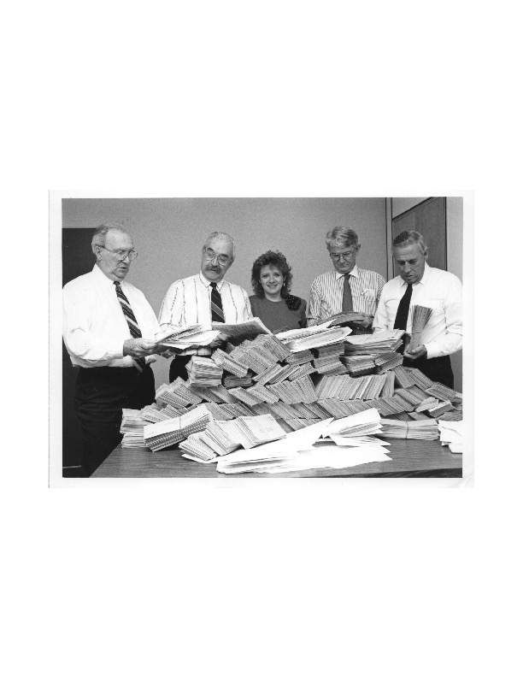

Réal Sabourin, Bernie Bougie, Lorraine Rose (Bernie Lockman’s secretary), Daniel Mulvihill, and Clarence Smith going through early returns for the Heritage Club.

