

Exciting new changes to our Membership Policies have been put into place. Now your friends and family can join our club as an Associate member and take advantage of all the great rewards and benefits that are available.

Also, a big change was put into place so all employees of Canada Post can join the Heritage from day 1 of their employment as an Associate Member. After your years of service has reached 25+ for active employees and 10+ for retired employees, your category will change from Associate Membership to Full Membership.

Please welcome J.P. Leguerrier as our new National President for the Canada Post Heritage Club. I have decided to retire as the National President after 15+ years of service, however will continue as the Bluewater Chapter President. This was not an easy decision, however, I felt I needed more time with my family.

I have just returned from our Annual General Meeting in Edmonton, Alberta. Several new changes were put into place at this meeting. Some of these changes may reflect abilities for your friends and families to join our organization and become members of the Heritage Club. Further details will be explained in this newsletter.

I hope everyone is enjoying the weather, now that Spring and Summer are upon us. If you are taking a vacation during this time period, please drive carefully and make sure you have your Medoc Travel Insurance in place through Johnson Insurance. As you may know, we as Canada Post Heritage Club Members, receive a great savings and coverage on this product.

Our deepest sympathies go out to the friends and families of our Bluewater Chapter members who have passed away.

* John Butcher – Leamington, Ontario
* Mary Huffman – Leamington, Ontario
* Lucien Legault – Windsor, Ontario
* Ken Davis – Windsor, Ontario
* Gordon Yoell – Windsor, Ontario

# MEMBERSHIP

1 President’s Message

2 Membership

3 Lost Trails

4 Obituaries

**5** Annual Golf Tournament

6 Recycle

7 Sarnia Visit

8 Santa Letter Writing

9 Change of Address

10 Johnson Insurance Scholarship

**Bluewater Chapter**

**June, 2017**

# HERITAGE CLUB

**est. 1989   |   People helping people**



# President’s Message

**Obituaries**

* Kevin Crawford – Chatham, Ontario
* Robert Cummings
* Herve Daignault
* Marjorie Daye – Corunna, Ontario
* Frederick De Weyn – Wallaceburg, Ontario
* Marc Denis – Windsor, Ontario
* Leon D’Hondt
* Roland Digou
* Karen J Ducharme – Windsor, Ontario
* Janice L. Durfy – Wallaceburg, Ontario
* Norma Elder – Forest, Ontario
* Henry Emery – Essex, Ontario
* Rodger Emslie – Windsor, Ontario
* Joseph Farrugia –Windsor, Ontario
* James Filby –Chatham, Ontario
* Gabriel Filiatrault – Shallow Lake, Ontario

The names below are Chapter members we have lost contact with. Please contact us at [campbellkid1@bell.net](mailto:campbellkid1@bell.net), if you can help locate these members.

# Lost Trails

You will find the application for our Annual Golf Tournament attached to this newsletter. Every year we have an increase of players and it is so nice to gather together as a group for a fun day of golf. We hope this year we can increase our tournament even more to a total of 144 players. This is our goal!

Each year we ask for contributions of non-perishable food items for our local food banks. Please be generous for those in need within our own communities.

The tournament will take place on Thursday, August 17, 2017 with a shotgun start at 10:30 am at Countryview Golf Club, Chatham, Ontario. It would be nice to have some golfers from the Sarnia Area join us this year!

# Annual Golf Tournament

# Sarnia Visit

We are looking forward to gathering in Sarnia, on July 13, 2017. If you are a member in Sarnia or the surrounding area, please come out and join us for Coffee Hour at 1105 Lambton Mall Rd, Sarnia, Ontario at 2pm. It will be our pleasure to treat each of you. We are excited to increase our involvement in the Sarnia area.

**Recycle your old Eye Glasses**

Our chapter is going to start collecting your old eye glasses to donate to those less fortunate than ourselves. Providing the gift of sight, can change someone’s life. You can send them to either:

1. Bob Emmons – 12448 County Rd 34, RR#1, Maidstone, Ontario, N0R 1K0
2. Holly Perreault – 3350 Dolphin Court, Windsor, Ontario, N8R 2G7

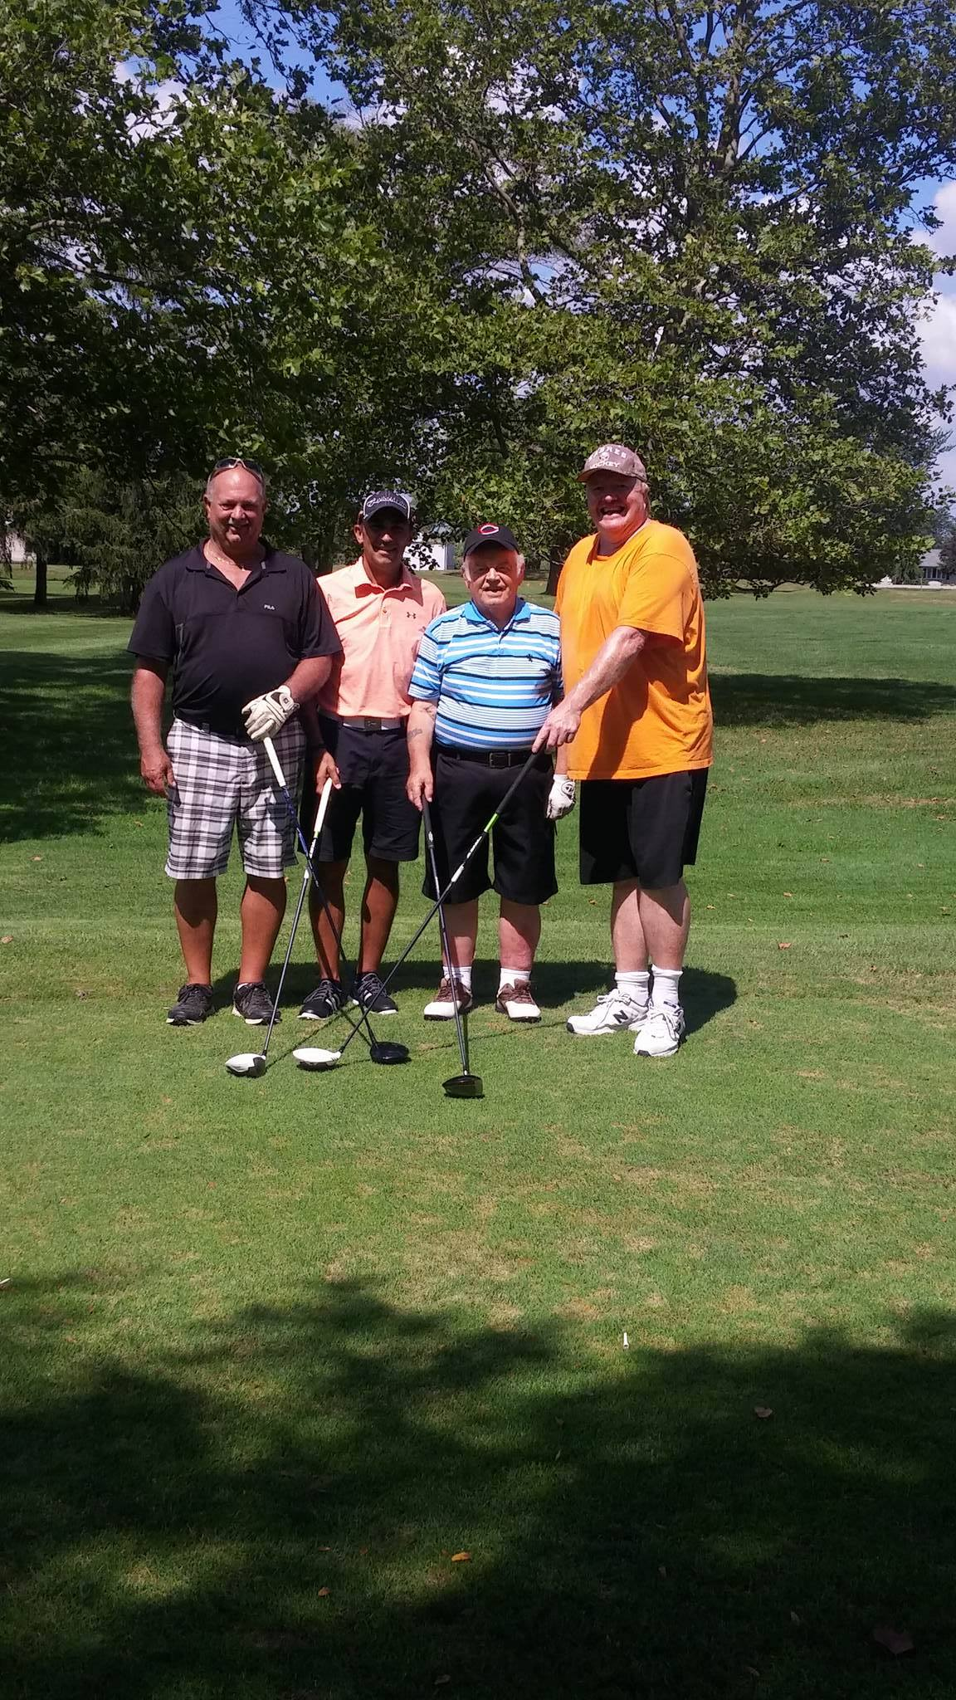

# Santa Letter Writing

The Christmas Season is getting closer day by day. The Canada Post Heritage Club is an important part of the Santa Letter Writing Campaign across our country and abroad. It is hoped that this holiday season we, as members of the Bluewater Chapter, can take a more active role in this project. If you would like to volunteer your time and make the difference in the life of a child, please contact me at, Bob Emmons [campbellkid1@bell.net](mailto:campbellkid1@bell.net) or at 519-737-0877

**CHANGE OF ADDRESS NOTICE**

Name:____________________ Heritage Club National Membership #:____________

Old Address:__________________________________________________________

New Address:_____________________________________________________________

Postal Code:__________________ Phone Number:________________________

Email:______________________________ Effective Date: _________________



#### 

#### **The 2017 Johnson Scholarship Program is open and applications can now be submitted.**

#### **Who May Apply**

To apply, applicants must be:

* a resident of a province or territory in Canada (other than Quebec);
* completing high school in 2017; and,
* enrolled full-time for the fall 2017 academic term at a recognized Canadian post-secondary institution.

Applicants must also fall into **one** of the following categories:

* have a home or auto policy through Johnson;
* be a member/employee of a Johnson recognized group*;
* have a parent/guardian or grandparent who has a home or auto policy through Johnson;
* have a parent/guardian or grandparent who is a member/employee of a Johnson recognized group*, and has a home or auto policy or group benefit plan through Johnson;
* have a parent/guardian or grandparent who is a member/employee of a Johnson recognized group*, but does not have a home or auto policy or group benefit plan through Johnson; or
* be a child/grandchild of a Johnson employee.

#### 

#### [**Online Application Form**](http://johnsonscholarship.2017.sgizmo.com/s3/)

Applications shall be submitted on the completion of the applicant’s graduating year of high school.

Completed application forms must be submitted by August 31, 2017 and must include an official high school transcript of your final year marks.

Please see the [online application form](http://johnsonscholarship.2017.sgizmo.com/s3/) to obtain full requirements and submission instructions.

#### 

#### **Scholarship Amount**

Johnson will award 50 scholarships each valued at $1,000 to students attending a post-secondary educational institution in Canada in the fall of 2017.

#### 

#### **Selection and Announcement of Winners**

An independent selection committee is retained to review and evaluate all applications and identify the successful candidates for 2017. Please note that the decision of the selection committee is final and not subject to appeal.  Selection of successful applicants will be completed by October 31, 2017.

#### 

#### **For More Information**

If you require further information, please call toll free 1-866-544-2673 or email [scholarshipfund@johnson.ca](mailto:scholarshipfund@johnson.ca).

*A Johnson “recognized group” means an employer group, professional association, alumni association, union or other group that has an insurance program agreement currently in force with Johnson

|  |
| --- |
| Chapter President – Bob Emmons |
| 1st Vice-President - Mike Belchuk |
| 2nd Vice-President – Lyle Drouillard |
| Newsletter – Holly Perreault |
|  |
| 3rd Vice-President |
| Treasurer – Mike Belchuk |
| Membership – Holly Perreault |