

President’s Message

Members:

Due to health issues, I regret that I must step down as President of the Trent Severn Heritage Chapter at the end of September 2018.

Since the term for any position is 2 years, the remainder of my position (2018-2019) will be filled by Phyllis Kimmerer until the elections for President at the 2019 General Meeting for 2020-2021.

The elections at the General Meeting this October will be for Vice President (vacant), secretary (vacant) and treasurer’s position, currently Phyllis Kimmerer.

Anyone wishing to volunteer for these positions must declare their intention in writing to me at trentsevern22@hotmail.com by Sept 15, 2018 and must attend the General Meeting at the Carousel Restaurant on Wednesday October 3, 2018.

You must be a dues paying member to qualify.

On a much more pleasant note it was nice to see some new faces at

our Barrie luncheon and it was my honor to present to Bob Duff a gift

from the Heritage Club for his volunteer work as a Santa Elf.

I have enjoyed being President of the Trent Severn chapter for the

past 5 years and wish to thank all of you for your support to the club

and to me. I’ll still be around just not the big chief.

Thank you

L.W.K.

Les Kimmerer

President Trent Severn Chapter

trentsevern22@hotmail.com or 1 705-320-9480

Name________________________ Address____________________

I am interested in being active in the chapter yes_______ no_______

I would consider being an executive participant yes_______ no_______

iMalesuada quis, egestas quis, wisi. Donec ac sapien. Ut orci. Duis ultricies, metus a feugiat porttitor, dolor mauris convallis est, quis mattis lacus ligula eu augue. Sed facilisis. Morbi lorem mi, tristique vitae, sodales eget, hendrerit sed, erat lorem ipsum dolor.

Vestibulum eget purus vitae eros ornare adipiscing. Vivamus nec quam. Integer vestibulum malesuada libero. Sed vehicula fermentum leo. In condimentum. Nullam wisi arcu, suscipit consectetuer. Vestibulum imperdiet nonummy sem. Vivamus sit amet erat nec turpis tempus consequat. Praesent malesuada. Donec vitae dolor. Donec at lacus ac mi vehicula bibendum. Donec feugiat tempor libero. Nam uut, massa. Maecenas vitae ante et lacus aliquam hendrerit.

Curabitur nunc eros, euismod in, convallis at, vehicula sed consectetuer posuere, eros mauris dignissim diam, pretium sed pede suscipit. Fusce urna magna,lorem neque eget lacus.

Adiam condimentum purus, in Proin in sapien.

Fusce urna magna,neque eget lacus. Maecenas felis nunc, aliquam ac, consequat vitae, feugiat at, blandit vitae, euismod vel, nunc. Aenean ut erat ut nibh commodo suscipit. Fusce urna magna,neque eget lacus. Maecenas metus non quam.

Cras erat. Aliquam pede. vulputate eu, estmorbi tristique senectus et netus et male. Aliquam pede. Proin neque est, sagittis at, semper vitae, tincidunt quis Malesuada quis, egestas quis, wisi. Donec ac sapien. Ut orci. Duis ultricies, metus a feugiat porttitor, dolor mauris convallis est, quis mattis lacus ligula eu augue. Sed facilisis. Morbi lorem mi, tristique vitae, sodales eget, hendrerit sed, erat. Vestibulum.

Nam uut, massa. Fusce urna magna,neque eget lacus. Maecenas vitae ante et lacus aliquam hendrerit.

Malesuada quis, egestas quis, wisi. Donec ac sapien. Ut orci. Duis ultricies, metus a feugiat porttitor, dolor mauris convallis est, quis mattis lacus ligula eu augue. Sed facilisis. Morbi lorem mi, tristique vitae, sodales eget, hendrerit sed, erat lorem ipsum dolor.

Vestibulum eget purus vitae eros ornare adipiscing. Vivamus nec quam. Integer vestibulum malesuada libero. Sed vehicula fermentum leo. In condimentum. Nullam wisi arcu, suscipit consectetuer. Vestibulum imperdiet nonummy sem. Vivamus sit amet erat nec turpis tempus consequat. Praesent malesuada. Donec vitae dolor. Donec at lacus ac mi vehicula bibendum. Donec feugiat tempor libero. Nam uut, massa. Maecenas vitae ante et lacus aliquam hendrerit.

Curabitur nunc eros, euismod in, convallis at, vehicula sed consectetuer posuere, eros mauris dignissim diam, pretium sed pede suscipit. Fusce urna magna,lorem neque eget lacus.

Adiam condimentum purus, in Proin in sapien.

Fusce urna magna,neque eget lacus. Maecenas felis nunc, aliquam ac, consequat vitae, feugiat at, blandit vitae, euismod vel, nunc. Aenean ut erat ut nibh commodo suscipit. Fusce urna magna,neque eget lacus. Maecenas metus non quam.

Cras erat. Aliquam pede. vulputate eu, estmorbi tristique senectus et netus et male. Aliquam pede. Proin neque est, sagittis at, semper vitae, tincidunt quis Malesuada quis, egestas quis, wisi. Donec ac sapien. Ut orci. Duis ultricies, metus a feugiat porttitor, dolor mauris convallis est, quis mattis lacus ligula eu augue. Sed facilisis. Morbi lorem mi, tristique vitae, sodales eget, hendrerit sed, erat. Vestibulum.

Nam uut, massa. Fusce urna magna,neque eget lacus. Maecenas vitae ante et lacus aliquam hendrerit.

Trent Severn Chapter

Summer 2018

What’s to come at a glance?

Lunch at Boston Pizza in Lindsay

Bob Wludyka’s monthly lunch

Trent Severn Annual Charity Golf Tournament

Santa Claus Letters

Lunch at the Carousel in Peterborough

Elections & Yearly Meeting

Points of Interest

Each year one of the Heritage Chapters hosts the Annual General Meeting (AGM)
This year all three Toronto Chapters (Humber, Simcoe & Pineridge) as well as the Trent Severn Chapter hosted the AGM in Toronto.
The presidents of the Heritage club from across Canada as well as the Heritage Club Executive attend this meeting.

Discussions included expectations, suggestions on promoting memberships, awards for various accomplishments to the chapters,
a presentation by Johnson’s Insurance and a presentation from the charity that the Heritage Club donates to that year. This year Heritage Club donated to Sick Kids Hospital.

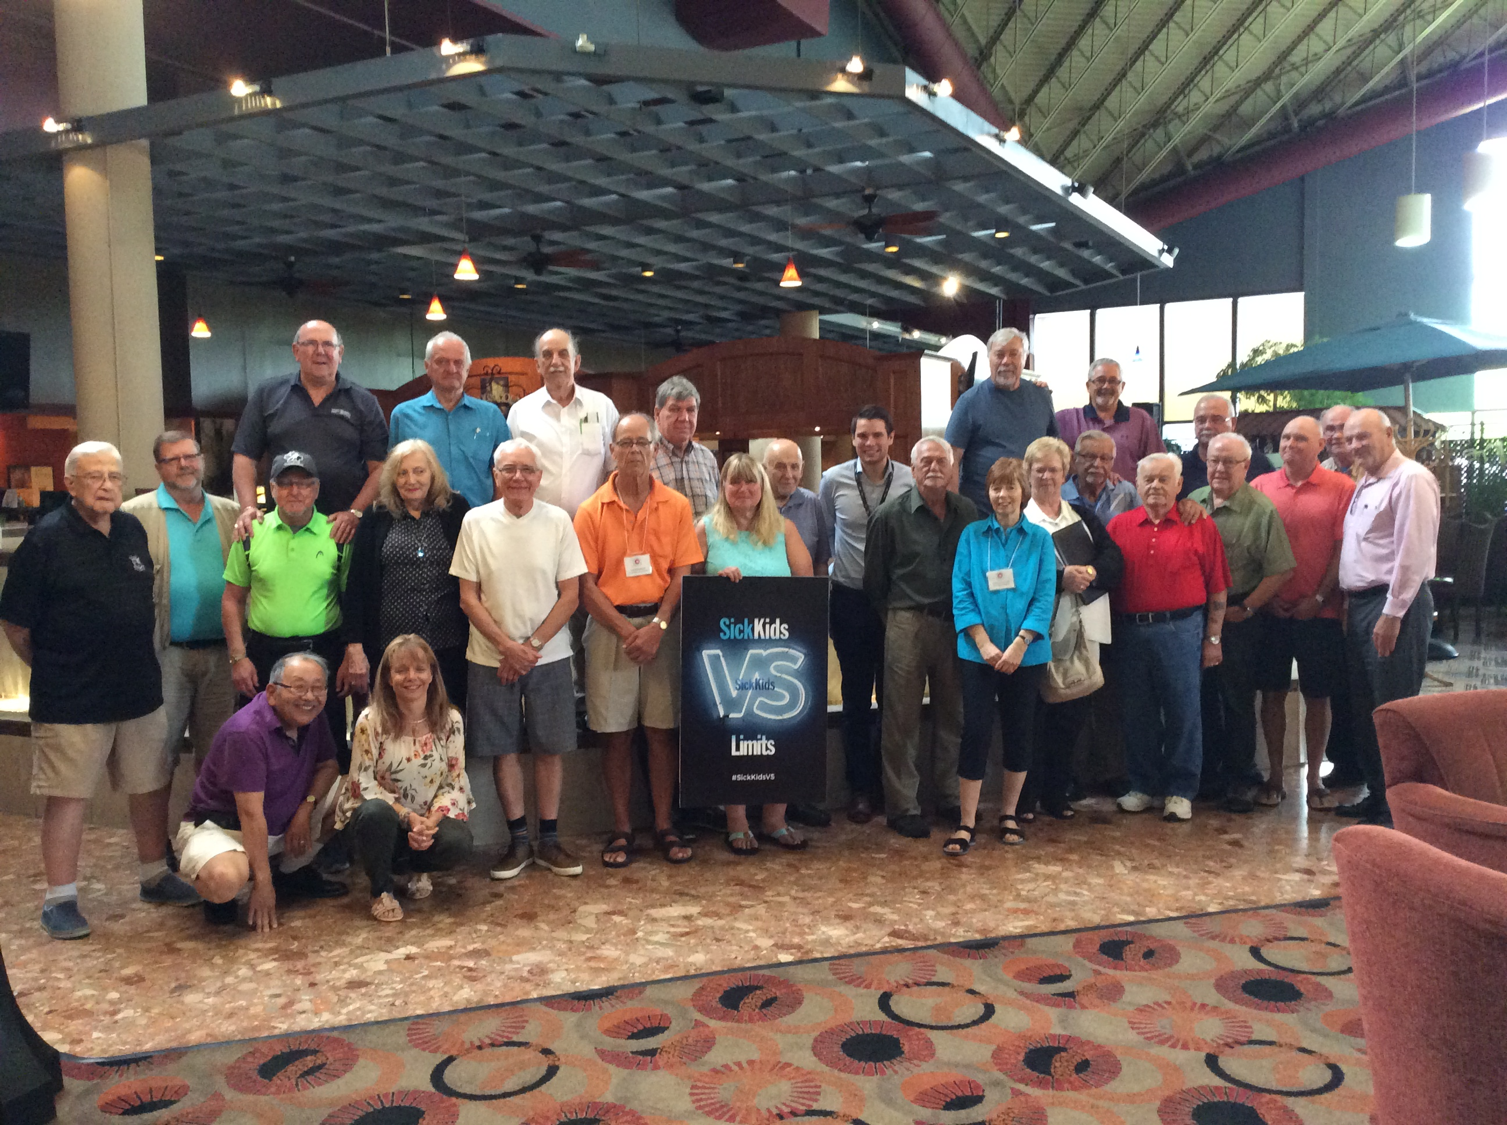

Aidan Carroll was the representative from Sick Kids. We were shown videos of all the programs available at Sick Kids as well as the plans for a new and modern hospital to be built on site.

Trent Severn Chapter is pleased to have donated $300.00 to the Sick Kids Foundation. This donation was possible because of the dues paying members of our chapter. Thank you to all our dues paying members.

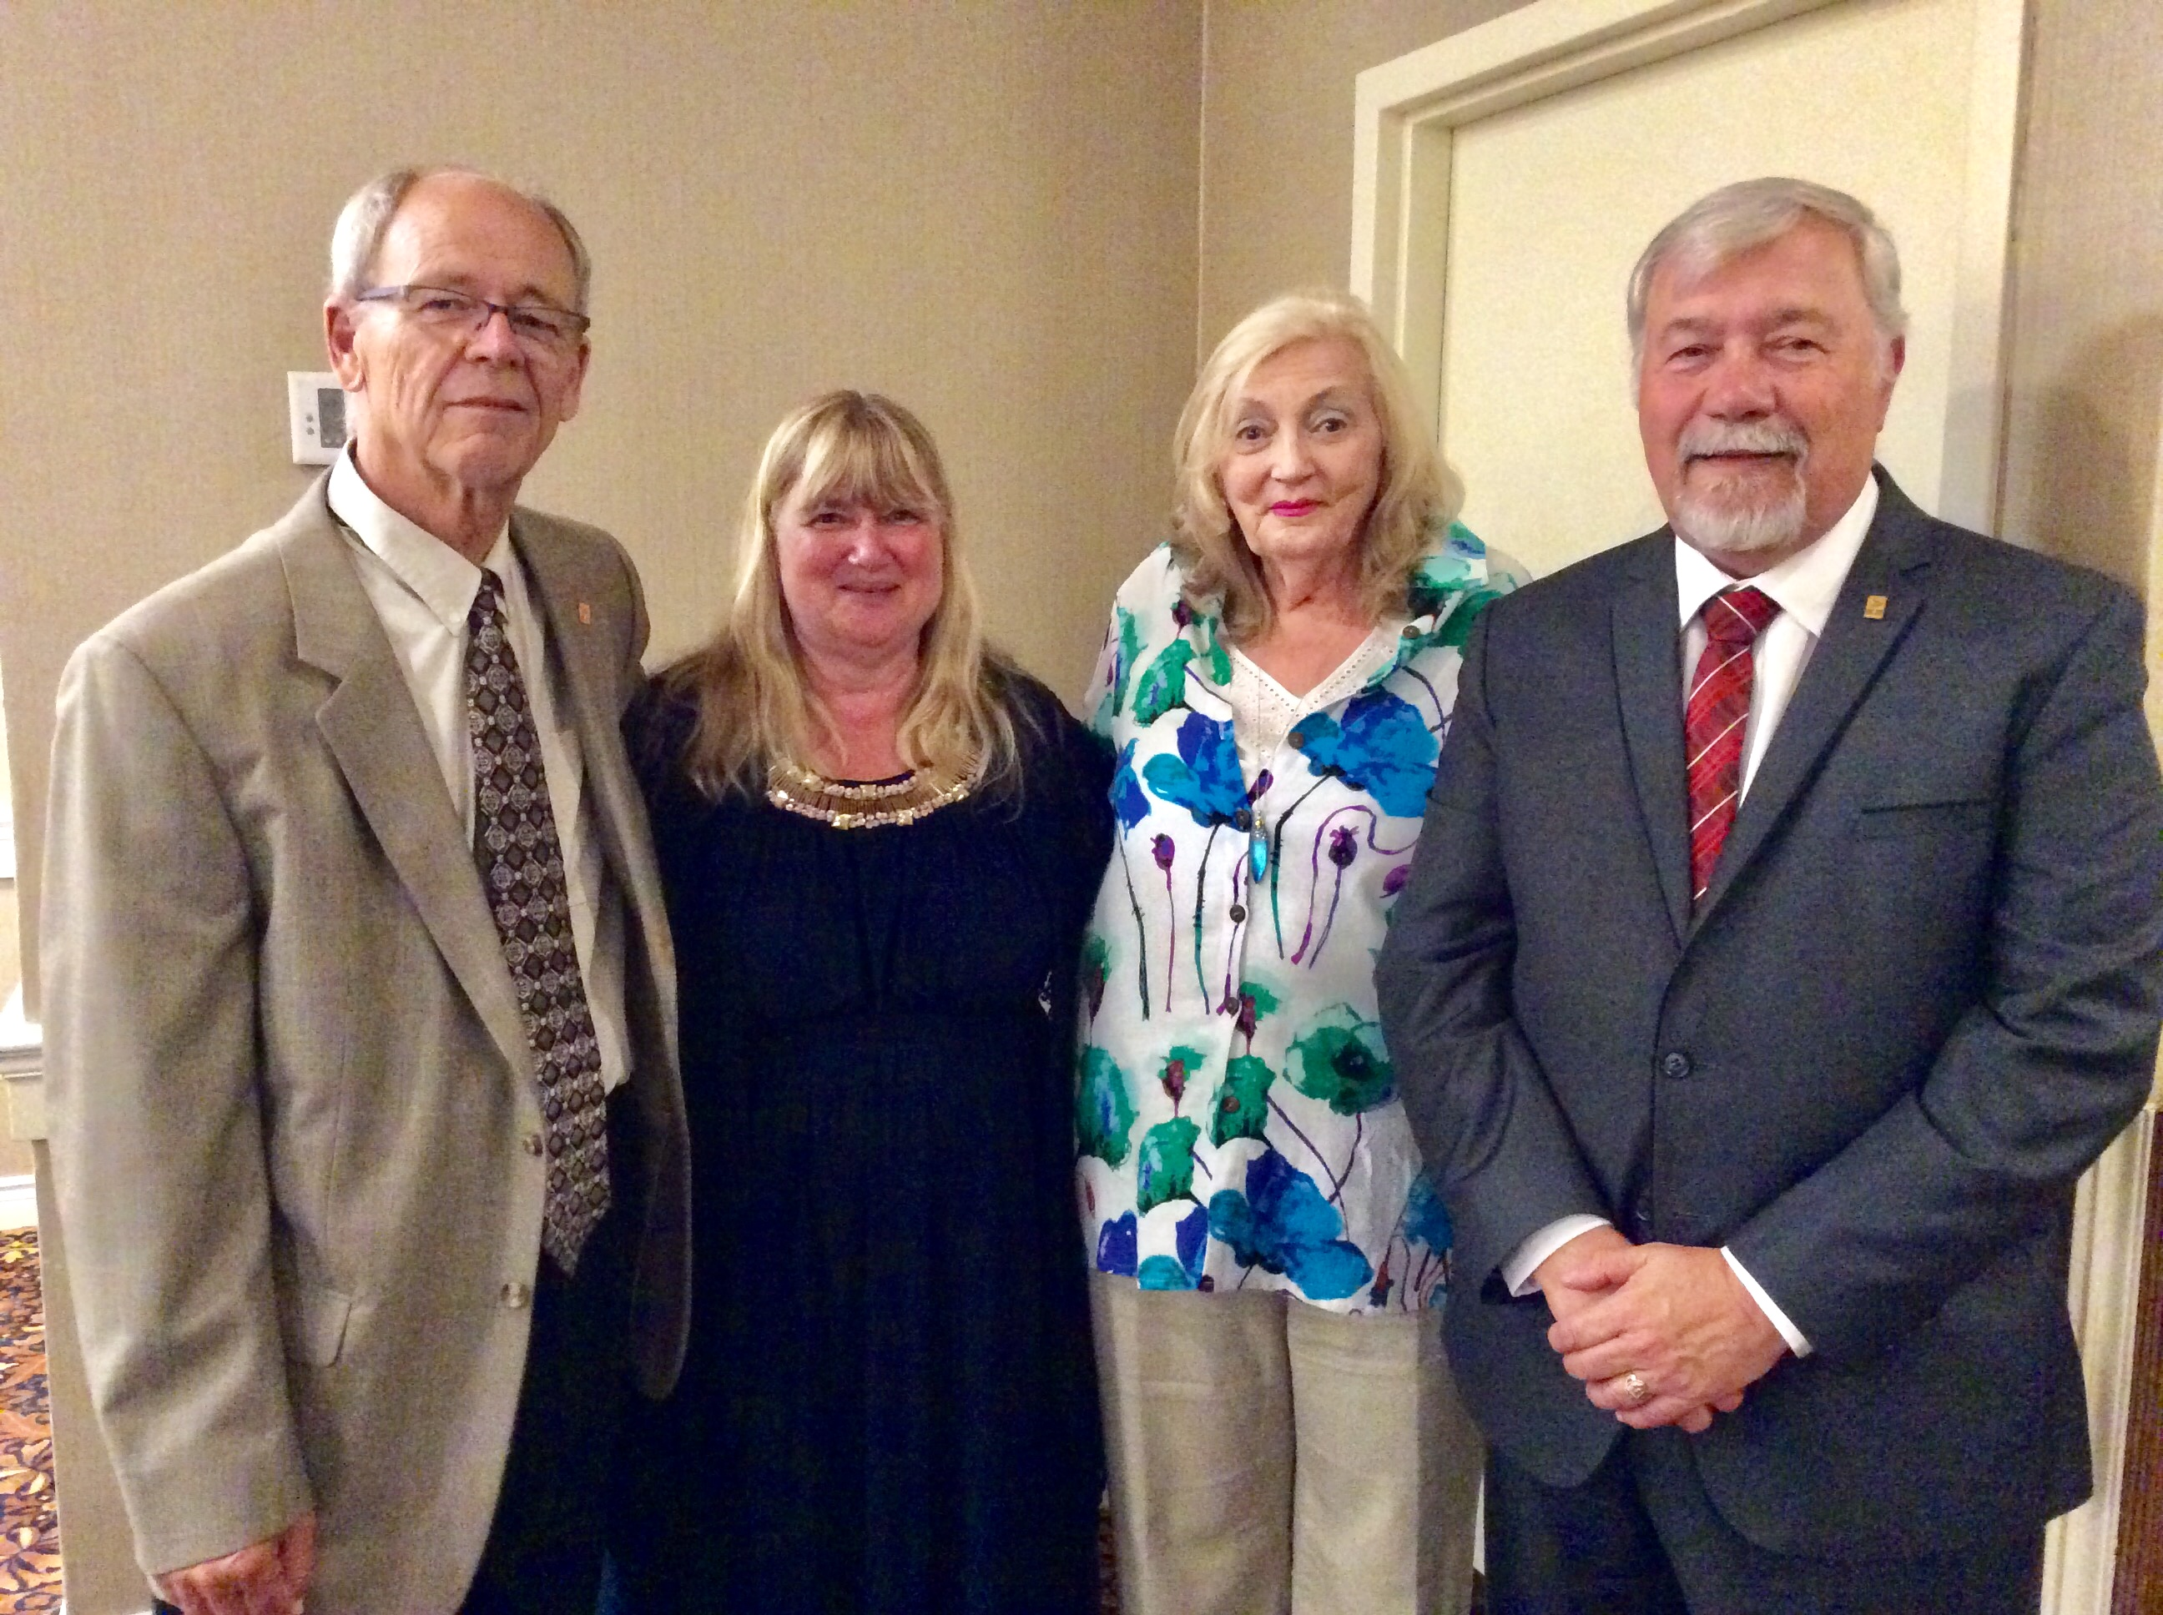

AGM MEETING 2018

Les Kimmerer- Pres. Trent Severn; Lea Maynard – Pres. Simcoe;
Diane Biggs- Pres. Humber and J.P. Leguerrier- Pres. Pineridge and National Executive Pres.

One of the presentations at the AGM was a gift given to volunteers for the Santa Letter writing Program.

Each year all the “Santa Letter Writing” volunteers’ names are put in a draw and randomly drawn. The winners are presented at the AGM to the Chapter Presidents.

Trent Severn is happy to announce that Bob Duff’s name for our Trent Severn Chapter was one of the names drawn.

Bob Duff was presented with his gift at our annual Barrie luncheon.

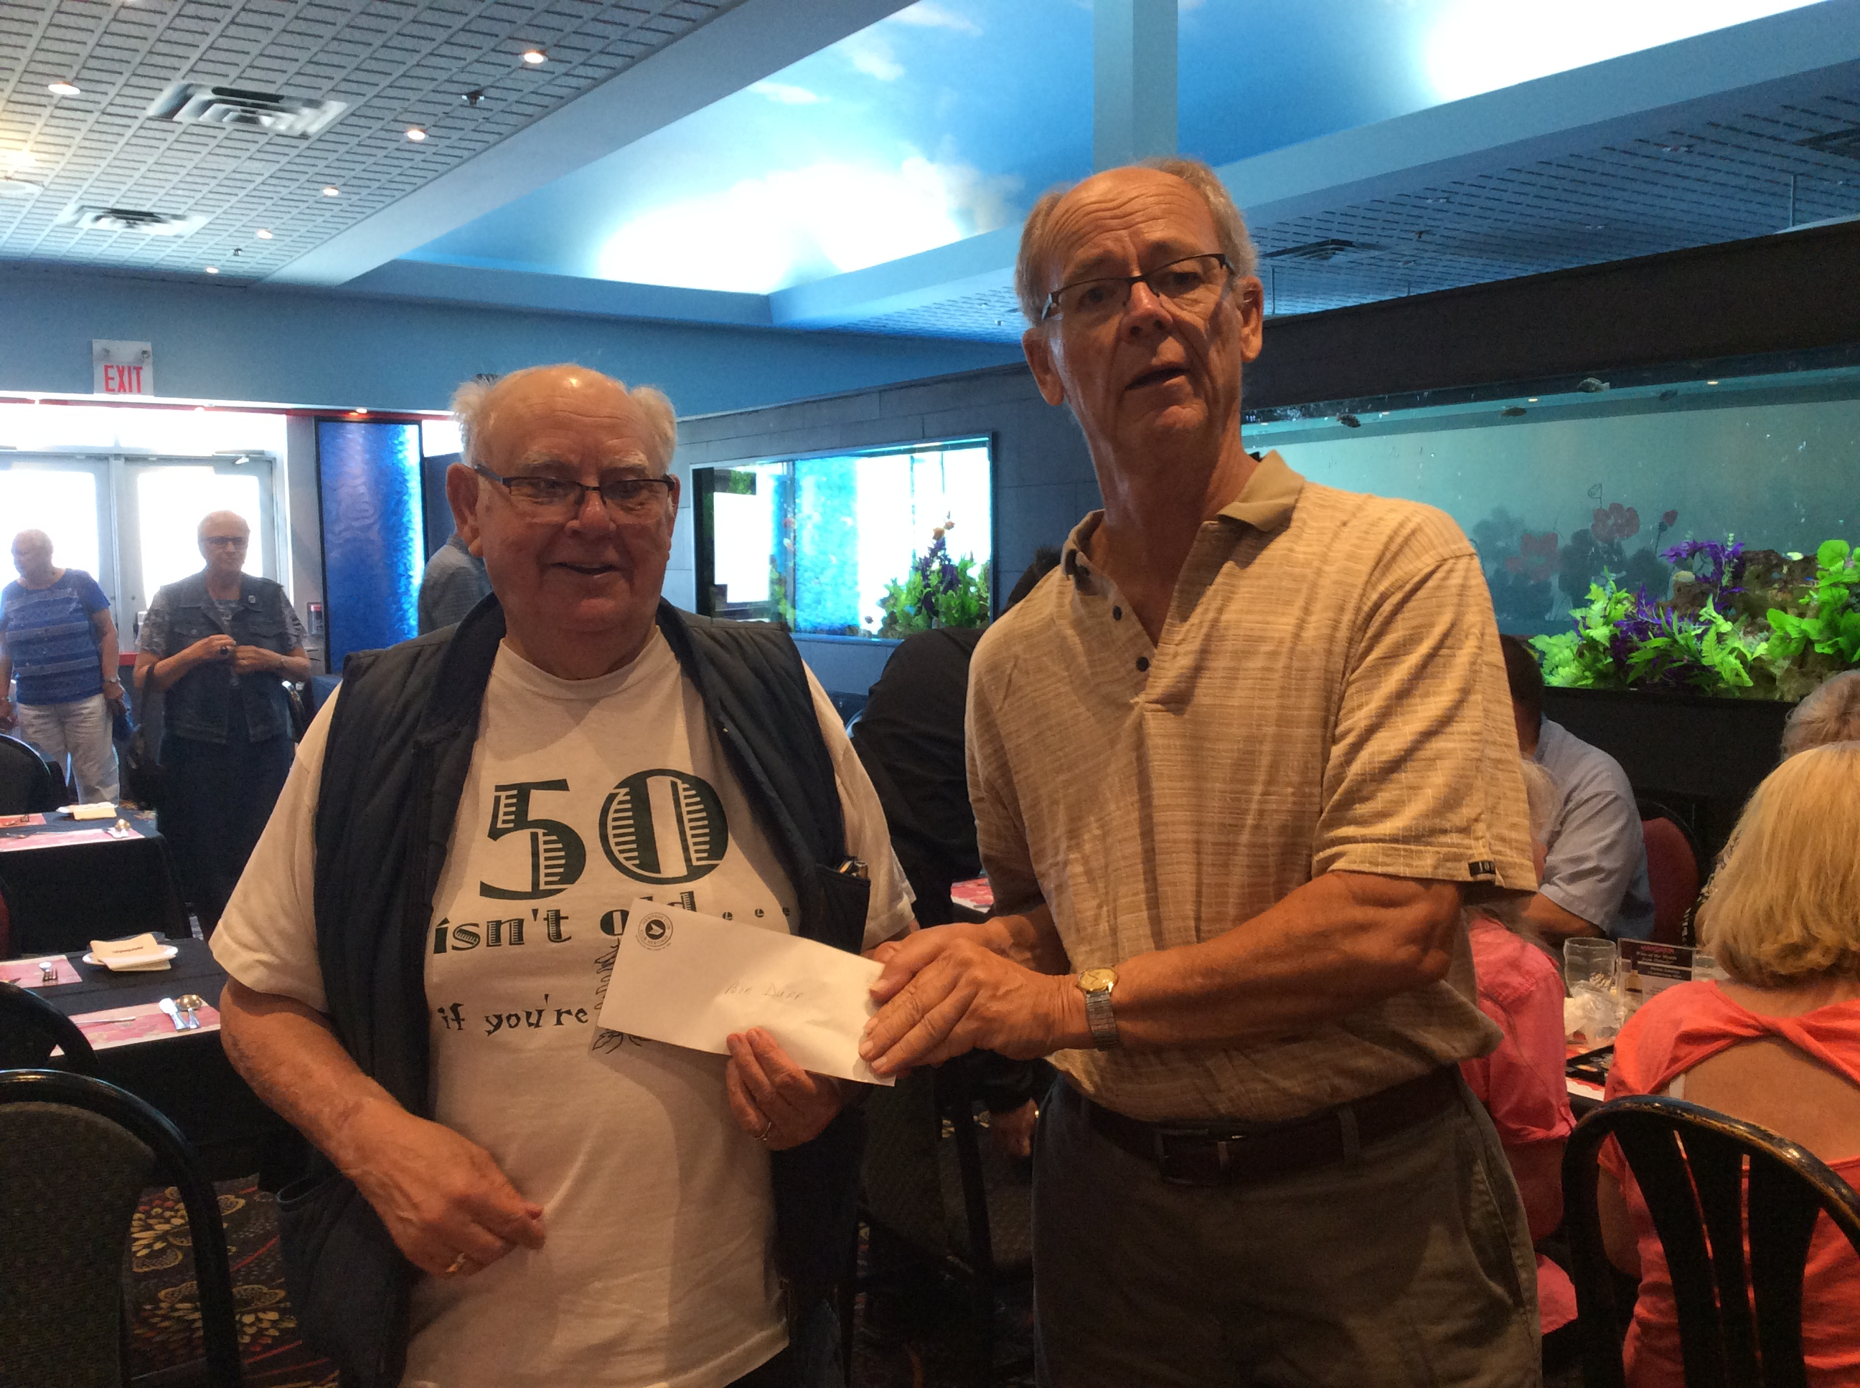

The turnout at our Barrie luncheon at the Mandarin was great.
Everyone had a good time and enjoyed meeting fellow Heritage members. It was nice to see some new faces.
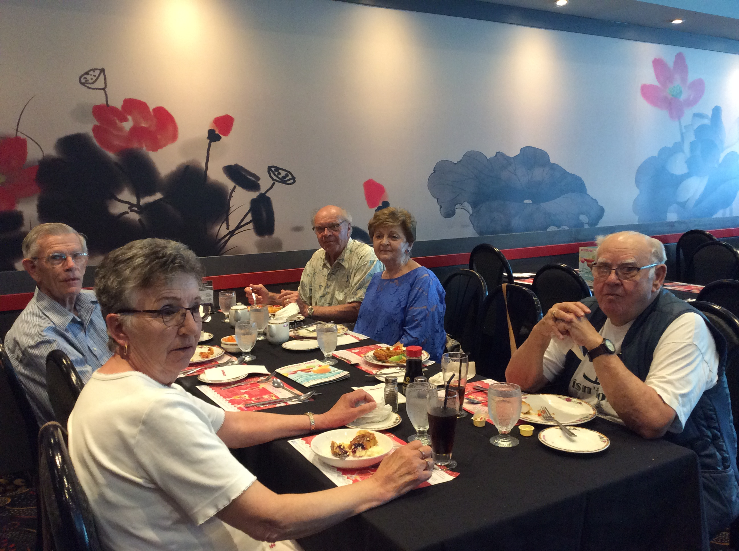

More pictures of our Barrie Lunch

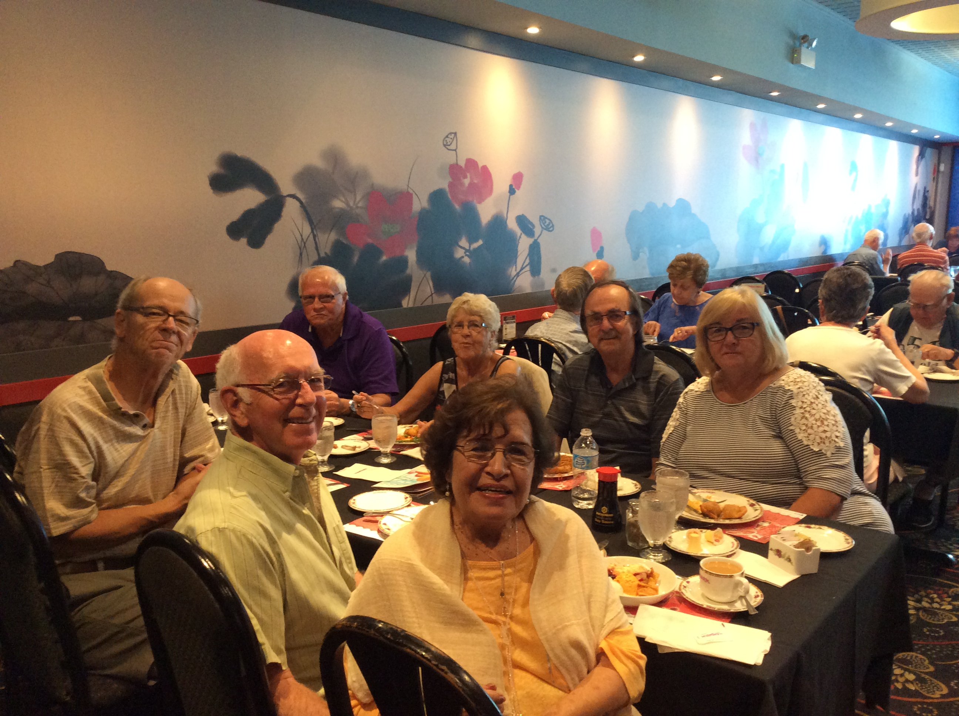

Thanks to all who attended.

Our next luncheon is:

Tues August 14, 2018 at 12:00 P.M. at Boston Pizza in Lindsay
The address is 435 Kent St w. in Lindsay, On K9V 6C3

Join us for Pizza Tuesday. Paid members $10.00 and non-paying members and guests $15.00
Don’t forget your donation to the food bank. A non-perishable item is appreciated.

Reserve with Les Kimmerer at trentsevern22@hotmail.com or
1 705-320-9480 by August 10, 2018

Our final luncheon of the season will be at the Carousel Restaurant on Wednesday October 3, 2018 at 12:00 PM
116 Lansdowne St E. in Peterborough, On

Paid members $12.00 and non-paying members $15.00

Donations to the Food Bank will again be greatly appreciated.

Reserve with Les Kimmerer at trentsevern22@hotmail.com or
1-705-320-9480

Our yearly elections will be held at our general meeting at the Carousel Restaurant in Peterborough

The positions up for election are:

1st Vice President and Secretary – currently vacant and Treasurer’s position, currently Phyllis Kimmerer.

All positions are held for 2 years.

Pineridge Golf Tournament – Friday June 22,2018
Members of Pineridge, Simcoe and Trent Severn Chapters attended
Les Kimmerer, President of Trent Severn Chapter was MC.

1st place winners:
Bruce Stephen
Mike O’Neil
Rick Collins
Jim Hunter

Closest to the Hole (men) Closest to the Hole (women)
Mike O’Neil Cheryl Leith

Longest Drive (men) Longest Drive (women)
Bruce Stephen Cheryl Leith

Putting contest: shared by Don Harris & Don Harris Jr.

Congratulations to Justin Fisher who had a hole in one!
Scholarship Program 2018

Johnson Insurance is proud to offer 50 scholarships, valued at $1000.00 each, to students completing high school in 2018 and stating post-secondary education in the fall.

APPLICATION DEADLINE: August 31, 2018

For eligibility criteria visit johnson.ca/scholarship
1-866-544-2673

This application is for new graduates.

More on Bill C- 27

In October 2016, the Federal government introduced Bill C-27.
This legislation would allow employers to change employee pension plans, even after they have retired

Link to website: http://www.federalretirees.ca/en/Advocacy/Honour-Your-Promise

Santa Claus Letters

Once again I want to remind all our Santa Elves that we will look forward to their participation in the Santa Letter Writing program.
I will be contacting all Elves from last year to see if the Trent Severn Chapter can count on them this year.

For those who wish to volunteer, these letters are sent directly to your home along with response letters and envelopes. New volunteers are welcome. This is such a worthy cause and we appreciate all your efforts.

This year Trent Severn has committed to doing 2000 letters from our Chapter. Hopefully we will meet our goal. Whatever amount you do is greatly appreciated.

If you are interested in volunteering for this program, contact me, Les Kimmerer by October 24, 2017 at 705-320-9480 or email at trentsevern22@hotmail.com
Membership Advantages

Johnson Auto Insurance – exclusive savings up to 40%
Homeowners’ Comprehensive policy, members can benefit from over 30 new and improved home insurance coverage. Plus you get AIR MILES Reward Miles.
Discounts for you and who travels with you through Medoc Travel Insurance
Goodlife Fitness: discounts up to 50% off the regular all club access rates. www.goodlifefitness.com You will require your Heritage Club number to access information regarding this program
Choice Hotels: discounts of up to 20% at 325 locations in Canada and 6300 worldwide. Choice client ID # 00088652

Important: In order to benefit from these discounts, you must mention your Heritage Club membership number and you must have paid your membership dues to the Trent Severn Chapter for the current year, otherwise coverage could be denied or terminated

Newsletter Distribution
This newsletter is produced fives times a year and is distributed to every member and associate who has paid the annual dues to the Chapter. Also, a general distribution is made once a year to every person currently listed as retired, or has 25 years of service in our Chapter area. Articles of general interest for the newsletter are always welcomed from our members.

New Members
New members will receive our Trent Severn Chapter newsletter in the current year of becoming a Heritage member, after that, they need to signify their intent to join by paying dues to the Chapter yearly in order to continue to receive our newsletters.

REMINDER

To those members who have not paid their 2018 dues as of yet, we would appreciate your attention to this matter.

New Members: Welcome and Congratulations:

Mark Miller – Norwood, On

BELLEVILLE COUNCIL

Bob Wludyka heads the council chapter in Belleville. Along with his executive and volunteers he organizes and participates in a great many functions. Some of which are as follows:

Monthly lunches held at the end of each month
Bus Trips
50/50 draws
Beer cans and liquor bottles drives – For charity
As well as other charity drives
He has also been responsible for establishing the Belleville Postal Museum.

Bob is enthusiastic about sharing ideas and events in the Belleville area.

His next luncheon is on Monday, July 30, 2018 at Royal Buffet Gardens at 365 North Front St in Belleville, On.

Anyone living in or around Belleville who would like to join in any of Bob’s functions, can contact him by phone or e-mail. bdwludyk@gmail.com or 613-986-3874

Check out our website at www.heritageclub.ca to see some of his functions.

The motto of the Heritage Club is “People Helping People”: we would like to know of any activity you are currently participating in that benefits people and/or the community and how many hours you spend per month. This is one of the criteria we are measured on by Canada Post and it affects our funding.

TRENT SEVERN HERITAGE CHAPTER
CHARITY GOLF TOURNAMENT

SATURDAY SEPTEMBER 8, 2018

1:00 P.M.

DEER RUN GOLF COURSE
10 BROOK STREET
LITTLE BRITIAN, ON
K0M 2C0

TEL: 705 328-3781

8 KM SOUTH OF HWY #7 ON ELM TREE ROAD
SOUTH OF THE FLASHING LIGHT

INCLUDES

12 HOLES WITH CART

STEAK DINNER

PRIZES

$70.00 EACH

PUTTING CONTEST 3 BALLS FOR $5.00

50% TO WINNERS / 50% TO CHARITY

*********************
CONTACT: LES KIMMERER @ 705 320-9480
OR trentsevern22@hotmail.com

*********************
PLEASE REPLY BY AUGUST 29, 2018



YOUR EXECUTIVE MEMBERSHIP

Chapter President: Les Kimmerer, Writer-Editor Newsletter

Email: trentsevern22@hotmail.com

1st Vice President: – Vacant

Treasurer: Phyllis Kimmerer

Secretary: Vacant

BELLEVILLE COUNCIL

BOB WLUDYKA – (613) 395-5225 E-MAIL: bdwludyka@gmail.com

Bruce Nickle

Dixie Locke

FORMS

---------------------------------------------------------------------------------------------------------------------------------------------------

CHANGE OF ADDRESS NOTICE

Name:

Old Address:

New Address:

Postal code:

Phone number:

MEMBERSHIP DUES RENEWAL

Name:

Address:

Postal Code:

Phone Number: Renewal for Self? $10.00 Couple? $20.00

Reminder: have you enclosed dues? Amount Enclosed

----------------------------------------------------------------------------------------------------------------------------------

Send completed forms and/or information to: Trent Severn Heritage Chapter.

91 Sweetnam Drive, Lindsay, On., K9V 0A6. You may also phone our Treasurer,

Phyllis (705) 320-9480

Cheques for luncheons and/or membership dues should be made out to Trent

Severn Heritage Chapter.

