THAMES HERITAGE CLUB NEWS
WINTER 2019/2020

Hello,

Winter is here with us again. The leaves we forgot to rake up and bag are now evident as we uncover them when we clean the driveway. Since our last newsletter we have had our Annual Banquet and Columbia Employee Store Invite. Thames Heritage Club Volunteers staffed the Salvation Army Kettle at Masonville Mall. In November we launched the Letters-To-Santa campaign. There is a section later in this newsletter on this campaign and how your Heritage Club supported this endeavour during the 2019 Christmas season.

Your Benefits
Contact Numbers

C.P.C. Pension 1-877-480-9220
Superannuation 1-800-561-7930
C.P.P. / O.A.S. 1-800-277-9914
Great West Life 1-866-249-5723
Access H.R. 1-877-807-9090
Employment Ins 1-800-206-7218
Passport 1-800-567-6868

Your Benefits
Survivor procedures: To ensure the survivor of a retiree maintains pension , health and medical benefits , a number of contacts must be made after the retiree’s death.

Access H.R. (1-877-807-9090)
..retiree name
..employee I.D. number
..social insurance number
..copy of death certificate
C.P.C. Pension (1-877-480-9220)
..retiree name
..employee I.D. number
..postal code
..month and date of birth
..copy of death certificate
Great West Life (1-866-249-5723)
..retiree name
..employee number
..copy of death certificate
..plan numbers ..51057 & 51391
NOTE: Very important to notify Great West as soon as possible in order to set up a new automatic withdrawl in the survivor’s name in order to keep policy in force and maintain medical , dental and vision benefits.
C.P.P. / O.A.S. (1-800-277-9914)
..retiree name
..social insurance number
..copy of death certificate
NOTE: Besides the survivor pension
there is also a death benefit
payable to the survivor.

SUPERANNUATION (1-800-561-7930)
..retiree name
..social insurance number
..copy of death certificate

Letters-To-Santa Campaign – 2019

This year your Heritage Club continued the expansion of the Santa Letter Program to cover local initiatives related to children. Letters-To-Santa stations were set up at the London Regional Children’s Museum , the Boys and Girls Club , Ronald McDonald House and the Children’s Hospital of Southern Ontario. In total , your Thames Heritage Club created replies to 3,278 Letters-To-Santa (2811 English & 42 French)

Boys & Girls Club

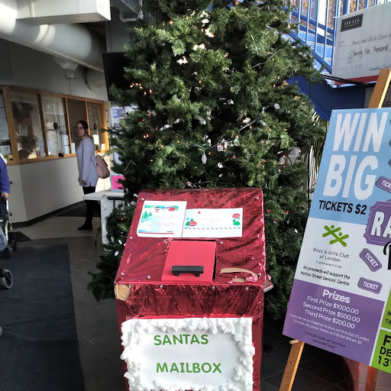

Ronald McDonald House

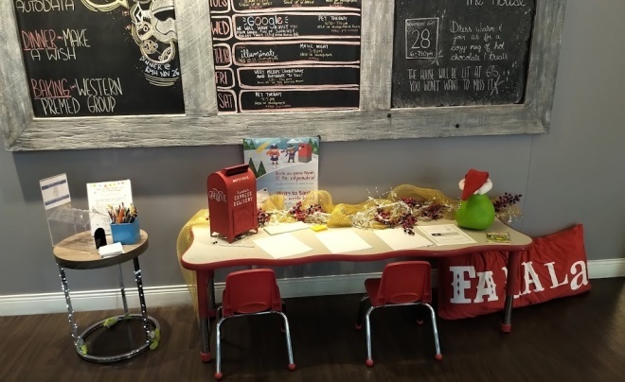

Children’s Museum
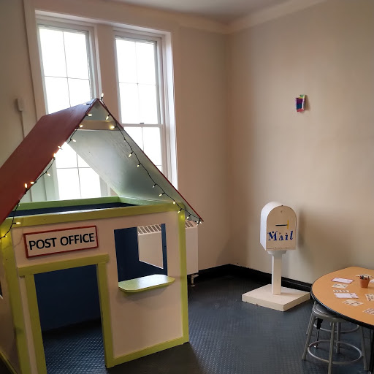

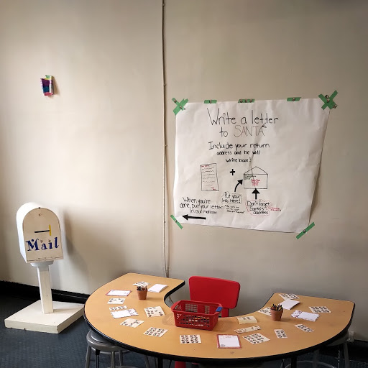

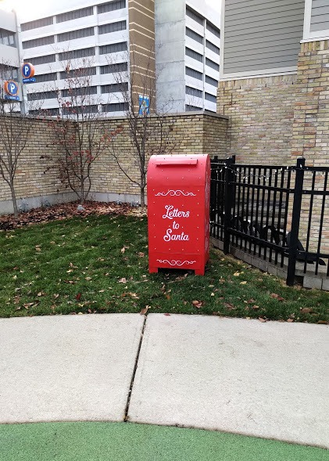

Children’s Hospital

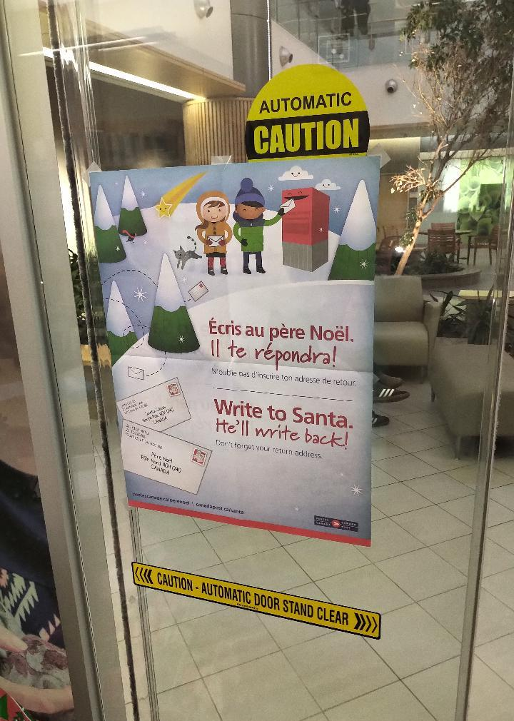

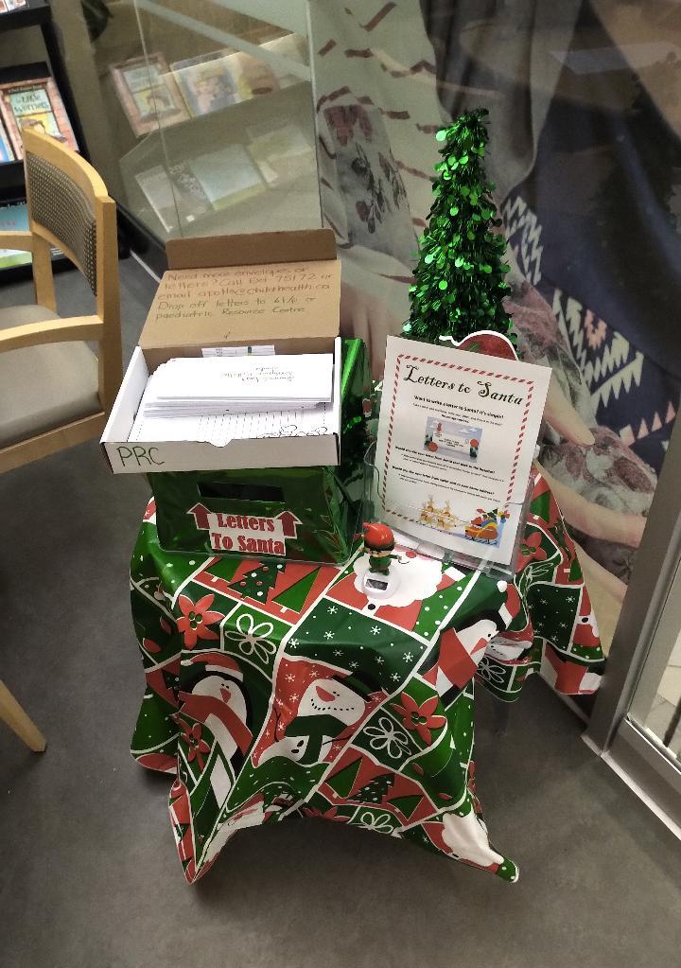

******************************

2020
Pension Indexing

Canada Post Pension………… 1.93%
C.P.P. ……………………… 2.00%
Superannuation …………… 2.00 %
O.A.S.....adjusted Jan , Apr , Jul , Oct

Annual Reunion Banquet

The 2019 edition of the Annual Reunion Banquet was held on October 26 , 2019 at the Hellenic Community Centre
133 Southdale Rd West in London. Approx forty seven people attended. A great night was had by all. Live musical entertainment was supplied by Celebrity Productions. Everyone
left with a prize ranging from a sightseeing flight for two , to a Columbia men’s winter coat to shopping centre and various gift cards. The food prepared on-site by staff was of high quality. Changes have been made in the menu to ensure the variety of selection and quantity we had become familiar with.

******************************

Volunteer Programs

Boys and Girls Club
people needed one afternoon per month to serve meals to kids

Salvation Army Kettles
(Nov 25th – Masonville Mall)

Santa Letter Campaign
Four Mondays starting in latter November through mid December
(Nov 18th thru Dec 16th)
** now expanded to include pick-ups from Children’s Museum , Boys & Girls Club up to Dec 13th . Ronald McDonald House and Children’s Hospital had on-site pick-ups up to and including Dec 24th.

Member Benefit Partner

Just in time for Winter Sale Shopping

Your Heritage Club has arranged another Heritage Club Invitation for members to shop at the Columbia Sportswear Employee Store in London. Card carrying Thames Heritage Club Members for year 2020 can shop and enjoy a discount of between 40% - 50% off brands such as Columbia , Sorel , Mountain Hard Wear and Prana. This is an invitation-only event which occurs four times per year. Club members are to have their current club I.D., photo I.D. and the invitation and present it at the employee store from Jan 3 – Jan 26 , 2020 and shop.
Each member can spread the joy and bring along up to four (4) family and/or friends.
Full details on attached Columbia Invite.

******************************

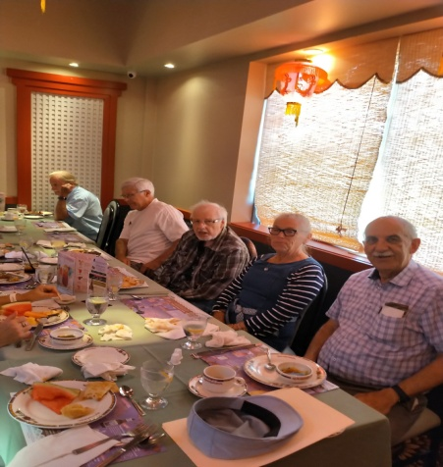

Volunteer Programs

Boys and Girls Club
people needed one afternoon per month to serve meals to kids

Salvation Army Kettles
(Nov 25th – Masonville Mall)

Santa Letter Campaign
Four Mondays starting in latter November through mid December
(Nov 18th thru Dec 16th)
** now expanded to include pick-ups from Children’s Museum , Boys & Girls Club up to Dec 13th . Ronald McDonald House and Children’s Hospital had on-site pick-ups up to and including Dec 24th.

******************************

Luncheons

In September 2019 we held a luncheon in Bayfield for our northern area members who may not be able to attend some of the London area social events.

In October 2019 a luncheon was held at the Mandarin in London

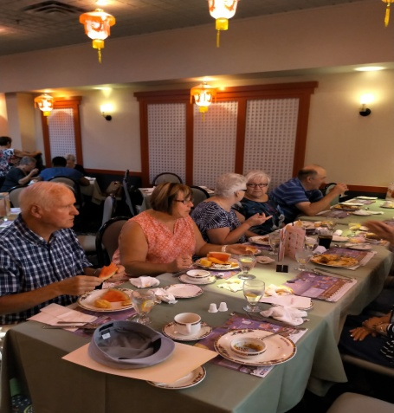

Membership Changes In 2019

Welcomed

Susan Browning
Tracie Cavanagh
Tim Costello
Walter Dowden
William Duncan
Rhonda Gibson
Catherine Haggith
Terri-Lynn Jenner
Marci Kosac
Tony Larusso
Ken Lloyd
Klaus Madinger
Donna McCreary
Jeff Moyes
Carolyn Moyne
Janja Pasic
Irene Shea
Manmohan Singhla
Rick Sutherland
Don Wright
Sue Zrini

Bid Farewell (In Memoriam)

Jack Arnold
Nicole Bigham
Catherine Capitano
Robert Elkerton
William George
Daniel O`Brien
Neil O`Neil
Rita Rose
Kenneth Sheppard
Marilyn Shoebottom
Gerry tapley
Joseph Vowles

Chapter Executive

President: Henry Masek
519-204-8873 thamesheritageclub@gmail.com

Vice-President: Don Manns
519-451-4959
Vice-President: Jane D’Earmo
519-453-7102
Treasurer: Stew Metcalf
519-660-4193
Secretary: Dianna Snell
519-601-0085

**************************

Heritage Club members receive up to 50% off - online registration with (paid-up) Thames Heritage membership

To learn more about this offer visit
https://corporate.goodlifefitness.com

[you will require your (paid-up) Thames Heritage Club number to access information regarding this offer]

REMINDER:

Any GoodLife renewals will be denied if 2020 dues are not paid.

Thames Heritage Club Card Renewal Time

For those of you who haven’t already done so , it soon will be time to renew the Thames Heritage Club Activity Card for 2020 through payment of the $12.00 annual dues.

Make cheque payable to
Thames Heritage Club and send to:
Thames Heritage Club
955 Highbury Ave
London , On N5Y 1A3

Some of the member benefits are …
- Discount of approx 50% at GoodLife Fitness
- 40% to 50% discount at Columbia Sportswear Employee Store Events
- very attractive travel insurance rates with Medoc (Johnson Insurance)
- discount on the cost of the Annual Banquet of Thames Heritage Club
- Annual Golf Tournament
- Periodic luncheons at the Mandarin and other eating establishments
- Up to 20% discount at Choice , Clarion , Comfort and Quality Hotels

******************************

Housecleaning

Death of member

In an effort to keep our information
up to date , we need to know when
any of our members is deceased.

TRAVEL INSURANCE

Contemplating travelling south this winter ?

You should consider Medoc Travel
Insurance for your coverage.

Heritage Club members receive a substantially reduced rate on their travel Insurance.

One main interest to members is the
coverage for pre-existing medical
conditions. A member doesn”t have to be in perfect health to take advantage of these preferential rates.

Visit: johnson.ca/medoc
Call: 1-866-606-3362

******************************

Housecleaning

Aaddress change

To keep our mailing list current it
is necessary to have the latest proper
address of each member.

Send any changes to the above either
by mail to:

Thames Heritage Club
955 Highbury Ave
London , On N5Y 1A3

OR

by e-mail to:

thamesheritageclub@gmail.com

