THAMES CHAPTER HERITAGE CLUB NEWS FALL 2019

Hello,

Summer has now passed and the fall is here. The leaves will soon be changing colour. Your Heritage Club is preparing for a slate of events for the fall season including luncheons , Annual Banquet , another Columbia Employee Store shopping event and preparations for seasonal volunteer programs that will launch closer to the Christmas time period.

In This Issue:

- survivor contact procedures
- 2019 Fall Mandarin Luncheon
- Columbia Sportswear discount invite
- Patient Assistance Programs
- 2019 Heritage Golf Tournament
- GoodLife Fitness Memberships
- volunteer programs

Your Benefits
Contact Numbers

C.P.C. Pension 1-877-480-9220
Superannuation 1-800-561-7930
C.P.P. / O.A.S. 1-800-277-9914
Great West Life 1-866-249-5723
Access H.R. 1-877-807-9090
Employment Ins 1-800-206-7218
Passport 1-800-567-6868

Your Benefits
Survivor procedures: To ensure the survivor of a retiree maintains
pension , health and medical benefits , a number of contacts must be made after the
retiree’s death.
Access H.R. (1-877-807-9090)
..retiree name
..employee I.D. number
..social insurance number
..copy of death certificate
C.P.C. Pension (1-877-480-9220)
..retiree name
..employee I.D. number
..postal code
..month and date of birth
..copy of death certificate
Great West Life (1-866-249-5723)
..retiree name
..employee number
..copy of death certificate
..plan numbers ..51057 & 51391
NOTE: Very important to notify Great West
as soon as possible in order to set up
a new automatic withdrawl in the
survivor’s name in order to keep
policy in force and maintain medical
dental and vision benefits.
C.P.P. / O.A.S. (1-800-277-9914)
..retiree name
..social insurance number
..copy of death certificate
NOTE: Besides the survivor pension
there is also a death benefit
payable to the survivor.
SUPERANNUATION (1-800-561-7930)
..retiree name
..social insurance number
..copy of death certificate

Member Benefit Partner

Just in time for Summer Sale Shopping

Your Heritage Club has arranged another Heritage Club Invitation for members to shop at the Columbia Sportswear Employee Store in London. Club I.D. card carrying Thames Heritage Club Members can shop and enjoy a discount of between 40% - 60% off brands such as Columbia , Sorel , Mountain Hard Wear and Prana. This is an invitation-only event which occurs four times per year. Club members are to have their Thames Heritage Club I.D., photo I.D. and the invitation and present them at the employee store from Oct 04 – 27 , 2019 and shop.
Each member can spread the joy and bring along up to four (4) family and/or friends.
Full details on attached Columbia Invite.

Volunteer Programs

Boys and Girls Club
people needed one afternoon per month to serve meals to kids
Salvation Army Kettles
(Nov 23rd – Masonville Mall - London)
Salvation Army Hamper Program
Donations of knitted items to annual hamper
program for the needy each December
Santa Letter Campaign
Three to four Mondays in November through early December (always in need of help)
Children`s Health Foundation Telethon
Staff the phone bank at the Telethon collecting private and business donations
Patient Assistance Programs

As we age and require drugs due to ailments from diabetes to cancer , we often find that our medical plans only cover a portion of the cost. Some pharmaceuticals such as Chemotherapy drugs are very expensive. Some drug manufacturers have Patient Assistance Programs that will pay part or all of the cost above what medical plans cover. Some of these companies are
Astra Zeneca , Eli Lilly, Glaxo-Smith-Kline , Merck , Pfizer and Roche.
Make sure to contact the drug company who makes any costly medications to see if they have a Patient Assistance Program
These companies can be found on the web

***********************************

Golf Tournament
The 2019 edition of the Annual Thames Heritage Club Golf Tournament was held at the Crumlin Creek Golf Course on Wednesday , August 21 , 2019. It was attended by 28 golfers from our club as well as the Humber Heritage Club from Toronto. Top Mens Trophy went to Jim Yu while Top Womens Trophy went to Doris Lodin. Most Honest Golfer Trophy went to Sue Scott-Mallett.

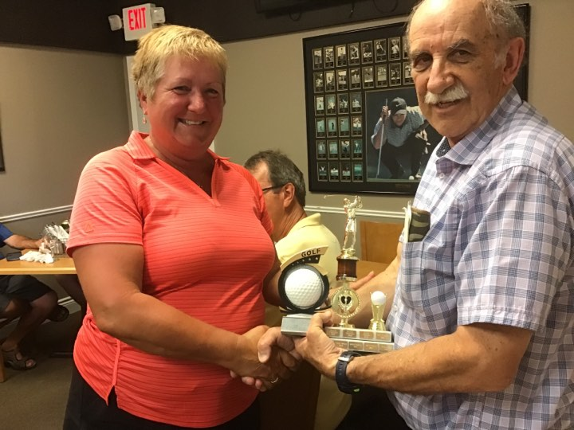
Winner – Women ... Doris Lodin
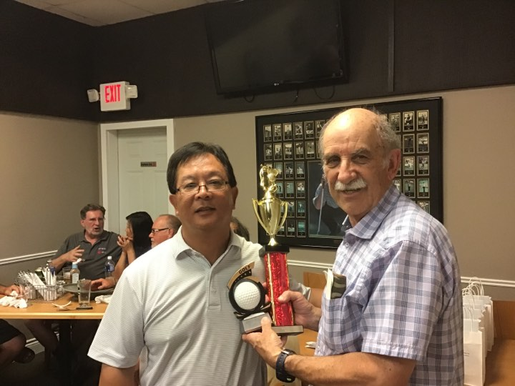
Winner – Men ... Jim Yu
************************************

Heritage Club members receive up to 50% off GoodLife memberships.

Online registration with paid-up Thames Heritage Club membership.

To learn more about this offer visit
https://corporate.goodlifefitness.com

(you will require your Thames Heritage Club Number to access information regarding this offer)
REMINDER:
Any GoodLife renewals will be denied if 2019 dues are not paid.

**********************************

Death of member

In an effort to keep our information
up to date , we need to know when
any of our members is deceased.

**********************************

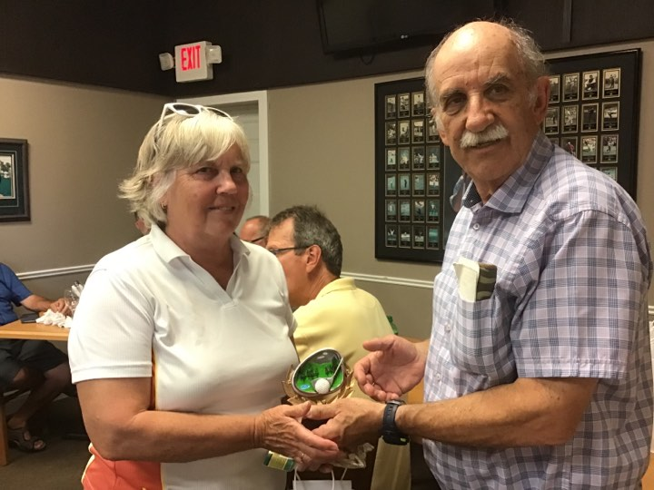
Most Honest Golfer ... Sue Scott-Mallett
************************************

Membership Changes for 2019

Welcome: 2019

Josette Boismier
Marilyn Boland
Susan Browning
Tim Costello
William Duncan
Rhonda Gibson
Terri – Lyn Jenner
Marci Kosac
Kenneth Lloyd
Klaus Madinger
Irene Shea
Manmohan Singhla
Don Wright

In Memoriam 2019

Jack Arnold
Nicole Bigham
Robert Elkerton
Daniel O’Brien
Neil O’Neil
Kenneth Sheppard
Leslie Rose
Marilyn Shoebottom
Gerry Tapley
Joseph Vowles

Luncheons

The 2019 edition of the Bayfield Luncheon
will be held in September exclusively for our members in the northern area of our club. Members will receive an invitation sent out to them in advance of the luncheon date. In 2018 the first edition of the Bayfield Luncheon was well attended.

Mandarin

A get together for members will also be held on October 1st at the Mandarin Restaurant in the Metro Plaza at Commissioners Rd & Wellington Rd in London. This year all seniors will be paying half price for their meal. Non-seniors will pay regular price. We managed to get 35 spots for this event so it will be open for reservations until I receive a total of 35. Send requests to attend the Mandarin Luncheon to
thamesheritageclub@gmail.com
or call me at ... 519-204-8873

Chapter Executive

President: Henry Masek
519-204-8873 thamesheritageclub@gmail.com

Vice-President: Don Manns
519-451-4959
Vice-President: Jane D’Earmo
519-453-7102
Treasurer: Stew Metcalf
519-660-4193
Secretary: Dianna Snell
519-601-0085

Heritage Club Membership Card Renewal

For those of you who haven’t already done so , it is time to renew the Thames Heritage Club Activity Card for 2019 through payment of the $12.00 annual dues.

Make cheque payable to
Thames Heritage Club and send to:
Thames Heritage Club
955 Highbury Ave
London , On N5Y 1A3

Some of the member benefits are …
- discounted fees at GoodLife Fitness
- 40% to 60% discount at Columbia Sportswear Employee Store Events
- very attractive travel insurance rates with Medoc (Johnson Insurance)
- discount on the cost of the Annual Banquet of Thames Heritage Club
- Annual Golf Tournament discount
- periodic luncheons at the Mandarin and other eating establishments

Members who are not sure if they have paid their 2019 dues may contact the club at the numbers shown on the contact listing or by e-mail to the Thames Heritage Club e-mail address also shown in this newsletter.

********************************
Address change

To keep our mailing list current it
is necessary to have the latest proper
address of each member.

Send any changes to the above either
by mail to: Thames Heritage Club
955 Highbury Ave
London , On N5Y 1A3
OR
by e-mail to:

thamesheritageclub@gmail.com

Travel
TRAVEL INSURANCE

If you are contemplating travelling south this spring , you should consider Medoc Travel
Insurance for your coverage.

Heritage Club members receive a substantially reduced rate on their travel
Insurance.

One main interest to members is the
coverage for pre-existing medical
conditions. A member doesn`t have to
be in perfect health to take advantage of
these preferential rates.

Visit: johnson.ca/medoc
Call: 1-866-606-3362

Tips for fooling home burglars while you’re away on vacation

- install motion sensor lights
- add “fake-TV” device
- have a car parked in driveway
- have someone collect mail , flyers , papers
- look into lawn / yard maintenance
- keep main floor blinds closed

Pre-retirement Reviews

A service provided by your Heritage Club is reviews of upcoming retirements to allow future retirees to discuss the documentation packages they will receive from Canada Post when retiring.

You can meet with your Heritage Club president to gain an understanding of what to expect in such areas as health , dental , vision and prescription benefits. Another topic which will be covered is pension benefits which will include beneficiary forms.

To set up a meeting please contact your Heritage Club president at 519-204-8873

*********************************

Member Ad

For Rent :

Fully Furnished , clean executive home in London , Ontario … available Nov – Apr
inclusively. $1,000.00 per month plus heat and hydro. For further info contact Rose at clweirz@gmail.com or call 705-929-6345

Annual Reunion Banquet

The 2018 edition of the Thames Heritage
Club Annual Reunion Banquet will be held on Saturday , October 26 , 2019 at the Hellenic Community Centre located at 133 Southdale Rd West in London.

Social Hour starts at 5:30 P.M.

Dinner starts at 6:30 P.M. followed by entertainment from Celebrity Productions.

***********************************
Additional images from the Golf Tournament

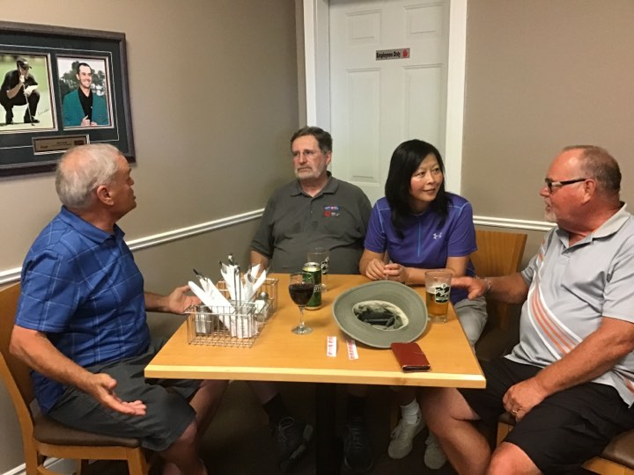
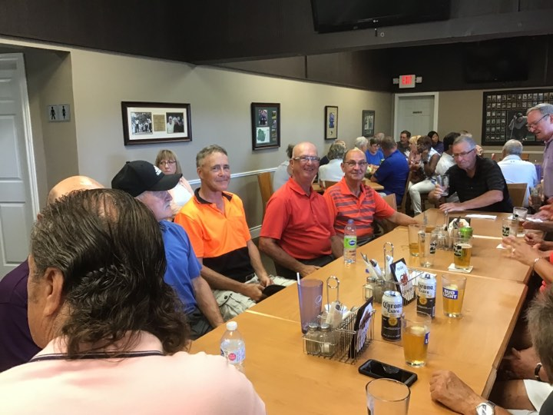

There will be a grand prize draw for a 40 minute sightseeing flight for two

A second draw will be held for a Columbia Sportswear X-Lg mens winterjacket

A 50/50 share-the-wealth draw will also be held.

Full details can be found on the accompanying Annual Banquet Information Notice and response form

