THAMES CHAPTER HERITAGE CLUB NEWS SPRING 2019

Hello,

Spring is just around the corner as we can’t wait to say goodbye to shovels and snow blowers. In this issue we look back at initiatives we took part in last season and look forward to upcoming activities.

In This Issue:

- survivor contact numbers
- success of Santa Letter expansion
- Columbia Sportswear discount invite
- outlook for 2019 Annual Banquet
- 2019 Annual General Meeting
- watchout for scams

2019 Pension Indexing

Canada Post Pension………… 2.21 %
C.P.P. ……………………… 2.20 %
Superannuation …………… 2.20 %
O.A.S. ….adjusted every Jan , Apr , Jul , Oct

Your Benefits
Contact Numbers

C.P.C. Pension 1-877-480-9220
Superannuation 1-800-561-7930
C.P.P. / O.A.S. 1-800-277-9914
Great West Life 1-866-249-5723
Access H.R. 1-877-807-9090
Employment Ins 1-800-206-7218
Passport 1-800-567-6868

Your Benefits
Survivor procedures: To ensure the survivor of a retiree maintains
pension , health and medical benefits , a number of contacts must be made after the
retiree’s death.
Access H.R. (1-877-807-990)
..retiree name
..employee I.D. number
..social insurance number
..copy of death certificate
C.P.C. Pension (1-877-480-9220)
..retiree name
..employee I.D. number
..postal code
..month and date of birth
..copy of death certificate
Great West Life (1-866-249-5723)
..retiree name
..employee number
..copy of death certificate
..plan numbers ..51057 & 51391
NOTE: Very important to notify Great West
as soon as possible in order to set up
a new automatic withdrawl in the
survivor’s name in order to keep
policy in force and maintain medical
dental and vision benefits.
C.P.P. / O.A.S. (1-800-277-9914)
..retiree name
..social insurance number
..copy of death certificate
NOTE: Besides the survivor pension
there is also a death benefit
payable to the survivor.
SUPERANNUATION (1-800-561-7930)
..retiree name
..social insurance number
..copy of death certificate

Letters-To-Santa Campaign – 2018

In 2018 your Heritage Club decided to expand the Santa Letter Program to cover local initiatives related to children. Letters-To-Santa stations were set up at the London Regional Children’s Museum , the Boys and Girls Club , Ronald McDonald House and the Children’s Hospital of Southern Ontario.

Total Letters-To-Santa Answered

Boys & Girls Club
16

Children’s Museum
258

Ronald McDonald House
23

Children’s Hospital
63

Mail Stream
1412

Cards and letters of appreciation

Numerous letters of appreciation and thank you cards were received from the expanded
iniatives involving the above locations.

Particularly heart warming were the thank you cards from the doctors and nurses at the Children’s Hospital with all their signatures and personal notes on them.

Member Benefit Partner

Just in time for Spring Sale Shopping

Your Heritage Club has arranged another Heritage Club Invitation for members to shop at the Columbia Sportswear Employee Store in London. Club I.D. card carrying Thames Heritage Club Members can shop and enjoy a discount of between 40% - 60% off brands such as Columbia , Sorel , Mountain Hard Wear and Prana. This is an invitation-only event which occurs four times per year. Club members are to have their Thames Heritage Club I.D., photo I.D. and the invitation and present them at the employee store from Mar 29 – Apr 21 , 2019 and shop.
Each member can spread the joy and bring along up to four (4) family and/or friends.
Full details on attached Columbia Invite.

Annual Reunion Banquet

The 2018 edition of the Annual Reunion Banquet was held on October 27 , 2018 at the Hellenic Community Centre in London. Approx fifty five people attended. A great night was had by all. Live musical entertainment was supplied by Celebrity Productions. For the 2019 version of the Banquet , we have already booked the larger room which we have had in the past. This room provides more area to allow the stage for our entertainment musicians and as well
makes it easier for banquet staff to supply and retrieve dishes and condiments.

************************************

Volunteer Programs

Boys and Girls Club
people needed one afternoon per month to serve meals to kids
Salvation Army Kettles
(Nov 25th – Masonville Mall)
Salvation Army Hamper Program
Donations of knitted items to annual hamper
program for the needy each December
Santa Letter Campaign
Three to four Mondays in November through early December
(Nov 20 , 27 , Dec 04 , 11)
** was expanded to include Children’s Museum , Boys & Girls Club , Ronald McDonald House and Children’s Hospital
Children`s Health Foundation Telethon
Staff the phone bank at the Telethon collecting private and business donations

Membership Since Last Newsletter

Welcome:

Josette Boismier
Marilyn Boland
Susan Browning
William Duncan
Marci Kosac
Klaus Madinger
Irene Shea
Don Wright

Departed
Jack Arnold
Nicole Bigham
Leslie Rose
Marilyn Shoebottom
Larry Spettigue
Gerry Tapley

Luncheons

In 2018 we held a luncheon in Bayfield for our northern area members who may not be able to attend some of the London area social events.

There was a get together held at The Mandarin Restaurant in the fall.
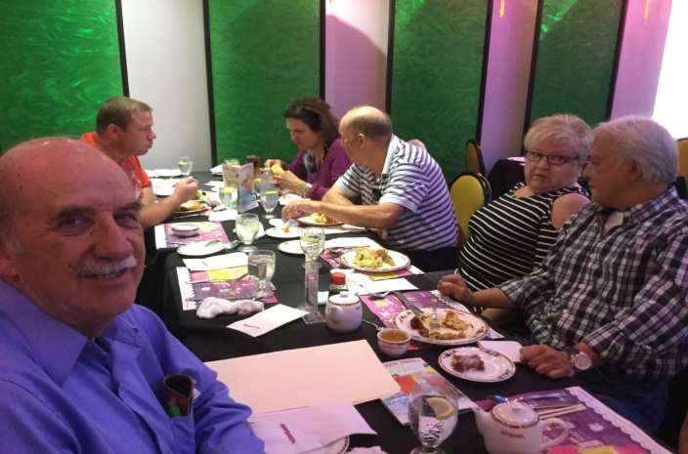
We intend to repeat this subsidized event in 2019.

Chapter Executive

President: Henry Masek
519-204-8873 thamesheritageclub@gmail.com

Vice-President: Judith Bourdage
519-672-9835
Vice-President: Jane D’Earmo
519-453-7102
Past-Presidents: Doug Anderson
Treasurer: Stew Metcalf
519-660-4193
Secretary: Dianna Snell
519-601-0085

******************************

Heritage Club members receive up to 50% off
- online registration with paid-up Thames
Heritage membership

To learn more about this offer visit
https://corporate.goodlifefitness.com

(you will require your Thames Heritage Club number to access information regarding this offer)

REMINDER:

Any GoodLife renewals will be denied if 2019 dues are not paid.

** total number of Heritage Club members
enrolled in GoodLife discounted program
as of this Newsletter is 178.

Scams

There are a number of scams going on out there by phone and via e-mail.

C.R.A.
I have even seen this one in my inbox.
A e-mail arrives in your inbox showing it as coming from the Canada Revenue Agency. It claims that you have a refund coming and all you have to do to receive it is send a credit card account information and it will be deposited to your account.
DELETE THE E-MAIL

Thames Heritage Club Card Renewal Time

For those of you who haven’t already done so , it is time to renew the Thames Heritage Club Activity Card for 2019 through payment of the $12.00 annual dues.

Make cheque payable to
Thames Heritage Club and send to:
Thames Heritage Club
955 Highbury Ave
London , On N5Y 1A3

Some of the member benefits are …
- discounted fees at GoodLife Fitness
- 40% to 60% discount at Columbia Sportswear Employee Store Events
- Gateway Casinos $10 free slot play events
- very attractive travel insurance rates with Medoc (Johnson Insurance)
- discount on the cost of the Annual Banquet of Thames Heritage Club
- Annual Golf Tournament
- Periodic luncheons at the Mandarin

Members who are not sure if they have paid their 2019 dues may contact the club at the numbers shown on the contact listing or by e-mail to the Thames Heritage Club e-mail address also shown in this newsletter.

Annual General Meeting

The Thames Heritage Club Annual General Meeting is being held on Sunday , April 14th at Angel`s Restaurant in London at 4 P.M.
There is a notice with full particulars included with this Newsletter. Come out and vote for members of the club executive. Have a say in the future direction of your Heritage Club.

Travel

TRAVEL INSURANCE

Contemplating travelling south this spring ?

You should consider Medoc Travel
Insurance for your coverage.

Heritage Club members receive a substantially reduced rate on their travel
Insurance.

One main interest to members is the
coverage for pre-existing medical
conditions. A member doesn`t have to
be in perfect health to take advantage of
these preferential rates.

Visit: johnson.ca/medoc
Call: 1-866-606-3362

2019 Annual Golf Tournament

We are presently looking at various locations for the upcoming tournament held each year in August. We welcome any suggestions from members for possible tournament sites.

Housecleaning

Death of member

In an effort to keep our information
up to date , we need to know when
any of our members is deceased.

Address change

To keep our mailing list current it
is necessary to have the latest proper
address of each member.

Send any changes to the above either
by mail to:

Thames Heritage Club
955 Highbury Ave
London , On N5Y 1A3

OR

by e-mail to:

thamesheritageclub@gmail.com

