THAMES CHAPTER HERITAGE CLUB NEWS WINTER 2018/2019

Hello,

Winter is here with us again. The leaves we forgot to rake up and bag are now evident as we uncover them when we clean the driveway or sidewalk. Snowtire time has arrived. Christmas is almost upon us. Since our last newsletter we have had our Annual Banquet and Columbia Employee Store Invite. Thames Heritage Club Volunteers have staffed the Salvation Army Kettle at Masonville Mall. In November we launched the Letters-To-Santa campaign. There is a section later in this newsletter on this campaign and how your Heritage Club expanded the Santa Letters campaign to include several local children’s focused initiatives. Pictures are included that show the extent of these endeavours.

2019 Pension Indexing

Canada Post Pension………… 2.21 %
C.P.P. ……………………… 2.20 %
Superannuation …………… 2.20 %
O.A.S. ….adjusted every Jan , Apr , Jul , Oct

Your Benefits
Contact Numbers

C.P.C. Pension 1-877-480-9220
Superannuation 1-800-561-7930
C.P.P. / O.A.S. 1-800-277-9914
Great West Life 1-866-249-5723
Access H.R. 1-877-807-9090
Employment Ins 1-800-206-7218
Passport 1-800-567-6868
Your Benefits
Survivor procedures: To ensure the survivor of a retiree maintains
pension , health and medical benefits , a number of contacts must be made after the
retiree’s death.
Access H.R. (1-877-807-990)
..retiree name
..employee I.D. number
..social insurance number
..copy of death certificate
C.P.C. Pension (1-877-480-9220)
..retiree name
..employee I.D. number
..postal code
..month and date of birth
..copy of death certificate
Great West Life (1-866-249-5723)
..retiree name
..employee number
..copy of death certificate
..plan numbers ..51057 & 51391
NOTE: Very important to notify Great West
as soon as possible in order to set up
a new automatic withdrawl in the
survivor’s name in order to keep
policy in force and maintain medical
dental and vision benefits.
C.P.P. / O.A.S. (1-800-277-9914)
..retiree name
..social insurance number
..copy of death certificate
NOTE: Besides the survivor pension
there is also a death benefit
payable to the survivor.
SUPERANNUATION (1-800-561-7930)
..retiree name
..social insurance number
..copy of death certificate
Letters-To-Santa Campaign – 2018

This year your Heritage Club decided to expand the Santa Letter Program to cover local initiatives related to children. Letters-To-Santa stations were set up at the London Regional Children’s Museum , the Boys and Girls Club , Ronald McDonald House and the Children’s Hospital of Southern Ontario.

Boys & Girls Club

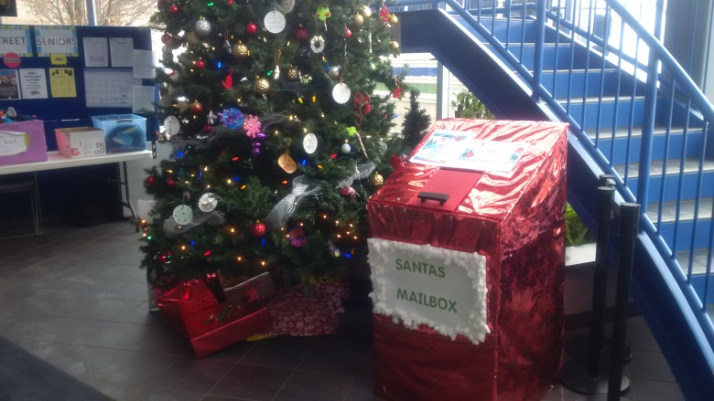

Children’s Museum
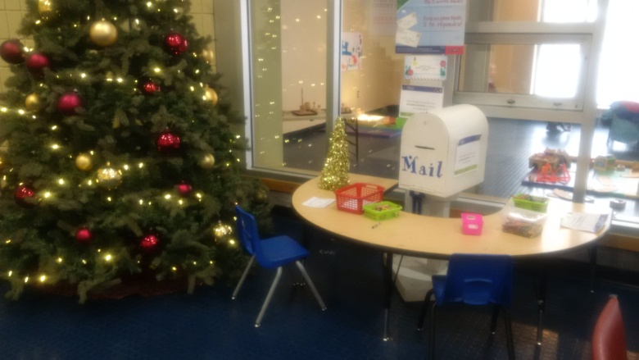

Ronald McDonald House
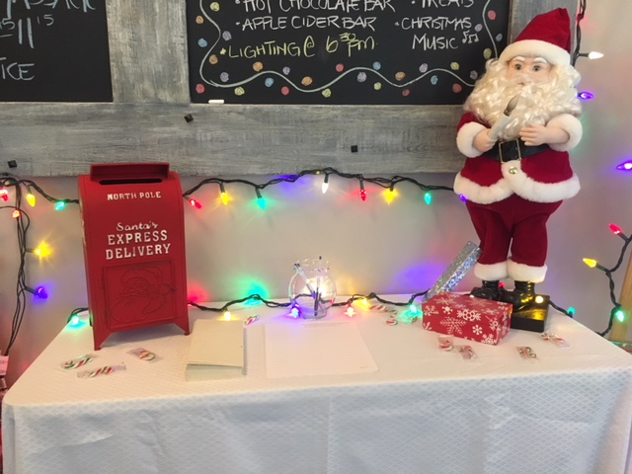

Children’s Hospital
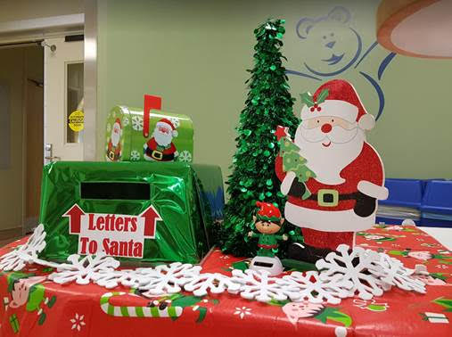

Member Benefit Partner

Just in time for Winter Sale Shopping

Your Heritage Club has arranged another Heritage Club Invitation for members to shop at the Columbia Sportswear Employee Store in London. Card carrying Thames Heritage Club Members can shop and enjoy a discount of between 40% - 60% off brands such as Columbia , Sorel , Mountain Hard Wear and Prana. This is an invitation-only event which occurs four times per year. Club members are to have their club I.D., photo I.D. and the invitation and present it at the employee store from Jan 4 – Jan 27 , 2019 and shop.
Each member can spread the joy and bring along up to four (4) family and/or friends.
Full details on attached Columbia Invite.
Annual Reunion Banquet

The 2018 edition of the Annual Reunion Banquet was held on October 27 , 2018 at the Hellenic Community Centre
133 Southdale Rd West in London. Approx
fifty five people attended. A great night was had by all. Live musical entertainment was supplied by Celebrity Productions. Everyone
left with a prize ranging from a his and her winter coat to shopping centre gift cards. The food prepared on-site by staff was of the highest quality.
There were some problems which came about mainly due to the smaller room we had because the larger room had been pre-booked prior to our reservation. I can assure everyone that in 2019 we will return to the larger room we have had in previous years. Changes have been made in the menu to ensure the variety of selection and quantity we had become familiar with.

************************************

Volunteer Programs

Boys and Girls Club
people needed one afternoon per month to serve meals to kids
Salvation Army Kettles
(Nov 25th – Masonville Mall)
Santa Letter Campaign
Three to four Mondays in November through early December
(Nov 20 , 27 , Dec 04 , 11)
** now expanded to include Children’s Museum , Boys & Girls Club , Ronald McDonald House and Children’s Hospital

Welcome:

Marilyn Boland
Richard Deeks
Claire Weirzbicki

Luncheons

In 2018 we held a luncheon in Bayfield for our northern area members who may not be able to attend some of the London area social events.
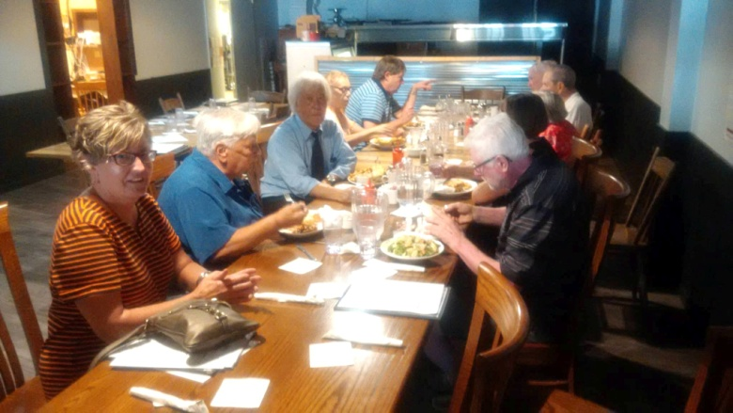

There was a get together held at The Mandarin Restaurant in the fall.
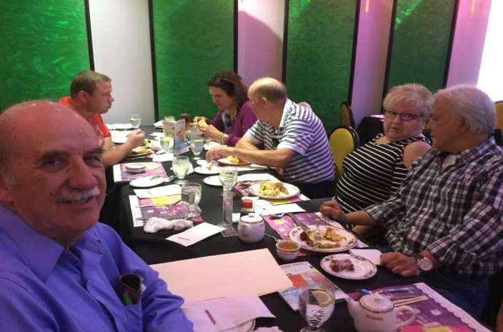

Chapter Executive

President: Henry Masek
519-204-8873 thamesheritageclub@gmail.com

Vice-President: Judith Bourdage
519-672-9835
Vice-President: Jane D’Earmo
519-453-7102
Past-Presidents: Doug Anderson
Treasurer: Stew Metcalf
519-660-4193
Secretary: Dianna Snell
519-601-0085
Past President: Doug Anderson

******************************

Heritage Club members receive up to 50% off
- online registration with paid-up Thames
Heritage membership

To learn more about this offer visit
https://corporate.goodlifefitness.com

(you will require your Thames Heritage Club number to access information regarding this offer)

REMINDER:

Any GoodLife renewals will be denied if 2019 dues are not paid.

Thames Heritage Club Card Renewal Time

For those of you who haven’t already done so , it’ll soon will be time to renew the Thames Heritage Club Activity Card for 2019 through payment of the $12.00 annual dues.

Make cheque payable to
Thames Heritage Club and send to:
Thames Heritage Club
955 Highbury Ave
London , On N5Y 1A3

Some of the member benefits are …
- discounted fees at GoodLife Fitness
- 40% to 60% discount at Columbia Sportswear Employee Store Events
- Gateway Casinos $10 free slot play events
- very attractive travel insurance rates with Medoc (Johnson Insurance)
- discount on the cost of the Annual Banquet of Thames Heritage Club
- Annual Golf Tournament
- Periodic luncheons at the Mandarin

Members who’ve already paid 2019 dues …

A101339 A101342 A101348
A101369 A101485

405604 405756 405791 412786 414726 417375 417734 420496 422194 422204 424107 424141 425379 604866 610241 610480 616307 616572 619362 619428 619516
620430 620505 620579 621927 622028 622078 622141
Check the above list. If your membership number is on the list , you don’t need to send in your 2019 dues.

Travel

TRAVEL INSURANCE

Contemplating travelling south this winter ?

You should consider Medoc Travel
Insurance for your coverage.

Heritage Club members receive a substantially reduced rate on their travel
Insurance.

One main interest to members is the
coverage for pre-existing medical
conditions. A member doesn”t have to
be in perfect health to take advantage of
these preferential rates.

Visit: johnson.ca/medoc
Call: 1-866-606-3362

Housecleaning

Death of member

In an effort to keep our information
up to date , we need to know when
any of our members is deceased.

Address change

To keep our mailing list current it
is necessary to have the latest proper
address of each member.

Send any changes to the above either
by mail to:

Thames Heritage Club
955 Highbury Ave
London , On N5Y 1A3

OR

by e-mail to:

thamesheritageclub@gmail.com

