THAMES CHAPTER HERITAGE CLUB NEWS FALL 2018

Hello,
Summer has given way to cooler weather and fall fairs. Leaves will soon begin to change to their autumn colour spectacular. We must locate those (dare I say it) snow tires and get them handy for changing in a couple of months. Get the fuel stabilizer ready for the lawnmower. Some final trips to the cottage before closing it up for the season.

Your Benefits
Contact Numbers

C.P.C. Pension 1-877-480-9220
Superannuation 1-800-561-7930
C.P.P. / O.A.S. 1-800-277-9914
Great West Life 1-866-249-5723
Access H.R. 1-877-807-9090

Patient Assistance Programs

As we age and require drugs due to ailments from diabetes to cancer , we often find that our medical plans only cover a portion of the cost. Some pharmaceuticals such as Chemotherapy drugs are very expensive. Some drug manufacturers have Patient Assistance Programs that will pay part or all of the cost above what medical plans cover. Some of these companies are
Astra Zeneca , Eli Lilly, Glaxo-Smith-Kline , Merck , Pfizer and Roche.
Make sure to contact the drug company who makes any costly medications to see if they have a Patient Assistance Program
These companies can be found on the web.

Beneficiary Forms

When you retired there were a number of life insurance beneficiary forms completed and submitted by you. One covered your Basic Life Insurance , One covered the 65+ Life Insurance and another covered the Pension. As time went by your personal and/or family
circumstances may have changed. It is important to keep these documents up-to-date. You can contact the C.P.C. Pension Centre at 1-877-480-9220 to update all of these documents.

Great West Life

Great West has created a new updated website for dealing with their drug , vision and hearing benefits. It requires a new registration to start. I have personally done the registration and found the new website a major improvement. You can now see all your benefits at one time .... amount used , next eligible date for eyeglasses and hearing aid benefits.
To access the new GroupNet , you must
re-register by signing in with your e-mail address and creating a new password. Don’t worry – it will only take a few minutes.
Go to www.greatwestlife.com
Sign in to GroupNet and select Register now

Heritage Club Scholarships Awarded - 2018

Elizabeth Lang .................... Edmonton , Ab
Hannah Ronsky ................... Calgary , Ab
Kathleen (Katie) Myatt ........ Hanover , On

Heritage Club – Departed Members - 2018

Bakker , Rilla
Chambers , Effie
Guemple , Inez
Langley , Bert
Linkevich , John
McGregor , Wayne
Morgan , Henry
Peaker , Don
Phillips , William
Sandall , Jim

Pre-retirement package review

Potential retirees will receive two information packages immediately prior to their retirement. One is from Canada Post HR. The other is from the Canada Post Pension branch. Each package contains all the benefits , forms , financial data and directions on where to send various applications and forms. If you are approaching retirement , your Heritage Club
President is available to meet with you to review your material with you should you have any questions or need clarification.

You can e-mail any requests for an appointment to :
thamesheritageclub@gmail.com

Volunteer Programs

If any member is involved in a volunteer program ( reading to sick kids in a hospital , assisting seniors at a nursing home or their own residence , exercising animals for a vet hospital , serving meals to the needy , providing guidance at a cancer clinic , collecting donation items for a charity )
we’d love to hear about it.

Golf

TheThames Heritage Club annual golf tournament was held on Wednesday , August 29th , 2018. Golfers and friends enjoyed a day of golf followed by a full meal then awarding of trophies.
- Mens Winner ........ Jim Yu
- Ladies Winner ........ Doris Manns
- Closest to The Hole . Bob Doyle
.. Klaus Madinger
- Longest Drive .......... Gord Ross
- Most Honest Golfer . Janine Greene

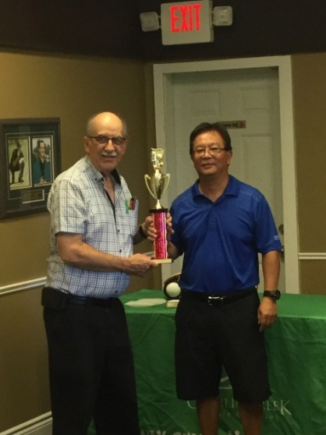

Winner – Men
Jim Yu

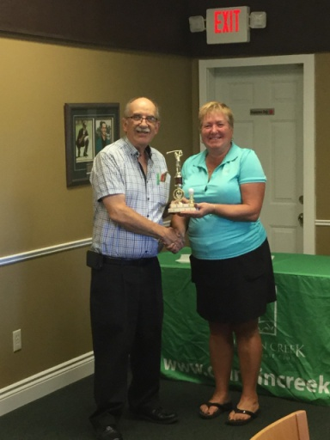

Winner - Women
Doris Manns

Member Benefit Partner

Just in time to get that winter gear , we have another personal invite from our benefit partner Columbia Sportswear to come out and shop for your needs and enjoy a discount of between 40% - 60% off brands such as Columbia , Sorel , Prana and Mountain Hard Wear. This is an invitation only event which occurs four times a year. To benefit from this event , the member must bring their Thames Chapter Heritage Club I.D. Card , a photo I.D. along with your invitation (attached to this Newsletter) and present it at the employee store from Nov 02 – 25 , 2018 and shop.
Each member can spread the joy and bring along up to four (4) family and/or friends
(Full details on attached Columbia Invite)

Volunteer Initiatives

Each year our Heritage Club participates in various programs such as ....
- Santa Letter Writing
- Salvation Army Kettle Program
- Boys And Girls Club meals

We are looking for people to assist in these modest programs. If you can participate and
would like details , please call 519-204-8873
and I will provide full details.

**************************
On-line Option
If you would like your Newsletter via e-mail, call 519-457-5375 or send request to thamesheritageclub@gmail.com

Membership Dues – REMINDER

If you haven’t already done so , you are urged to pay your 2018 membership dues.
If you are enjoying a GoodLife Fitness discounted membership , this will prevent any difficulties when you go to renew your GoodLife membership at the end of it`s present term.

Make cheque for $12.00 payable to
Thames Heritage Club and send to ...
Thames Heritage Club
955 Highbury Ave
London , On N5Y 1A3

*********************************
Some of the member benefits are …
- discounted membership fees at GoodLife Fitness
- 40% to 60% discount at Columbia Sportswear Employee Store Events
- Gateway Casinos $10 free slot play events
- very attractive travel insurance rates with Medoc (Johnson Insurance)
- discounted cost of the Annual Banquet of Thames Chapter Heritage Club
- access to special scholarships
- annual golf tournament

**************************
Northern Area – Luncheon
Bayfield , On ( August 15 , 2018 )

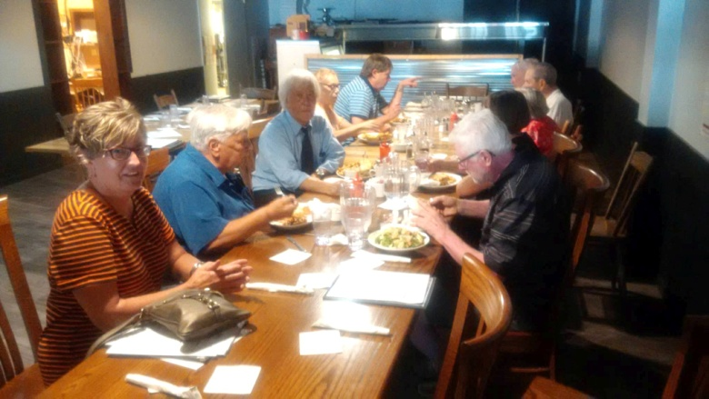

Heritage Club members receive up to 50% off GoodLife memberships.

Online registration

To learn more about this offer visit
https://corporate.goodlifefitness.com
(you will require your paid up Thames Heritage Club Number to access information regarding this offer)

************************************
Heritage Club Website

Check us out at heritageclub.ca
This is the national site for The Heritage Club. Once on the the site , you will see a red button called select-a-chapter. Click on it and then from the list of sites – click on
Thames. You are now on our website.

***********************************

Chapter Executive

President: Henry Masek
519-204-8873 thamesheritageclub@gmail.com

Vice-President: Judith Bourdage
519-672-9835
Vice-President: Jane D’Earmo
519-453-7102
Treasurer: Stew Metcalf
519-660-4193
Secretary: Dianna Snell
519-601-0085

Fall Luncheon at the Mandarin

You are invited to lunch at the
Mandarin Restaurant in London on
the corner of Wellington St and Commissioners Rd.

Date: Wednesday , September 26 , 2018

Time: 11:30 A.M.

Cost: $12.00 + beverage + HST
(your Heritage Club is subsidizing
the meal cost above the $12.00 )

Confirmation of Attendance Required:

Please confirm you are coming to the luncheon by Friday , September 21 st by phone ( 519-204-8873 ) or by e-mail to thamesheritageclub@gmail.com

Annual Reunion Banquet

The 2018 edition of the Thames Heritage
Club Annual Reunion Banquet will be held on Saturday , October 27 , 2018 at the Hellenic Community Centre located at 133 Southdale Rd West in London.

Social Hour starts at 5:30 P.M.

Full details can be found on the accompanying banquet response form.

