THAMES CHAPTER HERITAGE CLUB NEWS WINTER 2017/2018

Hello,
Winter is just around the corner. We no sooner finish raking the leaves and cleaning the eavestrough then we are preparing the shovels and snowblower for another season.

Golf
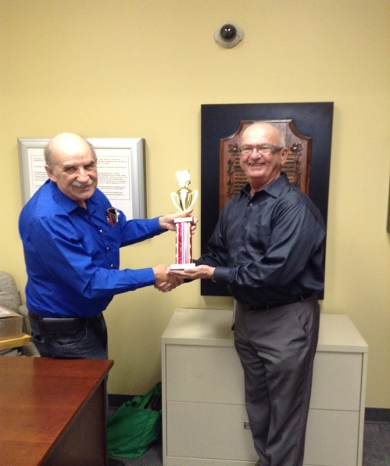 Don Manns: Winner – 2017 Golf Tournament – Top Male Score
Congratulations also to the following...
Top female score ....... Betty Gale
Closest to the pin ....... Gayle Stoddard
Longest drive .............Pat MacDonald

Your Benefits
Contact Numbers

C.P.C. Pension 1-877-480-9220
Superannuation 1-800-561-7930
C.P.P. / O.A.S. 1-800-277-9914
Great West Life 1-866-249-5723
Access H.R. 1-877-807-9090
Your Benefits
Survivor procedures: To ensure the survivor of a retiree maintains
pension , health and medical benefits , a number of contacts must be made after the
retiree’s death.
Access H.R. (1-877-807-990)
..retiree name
..employee I.D. number
..social insurance number
..copy of death certificate
C.P.C. Pension (1-877-480-9220)
..retiree name
..employee I.D. number
..postal code
..month and date of birth
..copy of death certificate
Great West Life (1-866-249-5723)
..retiree name
..employee number
..copy of death certificate
..plan numbers ..51057 & 51391
NOTE: Very important to notify Great West
as soon as possible in order to set up
a new automatic withdrawl in the
survivor’s name in order to keep
policy in force and maintain medical
dental and vision benefits.
C.P.P. / O.A.S. (1-800-277-9914)
..retiree name
..social insurance number
..copy of death certificate
NOTE: Besides the survivor pension
there is also a death benefit
payable to the survivor.
SUPERANNUATION (1-800-561-7930)
..retiree name
..social insurance number
..copy of death certificate
Member Benefit Partner

Just in time for Christmas Shopping

Your Heritage Club earlier finalized an agreement with Columbia Sportswear located in London that will permit card carrying Thames Heritage Club Members to shop at the Columbia Sportswear employee store and enjoy a discount of between 40% - 60% off brands such as Columbia , Sorel , Mountain Hard Wear and Prana. This is an invitation-only event which occurs four times per year. The first event occured last fall. To benefit from this event the member must bring their Thames Chapter Heritage Club I.D. Card , a photo I.D. along with your invitation and present it at the employee store from Dec 8 – Dec 31 , 2017 and shop.
Each member can spread the joy and bring along up to four (4) family and/or friends.
Full details on attached Columbia Invite.

Annual Reunion Banquet

The 2017 edition of the Annual Reunion Banquet was held on October 28 , 2017 at the Hellenic Community Centre
133 Southdale Rd West in London. Approx
fifty people attended. A great night was had by all. Live musical entertainment was supplied by Celebrity Productions. Everyone
left with a prize ranging from a his and her winter coat to shopping centre gift cards. The food prepared on-site by staff was of the highest quality.

Welcome to:

Dave Howlett London
Anna Baltus St Thomas

Volunteer Programs

Boys and Girls Club
people needed one afternoon per month to serve meals to kids
Salvation Army Kettles
(Nov 25th – Masonville Mall)
Santa Letter Campaign
Three to four Mondays in November through early December
(Nov20 , 27 , Dec 04 , 11)

Chapter Executive
President: Henry Masek
519-204-8873 thamesheritageclub@gmail.com

Vice-President: Judith Bourdage
519-672-9835
Vice-President: Jane D’Earmo
519-453-7102
Past-Presidents: Doug Anderson
Jim Sandall
Treasurer: Stew Metcalf
519-660-4193
Secretary: Dianna Snell
519-601-0085

Heritage Club members receive up to 50% off

Online registration began Sept 15th , 2017

To learn more about this offer visit
https://corporate.goodlifefitness.com

(you will require your Heritage Club Number to access information regarding this offer)

Thames Heritage Club Card Renewal Time

For those of you who haven’t already done so , it’ll soon will be time to renew the Thames Heritage Club Activity Card for 2018 through payment of the $10.00 annual dues.

Make cheque payable to
Thames Heritage Club

and send it to …

Thames Heritage Club
955 Highbury Ave
London , On N5Y 1A3

Some of the member benefits are …
- discounted fees at GoodLife Fitness
- 40% to 60% discount at Columbia Sportswear Employee Store Events
- Gateway Casinos $10 free slot play events
- very attractive travel insurance rates with Medoc (Johnson Insurance)
- discount on the cost of the Annual Banquet of Thames Chapter Heritage Club

TRAVEL INSURANCE

Contemplating travelling south this winter ?

You may want to consider Medoc Travel
Insurance for your coverage.

Heritage Club members receive a substantially reduced rate on their travel
Insurance.

One main interest to members is the
coverage for pre-existing medical
conditions. A member doesn”t have to
be in perfect health to take advantage of
these preferential rates.

Visit: johnson.ca/medoc
Call: 1-866-606-3362

