***Founding Member and 1st President of Pineridge Chapter, Keith Mac Donald, with 30th Anniversary President,***

***J.P. Leguerrier.***

***Head Office participants Christine Blain, and Lori Hennessey, with Gloria Mac Donald and J.P. Leguerrier.***

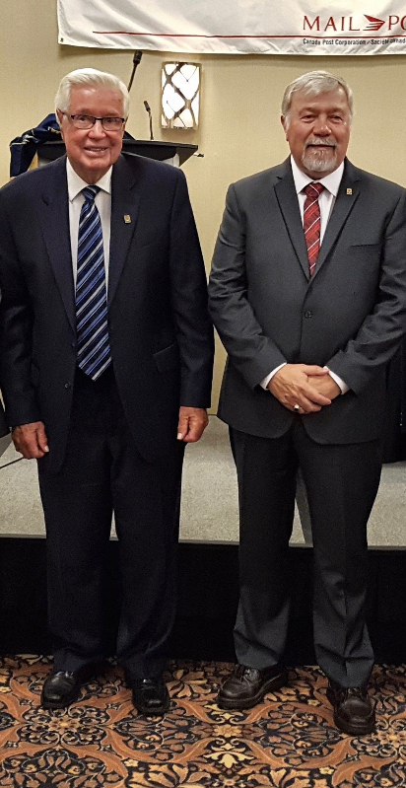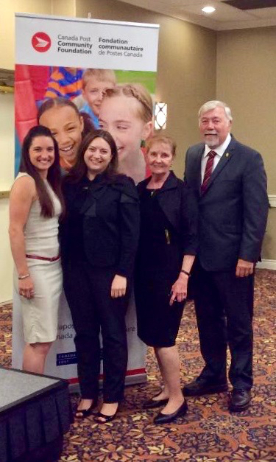

***National Executives Nick Ronsky, Treasurer, J.P. Leguerrier, National President,***

***Claude Bruneau, 1st Vice President.***

