Walters Dinner Theatre
$119 per person-includes luxury motor coach, HST, Gratuities. Does Not include Driver Tip.

Matinees Wed, Thurs & Friday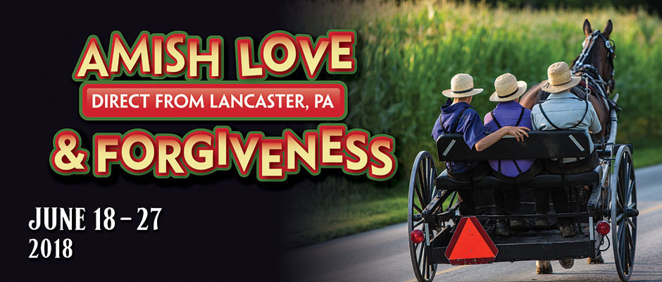
Direct From Lancaster, PA
Our Amish productions are some of our most popular shows that we’ve had at our theatre! This captivating theatre presentation lets you peek into the world of an Amish family once again. This time, you will merge into the lives of the King family. Tragedy strikes, and the family must find strength to cope with the difficulties. This performance is back by popular demand and has been a sold out show in Lancaster, Pennsylvania for years!
Matinee-Mon-Thurs & Mon - Wed

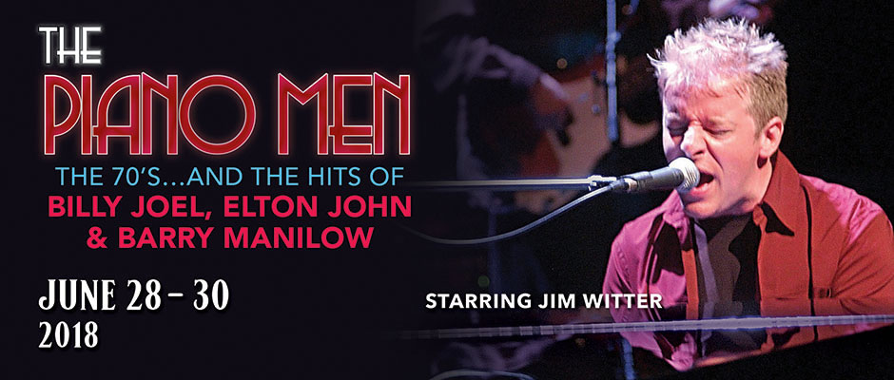

Matinee-June Thurs, Friday & Tues to Friday
Matinees-Tues to Friday

Matinees-Mon to Thurs

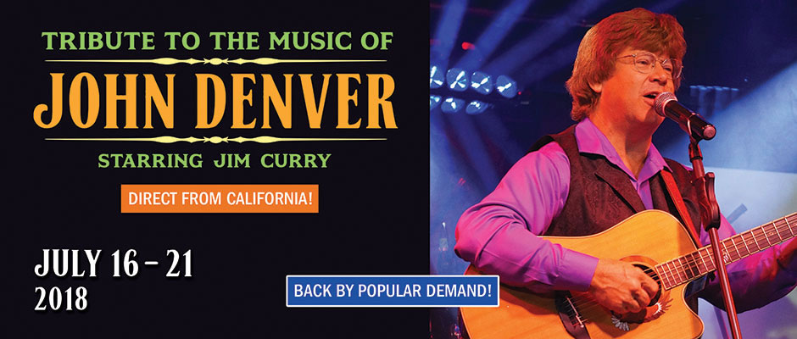
Matinees-Mon - Thurs

Matinee Mon - thurs

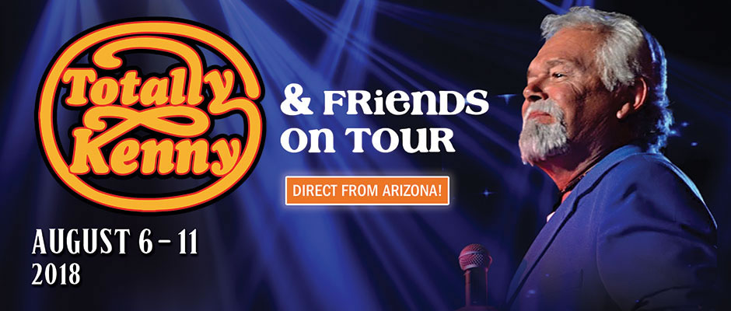
Matinee Mon to Thurs

Mon to Thurs & Mon to Thurs

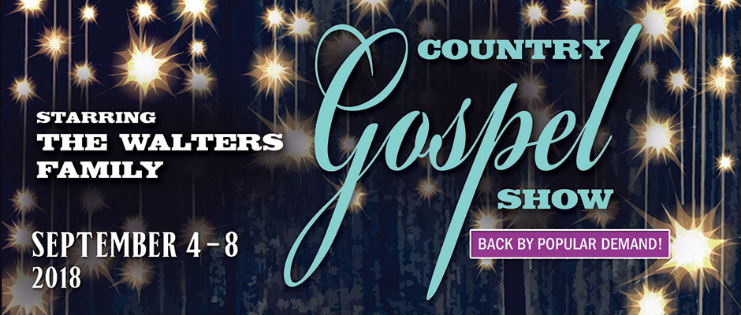
Matinees -Tues to Thurs

Matinees-Mon to Friday
Matinees -September Monday to Thursday

