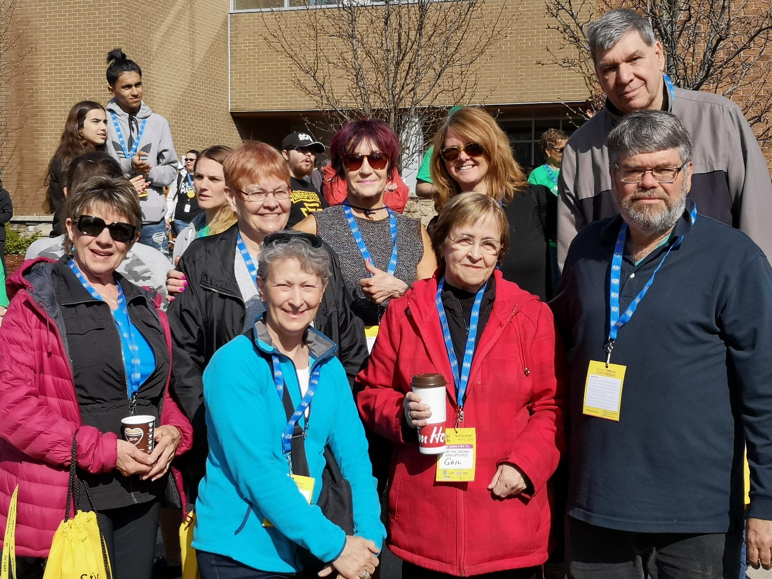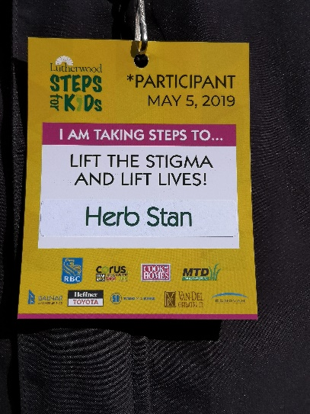

***Grand Saugeen Heritage Club members came out for a sunny day and graciously gave their time. We donated $900.00 to Lutherwood Steps for kids. We walked 5 kms.***

***Thanks to Judy Needam, Julie Dietrich, Brenda Gabot, Herb Stan, Donna Vandenhoff, Gail Bourhill and Dan Shirk. Fay Mahoney was there in spirit.***