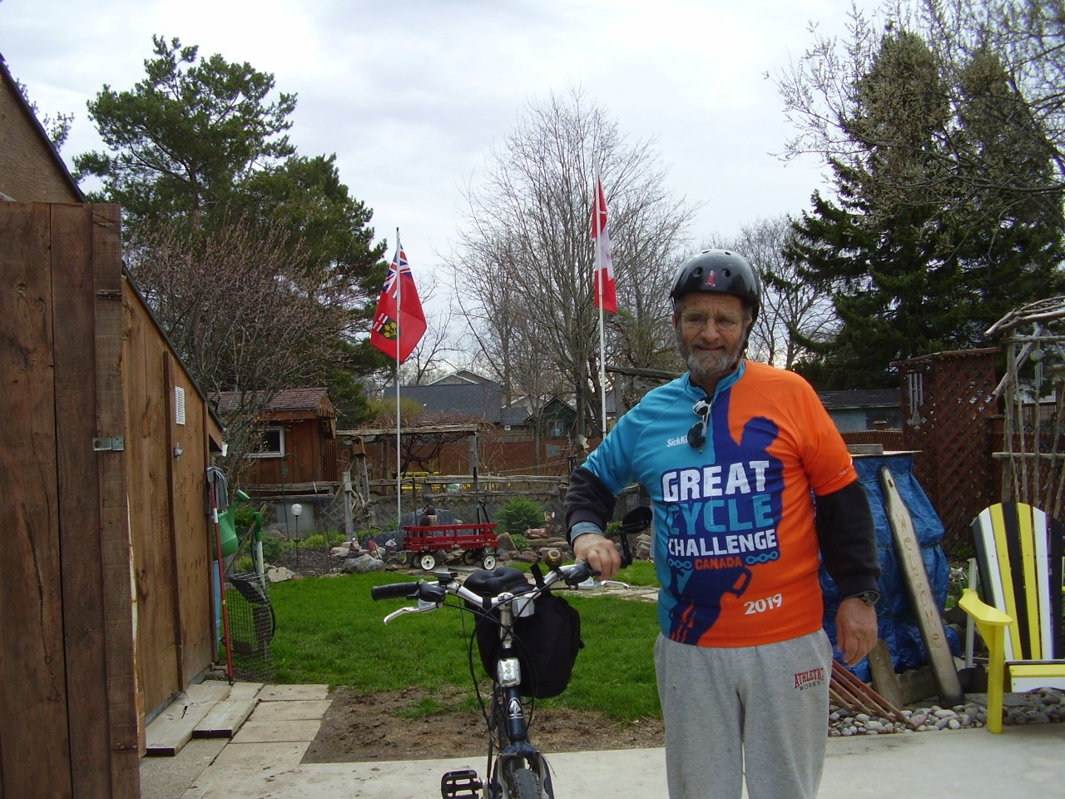
Carl Myatt Great Cycle Challenge

