Grand Saugeen

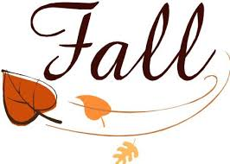
2018

“Think of all the beauty around you and you will be
happy.‘ Anne Frank
From the President’s desk
“Wow” it sure has been a hot humid summer but I hope we all took the time to take in the beauty of the world around us and stayed happy.
Our club had an excellent summer. We had a good turnout at our dinner at the Mandarin in Kitchener.
We had over 40 members join us for our dinner at Pebbles restaurant in Durham. The food was excellent and the comradeship even more so.
We had 20 members signed up for lawn bowling. However due to the threat of rain only a few brave people showed up. They were letter carriers who have never let the threat of rain stop them from delivering the mail.
The lawn bowling was a lot of fun and we will try this as an activity in the spring next year. I want to thank Fred Clark and his team for all their help with the teaching and the excellent barbecue after.
I am also happy to announce that Diane Mcnichol –Byers has joined the executive representing our northern interests and is now busy helping to make our northern banquet a success. The banquet will be held October 13th in Hanover. More information can be found in this newsletter.
We have also been tasked with trying to revive the Golden Horseshoe Chapter which is the Hamilton Brantford and Niagara area. Hopefully their members will enjoy the benefits of being a member of the Heritage Club and we can join each other in activities in both areas.
Finally, I am pleased to announce that Kathleen (Katie) Myatt, granddaughter of Carl and Ruth Myatt of Owen Sound is one of the recipients of the Heritage Club scholarship of $1,000.00.

“
In This Edition

From the President’s Desk 1
For the funny bone 2
Membership Dues 3
Columbia Offer 4
Pebbles Restaurant pictures 5,6
Lawn Bowling 7,8
Tommy Dee’s Dance 9
Diane’s World 10
Member News 11,12

.

You will find more information on these activities by visiting www.heritage club .ca and checking out the Grand Saugeen chapter and check out the photos.
Thanks to everyone for their support and making the executives job worthwhile with your participation.
Herb Stan

MEMBERSHIP DUES 2019
Mother Knows Best - Eventually

One day, young Sarah girl was watching her mother make a roast sirloin of beef. She cut off the ends, wrapped it in string, seasoned it and set it in the roasting dish.
Sarah politely asked her mum why she cut off the ends of the roast. Mum replied, after some thought, that it was the way that her mother had done it.
That night grandma came to dinner and Sarah and her mother asked why she had cut the end off of the roast before cooking. After some thought grandma replied, she cooked the meat the way her mother had done it.
Now great-grandma was quite old and lived in a residential nursing home, so Sarah, her mum and grandma went to visit her and again asked the very same question.
Great-grandma looked at them a bit surprised and said, 'So it would fit in the roasting dish, of course.'

For the funny bone

- .

In a Catholic school cafeteria, a nun places a note in front of a pile of apples, "Only take one. God is watching." Further down the line is a pile of cookies. A little boy makes his own note, "Take all you want. God is watching the apples."
A woman was taking an afternoon nap. When she woke up, she told her husband, "I just dreamed that you gave me a pearl necklace. What do you think it means?" "You'll know tonight," he said. That evening, the man came home with a small package and gave it to his wife. Delighted, she opened it to find a book entitled "The Meaning of Dreams.
A grandmother was telling her little granddaughter what her own childhood was like. “We used to skate outside on a pond. I had a swing made from a tire; it hung from a tree in our front yard. We rode our pony. We picked wild raspberries in the woods.” The little girl was wide-eyed, taking this all in. At last she said, “I sure wish I’d gotten to know you sooner!”

When do you know your grandfather is old enough to retire?
Instead of lying about his age he starts bragging about it!
My friend told me he had the body of a Greek god. I had to explain to him that Buddha is not Greek.

In order to fulfill our mission of “PEOPLE HELPING PEOPLE” your membership dues are essential to ensure we have sufficient funding to continue with the work of your Club. The annual fee is a modest amount of $12.00, which equates to only $1.00 a month. Your membership dues and our annual grant from the Corporation enable your Club to carry on its various functions. We also make donations to causes such as mental health and Alzheimer’s research. To those who paid their dues for 2018 we thank you. For those members wishing to pay their dues now for 2019, simply complete the form below and forward it along with your payment (payable to Grand Saugeen Chapter) in the postage paid envelope enclosed with this newsletter.

Note: On receipt of your dues payment you will be issued a new wallet card with your member number. It is important to have this number for certain discounts and when applying for Medoc Insurance. As well you must be a paid-up member to enjoy the Good Life Fitness discount.

Send in postage free envelope provided

MEMBERSHIP DUES PAYMENT FOR 2019 ($12.00)

NAME: ______________________________________________________

MEMBER # (if known):________________________________________

ADDRESS: ___________________________________________________

PHONE#:_____________________EMAIL:________________________

Send completed forms along with payment to:

Donna Vandenhoff
95 Millwood Cr.
Kitchener ON, N2P 1R3

Some of the member benefits are …
- discounted membership fees at GoodLife Fitness
- 40% to 60% discount at Columbia Sportswear Employee Store Events
- very attractive travel insurance rates with Medoc (Johnson Insurance)
- discounts to Grand Saugeen Heritage Club events
- access to special scholarships

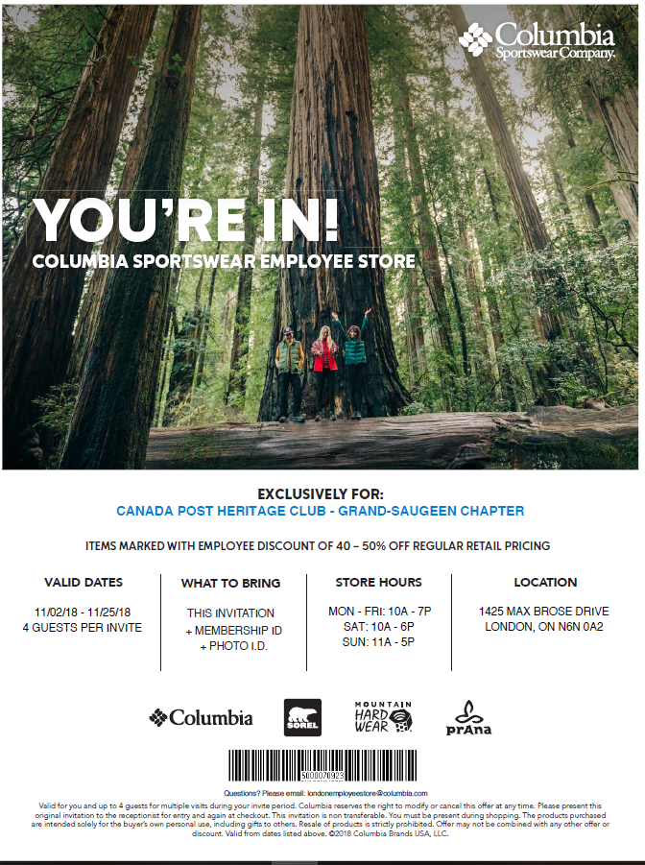

July 24, 2018

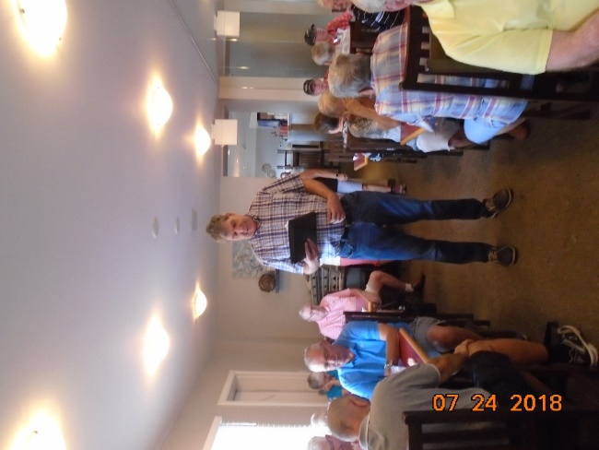

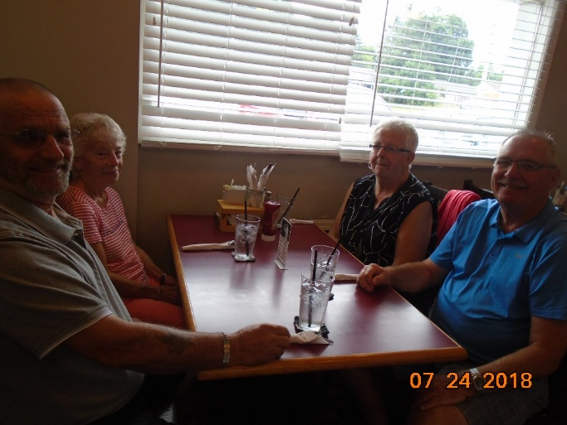
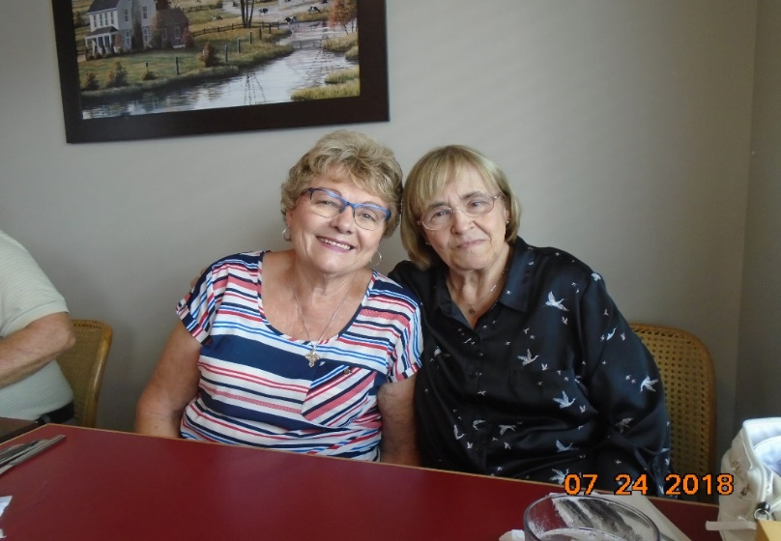
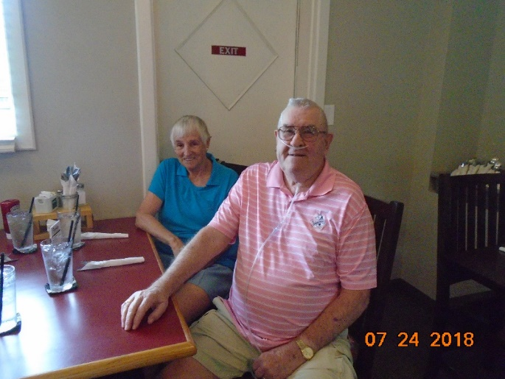
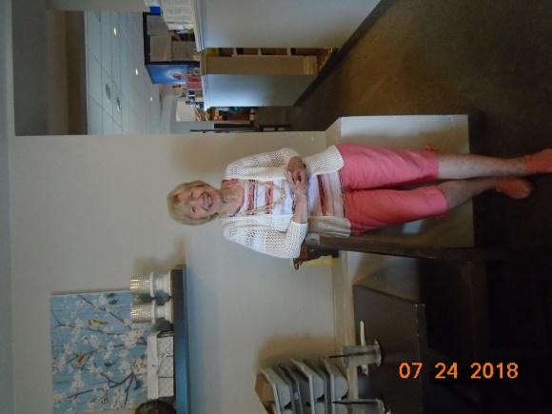
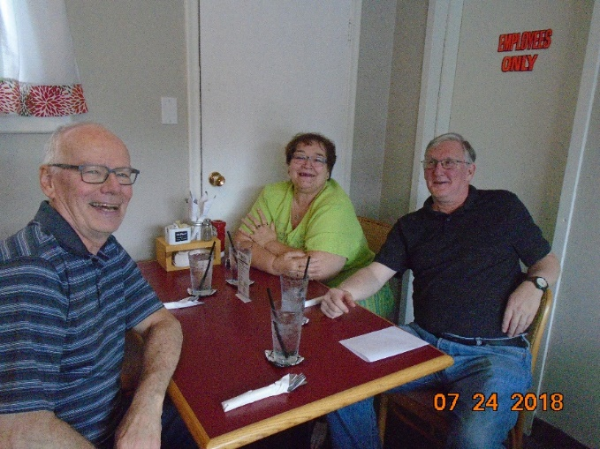
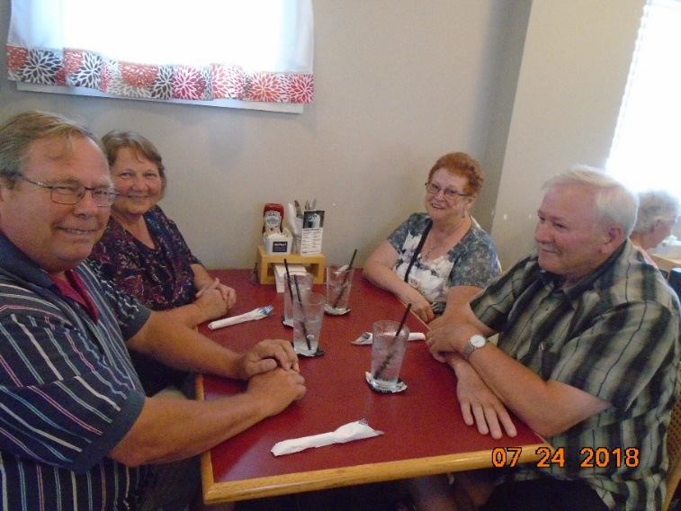
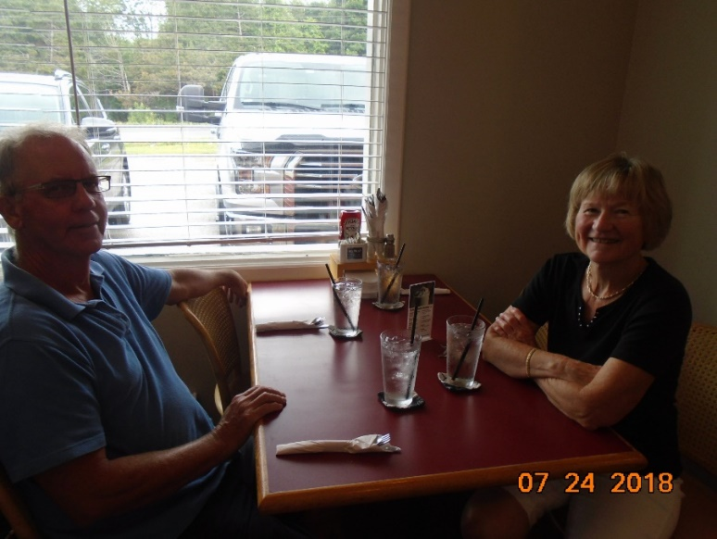
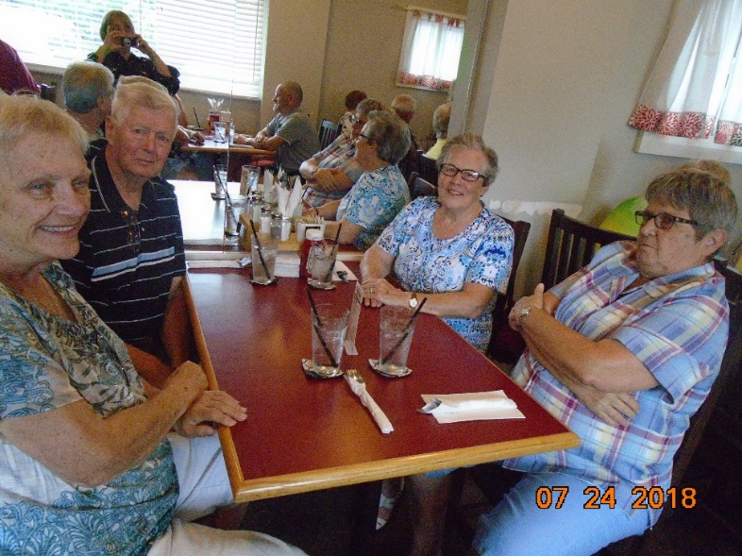
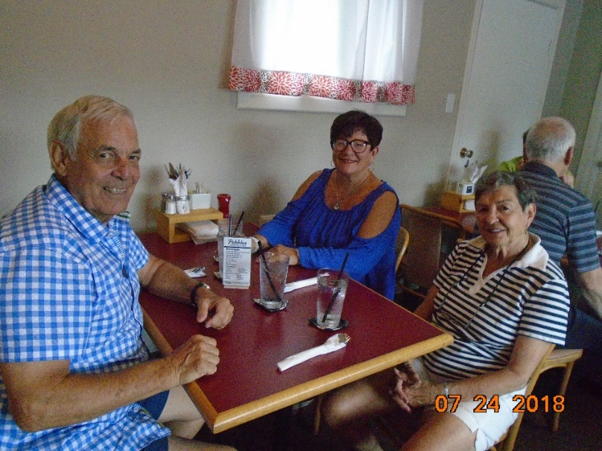
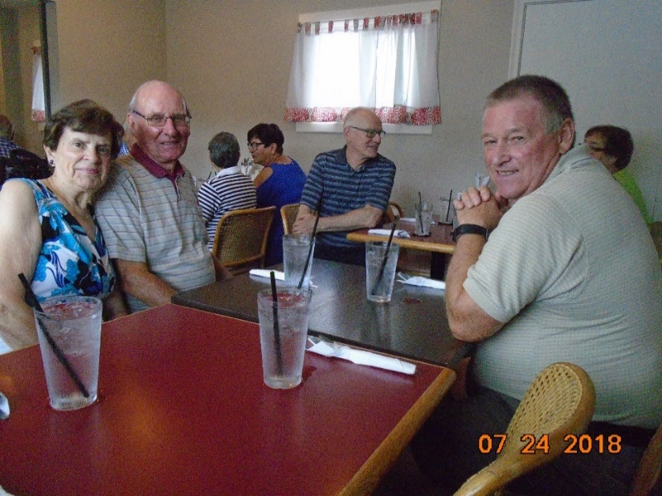
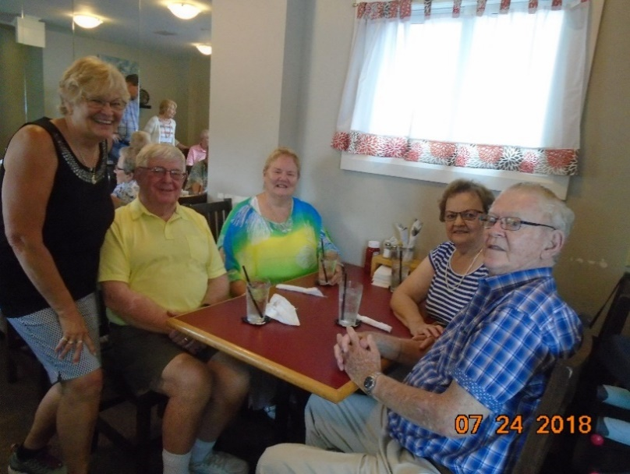
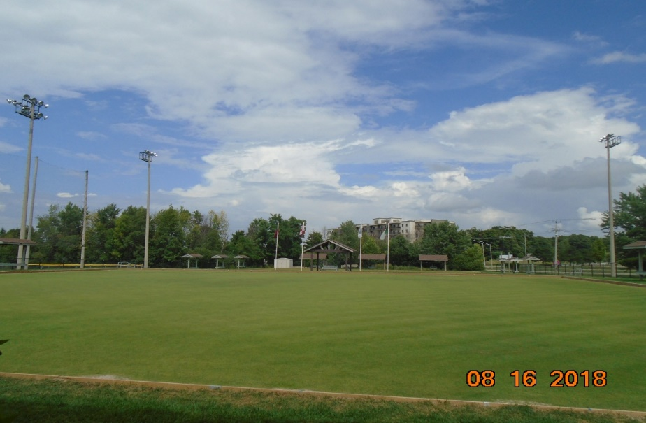
August 16, 2018
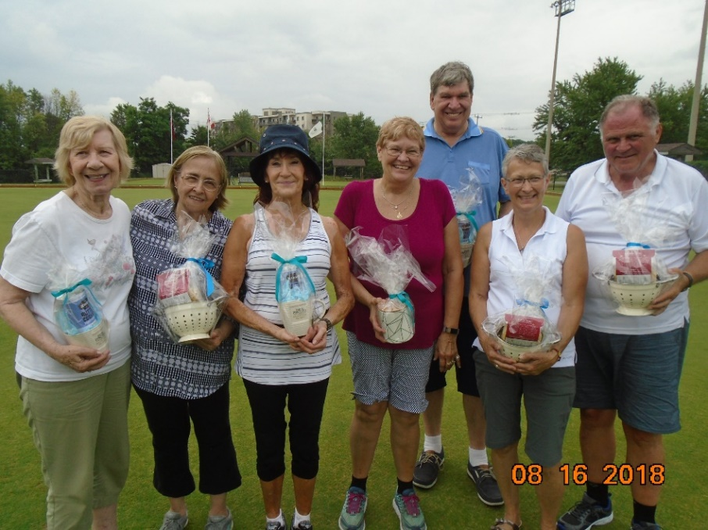
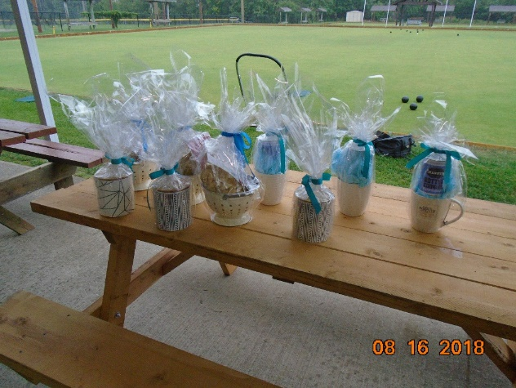
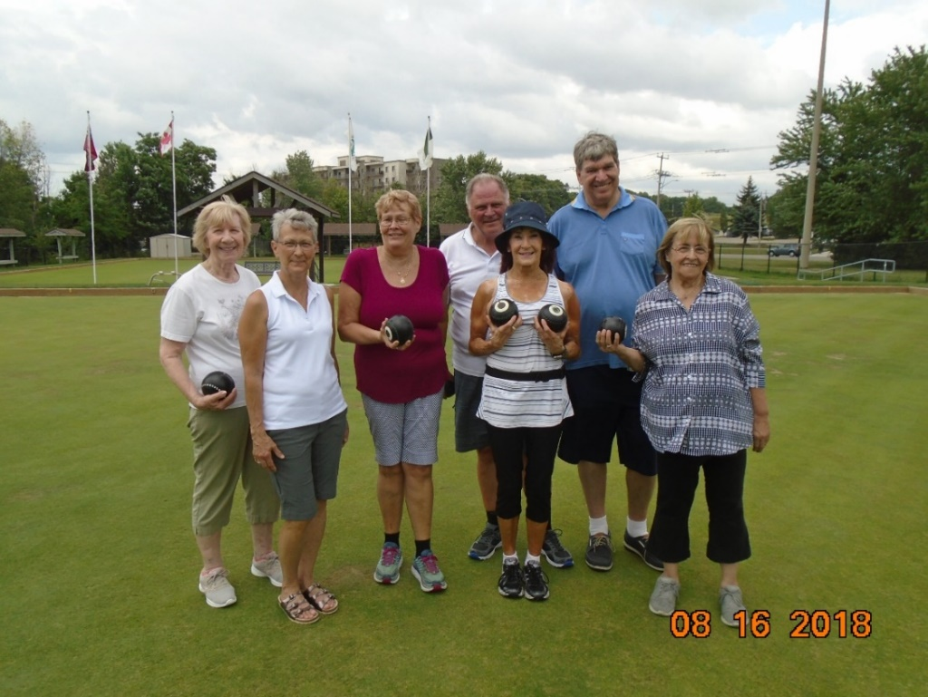
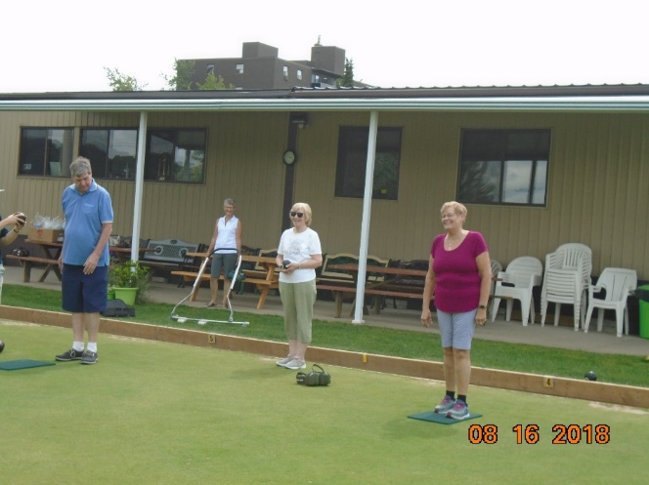
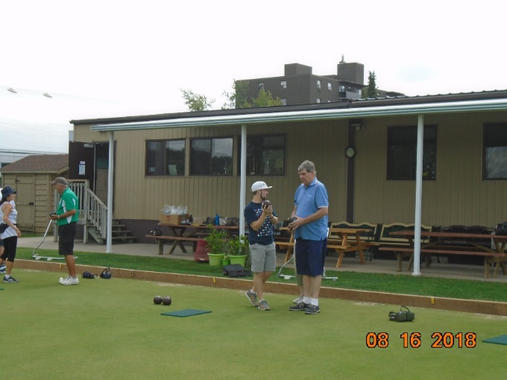

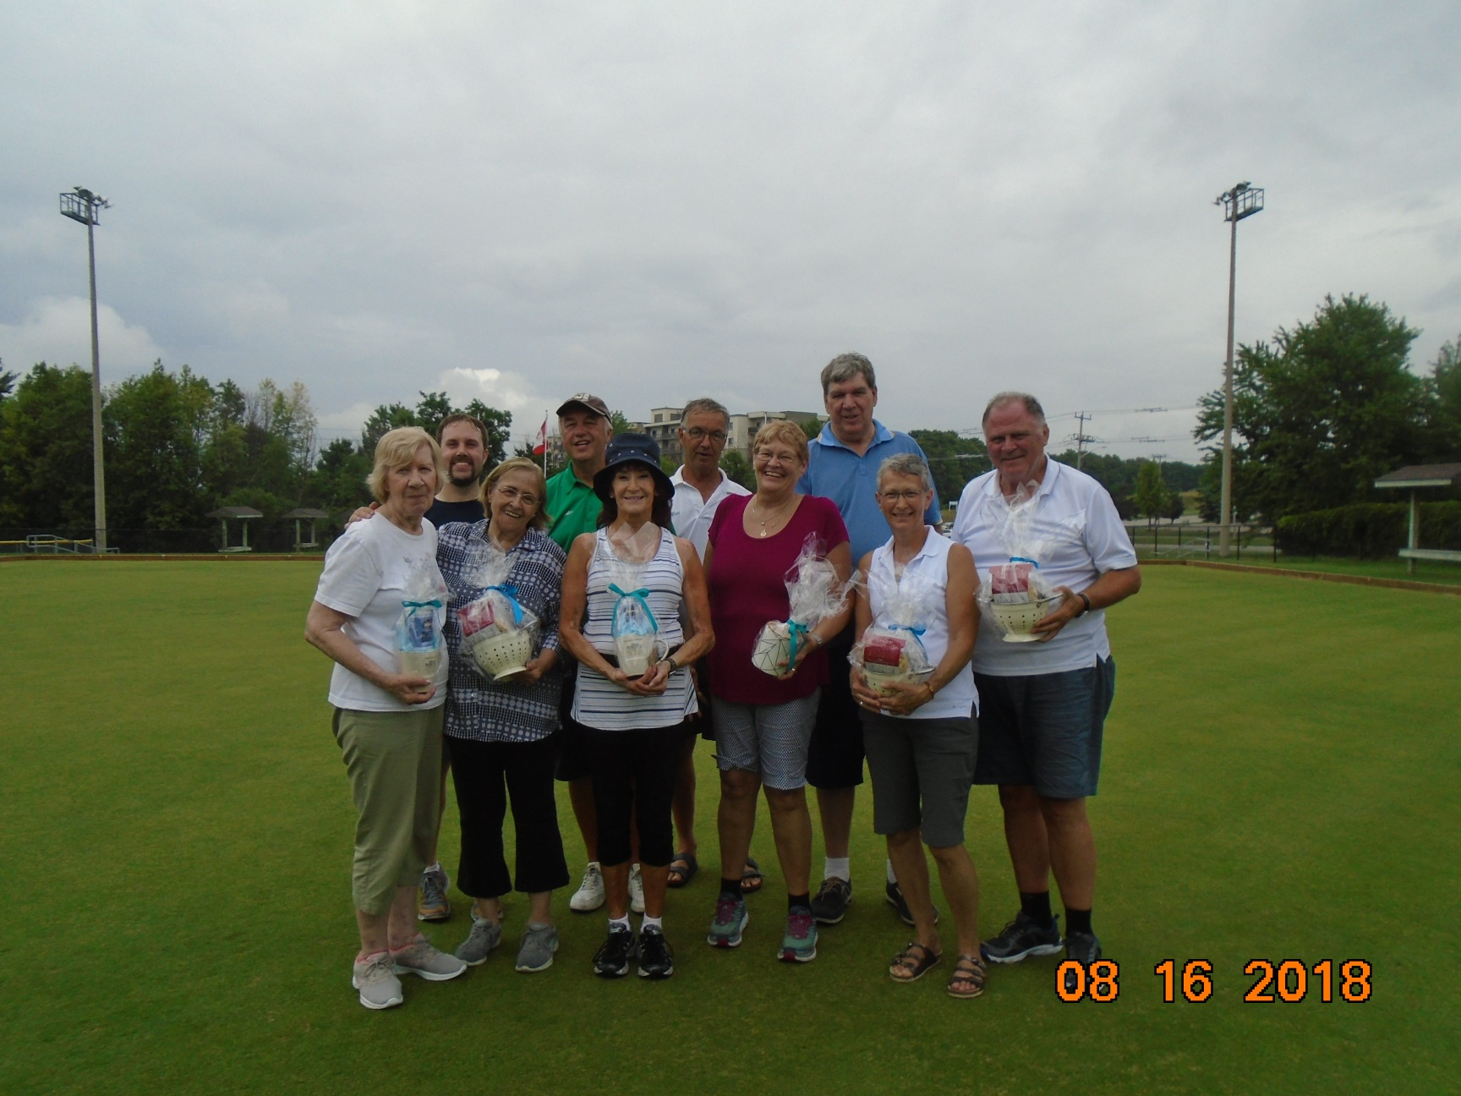

Followed by a BBQ –
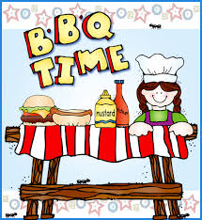
Many thanks to the Heritage Greens Lawn Bowling Club

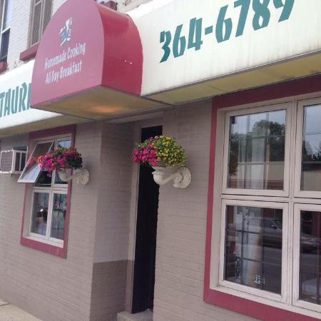

Dinner Dance

Tommy Dee’s Restaurant
Hanover, Ontario

Saturday, October 13, 2018

5:00 p.m. 5:30 p.m. sharp
You can order off of their menu,
which includes roast beef, fish
and chicken plates.
The steak will not be available
off of the menu for our event.
$15.00 a person, which includes your meal, coffee, desert and
gratuity.
The Heritage Club will pick up any extra costs over the $15.00

By our own Dave Schmidt, also known as Take One.

Come out for a night of good music, good food, dancing and prizes.

Please advise us by October 5th, by sending a cheque, made out to Grand Saugeen Chapter to: (envelope provided)

Donna Vandenhoff
95 Millwood Crescent
Kitchener ON N2P 1R3
Diane’s World
Grand Saugeen North Area Stories

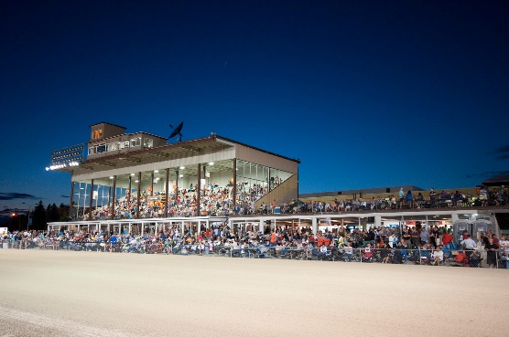
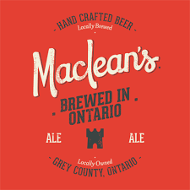
HANOVER RACEWAY

Hanover Raceway is operated by the Hanover, Bentinck & Brant Agricultural Society. Live Harness Racing begins the first week of June and ends in late September. Harness Racing is contested each Saturday night, with a live post time of 7:15 p.m. We offer a Simulcast lounge with wagering on tracks all over the world, 365 days a year. Our restaurant, The Coach House, features many delicious meals to enjoy.
Hanover Raceway, where live harness racing occurs right in the heart of Grey Country.

Charles MacLean might never have imagined while he was riding a Norton Commando through the countryside of England in the 70’s where his trip was leading him. A few months into the trip of a lifetime, Charles took a job at a pub for extra gas money. There he met brew masters who took him under their wing and taught him the art of English Ale making.

Charles brought this knowledge back to Canada and began helping to set up breweries while brewing in small batches on his farm. Somehow, a few people in the community would always seem to know when he was making a delivery. They’d be waiting patiently as he was unloading the truck while clutching a fistful of bills. It was known to sell out quickly.

Into the years where most would retire, Charles met partners Michael D’Agnillo and Curtis Schmalz. They convinced the wizard to come down from the mountain and build a new brewery in Hanover, Ontario. Now they work together to take Charles’ brew to all of Ontario and beyond.

Charles MacLean began brewing his signature Pale Ale in 1993. It’s been a favorite in the region ever since. A combination of British malts, English Fuggles and Golding hops. Add to that a distinctive strain of English ale yeast and the result is a well-hopped, malty ale with a fine balance and flavour.

This signature Ale is also available in certain LCBO and Beer Stores across the province

A new MacLean’s Ales Inc Brewery was built in Hanover in 2014. You can visit them at
52 14th Ave, Hanover ON.

MacLean’s Ales Inc Brewery Hanover On.
Hanover Ontario is a small town of 7500 people in southern Grey County, I was surprised to find that this is where they make the Ales of one of Ontario Craft Beer's founding fathers. Charles MacLean.

Hanover has been proud of MacLean's beer since Charles brought back English Ale making practices in the 1970.

Donations.
We have donated $100 to the Palmerston Hospital. One of our members, Faye Cronsberry is a volunteer in the gift shop there.

Your Benefits Contact Numbers

C.P.C. Pension 1-877-480-9220
Superannuation 1-800-561-7930
C.P.P. / O.A.S. 1-800-277-9914
Great West Life 1-866-249-5723
Access H.R. 1-877-807-9090

Good Life Fitness

Your club has invested in your health and wellness.
- Includes access to all GoodLife locations and Energie
Cardio locations (in Quebec)
- Towel service (where available, except Energie Cardio)
- World-renowned Group Fitness classes
- Professionally trained staff to assist you in achieving your goals
- Corporate rate extended to 4 additional family members.

For a location near you visit www.goodlifefitness.com.
To learn more about this offer or, to register, visit https://corporate.goodlifefitness.com (you will require your Heritage Club number to access information regarding this program)

You must be an active (paid up) member to take part in this offer.

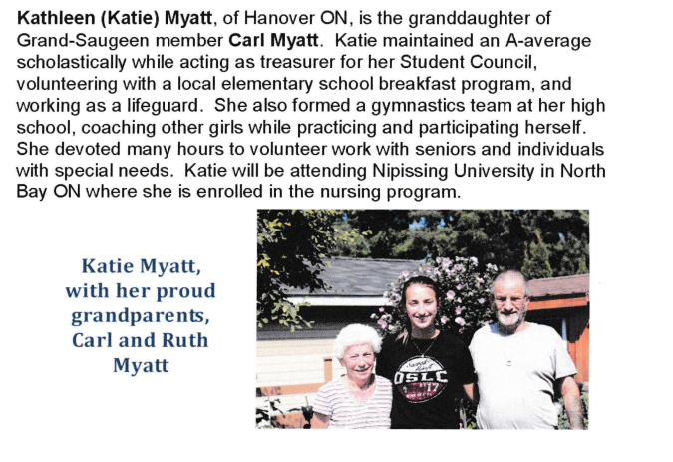

WEBSITE
We invite you to visit our website. Our 1st Vice President has done a fabulous job updating the site and you will find pictures of our events as well as information on upcoming events. Gail has also put copies of our newsletters on the site. You also can find several of our forms on the site. Just google Heritage Club or go to www.heritageclub.ca – click on Chapter in the right-hand corner and then click on Grand Saugeen

In Memorium
Marion Pinnell
Fred Clark and Debbie Clark celebrated their 40th wedding anniversary. They enjoyed an Alaskan cruise to celebrate. Congratulations Debbie and Fred.

I recently talked to John Mountford who advises he is doing well and has moved from Hanover to be with his daughter in Neustadt On. If you want to give him a call I am sure he would love to hear from you.
His phone number is 1-519-799-5965.

Gail Bourhill recently took the silver medal at the Ontario senior championships for Cribbage. This allows her to play in the Canadian Championships in Kelowna, B.C. in 2 years.. Great job Gail.

Judy Needham, along with Pat Mansz, Julie Dietrich and two others recently enjoyed a wonderful trip to Newfoundland. Judy explained it as 5 women driving a jeep through the Newfoundland outposts. Thanks for keeping us up to date and all the wonderful pictures on Facebook Judy.

YOUR EXECUTIVE

President Herb Stan Email – bgherb@hotmail.com
Phone: 519-746-3133
Secretary Treasurer Donna Vandenhoff Phone: 519-748-0252
First Vice President Gail Bourhill Phone: 519-208-9427
Second Vice President Stella Augerman Phone: 519-743-4648
Executive-at-large Diane Mcnichol-Byers
Past President Ron Kueneman

