Confederation Chapter

NEWSLETTER – SUMMER 2019

MESSAGE FROM THE PRESIDENT (Lise Miville-Dechêne)

In my Newsletter – winter 2019, you were advised that I would not renew my mandate in 2020 and a Nomination Form was included for the following Executive positions: President, Director of Events and Treasurer (all positions that I now hold). Unfortunately, there was no interest and due to the lack of support from my members, I had no choice to advise the National Heritage Club’s President that it would be my last year as an Executive of the Confederation Chapter. I will continue to organize events for the balance of the year 2019 and the Chapter’s bank account will be closed off and money transferred to the Secretary-Treasurer of the National Heritage Club.

During the National Annual General Meeting that took place in Regina SK at the beginning of June, it was decided that the Confederation Chapter will be merged with the other chapter operating in Ottawa. In my Newsletter – FALL 2019, it will be explained thoroughly as to where and to whom to send your annual dues for the year 2020.

There are few events left and it would be great to see more of you join us (see details at page 3).

The Confederation Chapter is pleased to welcome the following members:

- Gisèle Allaire from Casselman ON
- Lucie Keurentjes from Ottawa ON

IN MEMORIAM

Patricia Latremouille passed away in April 2018 at the Ottawa Heart Institute. Pat worked for Canada Post for 34 years and retired in 1974. She started working right after school as a steno/typist and finished her career in Advertising.

PROCEDURES TO FOLLOW FOR BENEFITS DUE TO SURVIVOR OF A RETIREE

To ensure the survivor of a retiree maintains pension, health and medical benefits, a number of contacts must be made after the retiree’s death:

- Access Human Resources (H.R.): 1-877-807-9090
  - Information required: retiree’s name, employee number, social insurance number and a copy of the death certificate.

- Canada Post Pension: 1-877-480-9220
  - Information required: retiree’s name, employee number, postal code, month/date of birth and copy of the death certificate.

- Great West Life: 1-866-249-5723
  - Information required: retiree’s name, employee number, copy of the death certificate and plans numbers (51057 and 51391).

    - NOTE: Very important to notify Great West as soon as possible in order to set-up a new automatic withdrawal in the Survivor’s name in order to keep policy in force and maintain medical, dental and vision benefits.

- Canada Pension Plan / Old Age Security: 1-800-277-9914
  - Information required: retiree’s name, social insurance number and copy of the death certificate.

    - NOTE: Besides the survivor pension there is also a death benefit payable to the survivor.

- Superannuation: 1-800-561-7930
  - Information required: retiree’s name, social insurance number and copy of the death certificate.

HISTORY OF THE MAC THE MOOSE
Picture taken of the National Heritage Club Executives and Presidents of each chapter.
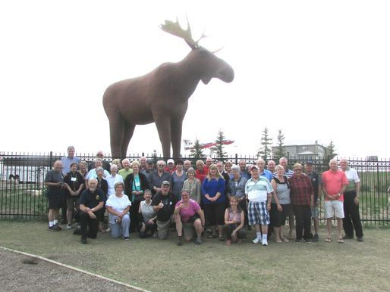

Mac the Moose was built in 1984 by Saskatoon’s artist Don Foulds with the goal of attracting visitors to the city. The construction process involved a steel frame with metal mesh and four coats of cement. A contest was held to name the moose, with the name “Mac” chosen after Les MacKenzie. The giant moose was one of the city’s first tourists attractions. The project was completed by May 1984.

In 2004, Mac was moved 2 kilometers using a flatbed truck and is now just off the Trans-Canada highway next to the Moose Jaw visitors’ center. Although Mac has been vandalized many times (once being painted blue and other physical damage was done, including losing his jaw), he still stands, although surrounded by a fence since 2009. In 2013, Mac was honoured by the Moose Jaw Times Herald as Moose Jaw’s Best Celebrity.

After 31 years of holding the title of the world’s largest moose, in 2015, Mac the Moose was surpassed by another moose statue in Stor-Elvdal, Norwway, called The Big Elk. The Big Elk deliberately stands about 50 centimeters taller. In an interview with Global News on the subject, Moose Jaw’s mayor Deb Higgins was not bothered, stating that “I think we have won the battle, first and foremost that Mac’s reputation has spread to Norway and beyond”. Subsequently, Mac the Moose now holds the title as North American’s largest moose, with Tourism Moose Jaw referring to it as the “World’s Second Largest Moose”.

In January 2019, two Canadian comedians urged Moose Jaw’s residents to add 31 centimeters to Mac’s height (likely by extending his antlers or giving him a helmet), so that the moose status would once again win the title of the world’s largest moose. The Norwegians responded and have stated that they will not give up the world record without a fight.

The Canadians do have one edge over Norway – our moose was built by Canadians in the country where it resides, making it essentially a ‘native’ moose; the Norway statue instead, while being conceived by Norwegian artist Linda Bakke, was erected in China and imported largely as a cost-saving measure.

PLANNED EVENTS

- WEDNESDAY, AUGUST 28, 2019: THOUSAND ISLANDS PLAYHOUSE – Show ‘’Ring of Fire’’ (the music of Johnny Cash) A music celebration of The Man in Black + early meal in a private room at the Gananoque Inn. Detailed information is enclosed.

- SUNDAY, SEPTEMBER 8, 2019 : ANDERSON LINKS GOLF & COUNTRY CLUB – 18 holes with cart + buffet-style dinner. Detailed information is enclosed.

The meal will comprise of the following: Chicken & ribs (already ate them - DELICIOUS), garden salad, pasta salad, roasted potatoes, french garden vegetables, corn on the cob (in season), fresh rolls and butter, dessert and coffee/tea.

NOTE : You are quite welcome to join us for the meal (even if you are not a golfer).

Future events

- FRIDAY, OCTOBER 11, 2019: Lunch at ROGER’S ITALIAN-BISTRO at Train Yards in Ottawa. Information will be detailed in the Newsletter – AUTUMN 2019.

Lise

Lise Miville-Dechêne
President - Confederation Chapter
Heritage Club
1324 Kingston Avenue
Ottawa ON K1Z 8L2
(613) 371-5228
Email : Confederation_Chapter@bell.net

