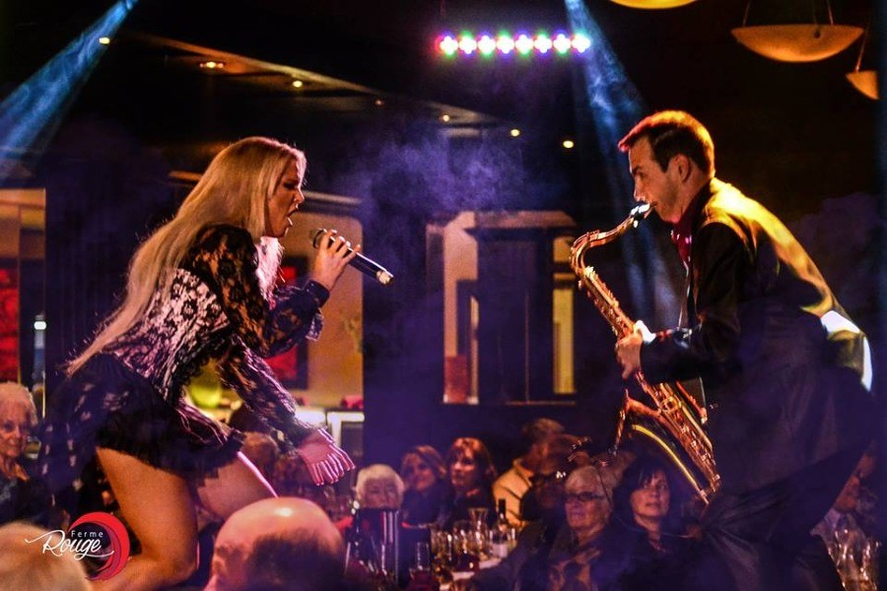

LA FERME ROUGE (A cabaret-style restaurant)

The Ferme Rouge showcases LIVE music. The pianist, accompanied by the servers-artists, present a variety of performance and tributes such as: Les Folies Bergères, Michael Jackson, Elvis, etc. This harmony of music, song and dance transports you into a festive world. Journey into the world of music accompanied by local hip servers-artists.

You can choose from a Menu à la carte or the all-you-can-eat surf & turf buffet.

DATE: Friday, February 23, 2018
TIME: 6:00pm (be sure to be there by 5:45pm)
LOCATION: 1170 Aylmer Road, Gatineau QC (next to the Château Cartier Golf Course)

Only 25 spaces have been reserved, so it is on FIRST COME- FIRST SERVE basis and friends are welcome.

To confirm your attendance, please call me at 613-371-5228 - or send me an email at: Confederation_Chapter@bell.net - or fill-out the coupon on page 2 and return it at the under-mentioned address:

Lise
Lise Miville-Dechêne, President
Confederation Chapter of the Heritage Club
1324 Kingston Avenue
Ottawa ON K1Z 8L2

LA FERME ROUGE – Friday, February 23, 2018

MEMBER’S NAME: _____________________________________________________________

TELEPHONE: ______________________

EMAIL: _______________________________________________________________________

# OF PERSONS ATTENDING: _______________

