

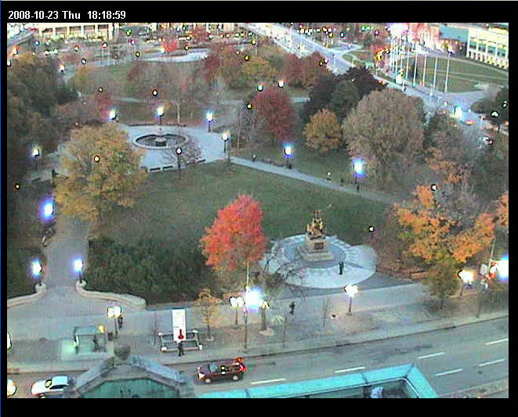

**NEWSLETTER - FALL 2016**

**SANTA LETTER PROGRAM 2016**

This year Santa Claus has called us to recruit elves to answer children’s letters. The list for the active elves is incomplete and we would like a confirmation of your participation or your interest in the Program by filling in the coupon and returning it in the self-addressed envelope as quickly as possible

**Name(s):** _________________________________________________________________

_________________________________________________________________

_________________________________________________________________

**Membre-elf:** NEW  EXISTANT 

**DINER FOR MEMBERS FOR THE MONTH OF NOVEMBER 2016**

For members residing in the East-end of Ottawa, the lunch will be from noon to 2:00pm at the under-mentioned restaurant. RSVP no later than Tuesday, November 8th, 2016 by filling in the coupon, checking-off the restaurant, and returning it in the same self-addressed envelope.

**DELICIOUS STEAK HOUSE**

Monday, November 14th 2016

2080, St-Joseph Blvd

Ottawa (Orleans) ON K1C 1E6

(613) 830-3366

For members residing in the West-end of Ottawa, the lunch will be from noon to 2:00pm at the under-mentioned restaurant. RSVP no later than Tuesday, November 1st, 2016 by filling in the coupon, checking-off the restaurant, and returning it in the same self-addressed envelope

**HEART and CROWN**

Tuesday, November 8th 2016

3161 Strandherd, Suite 300

Ottawa (Barrhaven) ON K2J 5N1

(613) 440-3906

Lise Miville-Dechêne, President

Confédération Chapter

Héritage Club

**Name** __________________________________________________________________

**Spouse : __________________________________________________________________**

**DELICIOUS STEAK HOUSE:**

**HEART and CROWN :**

NB: You are welcomed at both restaurants and drinks will be paid by the Chapter.