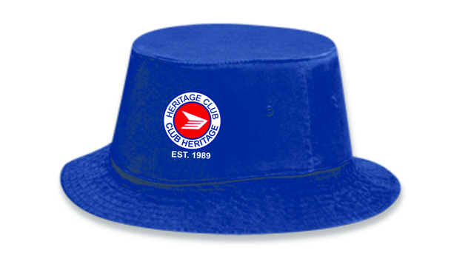
INTRODUCING THE CHAPTER 29 FUNDRAISER
We are very excited to offer these hats for sale
as our newest fundraiser. It is a bucket style available
in blue or white, in small/medium or large/xlarge. It will
have the logo embroidered as shown.

The cost is $20.00.

We will be offering this hat for sale across Canada
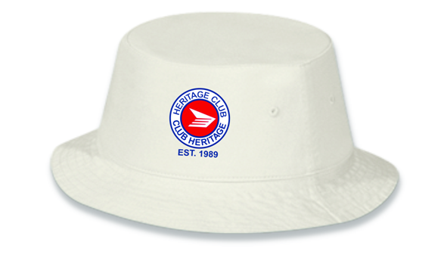
to all Heritage Club Chapters, through the
website.

These cotton hats can be worn for golfing, walking,
gardening, fishing etc. We want everyone to jump
on board and get one of these exclusive hats! The
money raised from the sale of the hats will go to either
BC Childrens’ Hospital or Variety.

Below is an order form to complete and return to
Gary Fisher, 101-3606 25th Avenue, Vernon B.C. V1T 1P3.
Please send a cheque made out to the Heritage Club.

Name:____________________________________

Address:__________________________________________________
__________________________________________________

Phone: ____________________

Colour – Blue _____ White _____ Size _____________

Please indicate how many of each colour you would like.

