# President’s Message

# HERITAGE CLUB

**est. 1989   |   People helping people**



Fall is upon us, and we have so much to report to you since our last newsletter:

* We have celebrated 30 years as the Heritage Club
* We had a record breaking attendance at our golf tournament this year
* We had a wonderful luncheon at Ming Wah’s in Windsor
* We donated money and food items to several charites
* We have a group together that we would love you to join for Santa Letter Writing.

**\* PLEASE READ ON FOR THE DETAILS, PICTURES AND EXCITEMENT. WE LOOK FORWARD TO HAVING YOU JOIN US.\***

Bob Emmons,

Bluewater Chapter President

**Bluewater Chapter**

**November, 2019**

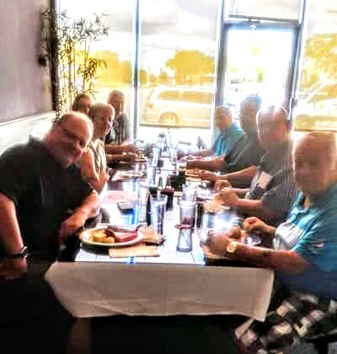

Our Luncheon at Ming Wah Chinese and Sushi Buffet

# Golf Tournament

We had a fantastic turnout to our golf tournament this year, with record breaking attendance.

We even made the local paper with our donations of nonperishable food items and a cheque for $200.

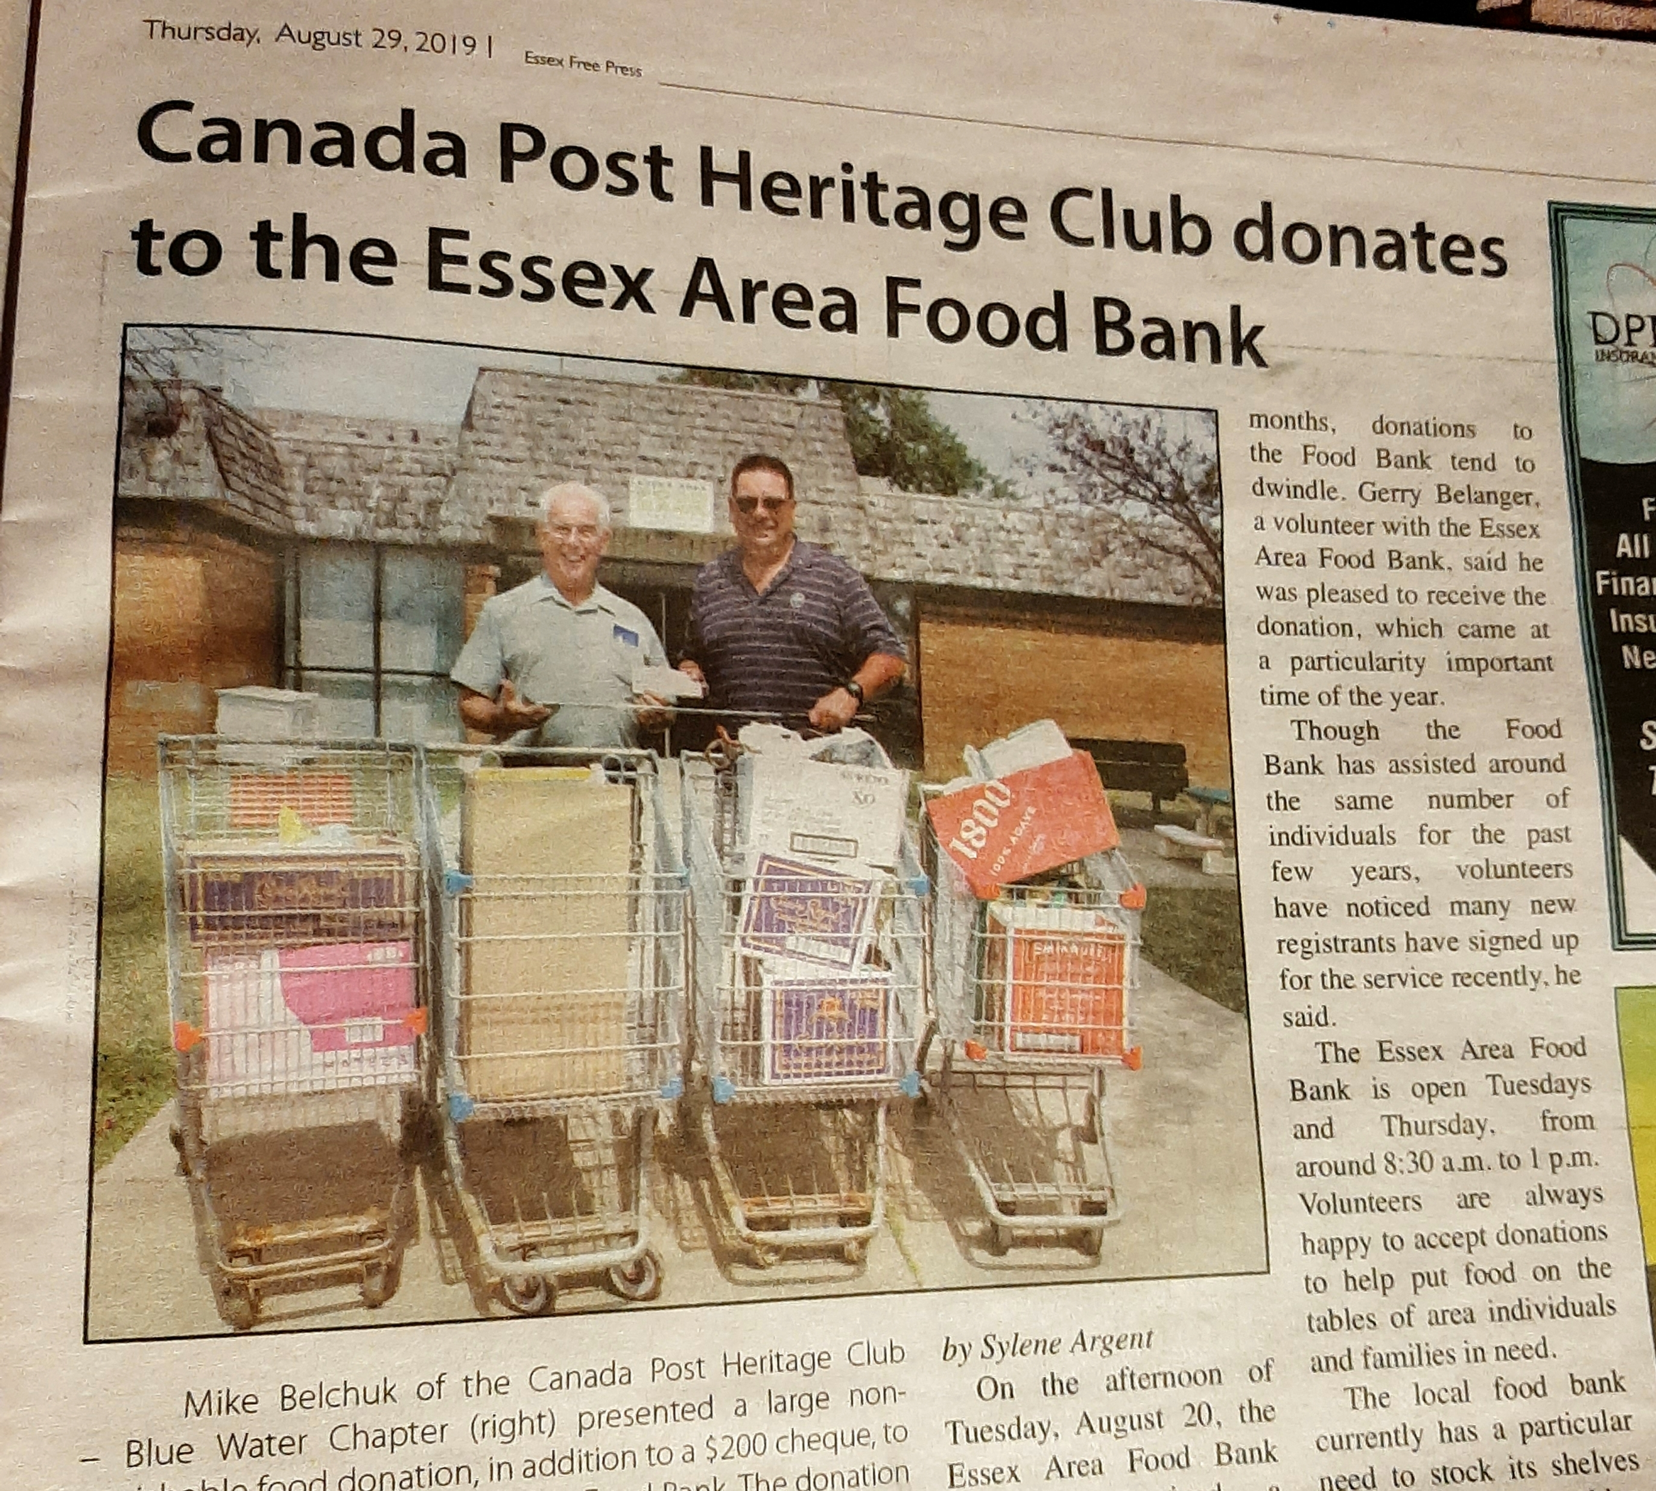

**SAVE THE DATE**

Thursday, August 20, 2020

Orchardview Golf Club

1357 County Road #34

Ruthven, Ontario

N0P 2G0

# Some photos from our day

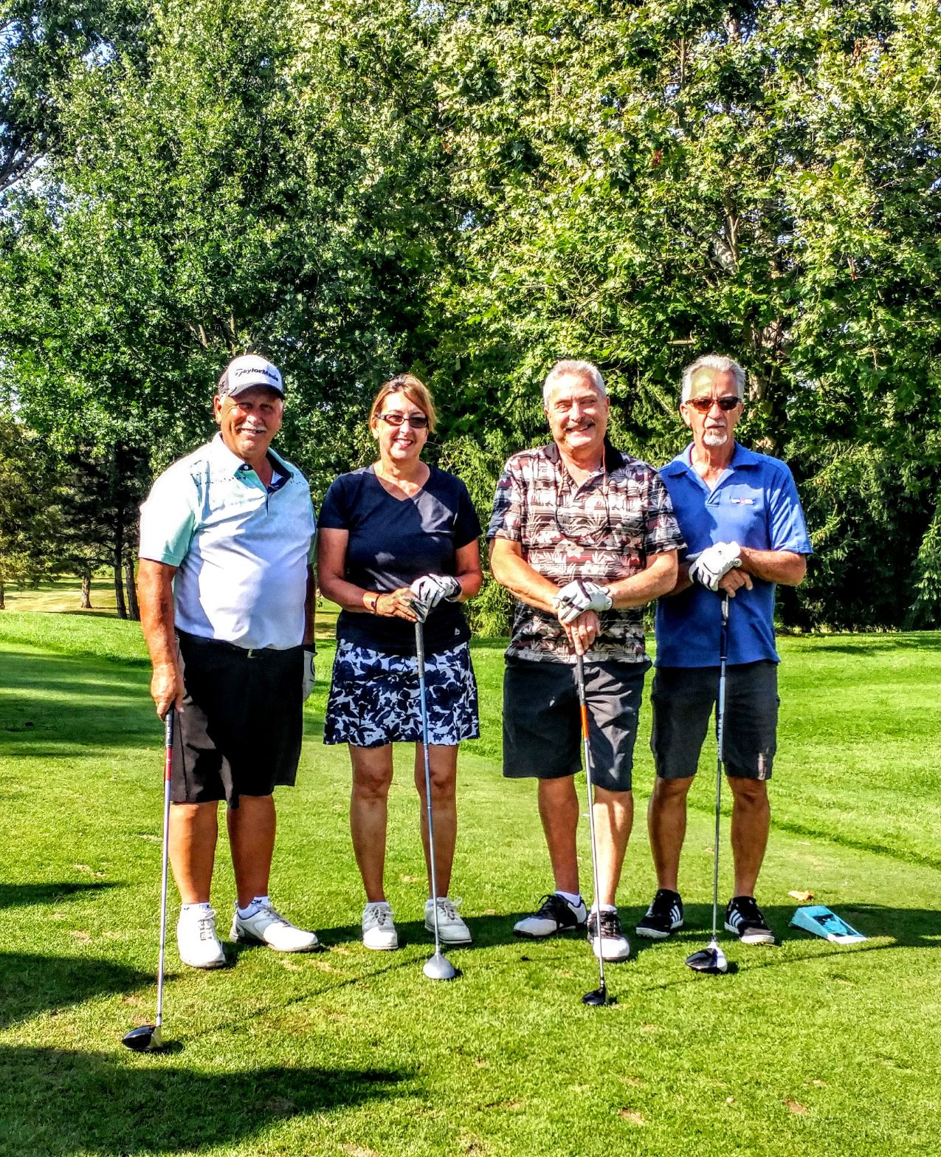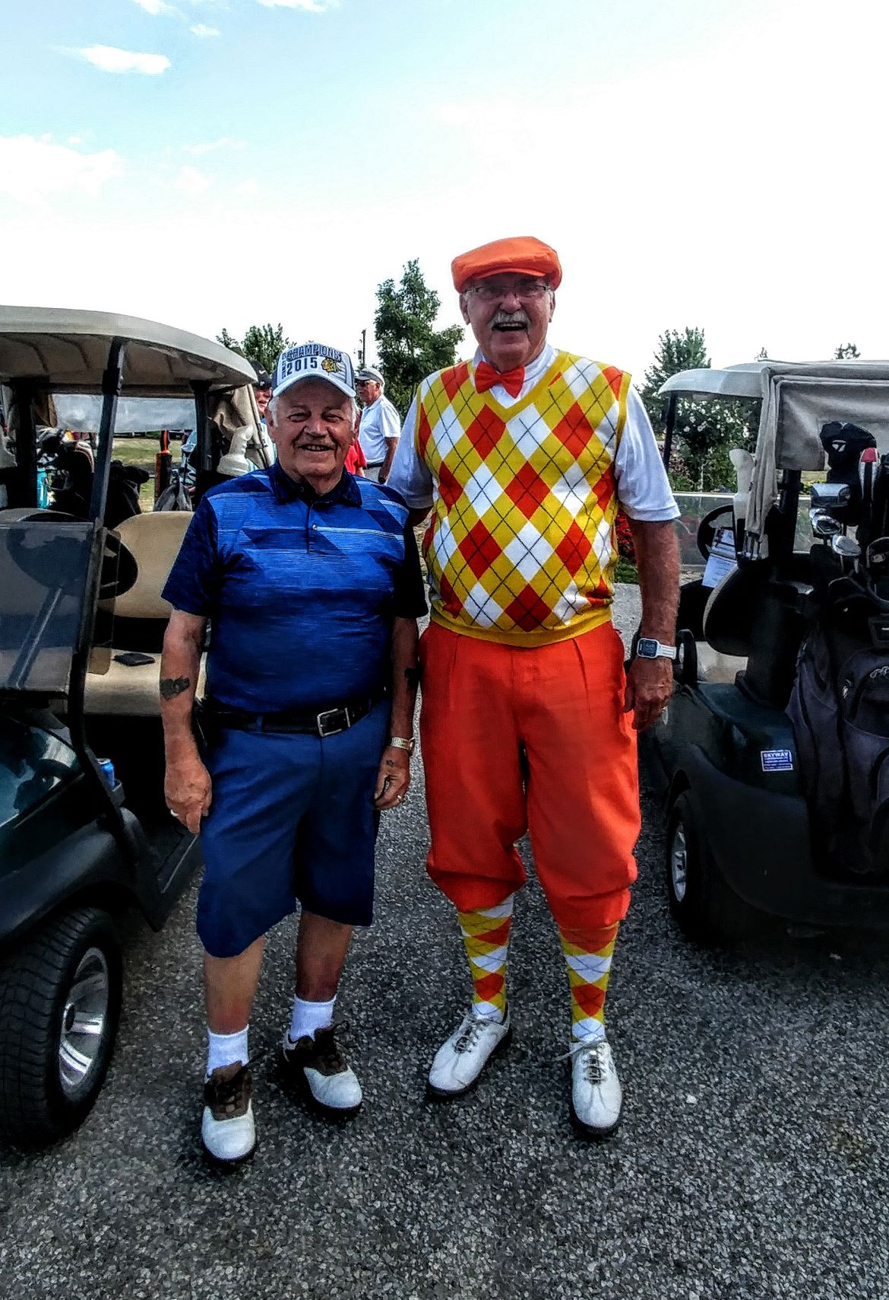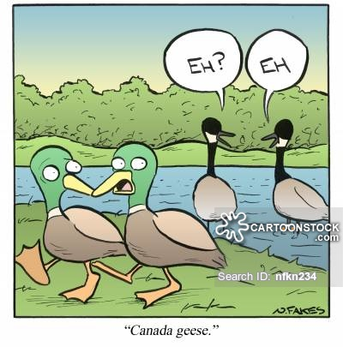

# Santa Letter Writing – Mark your Calendars

WE ARE SO EXCITED TO BE TAKING PLACE IN THIS VERY MEANINGFUL PROGRAM THIS YEAR.

Please mark your calendars to join us in helping make a difference in the life of a child. We will be meeting at the Royal Canadian Legion in Essex, Ontario on the following days:

1. Wednesday December 4, 2019 - 2pm. Wednesday at the Legion is Burger day. Come early and have lunch first. We will start writing at 2pm.
2. Friday December 6, 2019 – 11 am
3. Saturday December 7, 2019 – 11 am

IF YOU HAVE PUT YOUR NAME ON THE LIST, OR WOULD LIKE TO JOIN US, PLEASE EMAIL HOLLY PERREAULT AT [heritageclubmembership@gmail.com](mailto:heritageclubmembership@gmail.com) TO CONFIRM YOUR ATTENDANCE We have heard it on good authority that Santa Claus and Mrs. Claus will be joining us this year to help write letters.

# Ring in the New Year

# Membership Luncheon

We know this is a very busy season for everyone, so instead of having our Membership Luncheon before Christmas, we decided to RING IN THE NEW YEAR at the **Cascades Chatham Casino**. This is a halfway point in our Chapter and we are hoping to see even more of you join us for a day of fun and laughter. Please join us at

CASCADES CHATHAM CASINO

**615 Richmond St, Chatham, ON N7M 1R2**

**ON January 17, 2020.**

This invitation includes your spouse or significant other. We need to make reservations ASAP. Please let us know that you will attend no later than January 13, 2020. To RSVP please email Holly Perreault at [heritageclubmembership@gmail.com](mailto:heritageclubmembership@gmail.com)

**If there is enough chapter interest, we would like to book a bus trip to the Huron County Playhouse.**

**Email Holly Perreault if you are interested and we will make this happen.**

**Obituaries**

It is with heavy hearts that we announce the passing of the following chapter members:

* Richard Morand
* Marcel Morais
* Robert (Bob )Morris

We send our sympathies and condolences to their families and loved ones.

# Charitable Donations

We are so pleased and proud to announce that we have been able to contribute to the following charities since our last newsletter:

* 4 Grocery carts of nonperishable food donations
* $200 to Essex Food Bank
* $500 to Special Olympics
* $1000 to Ronald McDonald House.

# Membership Renewal

If you have not already renewed your Bluewater membership, you may do so by sending your Annual $10 dues to for 2020:

Mike Belchuk, Vice President

143 Brien Ave East

Essex, Ontario

N8M 2P2

This membership due entitles you to our various discounts. If you are not sure if you have paid your 2019 dues, you can again, contact Holly Perreault.



If you have recently moved or are planning a move, please let us know, so that we can keep our information up to date.