Hello to all! Hope you are enjoying your summer so far. I recently attended the AGM in Regina, Saskatchewan at the beginning of June and want to thank Conway Crozier-Smith and the Golden Sheaf Chapter for their hospitality. We have some changes and announcement to share with you all, so please read on to find out the NEWS!

WE ARE LOOKING TO BECOME MUCH MORE INVOLVED IN OUR CHAPTER AND WE NEED YOU TO JOIN US!

Bob Emmons,

.

# Discounts

# President’s Message

# HERITAGE CLUB

**est. 1989   |   People helping people**



# Earl Schulthies – Founding Member

It is with much sadness we announce the passing of Earl Schulthies, who passed away at the age of 98. Earl was one of our Founding Members of the Bluewater Chapter. Earl has held many positions during his career with Canada Post, his last being as Personnel Manager and Public Relations Officer of the Windsor Office. We send our most heartfelt condolences to his family.

**Obituaries**

It is with heavy hearts that we announce the passing of the following chapter members.

Earl Schulthies

Yvon Dubois

Richard Carrington

Gerald Skill

Randall Michea

**Bluewater Chapter**

**July, 2019**

# “IMPORTANT NOTICE”

# Golf Tournament

Due to circumstances beyond our control, we have had to change the location of the Annual Golf Tournament. It is being changed from Countryview Golf Club in Chatham to

Orchardview Golf Club

1357 County Road #34

Ruthven, Ontario

N0P 2G0

Thursday, August 15,2019

Registration at 9:30

Shotgun start at 10:30

$65 includes Golf, Cart and Buffet dinner

If you wish to attend for the dinner only, the cost is $15.

Please see the attachment. Fill out and mail back your forms ASAP

*We chose this location because as you all are aware; we have had a seasonably wet summer. This course has an exceptional drainage system and therefore carts can still be used.”

**PLEASE REMEMBER YOUR NONPERISHABLE FOOD ITEMS FOR THE FOOD BANK**

**PROCEDES FROM THE 50/50 DRAW WILL BE DONATED TO SPECIAL OLYMPICS**

# 

# 

We have a new discount offer for all paid members of the Heritage Club with

COLETTE TOURS

Details will be on the website soon. Our National Executive is always working hard to find us the best possible discounts and deals. This discount is in addition to our already amazing list of offers:

* Johnson Insurance
* Telus Mobility
* Choice Hotels
* Goodlife Fitness

*TO FIND OUT MORE DETAILS ABOUT THESE DISCOUNTS, PLEASE LOG INTO

[www.heritageclub.ca](http://www.heritageclub.ca)

SCROLL DOWN AND YOU WILL SEE ALL OF THE DETAILS UNDER PARTNERS.*

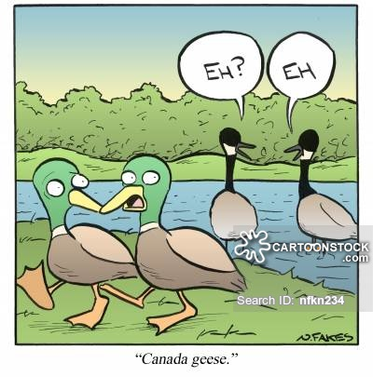

# Santa Letter Writing – Mark your Calendars

As a chapter, we would like to take a more active role in this very valuable program. Please mark your calendars in early November to join us in helping make a difference in the life of a child. The times and exact dates will be announced in our fall newsletter. Please email Holly Perreault at [heritageclubmembership@gmail.com](mailto:heritageclubmembership@gmail.com) and put your name on the list to volunteer. We have heard it on good authority that Santa Claus and Mrs. Claus will be joining us this year to help write letters.

# Summer Wrap Up

# Membership Luncheon

As summer comes to a close, we are excited to invite you to join us for a Luncheon to be held on August 23, 2019 at 12 noon. Our luncheon will be at

Ming Wah Chinese and Sushi Buffet

6711 Tecumseh Road East

Windsor, Ontario

N8T 3K7

The cost is $12.95 and our chapter will be paying for $6 of each member’s lunch. This includes your spouse or significant other. We need to make reservations ASAP. Please let us know that you will attend no later than August 6, 2019. To RSVP please email Holly Perreault at [heritageclubmembership@gmail.com](mailto:heritageclubmembership@gmail.com)

**OUR FALL NEWSLETTER WILL ANNOUCE OUR NEXT LUNCHEON DATE AND LOCATION TO BE HELD THIS FALL IN SARNIA.**

# Membership Renewal

If you have not already renewed your Bluewater membership, you may do so by sending your Annual $10 dues to:

Mike Belchuk, Vice President

143 Brien Ave East

Essex, Ontario

N8M 2P2

This membership due entitles you to our various discounts. If you are not sure if you have paid your 2019 dues, you can again, contact Holly Perreault.

# Day Trips

Would you be interested in joining us on a day trip? We a lot of great ideas that we would like to put into action, BUT we need your involvement to make this happen. Please send us an email at heritageclubmembership.ca and simply let us know that you would be interested. If we get enough of a response we will plan a trip for this fall.

# Benefit Contact Numbers

C.P.C. Pension 1-877-480-9220

Superannuation 1-800-561-7930

C.P.P. / O.A.S. 1-800-277-9914

Great West Life 1-866-249-5723

Access H.R. 1-877-807-9090

Employment Ins 1-800-206-7218

Passport 1-800-567-6868



If you have recently moved or are planning a move, please let us know, so that we can keep our information up to date.