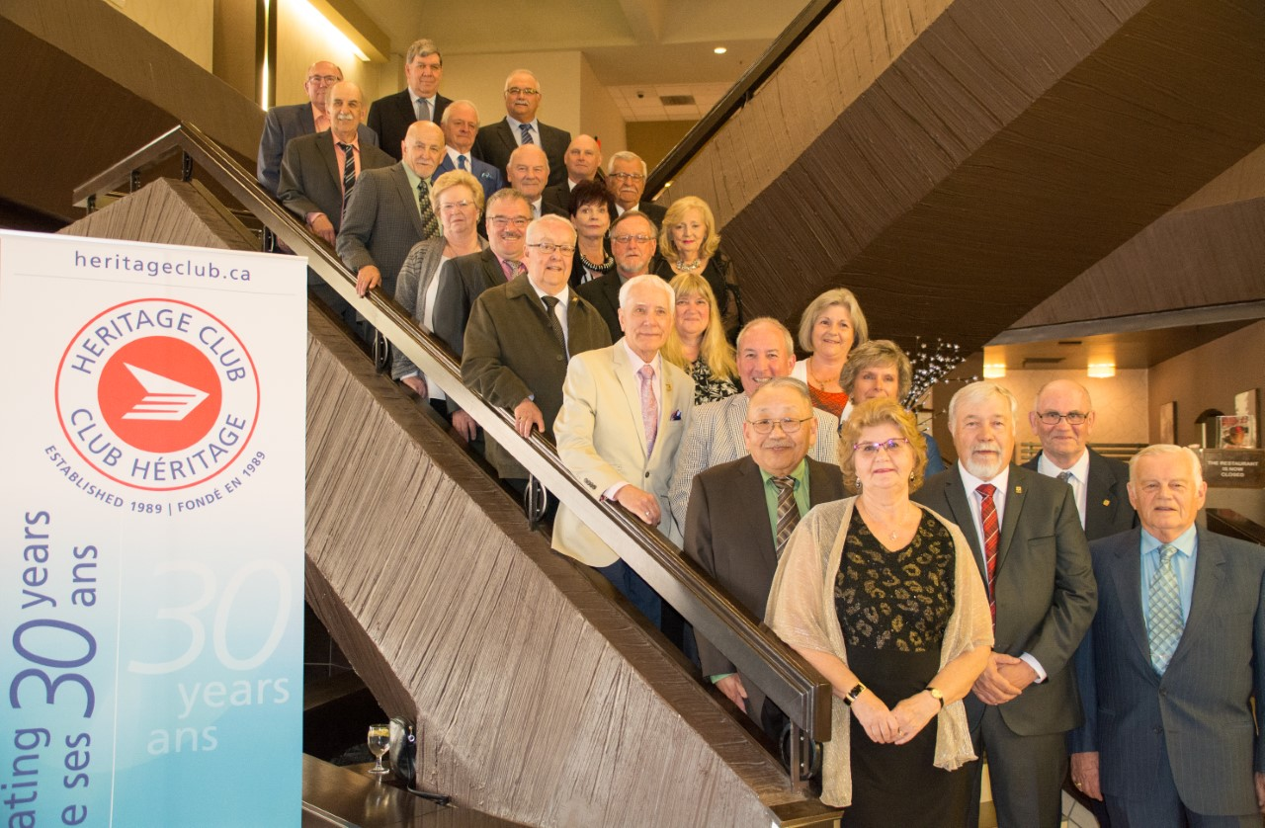
AGM REGINA – June 1 – 4, 2019

(see next page)

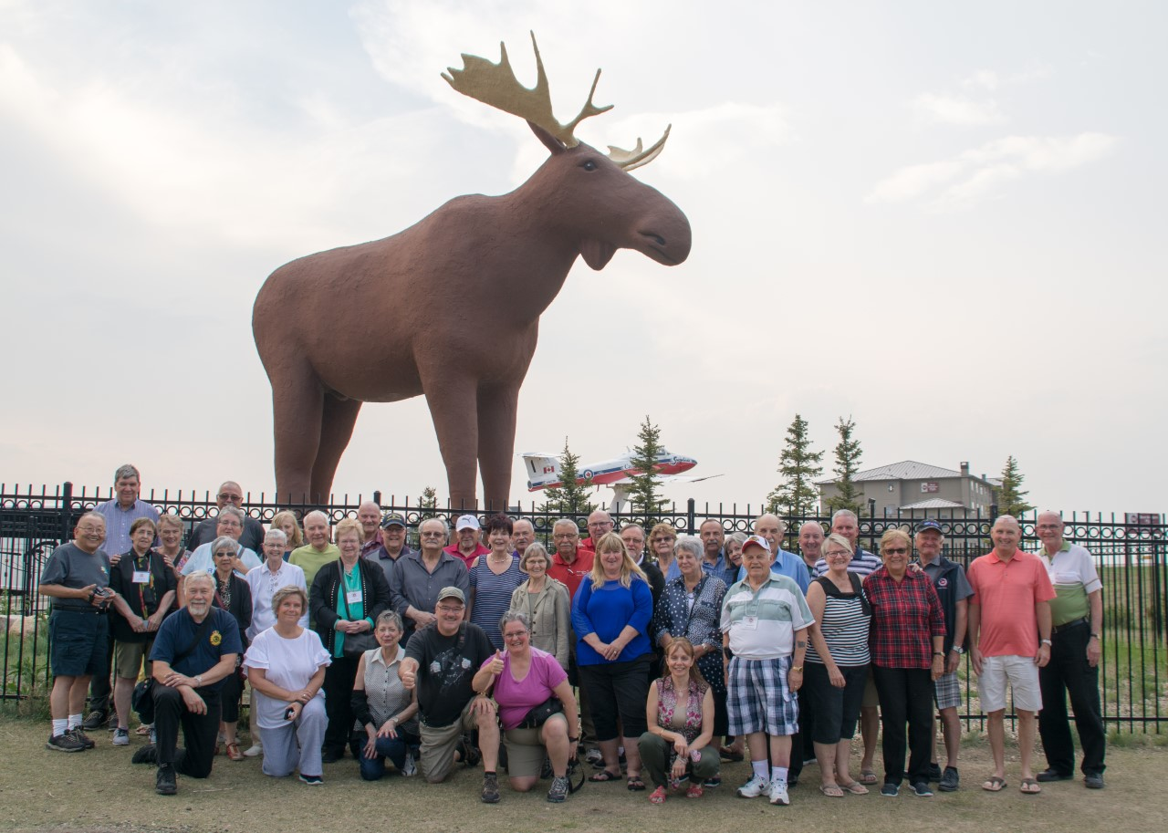
MAC THE MOOSE

